Hadoop Hive Lab:

# Assignment:

Complete following tasks based on the data set mentioned above:

1. Create NYSE_Partition table based on the **company symbol** field.
2. This table needs to store the data as ORC file.
3. Load data of only those records where open price of the day is greater than 68 and high price of the day is less than 70.

# Solution:

**Step 1:** *Creating new database in hive*

create database may29c;

**Step 2:** *Using existing database*

use may29c;

**Step 3:** *Creation of table without partition*

CREATE TABLE NYSE_WP(

stock_exchange STRING,

company_symbol STRING,

idate STRING,

open_price_of_the_day FLOAT,

high_of_the_day FLOAT,

low_of_the_day FLOAT,

close_of_the_day FLOAT,

volume BIGINT,

adjusted_close_price FLOAT

)

ROW FORMAT delimited fields terminated BY ','

STORED AS textfile;

**Step 4:** *Creation of Partition table based on company symbol field*

CREATE TABLE NYSE_PARTITION(

stock_exchange STRING,

idate STRING,

open_price_of_the_day FLOAT,

high_of_the_day FLOAT,

low_of_the_day FLOAT,

close_of_the_day FLOAT,

volume BIGINT,

adjusted_close_price FLOAT

)

PARTITIONED BY(company_symbol STRING)

ROW FORMAT delimited fields terminated BY ','

STORED AS orc;

**Step 5:** *Loading data in to table without partition*

load data local inpath '/mnt/home/arun.kpselvam_gmail/NYSE_daily_File.csv' into table NYSE_WP;

**Step 6:** *Checking if the data got loaded correctly*

select * from NYSE_WP where open_price_of_the_day > 68.0 and high_of_the_day < 70.0 limit 5;

**Step 7:** *Enabling Dynamic Partition since it is disabled by default*

set hive.exec.dynamic.partition=true;

set hive.exec.dynamic.partition.mode=nonstrict;

set hive.exec.max.dynamic.partitions=100;

set hive.exec.max.dynamic.partitions.pernode=100;

**Step 8:** *Insertion of data in to partition table based on conditions*

insert into table NYSE_PARTITION partition(company_symbol) select stock_exchange,idate,open_price_of_the_day,high_of_the_day,low_of_the_day,close_of_the_day,volume,adjusted_close_price,company_symbol from NYSE_WP where open_price_of_the_day > 68.0 and high_of_the_day < 70.0;

**Step 9:** *Query to test the partition*

select * from NYSE_PARTITION limit 5;

# Results:

**Hadoop Hive Console Log:**



**ScreenShots:**

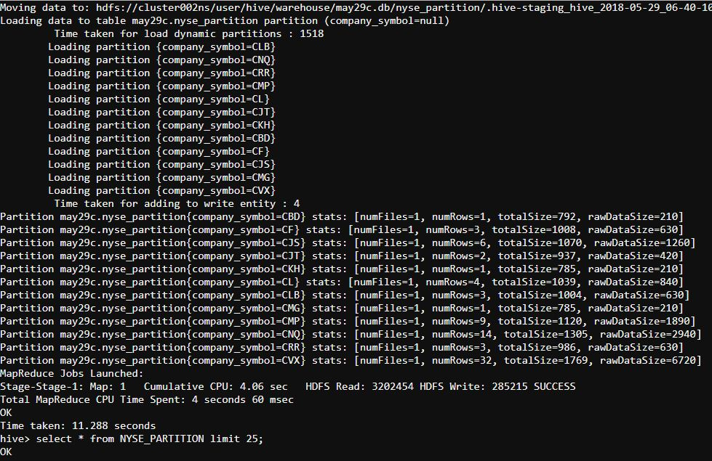**1.Data loaded to Partition Table:**

**2.Data from Partition table retrieved successfully**

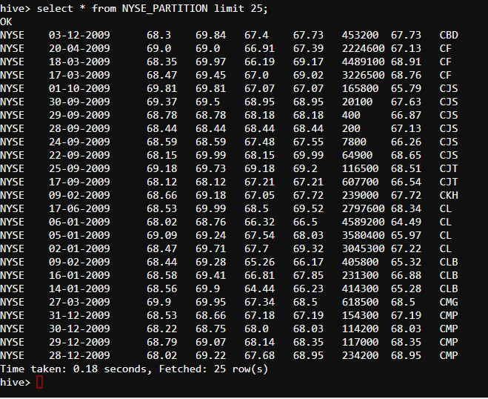

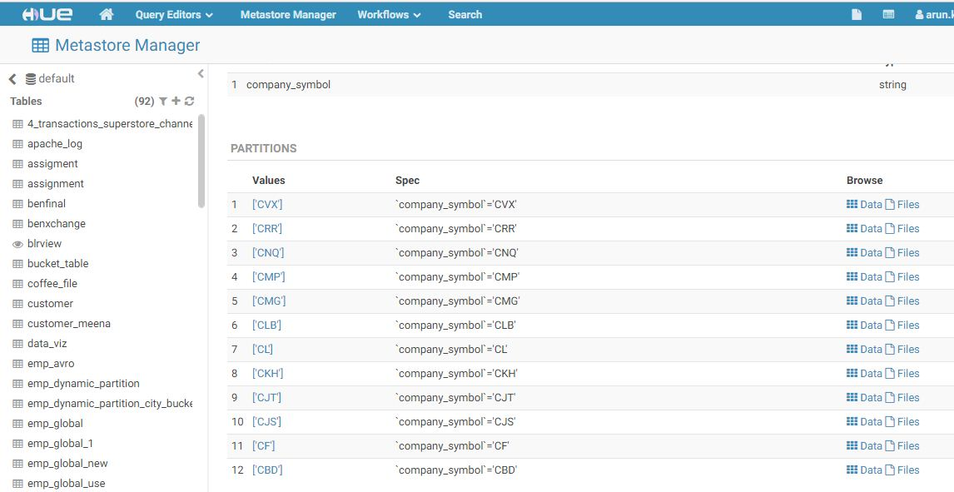**3.Partitions in HIVE**