Hiring

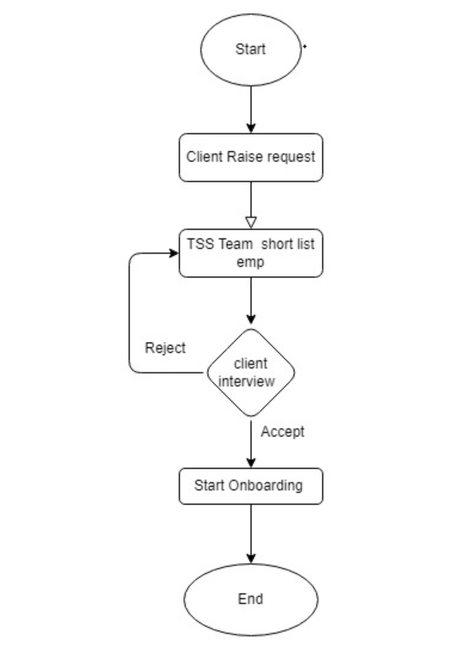

* Step 1 – Client will raise a request for vacant counter / New Counter.
* Step 2 – Request will be pending for TSS team. TSS tem will share the CVs of multiple candidate for the raise request.
* Step 3 – Client will short list the employee for interview.
* Step 4 – client will select the candidate for on boarding.
* Step 5 – TSS team will start on boarding of selected employee.

Step 1 Client entry form

Grid View

|  |  |  |  |  |  |  |  |  |
| --- | --- | --- | --- | --- | --- | --- | --- | --- |
|  |  |  |  |  |  |  |  |  |
| S.No. | Request No | Request date | Hired Type | Dealer Name | Region | State | Branch | Status |
|  |  |  |  |  |  |  |  |  |

Detail View

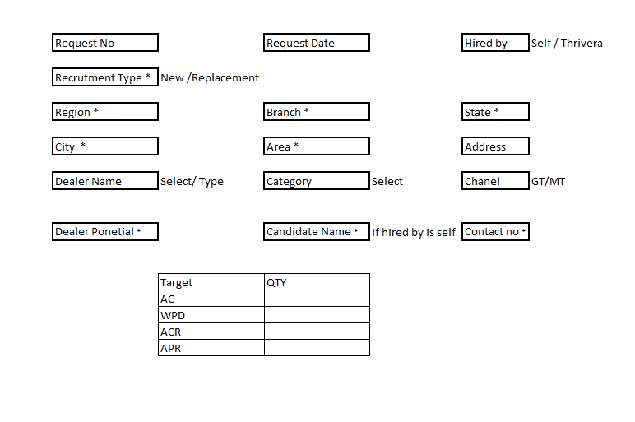

|  |  |  |  |  |  |  |  |
| --- | --- | --- | --- | --- | --- | --- | --- |
| **S.No** | **Filed Name** | **Filed Type** | **Max Char.** | **link with** | **Validation** | **Remarks** | **Mandate** |
| 1 | Request No | Alfa Numeric | 20 | NA | Cant be Null | System generated | Request Number Cannot be duplicate |
| 2 | Request Date | date | DD-MM-YYYY | NA | NA | System generated | YES |
| 3 | Hired By | Selection | 10 | Candidate Name | Single Selection | If Hired by self then user will input candidate details | Yes |
| 4 | recruitment Type | Selection | 10 | Dealer Name and Candidate | Single Selection | If user Select transfer then user will select the ISD name from the List | yes |
| 5 | Region | Selection | NA | Region Master | Single Selection |  | YES |
| 6 | State | Selection | NA | State Master | Single Selection | Filter as per the Region selected | YES |
| 7 | Branch | Selection | NA | Branch Master | Single Selection | Filter as per the Region selected | YES |
| 8 | City | Selection | NA | City Master | Single Selection | Filter as per the State selected | YES |
| 9 | Area | Selection | NA | Area Master | Single Selection | Filter as per the City selected | YES |
| 10 | Address | Text | 200 | NA |  | Dealer Address | NO |
| 11 | Dealer Name | Suggestion Box | 50 | Dealer Master | Single Selection | Show list with Dealer code and name | YES |
| 12 | Category | Text | 20 | NA |  | Dealer Category | YES |
| 13 | Channel | Selection | NA | Channel Type Master | Single Selection | GT/MT | YES |
| 14 | Dealer Potential | Numeric | 6 | na | na |  | Yes |
| 15 | Candidate Name | List/ text | 50 | Empmaster | List if recruitment Type is transfer else text | Show list with Emp code and name | Yes |
| 16 | Contact No | Numeric | 10 | Empmaster | Auto fill as per the emp select if Recruitment Type is transfer else User will input |  | YES |
| 17 | Target |  |  |  |  |  |  |
| Target list will dynamically shows |  |  |  |  |  |  |
| for Blue star it will show Product type as per data saved at Config file |  |  |  |  |  |  |
| 18 | QTY | Numeric | 3 | na | na | na | YES |

Step 2 Pending at TSS

Grid View

|  |  |  |  |  |  |  |  |  |
| --- | --- | --- | --- | --- | --- | --- | --- | --- |
| S.N0. | Request No | Request date | Hired Type | Dealer Name | Region | State | Branch | Status |
|  |  |  |  |  |  |  |  |  |

Detailed view

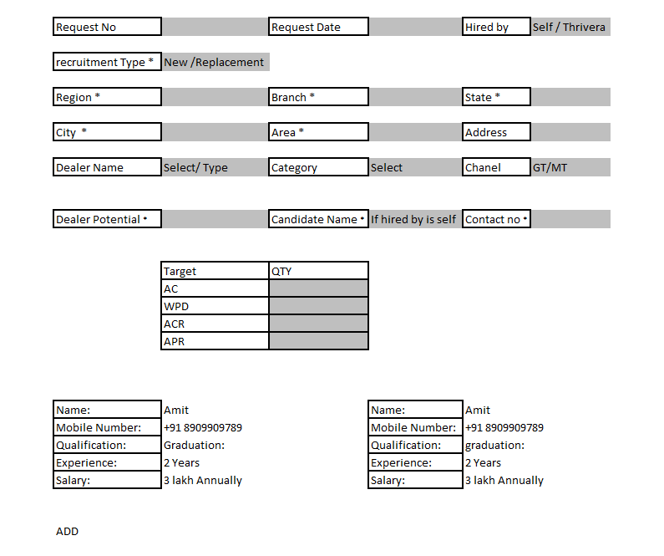

All date will be grey out, TSS user will not be able to change. TSS user will upload short listed employee details

|  |  |  |  |  |  |  |  |
| --- | --- | --- | --- | --- | --- | --- | --- |
| **S.No** | **Filed Name** | **Filed Type** | **Max Char.** | **link with** | **Validation** | **Remarks** | **Mandate** |
| 1 | Name | Text | 50 | NA | NA |  | YES |
| 2 | Mobile Number: | Numeric | 10 | NA | NA |  | YES |
| 3 | Qualification: | Text | 10 | NA | NA |  | YES |
| 4 | Experience: | Years | 2 | NA | NA |  | YES |
| 5 | Salary: | Numeric | 6 | NA | NA |  | YES |

Status

1. Pending
2. Client Confirmation- pending
3. Rejected/ Approved
4. On boarding
5. On board