Incentive calculator

1. Provision to define Incentive rate at item master/ Model wise incentive rate

|  |  |  |  |  |  |  |
| --- | --- | --- | --- | --- | --- | --- |
|  | Add Item | | | | |  |
|  |  |  |  |  |  |  |
|  |  |  |  |  |  |  |
|  | Code |  |  | Name |  |  |
|  |  |  |  |  |  |  |
|  |  |  |  |  |  |  |
|  | Product |  |  | Product Tran |  |  |
|  |  |  |  |  |  |  |
|  | Priority |  |  |  |  |  |
|  |  |  |  |  |  |  |
|  | Incentive Rate | |  |  |  |  |
|  |  |  |  |  |  |  |
|  | From |  | TO |  | Rate |  |
|  | 1 |  | 3 |  | 150 |  |
|  |  |  |  |  |  |  |
|  | 4 |  | 999 |  | 350 | ADD |
|  |  |  |  |  |  |  |
|  |  |  |  |  |  |  |

* Incentive rate will be saved at item level as show above
* If user sale item between 1 to 3 QTY then rate will be 150 incentive amount = sum of item sold * Incentive rate
* If user sale item between 1 to 3 QTY then rate will be 350 incentive amount = sum of item sold * Incentive rate

Incentive validation / Configuration

* Incentive will be calculated only for those SSR whose target is assigned
* SSR will be eligible for incentive of AC category if SSR achieve 80% of AC target.
* Above condition can be club with air cooler target as well.
* SSR will be eligible for incentive of AC category if SSR sell 2 unit of WPD category
* Eligible for incentive If ------% of select achieve

Step 1

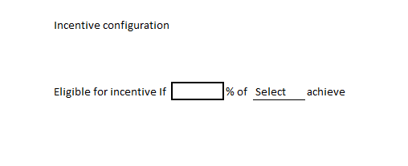

* Target percentage to be achieve
* Product Type can be multiple

Incentive Calculator

|  |  |  |  |  |  |  |
| --- | --- | --- | --- | --- | --- | --- |
|  |  |  | Process   |  | | --- | |  | |  |  |
| Month | Select |  |  | Process |  |
|  |  |  |  |  |  |

