**Exercise 1**

Checking in guests to your event is an important way to make a great first impression and collect valuable data. Design a check-in app on a tablet for a major conference attended by more than 200 people. It should have a dashboard to indicate the guest check ins with registration, the Walk ins without registration. The guests who have registered should have a QR Code Check In and the Guests who have not registered should have their details collected. ( Just get their Name, Designation, Company and City for now).

1. Assume that the tablet has a resolution of 1024x768 and will be used in landscape mode.
2. You can use bootstrap 4 framework to make it work on the required resolution.

**Exercise 2**

Design an interface that gives homeowners the ability to get information about their house and control lighting and appliances, via IoT devices, from a remote location.

1. The screen should be responsive and should work on every device and every screen size.
2. You can use bootstrap 4 framework to handle the breakpoints.

**Exercise 3**

Design a table that has expanding and collapsing table rows that toggle when clicked on the “>” sign in the last column. Do not use Datatables plugin to achieve this. This is useful when you want to allow users to view details of an object without reloading the page, or when the detail information is small and does not require its own page.

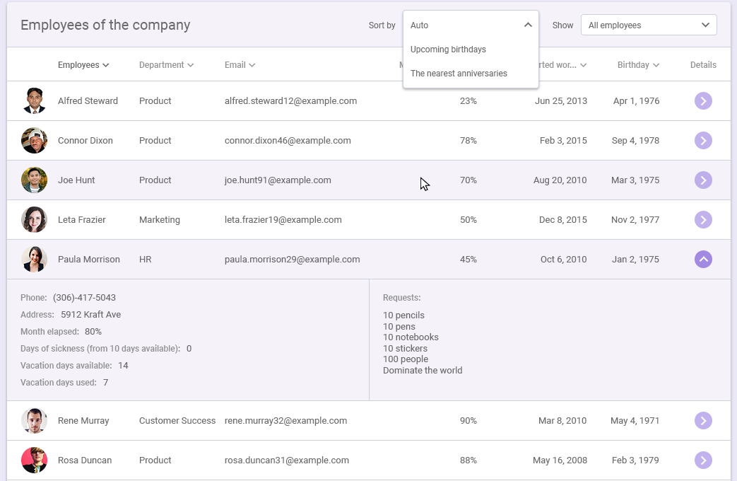

Spend time on both the UI/UX and the actual functionality of the screen. This view should be as complete as possible without interacting with a backend data service, so look at stubbing out fake data.

Try to time box this exercise to take no longer than 3 hours. If you don't feel like you're able to finish within that timeframe, focus on making parts of the exercise great rather than submitting a project that's 80% complete across the board. This gives us an opportunity to explore what it's like to work with you while we're fleshing out the remaining work or expanding on it.

Also, please don't use this as an opportunity to learn a new framework - instead, use tools and technologies you are comfortable with so we can have an in-depth discussion about your decisions and approach.