**Uploading/ Downloading Files on Azure Storage**

1. Create a Storage Account –
2. Sign in to the Azure portal.
3. On the Hub menu, select New -> Storage -> Storage account.
4. Enter a name for your storage account - vbsteststorageaccount
5. Specify the deployment model to be used: Resource Manager or Classic. Resource Manager is the recommended deployment model.
6. Select the type of storage account: General purpose or Blob storage. General purpose is the default.
7. Select the replication option for the storage account: LRS, GRS, RA-GRS, or ZRS. The default is RA-GRS.
8. Select the subscription in which you want to create the new storage account.
9. Specify a new resource group - vbstestresourcegroup
10. Select the geographic location for your storage account
11. Click Create to create the storage account.

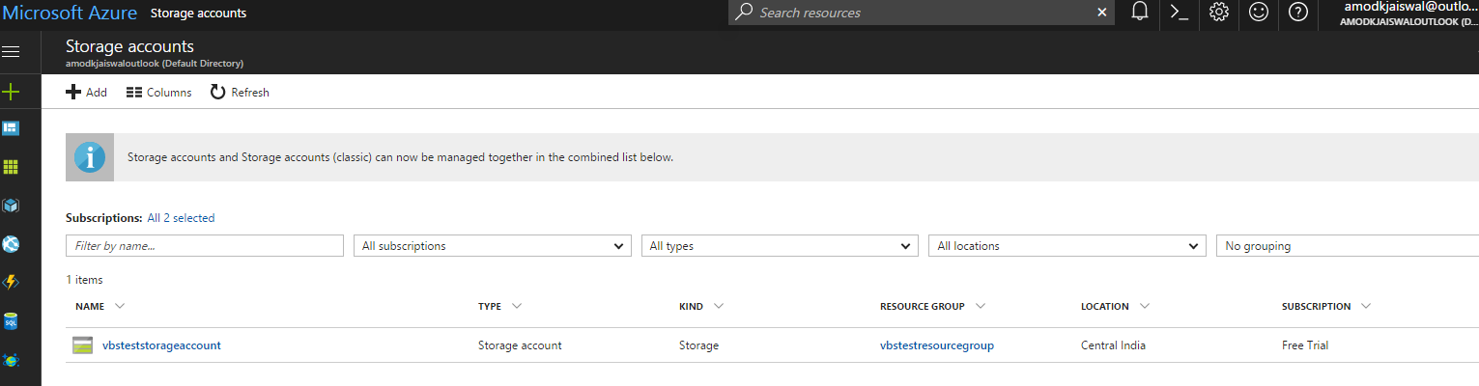

1. Select the Storage Account and then copy the Access keys information. We would be needing the same while connecting to Storage Account programmatically.

Key🡪

jo7CLh0cBYnyzHdujaMBjA1+kX1HGxEXmm+XDBLucO8ygIO6o1RePYBtPEA8EZXY+KBuSfCpuWXVTK+lC6JSUw==

Connection String 🡪 DefaultEndpointsProtocol=https;AccountName=vbsteststorageaccount;AccountKey=jo7CLh0cBYnyzHdujaMBjA1+kX1HGxEXmm+XDBLucO8ygIO6o1RePYBtPEA8EZXY+KBuSfCpuWXVTK+lC6JSUw==;EndpointSuffix=core.windows.net

1. Now configure the CDN for the storage account.

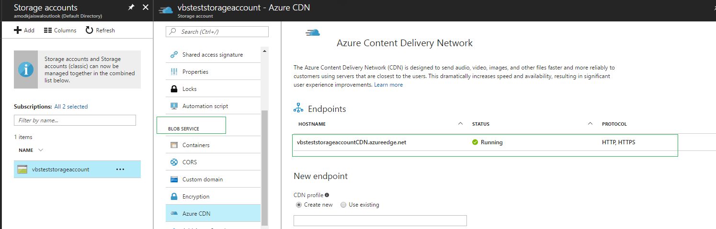

1. Install below Nuget packages in the solution –

i) Microsoft Azure Storage Client Library for .NET - WindowsAzure.Storage

ii) Microsoft Azure Configuration Manager library for .NET - WindowsAzure.ConfigurationManager

1. Accessing Azure storage programmatically –

Copy the Connection string in the config file and the same will be used to access the storage account.

<add key="StorageConnectionString" value="DefaultEndpointsProtocol=https;AccountName=vbsteststorageaccount;AccountKey=jo7CLh0cBYnyzHdujaMBjA1+kX1HGxEXmm+XDBLucO8ygIO6o1RePYBtPEA8EZXY+KBuSfCpuWXVTK+lC6JSUw==" />

CloudStorageAccount storageAccount = CloudStorageAccount.Parse(CloudConfigurationManager.GetSetting("StorageConnectionString")); CloudBlobClient blobClient = storageAccount.CreateCloudBlobClient();

// Retrieve a reference to a container.

CloudBlobContainer container = blobClient.GetContainerReference("testcontainer"); container.SetPermissions(new BlobContainerPermissions { PublicAccess = BlobContainerPublicAccessType.Blob });

// Create the container if it doesn't already exist.

container.CreateIfNotExists();

// Retrieve reference to a blob named "myblob".

CloudBlockBlob blockBlob = container.GetBlockBlobReference("Koala.jpg");

//// Uploading file

// Create or overwrite the blob with contents from a local file.

using (var fileStream = System.IO.File.OpenRead(@"D:\NY\AzureCDNDemo\AzureCDNDemo\Koala.jpg"))

{

blockBlob.UploadFromStream(fileStream);

}

//// Downloading File

// Save blob contents to a file.

using (var fileStream = System.IO.File.Open(@"C:\Users\ksharma\Desktop", System.IO.FileMode.OpenOrCreate))

{

blockBlob.DownloadToStream(fileStream);

}

Location of resources 🡪

<https://CDNName/containername/blobname>

<https://vbsteststorageaccount.blob.core.windows.net/testcontainer/Koala.jpg>

**Configurations:**

**Storage Account:** ts360storageaccount

**CDN Endpoint hostname:** <https://ts360cdn.azureedge.net>

**Origin hostname:** https://ts360storageaccount.blob.core.windows.net

**Blob service endpoint:** <https://ts360storageaccount.blob.core.windows.net/>

**Container:** ts360cloudcontainer

**Keys:**

**Name: key1**

**Key:** TYKSpzrawKfPaanqzdtKSK9jS20+ZuFdemTKL4a7CpHcTifD+9FBGeDUWpMCDkCXjeIxlunYWVVRyimazsoGlg==

**Connection String:** DefaultEndpointsProtocol=https;AccountName=ts360storageaccount;AccountKey=TYKSpzrawKfPaanqzdtKSK9jS20+ZuFdemTKL4a7CpHcTifD+9FBGeDUWpMCDkCXjeIxlunYWVVRyimazsoGlg==;EndpointSuffix=core.windows.net

**Name: key2**

**Key:** X2ZdcAVgURg8ZXZ+EifR+bJrMkpF/tvg9PrhRm9tBjDteVftq1zoMhJTvVX7bEMYc8zLRRjNDYzyPeERiulH4w==

**Connection String:** DefaultEndpointsProtocol=https;AccountName=ts360storageaccount;AccountKey=X2ZdcAVgURg8ZXZ+EifR+bJrMkpF/tvg9PrhRm9tBjDteVftq1zoMhJTvVX7bEMYc8zLRRjNDYzyPeERiulH4w==;EndpointSuffix=core.windows.net

<add key="AzureCloudAccountName" value=" " />

<add key="AzureCloudAccountKey" value="" />

<add key="AzureCloudContainer" value=" **ts360cloudcontainer**" />

**References:**

<https://docs.microsoft.com/en-us/azure/storage/storage-dotnet-how-to-use-blobs#upload-blob>​