**Equipment Specs:**

Equipment specs are templates where we can define the below,

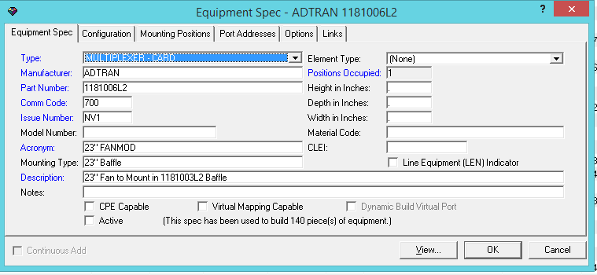

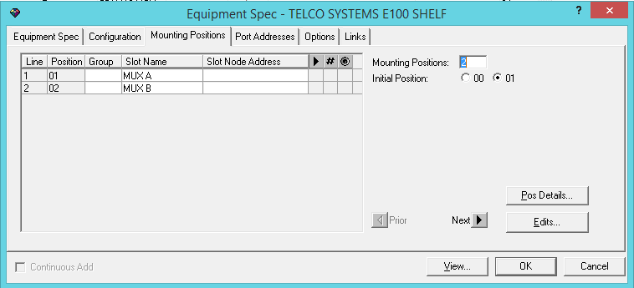 A mounting position is a physical place on a piece of equipment where other equipment can be fastened or installed.

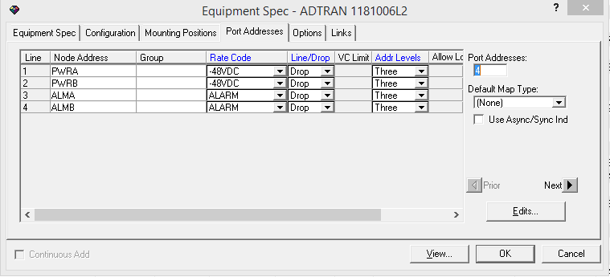

As a rule, mounting positions do not provide physical ports for attaching circuits. A **port address placeholder** is a construct in the MetaSolv Solution database that allows you to assign logical ports to mounting positions where equipment with physical ports is scheduled to be installed. In short, port address placeholders allow circuit design work to continue when equipment is not yet installed.

https://docs.oracle.com/cd/E41106_01/doc.621/e48908/cor_icmapi.htm#g1111661

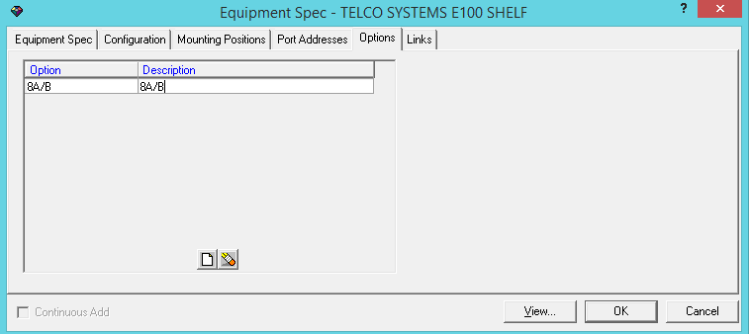

EQUIPMENT_SPEC – contains equip spec id, vendor( issue num, part num, com code, desc, make and model)

EQUIPMENT_SPEC_MOUNTING_POS – contains mount pos seq and num and slot name and group identifier

EQUIPMENT_SPEC_MOUNT_POS_REL -- ?

EQUIPMENT_SPEC_PA_PLACEHOLDER – contains the port address seq and rate code(ds0,ds1)

EQUIPMENT_SPEC_PORT_ADDRESS -- contains the port address seq and rate code(ds0,ds1), assignable_ind, allow lower ratecodes

EQUIPMENT_OPTION – contains the values in options tab( option code and desc)

**Equipments:**

Rack 🡪 Shelf [🡪Shelf] 🡪 Cards

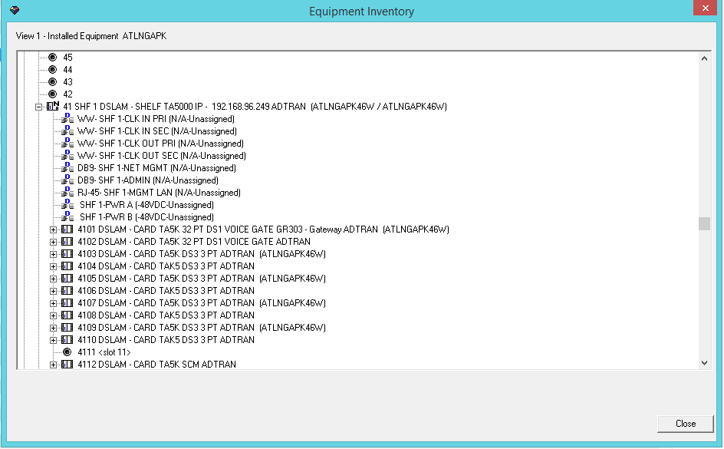

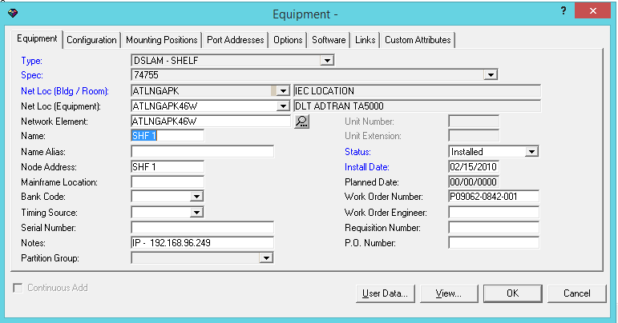

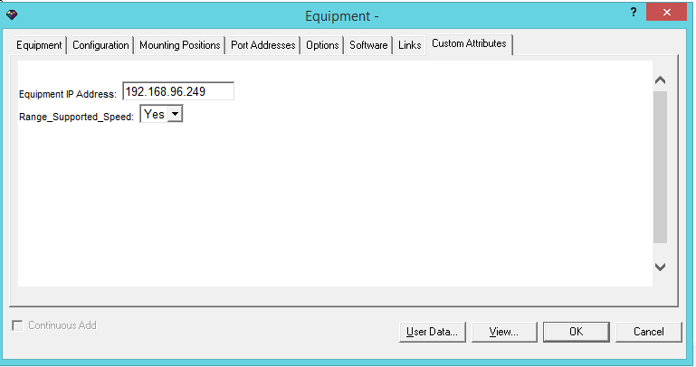

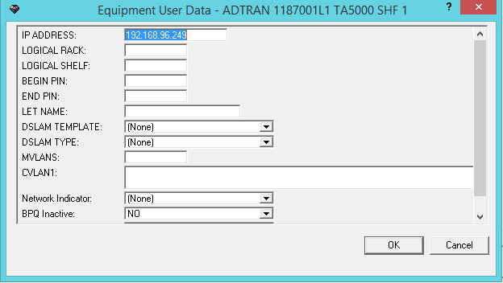

EQUIPMENT – contains equip name, notes availability status, location id, equip spec id, serial number,

EQUIPMENT_OPTION_ASSIGNMENT – contains the equip options associated for equipment

EQUIPMENT_USER_DATA – contains the user data created for equipment

EQUIP_CA_VALUE – contains the custom attributes created for this equipment

To a field engineer, a hard-wired cross-connect, also referred to as cabling, is the wiring of one equipment port to another. The hard-wired cross-connects you create in the MetaSolv Solution database represent the actual hard-wired cross-connects between equipment ports. An example of a hard-wired cross-connect is the cabling between a shelf and a DSX jack panel.

**Circuits:**

DS0,DS1,DS2,DS3,T0,T1,T3, OC3,OC12, OC48, OC192

DS0 - 64 k­ilobits per second

ISDN - Two DS0 lines plus signaling (16 kilobytes per second), or 128 kilobits per second

T1 - 1.544 megabits per second (24 DS0 lines) (1 DS1)

T2 – 6.312 megabits per second (1 DS2)

T3 - 43.232 megabits per second (28 T1s) (1 DS3)

OC3 - 155 megabits per second (84 T1s)

OC12 - 622 megabits per second (4 OC3s)

OC48 - 2.5 gigabits per seconds (4 OC12s)

OC192 - 9.6 gigabits per second (4 OC48s)

Broadband Circuits:

ADSL,ASDL2+,VDSL2,FTTP

**Connection Design:**

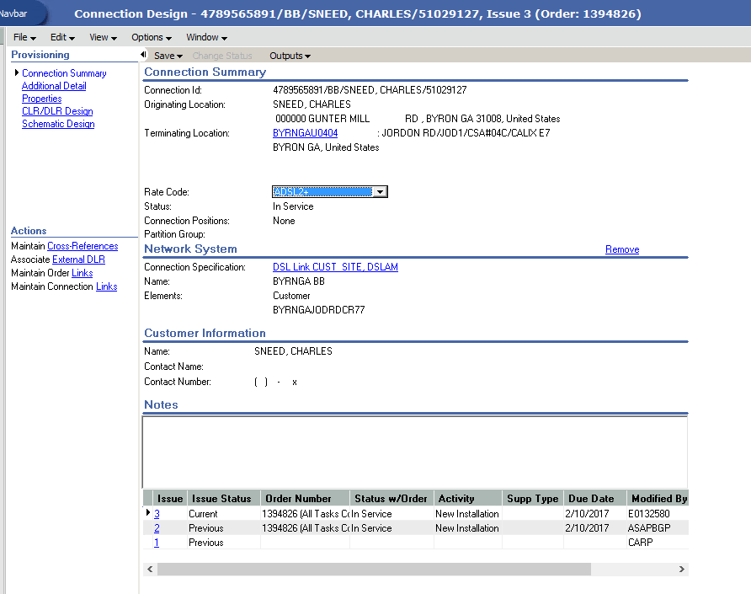

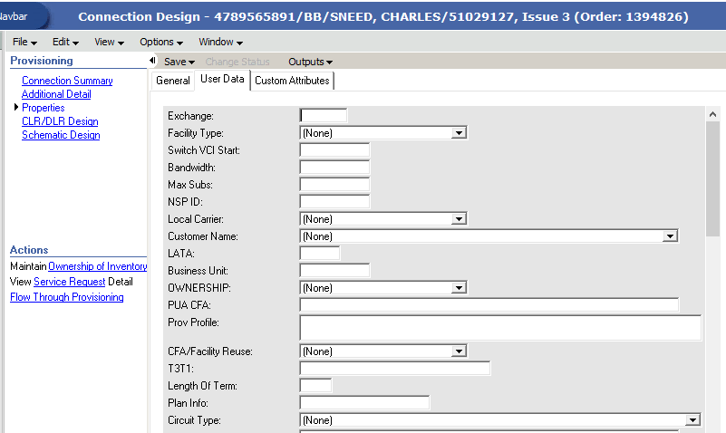

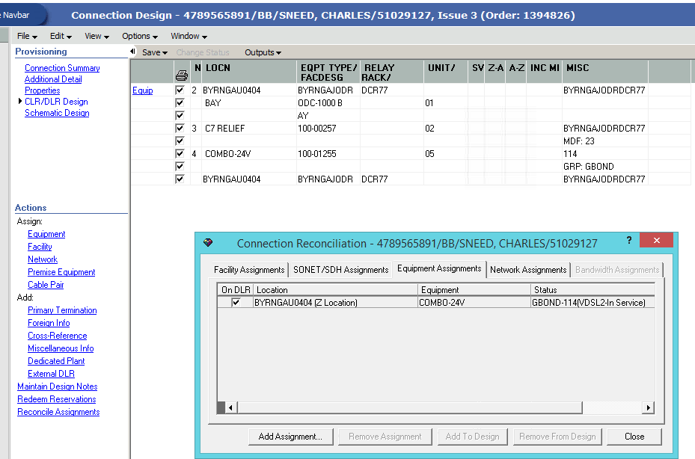

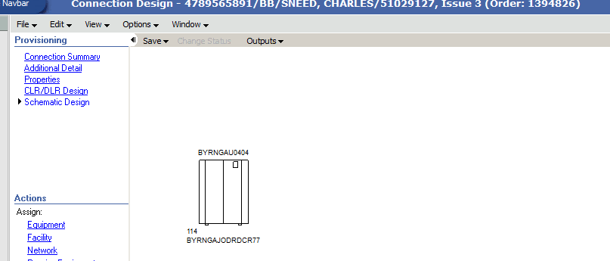

CIRCUIT

CIRCUIT_LAYOUT_REPORT

CIRCUIT_POSITION

CIRCUIT_POSITION_CONDITION

CIRCUIT_POSITION_PENDING

CIRCUIT_USER_DATA

CIRCUIT_XREF

DLR_CIRCUIT_DESIGN_LINE

TRANSMISSION_FACILITY_CIRCUIT

DESIGN

DESIGN_GLR_ASSGNMT_SEGMENT

DESIGN_LAYOUT_REPORT

DESIGN_LINE

**Connection Hierarchy:**

Has the info of child and parent circuits to which the current circuit is associated with.

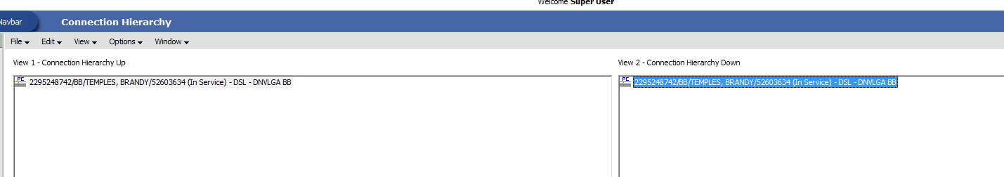

**Network Location:**

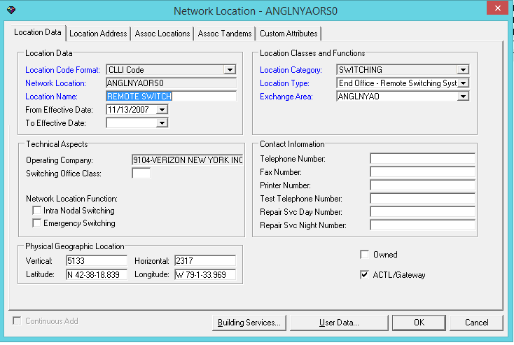

NETWORK_LOCATION

NETWORK_LOCATION_TYPE – (Building, Customer Location, End User, Room)

NETWORK_LOCATION_USER_DATA

Location format code – CLLI code

**HSTNTXMOCG0**

* HSTN = [Houston](https://en.wikipedia.org/wiki/Houston,_Texas)
* TX = [Texas](https://en.wikipedia.org/wiki/Texas)
* MO = The AT&T [telephone exchange](https://en.wikipedia.org/wiki/Telephone_exchange) office at 4068 Bellaire Boulevard in [West University Place, Texas](https://en.wikipedia.org/wiki/West_University_Place,_Texas)[[7]](https://en.wikipedia.org/wiki/CLLI_code#cite_note-7)—the office is known as the "Mohawk office"[[8]](https://en.wikipedia.org/wiki/CLLI_code#cite_note-8)
* CG0 = The first (or perhaps only) electronic [telephone switch](https://en.wikipedia.org/wiki/Telephone_switch) at that location (in this instance, [analog](https://en.wikipedia.org/wiki/Analog_signal) - now HSTNTXMODS0 as a digital switch)

The first six characters of a CLLI code represent the place the code refers to and contain two code elements:

* Four characters to denote the geographical area and the geographical area type (for example, city, town, and borough), known as the Geographical code element.[[4]](https://en.wikipedia.org/wiki/CLLI_code#cite_note-iowa.gov-4)
* Two characters to denote the state, province, or country, known as the Geopolitical code element.[[5]](https://en.wikipedia.org/wiki/CLLI_code#cite_note-state.ia.us-5) The codes HS (high seas) and EO (earth orbit) are reserved for ships at sea and satellites, respectively.[[6]](https://en.wikipedia.org/wiki/CLLI_code#cite_note-1982_CLLI-6)

**Network Areas:**

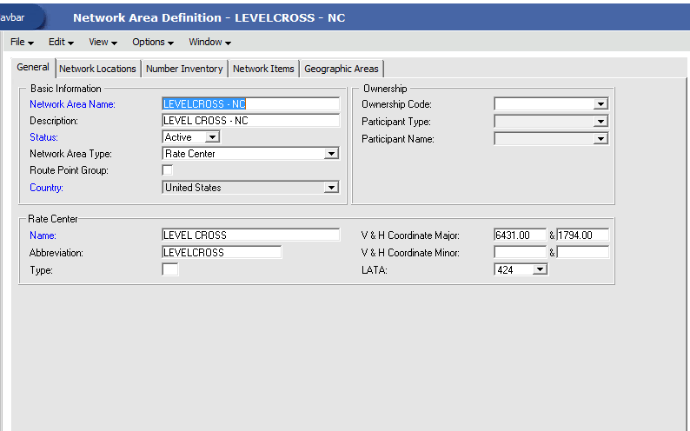

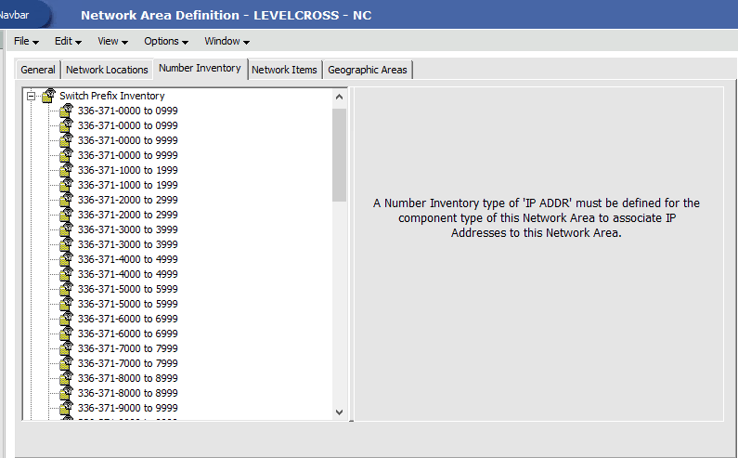

NA_NETWORK_AREA

NA_NETWORK_AREA_STRUCTURE

**PRODUCT_SPEC:**

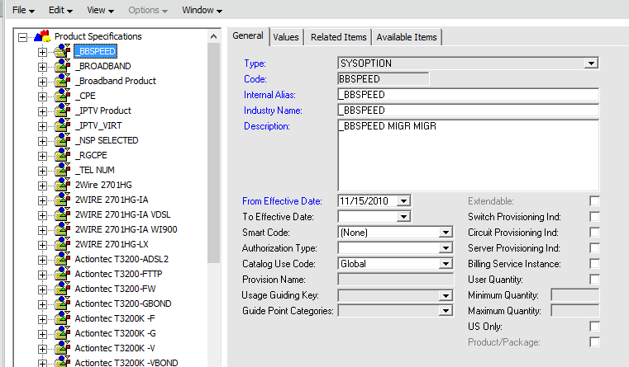

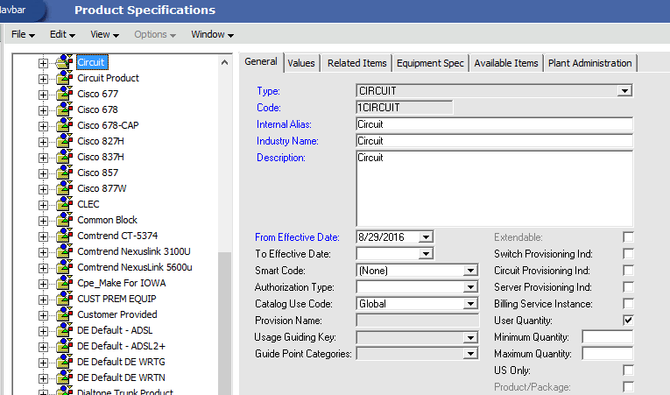

STD_ITEM

STD_ITEM_REL

STD_ITEM_VALID_VALUE

STD_ITEM_VALUE_LABEL

**Product Catalog:**

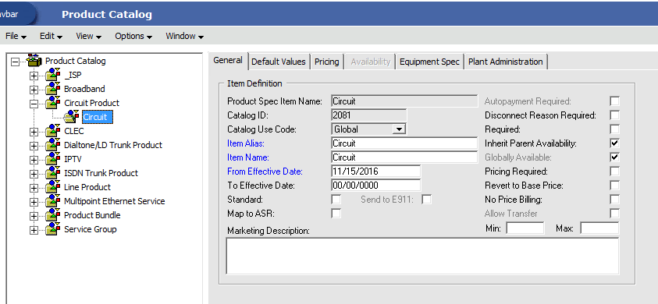

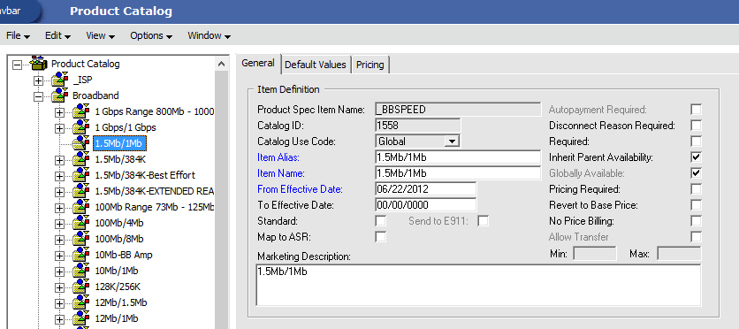

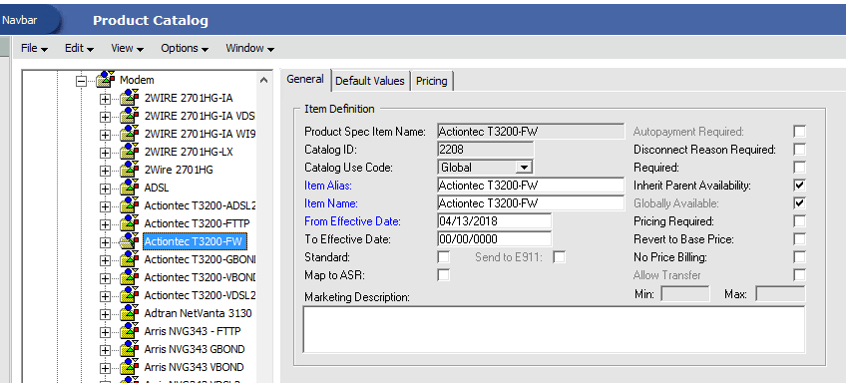

ITEM_REL_TYPE

ITEM_SPEC

SPEC_REL

LEVEL_1_ITEM

LEVEL_1_ITEM_PR

DEFAULT_VALUE

**Network Systems:**

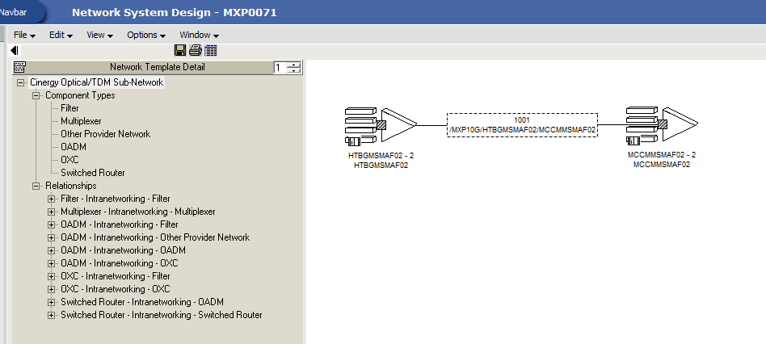

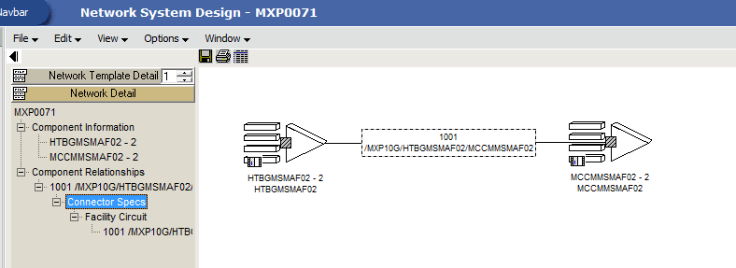

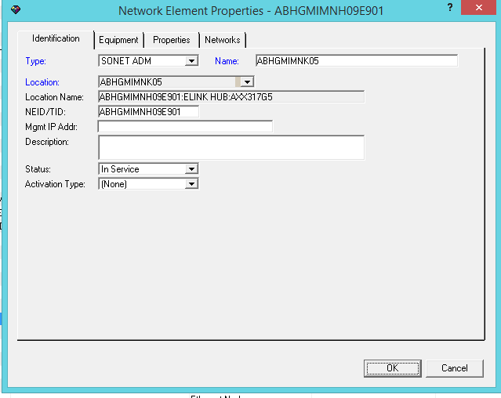

NS_NETWORK_SYSTEM

NS_NS_COMP

NS_NS_CON

NETWORK_NODE

NETWORK_ROUTE

NS_COMPONENT

NS_COMPONENT_ROLE

NS_COMP_CA_VALUE

NS_COMP_CA_VALUE_REL

NS_COMP_CONFIG_REL

NS_COMP_CONFIG_REL_CA_VALUE

NS_COMP_EQUIP

NS_COMP_PORT_ADDRESS

NS_COMP_REL

NS_COMP_REL_NS

NS_COMP_REL_NS_CON_SPEC

NS_COMP_SI

NS_MULTI_POINT_COMPONENT

NS_NS_COMP

NS_NS_COMP_ROLE