Advanced Data Analysis and Visualization in Logistics
Exploratory analysis of a simulated 2025 shipment dataset using Python (pandas, seaborn, matplotlib)
Scope: 2,492 simulated shipments, 5 origin hubs, 5 destination regions, 4 carriers, 4 transport modes, January to December 2025.
Deliverables in this report: dataset definition, exploratory data analysis, nine visualizations with justification, interpretation of logistics performance, Python code excerpts and recommendations.
Important note: all data is synthetic. It was generated with realistic cause-and-effect relationships so that the analysis methods can be demonstrated. Findings describe the simulated business, not a real one.

1. Introduction and Objectives
Logistics performance depends on three levers that constantly pull against one another: speed (how quickly goods arrive and whether they arrive when promised), cost (what each shipment costs to move) and reliability (how consistently the network delivers at volume). Analytics lets an operations team see which lever is under strain and why.
This report simulates a logistics dataset and works through the full analytical cycle: defining variables, exploring the data, visualizing patterns, interpreting them, and turning them into recommendations. The questions guiding the analysis are:
- How fast and how reliable is delivery, and does it differ by transport mode, carrier or hub?
- What drives transportation cost, and where is cost efficiency being won or lost?
- Where are the operational bottlenecks, and how much do they hurt on-time performance and customer satisfaction?

2. Methodology and Tools
The work followed five steps, all implemented in a single reproducible Python script (seeded with numpy.random.default_rng(42)):
- Simulate the dataset, embedding plausible relationships (distance drives cost, warehouse dwell drives delay, monsoon weather adds disruption, Q4 adds congestion).
- Profile the data: structure, missing values, central tendency, spread and skewness.
- Explore relationships using Spearman correlation, grouped summaries, a one-way ANOVA across carriers and a Welch t-test for weather.
- Visualize with matplotlib and seaborn, choosing each chart type to match the question being asked.
- Interpret and recommend, linking each finding back to operational action.
Libraries used: pandas (data handling), numpy (simulation and linear algebra), scipy.stats (hypothesis tests), seaborn and matplotlib (visualization). Spearman rather than Pearson correlation was chosen because weight, cost and dwell time are right-skewed, and Spearman is robust to skew and outliers.

3. Data Simulation

3.1 Dataset structure
Each row is one shipment. The table below lists the key variables.
Variable | Type | Description
ship_date | Date | Dispatch date (2025), with a Q4 peak-season volume uplift
origin_hub | Category | Chennai, Mumbai, Delhi, Kolkata, Bengaluru
dest_region | Category | North, South, East, West, Central
carrier | Category | Carrier A to D
mode | Category | Road (55%), Sea (18%), Rail (15%), Air (12%)
distance_km | Numeric | Route distance, gamma-distributed around a mode-specific mean
weight_kg / units | Numeric | Shipment volume; log-normal, so a few very heavy loads
dwell_hours | Numeric | Time spent in warehouse before onward movement
weather_event | Binary | 1 if a weather disruption occurred (higher in monsoon months)
planned_days / actual_days | Numeric | Promised and realized delivery time
delay_days / on_time | Numeric / Binary | actual minus planned; on time if delay is at most 0.5 days
transport_cost | Numeric | Total cost in currency units, from distance, weight, mode, fuel index, dwell and weather
customer_rating | Numeric | 1 to 5 satisfaction score, decreasing with delay

3.2 Simulation logic (code excerpt)
The excerpt below shows how causal structure was built in. Delivery time is true process time plus a share of dwell time, weather and carrier effects; the promised date adds a 1.5-day buffer.
base_days = np.ceil(transit_days + handling_days[mode] + 1) # true process time
planned = base_days + 1.5 # promised date with buffer

actual = (base_days
+ dwell / 24 * 0.9 # warehouse dwell
+ weather * rng.gamma(2, 0.8, n) # weather disruption
+ carrier_delay[carrier] # carrier effect
+ rng.normal(0, 0.6, n)).clip(0.5) # random noise

delay = actual - planned
on_time = delay <= 0.5

# cost grows slower than weight (economies of scale)
cost = fixed[mode] + rate[mode] * distance * (weight/1000) ** 0.55
cost = cost * fuel_index * lognormal(0, 0.12)
cost = cost + dwell * 1.8 + weather * gamma(2, 25)

4. Exploratory Data Analysis

4.1 Data quality and summary statistics
The dataset has 2,492 rows and no missing values. The table summarizes central tendency and spread for the main numeric variables.
Variable | Mean | Median | Std dev | Min | Max | Skew
distance_km | 1,194 | 853 | 991 | 81 | 6,000 | 1.91
weight_kg | 1,288 | 674 | 1,802 | 9 | 19,426 | 3.74
dwell_hours | 19.2 | 17.2 | 12.0 | 0.2 | 100.8 | 1.11
planned_days | 4.90 | 4.50 | 2.02 | 3.5 | 13.5 | 1.96
actual_days | 4.37 | 3.80 | 2.24 | 0.5 | 14.8 | 1.50
delay_days | -0.53 | -0.60 | 0.94 | -3.0 | 5.2 | 0.96
transport_cost | 2,124 | 1,358 | 2,345 | 131 | 30,614 | 3.82
customer_rating | 4.65 | 4.70 | 0.38 | 1.7 | 5.0 | -1.89

Three observations stand out. First, cost, weight and distance are strongly right-skewed: the mean transport cost (2,124) is about 56% above the median (1,358), so a minority of long, heavy shipments carries a large share of spend and the median is the fairer measure of a typical shipment. Second, the average delay is negative (-0.53 days), meaning most shipments arrive before the promised date, which reflects the buffer built into the promise. Third, customer ratings are left-skewed with a ceiling at 5, so average satisfaction masks a tail of unhappy customers.

4.2 Operational headline metrics
Metric | Value
Overall on-time rate | 89.1%
Mean delay versus promise | -0.53 days (early)
Mean transport cost per shipment | 2,124 (median 1,358)
Shipments with warehouse dwell over 24 hours | 28.5%
Shipments affected by a weather event | 9.1%
Mean customer rating | 4.65 / 5

4.3 Performance by transport mode
Mode | Shipments | Avg days | Avg cost | Cost per km | On-time
Air | 290 | 2.89 | 5,961 | 3.49 | 90%
Rail | 398 | 4.82 | 1,917 | 1.50 | 90%
Road | 1,397 | 3.41 | 1,115 | 1.75 | 88%
Sea | 407 | 8.30 | 3,057 | 1.24 | 90%

Air is nearly three times faster than sea but costs about 2.8 times more per kilometre. Road, the workhorse of the network at 56% of volume, has the lowest average shipment cost because its typical trip is shorter and lighter, even though per-kilometre cost is above rail and sea. On-time rate is similar across modes (88 to 90%), which suggests that reliability problems come from the shared process (hubs, carriers, dwell) rather than from the mode itself.

4.4 Carriers and hubs
Carrier | Shipments | Mean delay (days) | On-time | Avg rating
Carrier A | 869 | -0.67 | 92% | 4.67
Carrier B | 765 | -0.50 | 89% | 4.65
Carrier C | 494 | -0.19 | 83% | 4.59
Carrier D | 364 | -0.74 | 91% | 4.68

Origin hub | Shipments | Avg dwell (hrs) | Mean delay (days) | On-time
Bengaluru | 498 | 18.2 | -0.51 | 88%
Chennai | 598 | 16.8 | -0.61 | 91%
Delhi | 526 | 18.6 | -0.62 | 91%
Kolkata | 256 | 17.1 | -0.62 | 91%
Mumbai | 614 | 23.7 | -0.35 | 86%

Carrier C trails the others by 8 to 9 percentage points in on-time rate, and Mumbai stands out as the hub with the longest dwell time (23.7 hours versus 16.8 to 18.6 elsewhere) and the lowest on-time rate. A one-way ANOVA confirms that mean delay differs across carriers (p < 0.001), and a Welch t-test confirms that weather-affected shipments are delayed significantly more than others (p < 0.001; mean delay +0.84 days versus -0.67 days).

4.5 Correlations
Spearman rank correlations (Figure 4) quantify the relationships among the main variables:
Pair | Spearman rho | Reading
Distance and transport cost | 0.84 | Very strong; distance is the dominant cost driver
Dwell time and delay | 0.48 | Moderate positive; longer dwell means later delivery
Delay and customer rating | -0.30 | Moderate negative; lateness hurts satisfaction
Weight and transport cost | 0.33 | Weak to moderate; cost grows slower than weight
Dwell time and transport cost | 0.02 | Negligible; dwell is a service issue more than a cost issue

A simple ordinary-least-squares model of transport cost on distance, weight, dwell, weather and mode explains about 73% of cost variance (R-squared = 0.73). Each additional tonne adds roughly 460 currency units and each additional kilometre about 1.6, with air as the reference mode. This model is deliberately simple and linear; the true simulated cost is multiplicative in distance and weight, so the model is best read as indicative of direction, not as a pricing tool.

5. Visualizations and Interpretation
Each visualization below follows the same pattern: why that chart type was chosen, the code that produced it, and what it reveals about logistics performance. Common setup:
import pandas as pd, numpy as np
import matplotlib.pyplot as plt
import seaborn as sns
sns.set_theme(style='whitegrid', context='notebook')
PAL = {'Road':'#2a6f97','Rail':'#61a5c2','Air':'#e07a5f','Sea':'#81b29a'}

5.1 Delivery time distribution by mode
Why this chart
A kernel density plot shows the full shape of a continuous variable and lets four overlapping groups be compared on one axis. A bar of averages would hide the spread and the long tail of late deliveries.
for m in ['Road','Rail','Air','Sea']:
sns.kdeplot(df[df['mode']==m].actual_days, label=m, color=PAL[m],
fill=True, alpha=0.25, clip=(0, 30))
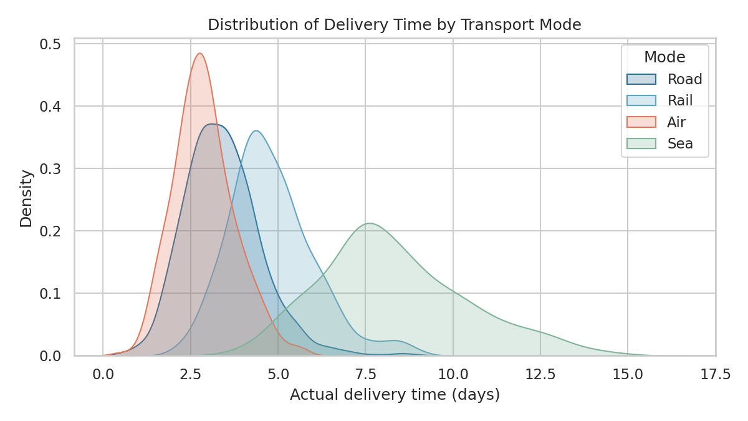
Figure 1. Density of actual delivery time by transport mode.
Interpretation
Air is tightly clustered at roughly 2 to 3.5 days (median 2.8), giving customers a predictable promise. Road peaks at around 3 days (median 3.3) but has a longer right tail, reaching 9 days in the worst cases. Sea is both slow and widely spread (median 8.0 days, interquartile range 6.9 to 9.6), so planners need larger buffers for sea freight. Rail sits between road and sea. The practical message is that mode choice should account for variability as well as average speed.

5.2 Cost per kilometre by mode
Why this chart
A box plot summarizes median, spread and outliers for each category in a compact form. A log scale is used because cost per kilometre varies by an order of magnitude between short air hops and long sea routes, and a linear axis would compress most boxes.
sns.boxplot(data=df, x='mode', y='cost_per_km', order=['Road','Rail','Air','Sea'],
palette=PAL, hue='mode', legend=False, fliersize=2)
plt.yscale('log')
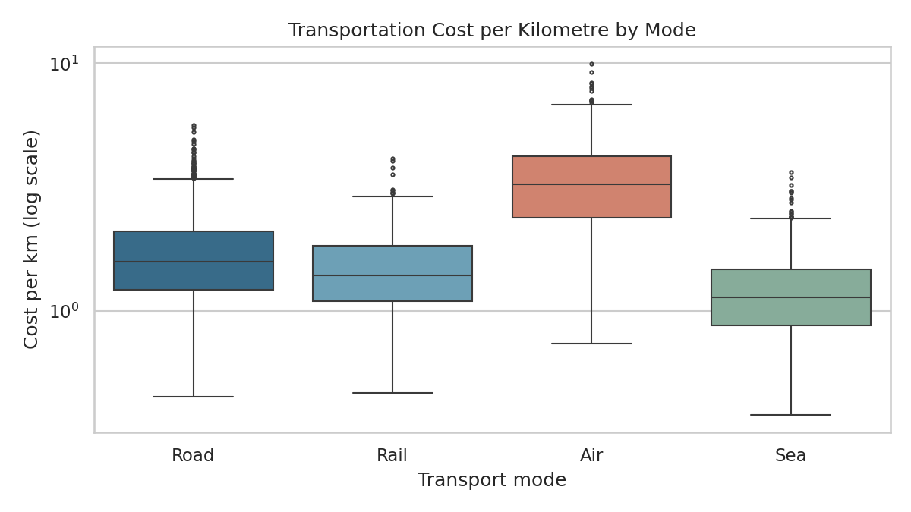
Figure 2. Transportation cost per kilometre by mode (log scale).
Interpretation
Air has the highest median cost per kilometre by a clear margin (3.24 versus 1.58 for road, 1.39 for rail and 1.13 for sea). The spread inside each mode is similar in relative terms, and cost per kilometre falls only slightly with distance (Spearman rho between -0.11 and -0.16 within each mode), so fixed handling charges are a minor factor. The bigger lever is shipment weight: median cost per kilogram falls from about 5.0 for the lightest quarter of shipments to 0.84 for the heaviest quarter, because cost grows more slowly than weight. This points to a consolidation opportunity for light shipments.

5.3 Monthly volume versus on-time rate
Why this chart
A bar-and-line combination with two axes shows a volume measure and a service-quality rate over the same time axis. This makes it easy to test the question: does service degrade when the network is busy?
fig, ax1 = plt.subplots(figsize=(8, 4.5))
ax1.bar(mo.month, mo.vol, color='#61a5c2', alpha=0.8)
ax2 = ax1.twinx()
ax2.plot(mo.month, mo.ot*100, color='#e07a5f', marker='o', lw=2)
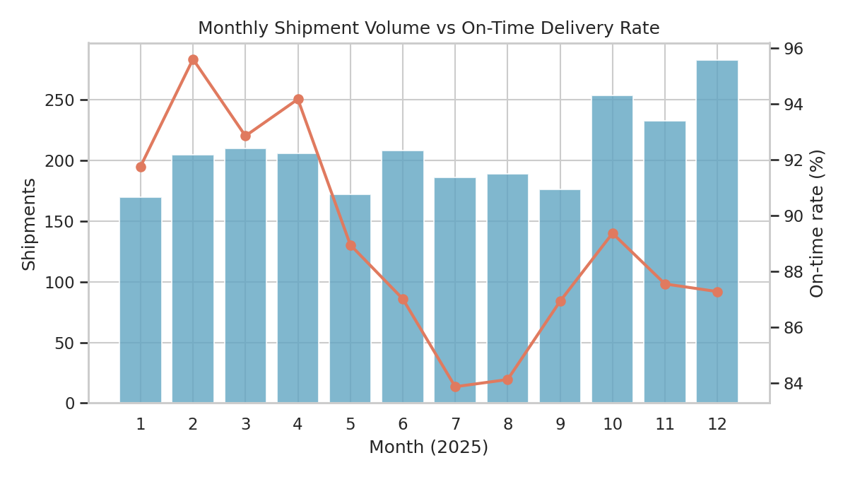
Figure 3. Monthly shipments (bars) and on-time rate (line).
Interpretation
Volume rises sharply in October to December (peak season), and average warehouse dwell time jumps from 16.9 hours in January to September to 24.3 hours in October to December. On-time performance shows two dips: a monsoon dip in July and August (about 84%) and a smaller peak-season softening from November. Notably, the peak-season on-time rate (88.1%) is only slightly below the rest of the year (89.6%) because the promise buffer absorbs part of the extra dwell, but that buffer is being consumed, which is a warning sign for future growth.

5.4 Correlation heatmap
Why this chart
A heatmap displays every pairwise relationship in one view and is the standard first step for spotting cost drivers and redundant variables. The diverging colour scale (blue for negative, red for positive) centred on zero makes the sign and strength readable at a glance.
corr = df[corr_cols].corr(method='spearman')
sns.heatmap(corr, annot=True, fmt='.2f', cmap='RdBu_r',
center=0, vmin=-1, vmax=1, square=True)
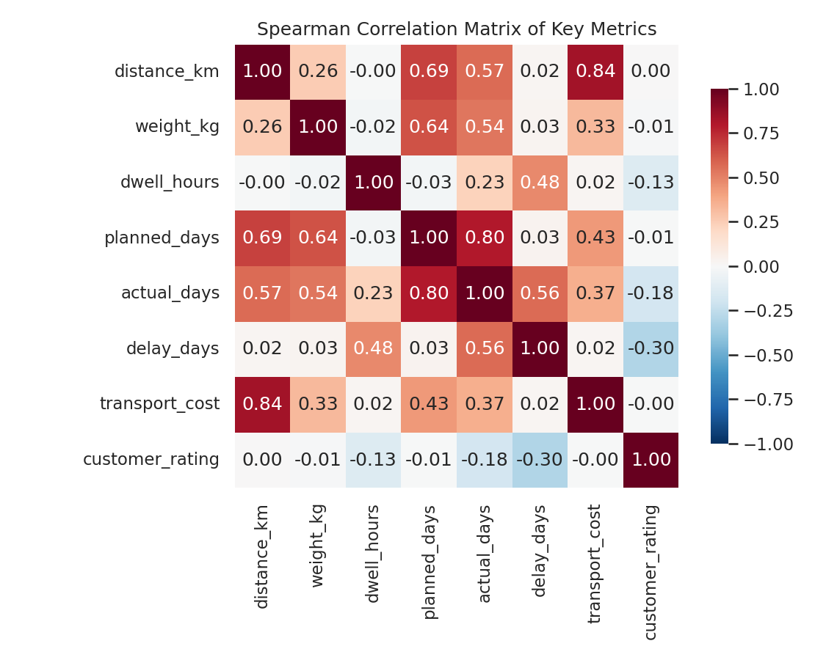
Figure 4. Spearman correlation matrix.
Interpretation
Distance and cost move together very strongly (0.84), confirming distance as the main cost driver. Dwell time correlates with delay (0.48) but not with cost (0.02): dwell hurts the customer promise, not the freight bill. Delay correlates negatively with rating (-0.30), linking operational performance directly to customer experience.

5.5 Distance versus cost
Why this chart
A scatter plot is the natural choice for a relationship between two continuous variables, and colouring by mode adds a third dimension. It reveals both the slope of cost with distance and the cost step between modes.
sns.scatterplot(data=df, x='distance_km', y='transport_cost',
hue='mode', palette=PAL, alpha=0.45, s=18)
plt.yscale('log')
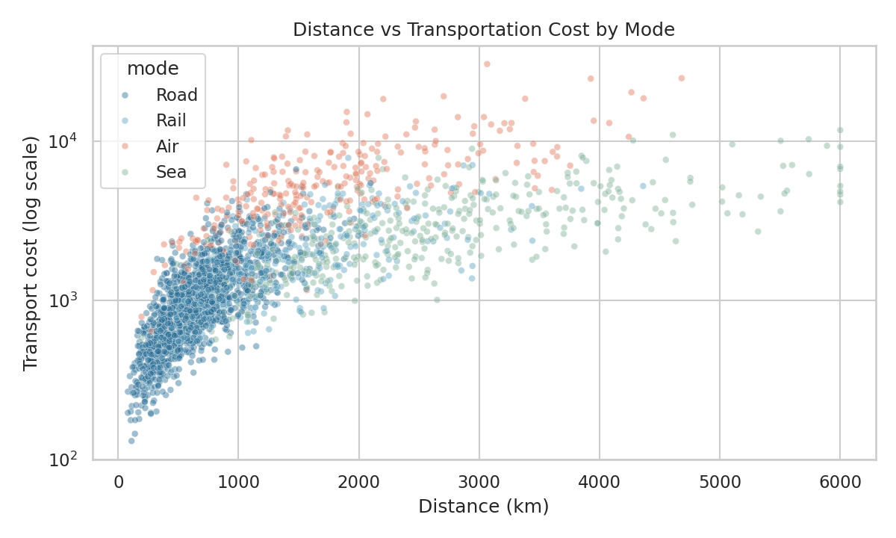
Figure 5. Distance versus transport cost, coloured by mode.
Interpretation
Each mode forms its own band: for the same distance, air sits well above road and rail, and sea sits lowest per kilometre. The vertical scatter inside each band reflects shipment weight. This supports a mode-selection rule: use sea or rail for heavy, non-urgent long-haul loads, and reserve air for the small share of shipments where speed is worth the premium.

5.6 Carrier performance
Why this chart
Annotated bar charts are best for comparing a small number of categories on a single metric. Pairing on-time rate with mean delay shows that the ranking is consistent across two views of the same problem.
sns.barplot(data=cs, x='carrier', y=cs.ot*100, color='#2a6f97', ax=axes[0])
sns.barplot(data=cs, x='carrier', y='delay', color='#e07a5f', ax=axes[1])
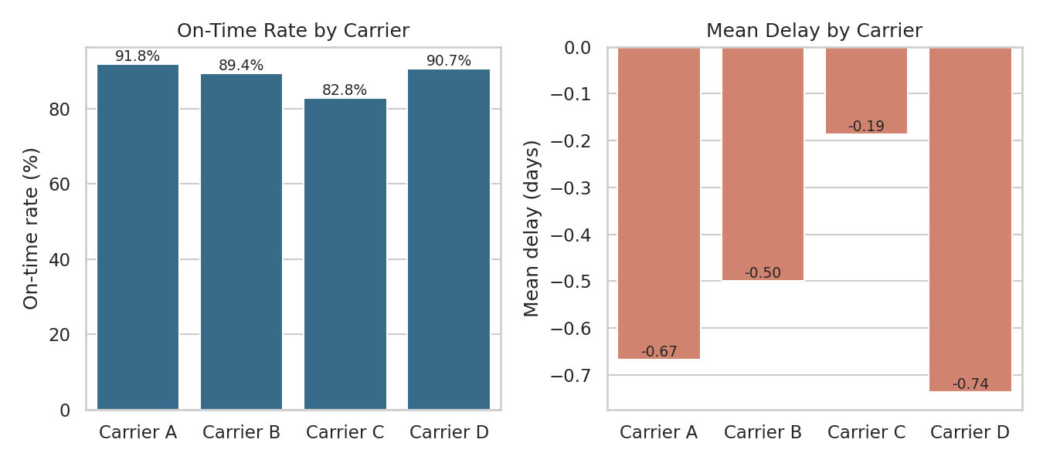
Figure 6. On-time rate and mean delay by carrier.
Interpretation
Carriers A and D perform best (92% and 91% on time), Carrier B is mid-field (89%), and Carrier C lags (83% on time, mean delay of -0.19 days versus -0.67 to -0.74 for A and D). Carrier C also earns the lowest customer rating (4.59). Because Carrier C handles about 20% of volume, improving or reallocating its share is a high-leverage action.

5.7 Warehouse dwell time as a bottleneck
Why this chart
Binning a continuous driver (dwell hours) and drawing a box plot of the outcome (delay) in each bin reveals threshold effects that a single correlation coefficient would average away.
df['dwell_bucket'] = pd.cut(df.dwell_hours, [0,12,24,36,48,500],
labels=['<12h','12-24h','24-36h','36-48h','>48h'])
sns.boxplot(data=df, x='dwell_bucket', y='delay_days', color='#81b29a')
plt.axhline(0.5, color='grey', ls='--') # on-time threshold
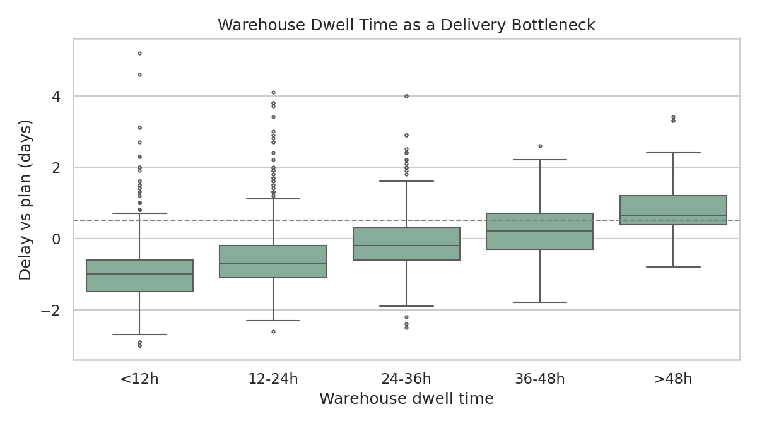
Figure 7. Delay versus warehouse dwell-time bucket.
Interpretation
Dwell bucket | Shipments | Mean delay (days) | On-time rate
Under 12 h | 791 | -0.95 | 96%
12 to 24 h | 992 | -0.59 | 92%
24 to 36 h | 475 | -0.14 | 85%
36 to 48 h | 170 | +0.20 | 69%
Over 48 h | 64 | +0.82 | 44%

Delay rises steadily with dwell time and the on-time rate falls off a cliff beyond 36 hours (69% and then 44%). Although only about 9% of shipments dwell longer than 36 hours, they account for a disproportionate share of late deliveries. Dwell time is the clearest controllable bottleneck in this network.

5.8 Dwell time by hub and month
Why this chart
A two-dimensional heatmap of a pivot table shows where and when a problem occurs by combining a location axis and a time axis. It turns 60 numbers into a pattern a manager can read in seconds.
hm = df.pivot_table(index='origin_hub', columns='month',
values='dwell_hours', aggfunc='mean')
sns.heatmap(hm, annot=True, fmt='.0f', cmap='YlOrRd')
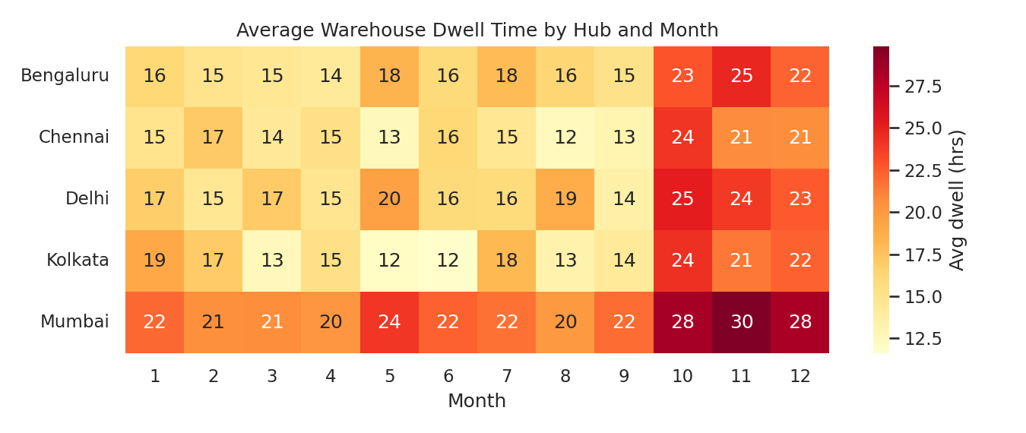
Figure 8. Average warehouse dwell time (hours) by hub and month.
Interpretation
Two patterns overlap: a vertical band of darker cells in October to December (network-wide peak-season congestion) and a horizontal band of darker cells for Mumbai in every month (a structural, hub-specific problem). The first calls for seasonal capacity planning; the second calls for a process or capacity review at the Mumbai facility.

5.9 Impact of delay on customer rating
Why this chart
A scatter plot with a fitted regression line shows both the individual-level noise and the average trend, which is the right way to present the business consequence of a performance metric.
sns.regplot(data=df.sample(1200, random_state=1), x='delay_days', y='customer_rating',
scatter_kws={'alpha':0.25,'s':14}, line_kws={'color':'#e07a5f'})
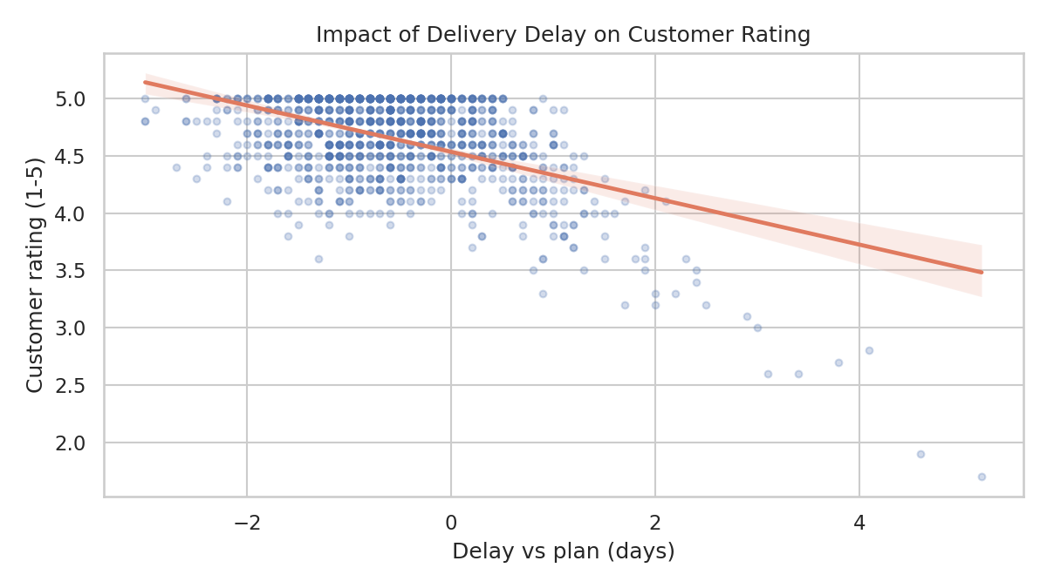
Figure 9. Customer rating versus delay.
Interpretation
Average ratings stay near 4.7 for early shipments and fall steadily once delay exceeds zero: about 4.35 for delays of 0.5 to 1 day, 3.98 for 1 to 2 days and 3.12 beyond 2 days. The slope shows that delay is penalised by customers, so improving reliability protects satisfaction as well as cost of service recovery.

6. Analytical Insights

6.1 Operational efficiency
- Overall on-time performance is solid at 89.1%, helped by a 1.5-day promise buffer. Average shipments arrive about half a day early.
- Reliability is similar across modes (88 to 90%), so the problems are in shared processes (hubs, carriers, dwell), not in the transport modes themselves.
- Seasonality matters twice a year: monsoon months (July to August, about 84% on time) and peak season (October to December, rising dwell and volume).

6.2 Cost drivers
- Distance is the dominant cost driver (rho = 0.84), followed by mode choice and weight. A simple linear model explains about 73% of cost variance.
- Per kilometre, air costs about 2.8 times sea and about 2 times road (mean cost per km of 3.49, 1.24 and 1.75). Cost per shipment is highest for air (5,961) and lowest for road (1,115), driven by shipment size and distance.
- Cost is skewed: a minority of long, heavy shipments dominates spend. The mean (2,124) overstates a typical shipment (median 1,358).

6.3 Bottlenecks
- Warehouse dwell over 36 hours cuts on-time performance to 69% and below; 28.5% of shipments dwell more than 24 hours.
- Mumbai hub has about 6 more hours of average dwell than the other hubs and the lowest on-time rate (86%).
- Carrier C is the weakest carrier (83% on time, rating 4.59) while handling about one in five shipments.
- Weather affects 9.1% of shipments and moves mean delay from -0.67 to +0.84 days when it occurs.

7. Recommendations
- Set a dwell-time service limit of 36 hours with escalation alerts. This targets the steepest drop in on-time performance.
- Run a capacity and process review at the Mumbai hub (dock scheduling, staffing, cross-docking) to bring its dwell time in line with the 17 to 19 hour average of other hubs.
- Add temporary peak-season capacity (extra shifts, overflow storage) from October, and pre-position inventory before the volume surge.
- Put Carrier C on a performance improvement plan with on-time targets, and shift volume towards Carriers A and D if targets are not met within a quarter.
- Introduce a weather-contingency plan for July and August: dynamic routing, wider delivery windows and proactive customer notices.
- Consolidate light shipments (the lightest quarter costs about 5.0 per kg versus 0.84 for the heaviest quarter), and apply a mode-selection rule that favours rail and sea for heavy, non-urgent loads.
- Track a live dashboard of on-time rate, dwell by hub and carrier delay, using the same charts from this report, refreshed weekly.

8. Limitations
- The dataset is simulated, so the relationships found are those that were built in. On real data, effect sizes will differ and additional confounders will appear.
- Correlation does not prove causation; the dwell-to-delay link is causal here only because it was designed that way.
- The linear cost model is simple. A log-log model or gradient-boosted model would fit better and should be used for forecasting.
- Cost is expressed in generic currency units, and fuel and exchange-rate effects were modelled only crudely.

9. Conclusion
The analysis shows how a small set of well-chosen charts can turn raw shipment records into operational decisions. Distance and mode explain most of the cost; dwell time, one hub and one carrier explain most of the avoidable lateness; and seasonality creates predictable pressure points. Because customer ratings fall as delays rise, fixing these controllable bottlenecks improves cost-to-serve, reliability and satisfaction at the same time.

Appendix: Reproducing the Analysis
The complete script (logistics_analysis.py) generates the dataset (saved as logistics_data.csv), computes all statistics and writes the nine figures. To reproduce the results:
pip install pandas numpy scipy matplotlib seaborn
python logistics_analysis.py
Plotly could be substituted for seaborn to make Figures 3, 5 and 8 interactive (hover tooltips, zoom), for example with plotly.express.scatter(df, x='distance_km', y='transport_cost', color='mode', log_y=True).

