WEEK 2 REPORT
Data Collection, Cleaning and Preprocessing for Logistics Analysis
A reproducible Python pipeline on the DataCo Smart Supply Chain dataset
Item | Details
Author | Arunkumar M
Dataset | DataCo Smart Supply Chain: 180,508 order-item records, 65,741 orders, 2015 to 2018
Tools | Python 3, pandas, NumPy, Matplotlib, Seaborn, scikit-learn
Deliverables | This report, logistics_preprocessing.py, dataco_model_ready.csv.gz, dataco_cleaned.csv.gz
Code repository | GitHub URL: <add your repository link here>

Executive summary
This report builds and documents a complete data preparation pipeline for a real logistics dataset: 180,508 order-item records from an e-commerce supply chain covering delivery modes, markets, customers, products and delivery outcomes. The pipeline covers data collection, quality auditing, cleaning, missing-value handling, outlier treatment, normalisation, encoding and validation.
- Audit findings (real, in the source data): 3 constant columns, 6 pairs of identical columns, text with stray or repeated spaces, 227 customer coordinates that fall outside the United States and Puerto Rico, 423 location values with corrupted characters, a mixed-language country label, and 7,754 cancelled shipments that distort delivery-performance metrics.
- Missing values: the public copy has none, so I simulated four realistic gaps (2% to 5% of rows) and kept the true values. This let me score each imputation method against the truth instead of guessing which is best.
- Key result: domain rules beat statistics. Recovering Shipping Mode from the scheduled window was 100% accurate (most-frequent value: 58.9%), and a discount rule cut the error from about 15.1 to 0.06 currency units.
- Outliers: 13,727 profit values fall below the IQR fence, but inspection showed they are genuine large-ticket loss-making sales. They were kept, winsorised and scaled, not deleted.
- Validation: late-delivery rates by shipping mode and total sales are unchanged by the pipeline. A model with a post-shipment feature scores AUC 0.974 against 0.741 with order-time features only, which shows why leakage control matters in logistics.

1. Introduction and Logistics Context
Logistics decisions such as which carrier to use, how much safety stock to hold, what delivery promise to make and where to place a hub all depend on data about orders, shipments and delivery times. That data is produced by many systems (order entry, warehouse, carrier tracking, payment) and arrives with gaps, duplicated fields, inconsistent labels and extreme values. If these are not handled deliberately, they flow straight into dashboards and models and change the decisions that come out.
The task is to simulate a data preprocessing pipeline for logistics data: describe how the data was collected, identify the quality problems, fix them with justified techniques, and explain how each choice affects later analysis. The sections follow that order.
Objectives
- Select a public logistics dataset and describe its characteristics as a data-collection exercise.
- Audit the data for missing values, outliers, duplicates, inconsistencies and invalid entries.
- Clean and impute with methods chosen by evidence, and measure how good they are.
- Normalise and encode the data for analysis and modelling, without leaking information.
- Reflect on how data quality shapes analytics and decisions in logistics.

2. Data Collection

2.1 Source and selection
I used the DataCo Smart Supply Chain dataset, a publicly available order-item level logistics dataset that is widely used in supply chain research. It was chosen because it covers the full order-to-delivery flow (shipping mode, scheduled versus actual delivery days, delivery status, market, product, payment type, discount and profit), it is large enough to behave like real operational data, and it contains realistic quality problems.
The file is read directly from a public GitHub mirror, so the pipeline can be rerun without manual downloads. One caveat should be stated clearly: to my knowledge the original release has about 180,519 rows and 53 columns, while this copy has 180,508 rows and 51 columns and contains no null values. It therefore looks like a lightly pre-processed version of the original. This matters for Section 4.
PYTHON CODE
import numpy as np
import pandas as pd
import matplotlib.pyplot as plt
import seaborn as sns
from sklearn.preprocessing import MinMaxScaler, StandardScaler, RobustScaler
from sklearn.linear_model import LogisticRegression
from sklearn.model_selection import train_test_split
from sklearn.metrics import roc_auc_score

URL = ("https://raw.githubusercontent.com/create-sourav/"
"supply-chain-analysis-python-sqlite3-project/main/supply_chain_clean.csv.gz")
df_raw = pd.read_csv(URL, low_memory=False) # pandas reads the .gz directly
df = df_raw.copy() # raw copy kept for before/after checks

2.2 Dataset characteristics
Characteristic | Value
Granularity | One row per order item (an order can contain several items)
Rows / columns | 180,508 / 51
Distinct orders | 65,741 (about 2.7 items per order)
Distinct customers / products | 20,641 / 118
Markets / order destination countries | 5 / 164
Order period | 2015-01-01 to 2018-01-31
Column types | 24 text, 14 integer, 13 decimal
Analytical target | Late_delivery_risk (1 = delivered late), mean 54.8% over all rows

Main column groups
Group | Columns (examples) | Role in logistics analysis
Delivery performance | Days for shipping (real), Days for shipment (scheduled), Delivery Status, Late_delivery_risk, Shipping Mode | Service level, lead time, SLA compliance
Order and finance | Sales, Order Item Quantity, Order Item Discount, Order Item Total, Order Profit Per Order, Type | Revenue, margin, payment behaviour
Customer | Customer Id, Segment, City, State, Country, Zipcode, Latitude, Longitude | Demand location, segmentation
Destination | Market, Order Region, Order Country, Order State, Order City | Network and regional planning
Product | Category Name, Department Name, Product Name, Product Card Id | Assortment and product mix
Time | order date, shipping date | Seasonality, processing time

3. Data Quality Audit
Before changing anything, I ran a systematic audit. Generic checks (missing values, duplicates) are not enough on their own, so I also tested logical relationships between columns: whether two columns are identical, whether text labels are consistent, whether coordinates are plausible for the stated country, and whether dates and delivery days agree.
PYTHON CODE
print(df_raw.shape)
print("Missing cells:", df_raw.isna().sum().sum())
print("Duplicate rows:", df_raw.duplicated().sum())
print("Duplicate Order Item Id:", df_raw["Order Item Id"].duplicated().sum())

# constant columns carry no information
constant_cols = [c for c in df_raw.columns if df_raw[c].nunique() == 1]

# identical column pairs (redundant information)
def find_redundant(d):
cols = [c for c in d.columns if d[c].nunique() > 1]
nun = {c: d[c].nunique() for c in cols}
pairs = []
for i, a in enumerate(cols):
for b in cols[i + 1:]:
if nun[a] != nun[b]:
continue
if pd.api.types.is_numeric_dtype(d[a]) and pd.api.types.is_numeric_dtype(d[b]):
same = np.allclose(d[a].to_numpy(float), d[b].to_numpy(float), atol=1e-6)
else:
same = (d[a].astype(str).to_numpy() == d[b].astype(str).to_numpy()).all()
if same:
pairs.append((a, b))
return pairs

# coordinates must fall inside the US / Puerto Rico box for these customers
def in_us_pr(lat, lon):
return lat.between(17, 72) & lon.between(-170, -60)
bad_coord = ~in_us_pr(df_raw["Latitude"], df_raw["Longitude"])

OUTPUT
Missing cells: 0 | duplicate rows: 0 | duplicate Order Item Id: 0
Constant columns: ['Customer Email', 'Customer Password', 'Product Status']
Redundant (identical) column pairs:
Benefit per order == Order Profit Per Order
Sales per customer == Order Item Total
Category Id == Product Category Id
Customer Id == Order Customer Id
Order Item Cardprod Id == Product Card Id
Order Item Product Price == Product Price
Text columns with leading/trailing spaces: Category Name 1475, Customer Street 1829,
Department Name 362, Order Region 17925, Product Image 886, Product Name 1774
Text columns with repeated internal spaces: Category Name 68, Customer Street 1220, Order Region 4045
Garbled '?' characters Order State: 293 | Order City: 130
Customer Country labels: ['Puerto Rico', 'EE. UU.']
Customer coordinates outside the US/Puerto Rico box: 227 | of which positive longitude: 105
Order dates: 2015-01-01 to 2018-01-31 | shipped before ordered: 0
Rows with Shipping canceled: 7,754 | Order Status on those rows: ['CANCELED', 'SUSPECTED_FRAUD']
Late rate (all rows): 0.5483 | excluding cancelled: 0.5729

Issue | Evidence | Why it matters in logistics | Treatment
No missing values in the public copy | 0 null cells | Real feeds always have gaps; a pipeline must be able to handle them | Simulate gaps (Section 4)
Constant columns | Customer Email, Customer Password, Product Status | No information; the first two are masked personal data | Drop
Identical column pairs | 6 pairs (profit, order total, ids, price) | Double-counts information, inflates feature correlation | Keep one of each pair
Personal and non-analytic text | Customer names, street, product image URL | Privacy risk; no analytical value | Drop (data minimisation)
Stray and repeated spaces | Order Region 17,925 rows; 'South of USA' has two spaces | Exact-match filters and joins silently fail | Trim and collapse spaces
Mixed-language label | Country 'EE. UU.' beside 'Puerto Rico' | Splits one country into two labels in reports | Map to 'United States'
Invalid coordinates | 227 customers placed outside the US/PR | Wrong distance, route and hub-location results | Fix sign, else refill from city or state
Corrupted characters | 293 state and 130 city values contain '?' | Region-level reporting for those rows is unreliable | Flag; not restorable without a gazetteer
Cancelled shipments | 7,754 rows (4.3%) | No delivery occurred, yet counted in late-rate: 54.8% vs 57.3% | Flag, exclude from delivery KPIs
Item-level grain | 180,508 rows but 65,741 orders | Counting rows as orders overstates volume about 2.7 times | Document; aggregate by Order Id
Skewed money columns | Profit skew -4.74, Sales 2.88, Discount 3.04 | Extreme values dominate means and distances | Section 7
Post-shipment columns | Days for shipping (real), Delivery Status, shipping date | Leak the outcome into predictive models | Exclude from model inputs

Two audit checks passed and are worth recording, because a passed check is also a finding: no shipping date precedes its order date, and the recorded real shipping days agree exactly with the difference between the two dates on every row.

4. Simulating Data-Collection Faults
The task asks to handle missing values, but this copy has none. Rather than skip that step, I simulated the gaps that occur when logistics data is collected from several systems, and I kept the true values aside. This turns imputation from an unverifiable choice into a measurable experiment: for each method I can compute the exact error.
Four columns were chosen to represent different situations: a numeric measure with weak predictors (Days for shipping), a numeric measure that can be derived from other columns (Discount), a categorical field that is fully determined by another field (Shipping Mode), and a categorical field with no obvious structure (Customer Segment). Values were removed completely at random (MCAR) with a fixed seed so the experiment can be repeated.
PYTHON CODE
SEED = 42
rng = np.random.default_rng(SEED)
faults = {"Days for shipping (real)": 0.05, "Order Item Discount": 0.04,
"Shipping Mode": 0.02, "Customer Segment": 0.03}
truth, inj_idx = {}, {}
for col, frac in faults.items():
idx = df.index[rng.random(len(df)) < frac] # MCAR mask
inj_idx[col] = idx
truth[col] = df_raw.loc[idx, col].copy() # ground truth kept aside
df.loc[idx, col] = np.nan

Column | Missing rows | Share
Days for shipping (real) | 9,056 | 5.02%
Order Item Discount | 7,051 | 3.91%
Customer Segment | 5,381 | 2.98%
Shipping Mode | 3,595 | 1.99%

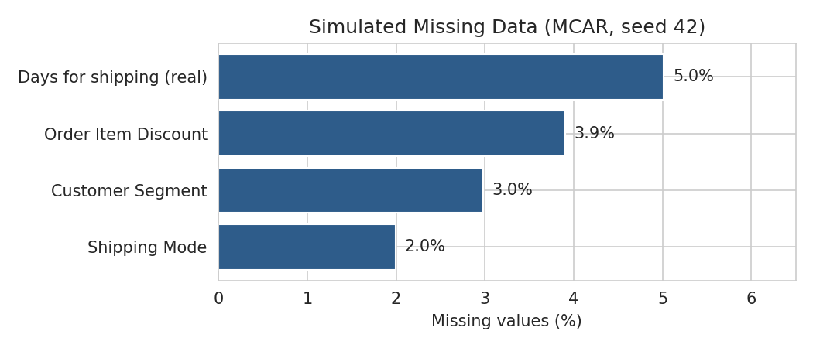
Figure 1: Simulated missing values by column
Honest limitation. Real missing data is rarely completely random. In practice, gaps cluster by carrier, warehouse or time. MCAR is the easiest case, so the imputation scores in Section 6 are best-case figures and real performance would likely be somewhat worse.

5. Data Cleaning

5.1 Text hygiene and label consistency
All text columns were trimmed and repeated internal spaces were collapsed. Without this, a filter such as Order Region == 'South of USA' would return nothing, because the stored value has two spaces. In this dataset the stray spaces did not split any category into two (each label was consistently padded), but they remain a latent defect for joins and lookups, so they were removed. The Spanish-abbreviation country label was mapped to a single English label.
PYTHON CODE
for c in df.select_dtypes(include=["object", "string"]).columns:
df[c] = df[c].str.strip().str.replace(r"\s+", " ", regex=True)
df["Customer Country"] = df["Customer Country"].replace({"EE. UU.": "United States"})

5.2 Removing redundant, constant and personal columns
Constant columns cannot help any analysis. For each identical pair, I kept the more descriptive column name and dropped its twin, because duplicated columns inflate correlations and confuse feature-importance results. Customer names, street addresses and product image links were removed under data minimisation: they have no analytical value here, and keeping personal data without a purpose adds risk. The code asserts that every dropped column really is in an identical pair, so the drop cannot silently remove unique information.
PYTHON CODE
redundant_drop = ["Benefit per order", "Sales per customer", "Order Customer Id",
"Order Item Cardprod Id", "Product Category Id", "Product Price"]
in_pairs = {x for p in find_redundant(df_raw) for x in p}
assert set(redundant_drop) <= in_pairs
pii_drop = ["Customer Fname", "Customer Lname", "Customer Street", "Product Image"]
df = df.drop(columns=constant_cols + redundant_drop + pii_drop)

OUTPUT
Columns after dropping: 38 (from 51)

5.3 Data types
Dates were stored as text and were parsed into timestamps. The zipcode was stored as a decimal number, which would drop leading zeros and invites arithmetic on an identifier, so it was converted to a zero-padded five-character string.
PYTHON CODE
df["order_dt"] = pd.to_datetime(df["order date (DateOrders)"], format="%m/%d/%Y %H:%M")
df["ship_dt"] = pd.to_datetime(df["shipping date (DateOrders)"], format="%m/%d/%Y %H:%M")
df["Customer Zipcode"] = df["Customer Zipcode"].astype(int).astype(str).str.zfill(5)

5.4 Erroneous entries: invalid coordinates
The customers in this dataset are all in the United States or Puerto Rico, yet 227 rows carry coordinates in the Atlantic or the eastern hemisphere. Two patterns appear: a positive longitude where a minus sign was lost (for example, Georgia at +84.7), and western-US longitudes that have lost a digit (Oregon at about -12). The first pattern is repairable and the second is not, so the treatment has two steps: flip the sign when that produces a valid location, and otherwise blank the value and refill it from the median of valid coordinates in the same city, then the same state.
PYTHON CODE
lat, lon = df["Latitude"].copy(), df["Longitude"].copy()
bad = ~in_us_pr(lat, lon)
flip = bad & (lon > 0) & in_us_pr(lat, -lon) # lost minus sign
lon[flip] = -lon[flip]
still_bad = ~in_us_pr(lat, lon)
lat[still_bad], lon[still_bad] = np.nan, np.nan # not repairable by rule
key_city = df["Customer State"] + "|" + df["Customer City"]
for s in (lat, lon):
s[:] = s.fillna(s.groupby(key_city).transform("median"))
s[:] = s.fillna(s.groupby(df["Customer State"]).transform("median"))
df["Latitude"], df["Longitude"] = lat, lon

OUTPUT
Coordinates: sign flipped = 96 | blanked and refilled = 131 | remaining invalid = 0

City-level refills are approximations, not true addresses. That is acceptable for regional demand maps, but not for route-level distance calculations on those 131 rows.

5.5 Flags instead of deletions
Two problems are better flagged than fixed. Cancelled shipments (7,754 rows) are real orders, but no delivery happened, so they should not count towards delivery performance. Corrupted place names cannot be restored without an external list of place names. Both were kept with a flag column, so each analysis can decide whether to include them.
PYTHON CODE
df["is_cancelled"] = df["Delivery Status"].eq("Shipping canceled").astype(int)
df["garbled_location"] = (df["Order State"].str.contains("?", regex=False) |
df["Order City"].str.contains("?", regex=False)).astype(int)

The effect of the cancelled-shipment flag is not small. The late-delivery rate is 54.83% over all rows and 57.29% when cancelled shipments are excluded, a difference of 2.5 percentage points in a headline service-level figure.

6. Handling Missing Values
Each simulated gap was treated with several candidate methods, and each was scored against the true values that were set aside. Mean absolute error (MAE) is the average size of the miss; root mean squared error (RMSE) punishes large misses more. The order of imputation matters: Shipping Mode was filled first, because it is used to impute shipping days.

6.1 Shipping Mode: a business rule beats a statistic
Each scheduled delivery window maps to exactly one shipping mode (0 days = Same Day, 1 days = First Class, 2 days = Second Class, 4 days = Standard Class). The relationship is deterministic, so the lookup recovers the missing value exactly. Filling with the most frequent mode would be right only 58.9% of the time and would wrongly push rows into Standard Class.
PYTHON CODE
known = df["Shipping Mode"].notna()
mode_map = (df[known].groupby("Days for shipment (scheduled)")["Shipping Mode"]
.agg(lambda s: s.mode().iloc[0]))
idx = inj_idx["Shipping Mode"]
pred_rule = df.loc[idx, "Days for shipment (scheduled)"].map(mode_map)
print((pred_rule == truth["Shipping Mode"]).mean())
df.loc[idx, "Shipping Mode"] = pred_rule

OUTPUT
Shipping Mode accuracy rule lookup: 1.0000 | most-frequent: 0.5889

6.2 Days for shipping (real): group medians
Four strategies were compared. A single mean or median ignores that Same Day and First Class shipments take very different times from Standard Class. A median per shipping mode captures that. The fourth option, a median per shipping mode and late-delivery flag, scores best, but I did not use it. Late_delivery_risk is the outcome of interest and is itself defined by the shipping days, so using it to fill the days would make the two columns agree artificially and hide the very relationship an analyst might want to study. A lower error is not worth circular logic.
PYTHON CODE
col = "Days for shipping (real)"; idx = inj_idx[col]; obs = df[col].notna(); t = truth[col]
cands = {}
cands["Mean"] = pd.Series(df.loc[obs, col].mean(), index=idx)
cands["Median"] = pd.Series(df.loc[obs, col].median(), index=idx)
g1 = df[obs].groupby("Shipping Mode")[col].median()
cands["Median by Shipping Mode"] = df.loc[idx, "Shipping Mode"].map(g1)
g2 = df[obs].groupby(["Shipping Mode", "Late_delivery_risk"])[col].median()
cands["Median by Mode x Late flag"] = pd.Series(
[g2[(m, l)] for m, l in zip(df.loc[idx, "Shipping Mode"], df.loc[idx, "Late_delivery_risk"])], index=idx)
scores = {k: {"MAE": (v - t).abs().mean(), "RMSE": np.sqrt(((v - t) ** 2).mean())} for k, v in cands.items()}
df.loc[idx, col] = cands["Median by Shipping Mode"] # chosen: non-circular

Method (Days for shipping) | MAE (days) | RMSE (days) | Used
Mean | 1.423 | 1.623 | No
Median | 1.401 | 1.702 | No
Median by Shipping Mode | 0.967 | 1.261 | Yes
Median by Mode x Late flag | 0.545 | 0.834 | No (circular)

6.3 Order Item Discount: derive it
The discount equals the discount rate multiplied by the sales amount, and the rate was not removed. A statistical fill (mean or median) misses by about 15 currency units on average, while the rule misses by 0.06, because the rate is stored rounded to two decimals.
PYTHON CODE
col = "Order Item Discount"; idx = inj_idx[col]; obs = df[col].notna(); t = truth[col]
cd = {"Mean": pd.Series(df.loc[obs, col].mean(), index=idx),
"Median": pd.Series(df.loc[obs, col].median(), index=idx),
"Rate x Sales rule": df.loc[idx, "Order Item Discount Rate"] * df.loc[idx, "Sales"]}
df.loc[idx, col] = cd["Rate x Sales rule"]

Method (Discount) | MAE | RMSE | Used
Mean | 15.836 | 22.159 | No
Median | 15.130 | 23.236 | No
Rate x Sales rule | 0.057 | 0.278 | Yes

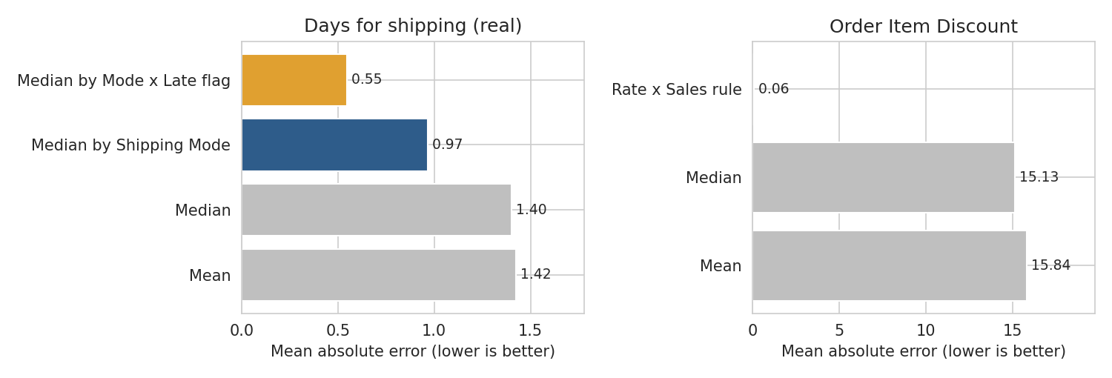
Figure 2: Imputation error by method (mean absolute error, lower is better)

6.4 Customer Segment: say "Unknown"
Nothing else in the data predicts a customer's segment. Filling with the most common segment (Consumer) would be correct only 52.0% of the time, so nearly half the filled values would be wrong while looking perfectly valid. An explicit Unknown category is honest, keeps the rows, and lets a model learn whether missing-segment orders behave differently.
PYTHON CODE
df["Customer Segment"] = df["Customer Segment"].fillna("Unknown")

6.5 Effect on the distributions
Statistic | True data | After imputation
Days for shipping: mean | 3.498 | 3.496
Days for shipping: standard deviation | 1.624 | 1.601
Discount: mean | 20.664 | 20.666
Discount: standard deviation | 21.801 | 21.800

Aggregates are preserved almost exactly, and the shipping-days standard deviation shrinks by about 1.4%, the usual cost of filling with typical values. The caution is at the row level: the shipping-days fill is off by about one day on average (MAE 0.97), which is fine for averages by mode and not fine for judging whether one specific shipment was late.

7. Outlier Detection and Treatment
Outliers were detected with the IQR rule (values beyond 1.5 times the interquartile range from the quartiles), which is robust to skew, and cross-checked with z-scores (absolute z above 3), which is not. Money columns in logistics data are almost always skewed, so a large number of flags is expected and should be investigated before any removal.
PYTHON CODE
def iqr_bounds(s, k=1.5):
q1, q3 = s.quantile([.25, .75]); iqr = q3 - q1
return q1 - k * iqr, q3 + k * iqr

for c in ["Order Profit Per Order", "Sales", "Order Item Discount",
"Order Item Product Price", "Order Item Profit Ratio"]:
lo, hi = iqr_bounds(df[c]); z = (df[c] - df[c].mean()) / df[c].std()
print(c, ((df[c] < lo) | (df[c] > hi)).sum(), (z.abs() > 3).sum(), df[c].skew())

Column | Skewness | IQR flagged | |z| > 3 | Min | Max
Order Profit Per Order | -4.74 | 18,938 | 3,608 | -4274.98 | 911.80
Sales | 2.88 | 488 | 467 | 9.99 | 1999.99
Order Item Discount | 3.04 | 7,537 | 2,107 | 0.00 | 500.00
Order Item Product Price | 3.19 | 2,045 | 488 | 9.99 | 1999.99
Order Item Profit Ratio | -2.89 | 17,300 | 6,013 | -2.75 | 0.50

Investigating before acting. The profit column has 13,727 values below the lower fence and 5,211 above the upper fence. The worst three losses are all large-ticket items sold at a deep loss:
Product | List price | Qty | Discount | Profit ratio | Profit
SOLE E35 Elliptical | 1999.99 | 1 | 100 | -2.25 | -4274.98
Dell Laptop | 1500.00 | 1 | 150 | -2.55 | -3442.50
Dell Laptop | 1500.00 | 1 | 180 | -2.55 | -3366.00

The large-loss rows have a median list price of 129.99 against 59.99 for all rows, so the extreme losses are concentrated in expensive products. They are not typing errors. Overall, 33,782 order items (18.7%) lose money. Deleting these rows would remove exactly the margin leakage a logistics or pricing team needs to see, so none were deleted.
Instead, the influence of extreme values was reduced in the modelling copies of the columns while the raw columns were kept for reporting: profit was winsorised to its 1st and 99th percentiles (-415.62 to 184.23), and sales and discount were log-transformed with log1p, which also handles zero discounts safely. Profit cannot be log-transformed because it can be negative.
PYTHON CODE
p1, p99 = df["Order Profit Per Order"].quantile([.01, .99])
df["Profit_w"] = df["Order Profit Per Order"].clip(p1, p99)
df["Sales_log"] = np.log1p(df["Sales"])
df["Discount_log"] = np.log1p(df["Order Item Discount"])

Column | Skewness before | Skewness after | Treatment
Order Profit Per Order | -4.74 | -2.28 | Winsorise 1-99%
Sales | 2.88 | -0.68 | log1p
Order Item Discount | 3.04 | -0.52 | log1p

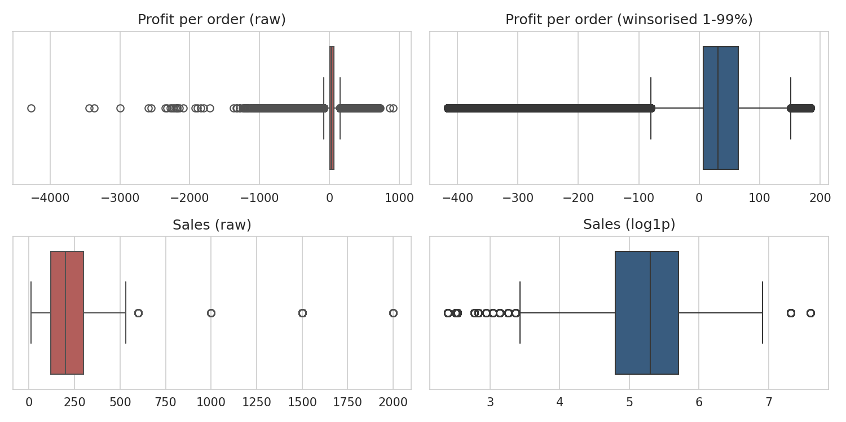
Figure 3: Profit and Sales before and after outlier treatment
The log transform slightly over-corrects Sales and Discount (skewness turns mildly negative), which is acceptable here. A residual set of points still lies outside the boxplot whiskers, which is expected: the aim was to reduce the influence of extremes, not to make them disappear.

8. Normalisation, Encoding and Feature Preparation

8.1 Choosing a normalisation method
Scaling puts columns with very different units (quantities of 1 to 5, sales up to 2,000, hours 0 to 23) on a comparable footing, which matters for distance-based and gradient-based methods. Three standard scalers were compared on Sales, with a log transform as the fourth option.
PYTHON CODE
x = df[["Sales"]]
MinMaxScaler().fit_transform(x) # (x - min) / (max - min)
StandardScaler().fit_transform(x) # (x - mean) / std
RobustScaler().fit_transform(x) # (x - median) / IQR
StandardScaler().fit_transform(df[["Sales_log"]]) # log first, then z-score

Method | Mean | Std | Min | Max | Skewness | Share in lowest 10% of range
Raw | 203.765 | 132.271 | 9.99 | 1999.99 | 2.88 | 64.9%
Min-Max | 0.097 | 0.066 | 0.00 | 1.00 | 2.88 | 64.9%
Z-score | -0.000 | 1.000 | -1.46 | 13.58 | 2.88 | 64.9%
Robust | 0.021 | 0.735 | -1.06 | 10.00 | 2.88 | 64.9%
log1p + Z-score | 0.000 | 1.000 | -4.00 | 3.65 | -0.68 | 0.6%

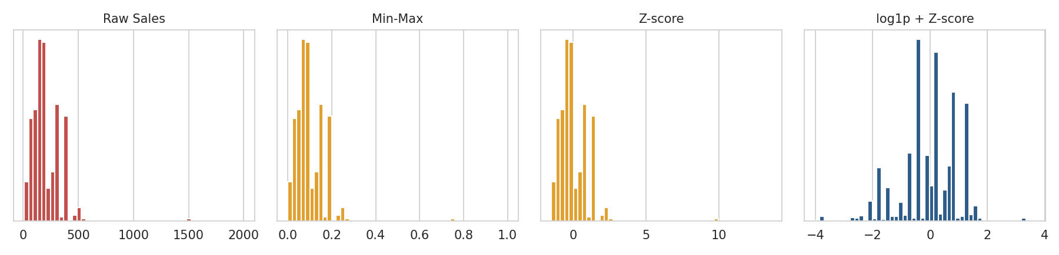
Figure 4: Distribution of Sales under different normalisation methods
The table shows what each method does and does not do. Min-Max squeezes the data into 0 to 1, but because a few sales near 2,000 define the maximum, 65% of all values end up in the bottom tenth of the range, so most of the 0 to 1 scale is wasted. Z-score and Robust scaling re-centre and re-scale the data but leave the skewness untouched (2.89), because they are linear. Only the log transform removes the skew. For the final matrix I therefore combined the two: log transform first for skewed columns, then standardise.

8.2 Encoding and the final feature matrix
Categorical fields were one-hot encoded with the first level dropped to avoid perfect redundancy. Order-time features were derived from the order timestamp (hour, day of week, month, weekend flag). Only information known when the order is placed was used as a model input. The scheduled days column was left out of the matrix, because it is fully determined by Shipping Mode (Section 6.1) and would add a perfectly collinear column. Post-shipment columns (actual days, delivery status, shipping date and processing time) were kept in the cleaned file for reporting but excluded from the model matrix.
PYTHON CODE
df["order_hour"] = df["order_dt"].dt.hour
df["order_dow"] = df["order_dt"].dt.dayofweek
df["order_month"] = df["order_dt"].dt.month
df["is_weekend"] = (df["order_dow"] >= 5).astype(int)

num_feats = ["Order Item Quantity", "Order Item Discount Rate", "Sales_log", "Discount_log",
"Profit_w", "order_hour", "order_dow", "order_month", "is_weekend"]
cat_feats = ["Shipping Mode", "Market", "Type", "Customer Segment", "Department Name"]
X = pd.get_dummies(df[num_feats + cat_feats], columns=cat_feats, drop_first=True, dtype=int)
y = df["Late_delivery_risk"]

8.3 Fitting the scaler on the training data only
A scaler learns the mean and spread of the data. If it learns them from all rows, information about the test rows leaks into training. The data was therefore split first (80% train, 20% test, stratified on the target), and the scaler was fitted on the training rows only, then applied to both. This is the correction to the limitation I noted in my Week 1 report, where preprocessing statistics were fitted on the whole dataset.
PYTHON CODE
tr_idx, te_idx = train_test_split(df.index, test_size=0.2, random_state=SEED, stratify=y)
scaler = StandardScaler().fit(X.loc[tr_idx, num_feats]) # fitted on TRAIN only
Xs = X.copy()
Xs[num_feats] = scaler.transform(X[num_feats])

OUTPUT
Model-ready matrix: (180,508, 32) | train 144,406 | test 36,102

One simplification should be acknowledged: the imputation statistics in Section 6 (group medians) were computed on all observed rows, not on the training rows alone. Because they feed only descriptive columns and not the scaler, the leakage risk is small, but a production pipeline would fit them on the training data as well.

9. Validation
A cleaning pipeline should remove defects without distorting the quantities that decisions depend on. I checked this in three ways.

9.1 Structure and business totals
Check | Raw | After pipeline
Rows | 180,508 | 180,508
Columns (cleaned file, with engineered features) | 51 | 47
Missing cells | 0 (25,083 after injection) | 0
Duplicate Order Item Id | 0 | 0
Total sales | 36,781,302 | 36,781,302
Total discount | 3,730,017 | 3,730,399 (+0.010%)

9.2 Delivery KPIs by shipping mode
Shipping mode | Late rate: raw | Late rate: clean | Mean real days: raw | Mean real days: clean
Standard Class | 38.07% | 38.07% | 3.996 | 3.995
Second Class | 76.63% | 76.63% | 3.991 | 3.990
Same Day | 45.74% | 45.74% | 0.478 | 0.455
First Class | 95.32% | 95.32% | 2.000 | 2.000

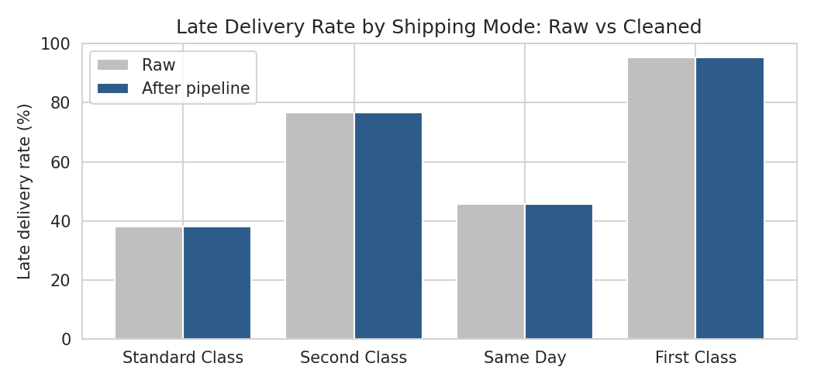
Figure 5: Late delivery rate by shipping mode, raw versus cleaned
Late-delivery rates are identical, as they should be, because that column was not altered. Mean real days are unchanged to two decimals for three modes. Same Day moves from 0.478 to 0.455, a small downward bias that comes from filling with the median (0 days) when the group mean is above 0. It is a visible example of how median imputation can shift a group average, and it is the kind of effect that is worth reporting instead of hiding.

9.3 Smoke test and a demonstration of leakage
As a final check, a logistic regression was trained on the model-ready matrix to predict late delivery. This is a smoke test that confirms the matrix is usable. It is not a tuned model and its score should not be read as a result. The same model was then trained with one extra column added: the actual shipping days.
PYTHON CODE
def auc_of(cols, extra=None):
A = Xs[cols].copy()
if extra is not None: A[extra.name] = extra
m = LogisticRegression(max_iter=2000).fit(A.loc[tr_idx], y.loc[tr_idx])
return roc_auc_score(y.loc[te_idx], m.predict_proba(A.loc[te_idx])[:, 1])

auc_clean = auc_of(list(Xs.columns))
auc_leaky = auc_of(list(Xs.columns), scaled_actual_days)

OUTPUT
Logistic regression AUC order-time features only: 0.741 | with post-shipment days: 0.974

The jump from 0.741 to 0.974 is not a better model. A shipment is late precisely when actual days exceed scheduled days, so the extra column hands the model the answer. In a live system that value does not exist at the moment a prediction is needed. A model built this way would look excellent in testing and be useless in operation, which is why post-shipment columns were excluded.

10. Challenges Faced and How They Were Overcome
Challenge | How it was resolved
The public file had no missing values, so the missing-data step could not be demonstrated on real gaps. | Simulated four MCAR gaps with a fixed seed and kept the truth, which also allowed every imputation method to be scored objectively. The limitation (MCAR is the easy case) is stated openly.
Choosing between statistical and rule-based imputation. | Scored candidates against the true values. Business rules gave 100% accuracy for Shipping Mode and cut discount error from about 15 to 0.06.
The best-scoring shipping-days method used the outcome variable. | Rejected it for circularity and used the second-best, non-circular method. Documented the trade-off.
Hundreds of IQR outliers in the money columns. | Inspected the extreme rows, found them to be genuine expensive items sold at a loss, and used winsorising and log transforms instead of deletion.
Coordinates in the wrong hemisphere for US customers. | Built a plausibility test from the known customer countries, repaired the sign error by rule, and refilled the rest from city or state medians.
Decided what to do with cancelled shipments and corrupted place names. | Kept both and added flag columns, so the decision can be made per analysis instead of being locked into the data.
Min-Max and Z-score scaling did not fix the skew. | Compared scalers numerically, found that only a log transform changes skewness, and combined log with standardisation.
Avoiding information leakage into the model matrix. | Excluded post-shipment columns, split before scaling, fitted the scaler on training rows only, and quantified the leakage effect (AUC 0.74 vs 0.97).

11. Reflection: Impact of Data Quality on Logistics Analytics and Decisions
The most important lesson from this exercise is that data quality problems do not stay in the data. Each one travels into a metric, and each metric drives a decision. The figures below come from this dataset.
- Service-level reporting. The headline late-delivery rate changes from 54.8% to 57.3% depending on whether cancelled shipments are counted. If carrier penalties, customer promises or bonus targets are tied to that figure, an unflagged cancellation changes who is judged to be performing well.
- Volume and capacity planning. The file has 180,508 rows but only 65,741 orders. Treating a row as an order overstates volume by roughly 2.7 times, which would lead to over-sized warehouse capacity or driver plans.
- Network and route decisions. 227 US customers were located in the Atlantic or the eastern hemisphere. Any hub-location, distance or delivery-time model fed those coordinates would compute meaningless distances for those customers.
- Safety stock and lead-time buffers. Lead-time buffers depend on the spread of delivery times, not just the average. Careless imputation can shrink that spread. Here the chosen method kept it close (standard deviation 1.62 to 1.60), but a naive mean fill gives an error of 1.42 days per row against 0.97 for the group median.
- Margin visibility. 13,727 profit values are statistical outliers, mostly large-ticket items sold at a loss. An automated outlier filter would have deleted the evidence of where money is being lost.
- Predictive models. A model given post-shipment information scored AUC 0.97 versus 0.74. Leakage makes a model look strong in testing and fail in operation, which in logistics means wrong delivery promises.
Three principles follow from this work. First, test hypotheses about data quality with evidence instead of applying defaults: the rule-based and group-based fills only won because they were scored. Second, prefer flags to deletions, so that the people using the data can decide what to exclude. Third, always ask when a number will be available: a column that is not known at decision time cannot be a model input, however predictive it looks.

12. Limitations
- Simulated missingness. The gaps are artificial and completely random. Real logistics gaps cluster by carrier, site or period, and imputation would perform worse. The scores are best-case figures.
- Pre-processed source. The public copy appears to have been cleaned before upload (no nulls, a few columns and rows missing relative to the original release). Quality problems found here are therefore a subset of what the original data would show.
- City-level coordinate refills are approximate and unsuitable for route-level analysis on the 131 affected rows.
- Corrupted place names (293 states, 130 cities) were flagged, not repaired.
- Imputation statistics were computed on all observed rows rather than on the training split, a simplification noted in Section 8.3.
- The smoke-test model is not a result. It uses default settings, one model type and one split, and it only shows that the matrix works.

13. Conclusion
A raw logistics dataset of 180,508 order items was audited, cleaned and transformed into a 180,508 by 32 model-ready matrix with no missing values and no leaked columns. Every method was chosen on evidence: rule-based recovery for fields that other columns determine, group medians for numeric fields that do not, an explicit Unknown category where nothing predicts the value, and transformation in place of deletion for genuine extreme values. Validation showed that delivery rates and business totals were preserved, and that the one visible side effect (a small downward shift in Same Day average days) came from median imputation. The data is ready for exploratory analysis and modelling in the following weeks.

Appendix A. Reproducibility and Deliverables
File | Description
logistics_preprocessing.py | Complete script reproducing every number, table and figure in this report
dataco_cleaned.csv.gz | Cleaned dataset for reporting (180,508 rows, 47 columns, includes flags and engineered columns)
dataco_model_ready.csv.gz | Encoded and scaled matrix for modelling, with Late_delivery_risk and a train/test split column
fig1 to fig5 (PNG) | Figures used in this report

To reproduce: install pandas, numpy, matplotlib, seaborn and scikit-learn, then run python logistics_preprocessing.py. The script downloads the data from the URL in Section 2.1, uses a fixed random seed (42), and writes the figures, both data files and a results file to the working directory.
GitHub repository: <add your repository link here>

