**TERM WORK PROJECT REPORT**

**GROUP – AG9**

**TITLE**

**Traffic Light Controller system for four-way intersection using Verilog**

Group Members:

K.D V N B Arun Kumar – CB.EN.U4ECE19024

Srirangam Sai Teja – CB.EN.U4ECE19051

**Abstract:**

Traffic is one of the main concerns for everyone in cities and towns. Probabilities of accidents are higher in Four-way and T intersections. So in order to ensure smooth traffic and to avoid accidents these Traffic lights are being used. The design of traffic control will be different for different type of junctions. The system which we proposed is an efficient traffic light control system for four-way intersection which is based on Moore machine. There are different types of traffic controller systems that are designed for various scenarios but the main drawback of those systems were they are not properly configured for maximum possible movement of vehicles across the intersection. Generally vehicles from other roads which are possible to go by free left are made to wait for long time at the intersection unnecessarily. The proposed system makes sure that it allows the vehicles through free left. In the system we proposed we also included a case of emergency on roads such that emergency vehicles get highest priority. In case of emergency, the lane in which emergency vehicle comes will be given highest priority and there will be moment of vehicles in that lane, while vehicles in other lanes will be halted until emergency vehicles leaves junction. The system is designed in ModelSim – Altera 6.6d version.

**Objectives:**

* Implementation of traffic light controller system for reducing congestion at intersections.
* Introduction of free left case for all directions at intersections.
* Giving priority to emergency vehicles at the junctions and allowing flow of traffic in that lane.

**Methodology:**

Since our proposed system is for Four-way intersection the waiting time for each direction is same. So, vehicles in all the directions will get an equal time to avoid traffic. This system mainly concentrates on developing a reconfigurable traffic light controller system and it works on FPGA as it doesn’t have fixed hardware structure and can be reprogrammed at our convenience using Hardware Description Language (HDL).

In our design we named each lane with respect to their geographic direction like east, west, north, and south. As each lane has three possible ways to get into other lanes. If we consider east direction case, we have three possibilities and we named them as east, east turn and east free left. East refers to vehicles from east to west direction, east turn refers to movement of vehicles from east to north direction and east free left refers to movement of vehicles from east to south direction and the other directions also follows the same pattern. In our design we included the free left case for every direction as a mandatory case which reduces the congestion on roads. In the proposed system we also designed for emergency condition. If there is an emergency vehicle on east direction then except east direction all other directions will get red signal and this will create a possibility for the movement of that emergency vehicle.

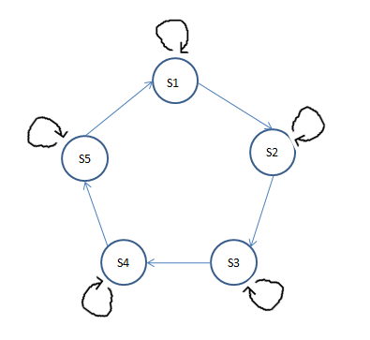

**Fig.1.** State diagram for the proposed system



**Fig.2.** State table of the proposed system

**Results:**

Simulation:

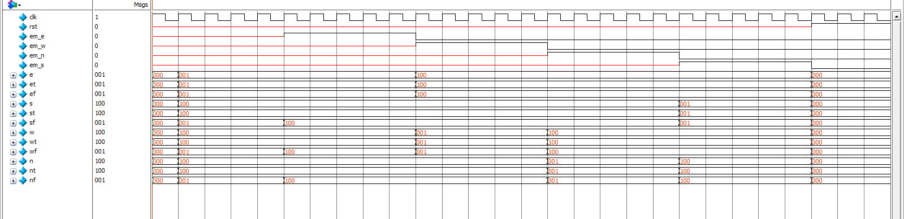

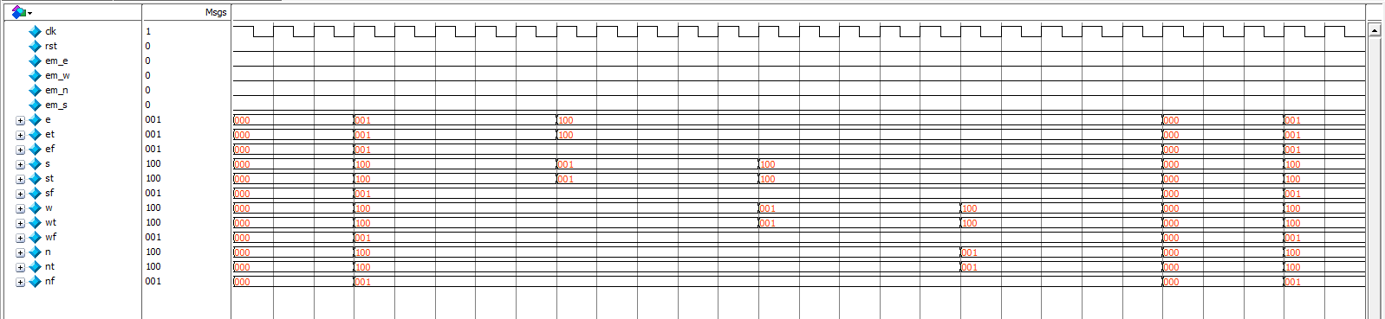

**Fig.3.** Simulated waveforms of the system.

In the above figures we can see the result of behavioural simulation showing the waveform of the Traffic light controller system for the test bench applied using Verilog HDL.

**References:**

[1] K. S. Reddy and B. B. Shabarinath, "Timing and Synchronization for Explicit FSM Based Traffic Light Controller," 2017 IEEE 7th International Advance Computing Conference (IACC), 2017, pp. 526-529, doi: 10.1109/IACC.2017.0114.

[2] B. K. Koay and M. M. Isa, "Traffic light system design on FPGA," 2009 IEEE Student Conference on Research and Development (SCOReD), 2009, pp. 269-271, doi: 10.1109/SCORED.2009.5443035.

[3] S. V. Kishore, V. Sreeja, V. Gupta, V. Videesha, I. B. K. Raju and K. M. Rao, "FPGA based traffic light controller," 2017 International Conference on Trends in Electronics and Informatics (ICEI), 2017, pp. 469-475, doi: 10.1109/ICOEI.2017.8300971.

[4] W. El-Medany and M. Hussain, "FPGA-Based Advanced Real Traffic Light Controller System Design," 2007 4th IEEE Workshop on Intelligent Data Acquisition and Advanced Computing Systems: Technology and Applications, 2007, pp. 100-105, doi: 10.1109/IDAACS.2007.4488383.