**EXP:No.1 221501013**

**21/01/25**

**PROGRAM TO IMPLEMENT TIME SERIES DATA FOR IMPORT LIBRARY, LOAD DATA, PREPROCESSING AND VISUALISING**

**AIM:**

To write Program to implement time series data for import library, load data, Preprocessing and visualising.

**PROCESS:**

import pandas as pd

import numpy as np

import matplotlib.pyplot as plt

**# Load the stock data**

file_path = r'Electric_Production.csv'

data = pd.read_csv(file_path)

**# Check the columns to see what data is available**

print("Columns in the dataset:", data.columns)

**# Ensure there are no leading/trailing spaces in column names**

data.columns = data.columns.str.strip()

**# Check if 'IPG2211A2N' column exists (assuming this is the relevant data)**

if 'IPG2211A2N' not in data.columns:

raise KeyError("'IPG2211A2N' column not found in the dataset. Please check the column name.")

**# Access the 'IPG2211A2N' column**

production_data = data['IPG2211A2N']

**# Reverse the order of the data to maintain chronological order**

production_data_reverse = production_data.iloc[::-1]

**# Reset index to maintain the correct time series order**

production_data_reverse.reset_index(drop=True, inplace=True)

**# 1. Handling Missing Values:**

**# Check for missing values in each column**

print("Missing values in each column:")

print(data.isnull().sum())

**# Fill missing values in 'IPG2211A2N' with the mean if there are any NaNs**

data['IPG2211A2N'].fillna(data['IPG2211A2N'].mean(), inplace=True)

**# 2. Handling Outliers:**

**# Using IQR (Interquartile Range) to handle outliers for 'IPG2211A2N' column**

Q1 = data['IPG2211A2N'].quantile(0.25)

Q3 = data['IPG2211A2N'].quantile(0.75)

IQR = Q3 - Q1

lower_bound = Q1 - 1.5 * IQR

upper_bound = Q3 + 1.5 * IQR

**# Filter data to remove outliers based on the IQR bounds**

data = data[(data['IPG2211A2N'] >= lower_bound) & (data['IPG2211A2N'] <= upper_bound)]

**# Normalize the 'IPG2211A2N' data for use in further analysis**

data_values = production_data_reverse.values.reshape(-1, 1) # Reshape for normalization

data_normalized = data_values / np.max(data_values) # Normalize the data

**# Split the data into training and testing sets (80% training, 20% testing)**

train_size = int(len(data_normalized) * 0.8)

train_data = data_normalized[:train_size]

test_data = data_normalized[train_size:]

**# Plotting the 'IPG2211A2N' data (electric production or the relevant dataset)**

plt.figure(figsize=(10, 6))

plt.plot(production_data_reverse)

plt.xlabel('Time')

plt.ylabel('Production Data')

plt.title('Electric Production Data')

plt.grid(True)

plt.show()

**OUTPUT:**

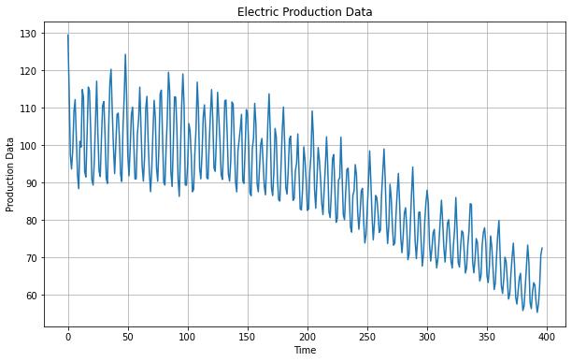

**RESULT:**

The program To write Program to implement time series data for import library, load data, Preprocessing and visualising is created and executed successfully.