**PYTHON PROGRAMMING USING SIMPLE STATEMENTS AND EXPRESSIONS**

**Aim:**

To draw flowchart, algorithm, and program for the given problem.

**Algorithm:**

**Step 1 :** Start

**Step 2 :** read values of a and b

**Step 3 :** assign c=a

**Step 4 :** assign a=b

**Step 5 :** assign b=c

**Step 6 :** display a, b

**Step 7 :** Stop

**PROGRAM:**

**# METHOD-1 USIGN THIRD VARIABLE:**

a=int(input('First value : '))

b=int(input('Second value : '))

c=a # using third variable

a=b

b=c

print(f'The exchanged values are a={a} and b={b}')

**OUTPUT:**

First value : 2

Second value : 3

The exchanged values are a=3 and b=2

**#METHOD-2 USIGN COMMA OPERATOR**

x=int(input('First value : '))

y=int(input('Second value : '))

x,y=y,x # using comma operator

print(f'The exchanged values are a={x} and b={y}')

**OUTPUT:**

First value : 2

Second value : 3

The exchanged values are a=3 and b=2

**#METHOD-3 USIGN ARITHMETIC OPERATOR**

a=int(input('First value : '))

b=int(input('Second value : '))

a=a+b

b=a-b # using arithmetic operator

a=a-b

print(f'The exchanged values are a={a} and b={b}')

**OUTPUT:**

First value : 10

Second value : 15

The exchanged values are a=15 and b=10

**#METHOD-4 USING XOR OPERATOR**

a=int(input('First value : '))

b=int(input('Second value : '))

a=a^b

b=a^b # using XOR operator

a=a^b

print(f'The exchanged values are a={a} and b={b}')

**OUTPUT:**

First value : 2

Second value : 3

The exchanged values are a=3 and b=2

**FLOWCHART:**

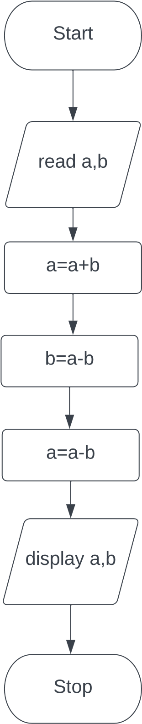

**Algorithm:**

**Step 1 :** Start

**Step 2 :** read list a

**Step 3 :** display a

**Step 4 :** assign i=0, n=size of a

**Step 5 :** Check if i<n

**5.1:** If Yes, then a.append(a[0]), a.pop(0), i=i+1

**5.2:** display a and go to step 5

**5.3:** If No, then go to step 6

**Step 6 :** Stop

**PROGRAM:**

**# METHOD-1 USING IN BUILD FUNCTION**

a=input('Enter values : ').split(',')

print(f'The origianl list is {a}','\n','Circulating the list')

for i in range(len(a)):

a.append(a[0])

a.pop(0) # using Build_in function

print(a)

**OUTPUT:**

Enter values : 1,2,3,4,5

The origianl list is ['1', '2', '3', '4', '5']

Circulating the list

['2', '3', '4', '5', '1']

['3', '4', '5', '1', '2']

['4', '5', '1', '2', '3']

['5', '1', '2', '3', '4']

['1', '2', '3', '4', '5']

**# METHOD-2 USING SLICING OPERATOR**

a=input('Enter values : ').split(',')

print(f'The origianl list is {a}','\n','Circulating the list')

for i in range(len(a)):

cir=a[1:]+[a[0]] # using slicing operator

print(cir)

**OUTPUT:**

Enter values : 1,2,3,4,5

The origianl list is ['1', '2', '3', '4', '5']

Circulating the list

['2', '3', '4', '5', '1']

['2', '3', '4', '5', '1']

['2', '3', '4', '5', '1']

['2', '3', '4', '5', '1']

['2', '3', '4', '5', '1']

**FLOWCHART:**

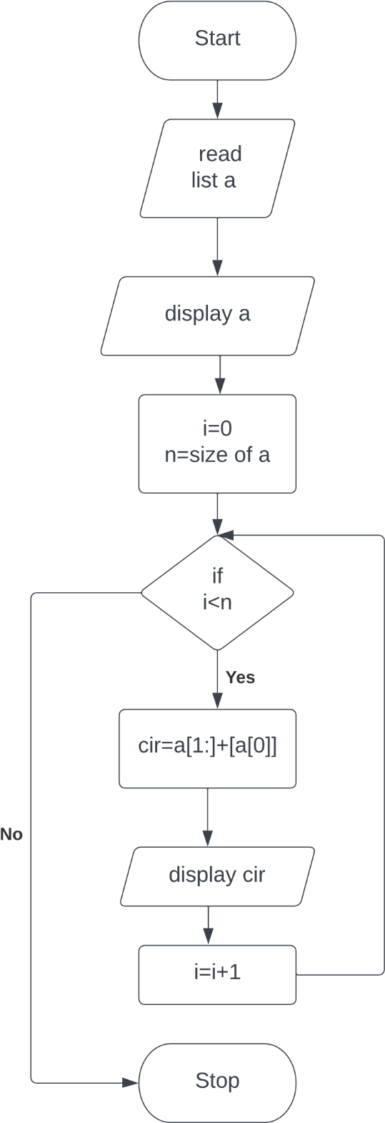

**Algorithm:**

**Step 1 :** Start

**Step 2 :** read values of x1,x2, y1, y2

**Step 3 :** import math

**Step 4 :** compute d= math.sqrt((x2-x1)**2+(y2-y1)**2)

**Step 5 :** display d

**Step 6 :** Stop

**PROGRAM:**

import math

x1=int(input('Enter x1 : '))

x2=int(input('Enter x2 : '))

y1=int(input('Enter y1 : '))

y2=int(input('Enter y2 : '))

d=math.sqrt((x2-x1)**2+(y2-y1)**2)

print(f'The distance between two points is {d}')

**OUTPUT:**

Enter x1 : 3

Enter x2 : 7

Enter y1 : 2

Enter y2 : 8

The distance between two points is 7.211102550927978

**FLOWCHART:**

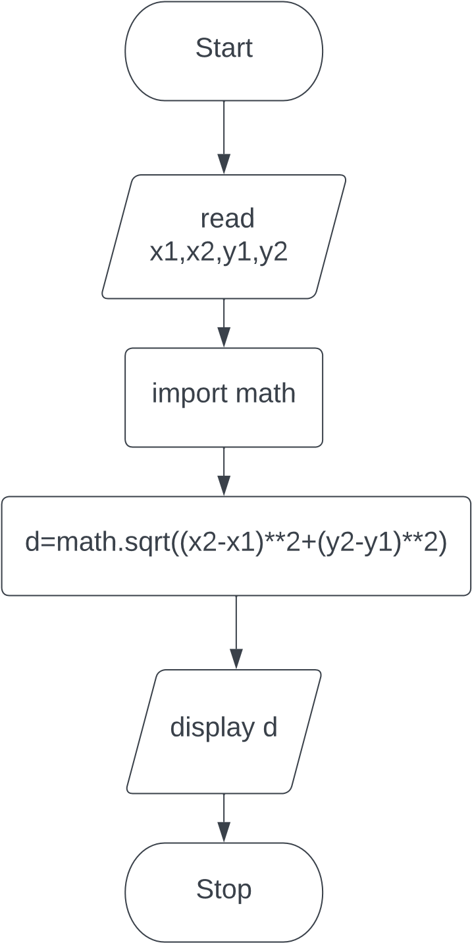

**Program;**

n=int(input('Number of books : '))

cost=int(int(input('cost of one book : ')))

total_cost=n*cost

discount=(5/100)*total_cost

final_cost=total_cost-discount

print(final_cost)

**output;**

Number of books : 10

cost of one book : 10

95.0

**Program;**

a=int(input('Enter number : '))

b=int(input('Enter number : '))

print(f'a+b = {a+b}')

print(f'a-b = {a-b}')

print(f'a*b = {a*b}')

print(f'a/b = {a/b}')

print(f'a//b = {a//b}')

print(f'a**b = {a**b}')

print(f'a%b = {a%b}')

**output;**

Enter number : 5

Enter number : 4

a+b = 9

a-b = 1

a*b = 20

a/b = 1.25

a//b = 1

a**b = 625

a%b = 1