S3-Simple Storage Service

What is Amazon S3?

Amazon Simple Storage Service (Amazon S3) is a scalable, high-speed, web- based cloud storage service. The service is designed for online backup and archiving of data and applications on Amazon Web Services (AWS).

Differences:

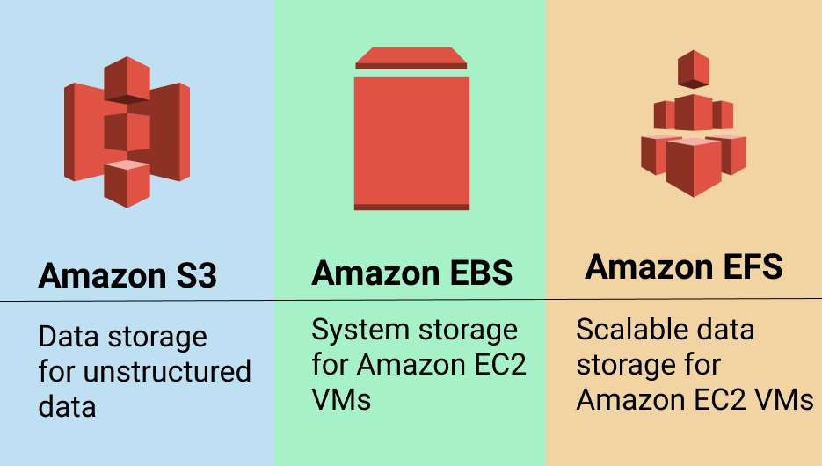

**What is S3 bucket versioning?**

Versioning in Amazon S3 is a means of keeping multiple variants of an object in the same bucket. You can use the S3 Versioning feature to preserve, retrieve, and restore every version of every object stored in your buckets.

Storage Classes in S3 :

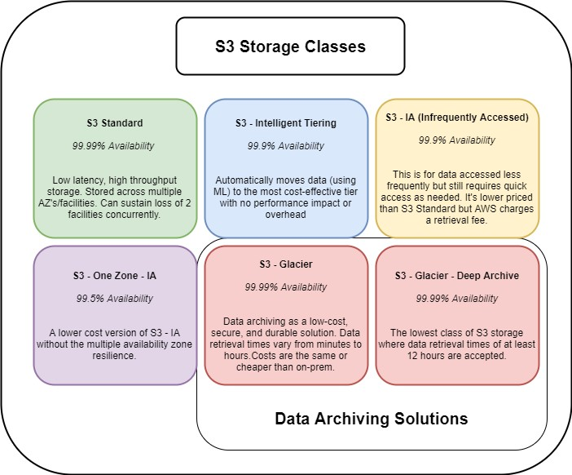

# Cross region replication # static web hosting

How to connect EC2 to S3 Bucket

1. **Create S3 bucket**

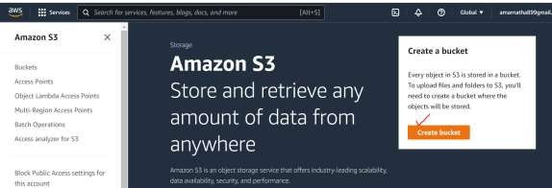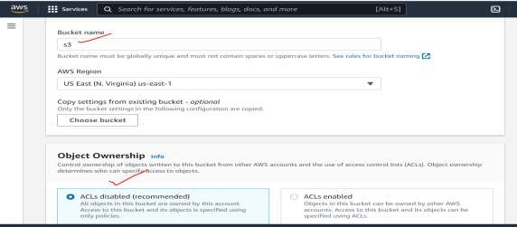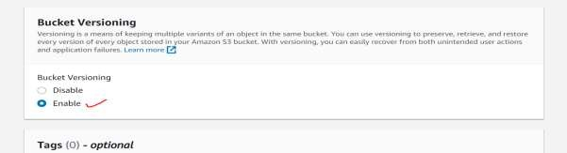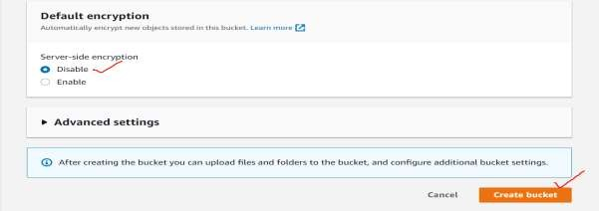

To create the Folders in the S3 Bucket:

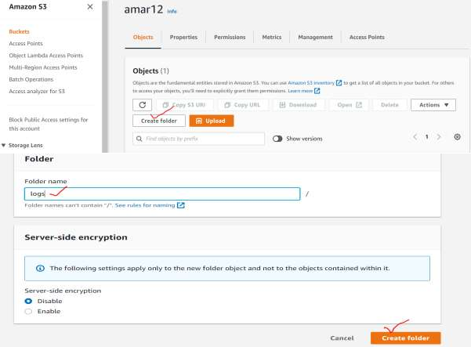

1. **Create IAM role with S3 full access and attach to EC2 Instance.**

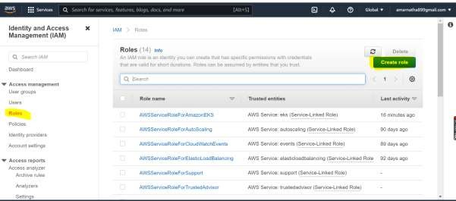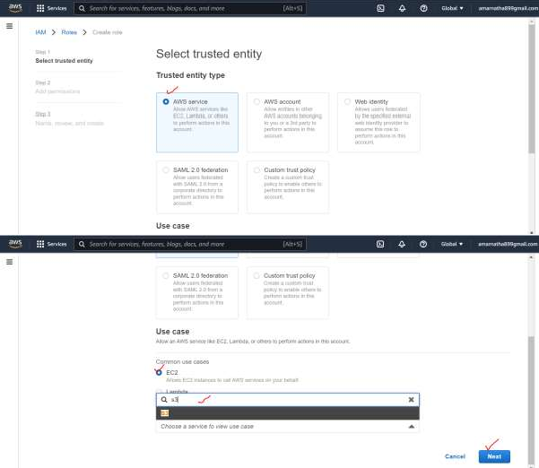

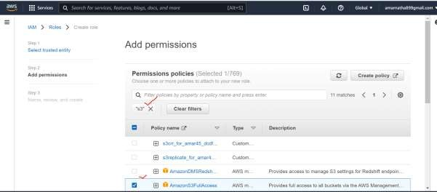

and then give a **Name** to the **Role,** take a **review** and finally click on **create.**

1. 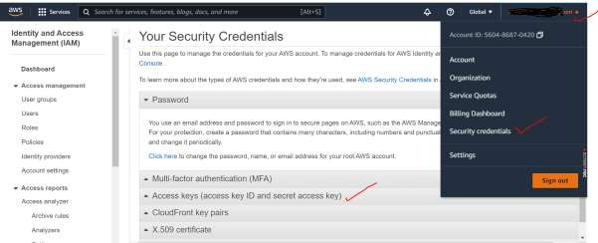**Generate aws secret key & access key in security credential Manager:**

**\*\*\*** Never share these Keys with anyone

1. **Login into EC2 Instance: # aws configure**

# access key # secret key

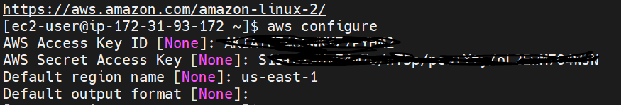# region →enter

1. **aws s3 ls**

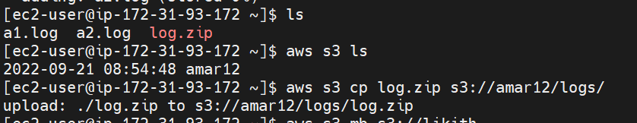

1. **aws s3 mb s3://bucketname (create bucket)**
2. 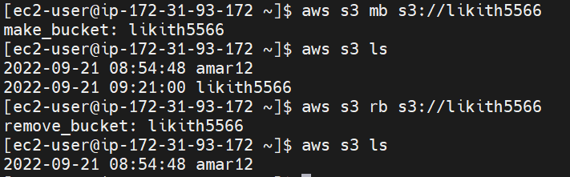**aws s3 rb s3://bucketname (remove bucket)**

Copy data from server to S3 console: # touch file.log file2.log

# zip –r log.zip . (creating log.zip)

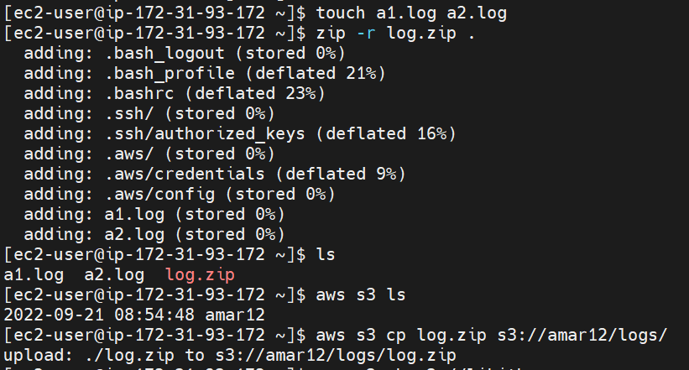# aws s3 cp log.zip s3://bucketname/folder/

S3 Static website hosting AWS:

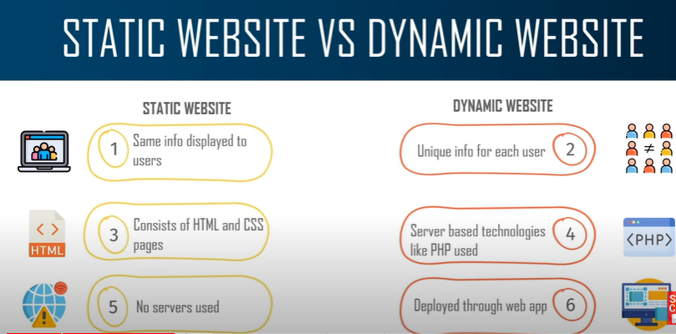

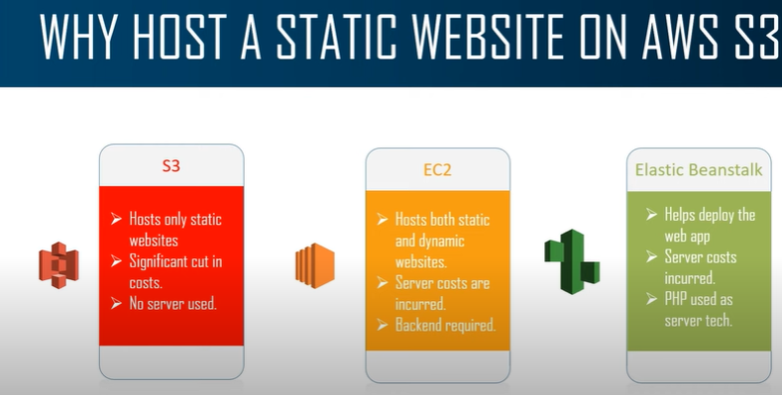

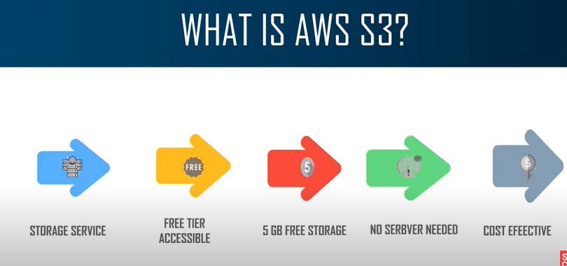

# enable public access for bucket

Edit bucket policy:

{

"Version": "2012-10-17",

"Statement": [

{

"Sid": "AllowPublicReadAccess",

"Effect": "Allow",

"Principal": "*",

"Action": "s3:getObject",

"Resource": "bucket arn/*"

}

]

}

Index.html file

<!DOCTYPE html>

<html>

<head>

<title>Welcome to nginx!</title>

<style>

html { color-scheme: light dark; }

body { width: 35em; margin: 0 auto;

font-family: Tahoma, Verdana, Arial, sans-serif; }

</style>

</head>

<body>

<h1>Welcome to Sample application!</h1>

<p>If you see this page, the nginx web server is successfully installed and

working. Further configuration is required.</p>

<p><em>Thank you for using nginx.</em></p>

</body>

</html>