SATHI 2026
Program Management System

User Guide & Tutorial

Vision-Aid
Smart Assistive Technology for Holistic Inclusion

Table of Contents
1. Getting Started
2. Login
3. Dashboard
4. Managing Partners
5. Managing Beneficiaries
6. Uploading Beneficiary Data from Excel
7. Managing Events
8. Recording Distributions
9. Inventory Management
10. Training Records
11. Follow-up & Impact Tracking
12. Budget Management
13. Milestones Tracking
14. Reports & Data Export
15. Activity Log
16. Tips & Best Practices

1. Getting Started
SATHI 2026 is a web-based program management system for Vision-Aid's assistive device distribution program. It runs locally on your computer and requires only Python and Flask.

Installation
Requirements: Python 3.8+ and Flask

Quick Setup
1. Unzip the sathi-2026.zip file to a folder
2. Open a terminal/command prompt
3. Navigate to the folder: cd sathi
4. Install Flask: pip install Flask openpyxl python-docx
5. Run the application: python app.py
6. Open your browser to http://localhost:5000

The database is automatically created on first run with all device types and 2026 milestones pre-loaded. No additional setup is needed.

For Anaconda Users
If you use Anaconda, create a dedicated environment:
conda create -n sathi python=3.10 && conda activate sathi && pip install Flask

2. Login
When you open the application, you will see the login screen. The default password is "sathi2026".


Step 1: Enter the password "sathi2026" in the password field.
Step 2: Click "Log In" to access the system.

To change the password, edit the config.py file and change the PASSWORD value. If you remove the password, the system will check the SATHI_PASSWORD environment variable. If neither is set, the system will run without authentication.

3. Dashboard
The dashboard is your home screen. It shows key program metrics at a glance.
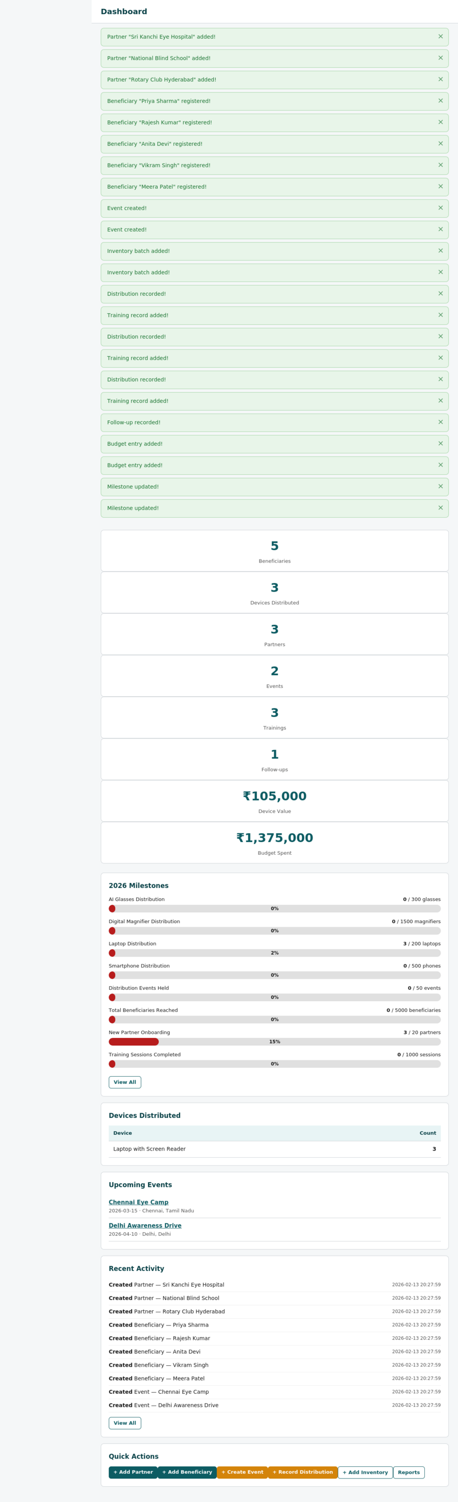

What You See
Stat Cards (top): Total beneficiaries, partners, distributions, events, trainings, follow-ups, total device value, and budget spent.
Milestone Progress: Visual progress bars showing how close you are to each 2026 target.
Device Breakdown: Table showing how many of each device type has been distributed.
Upcoming Events: List of next 5 scheduled events.
Recent Activity: Latest 10 actions taken in the system.
Quick Actions: Buttons for the most common tasks.

4. Managing Partners
Partners are organizations that help distribute devices — hospitals, schools, Rotary clubs, NGOs, etc.
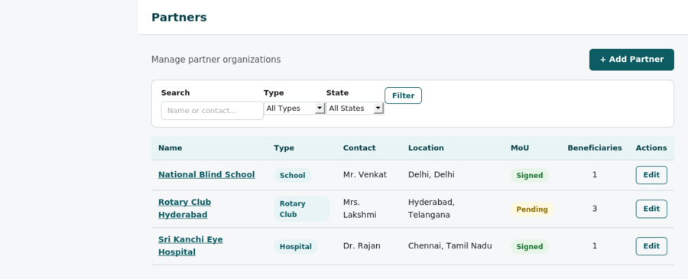

Adding a Partner
Step 1: Click "Partners" in the left sidebar.
Step 2: Click the "+ Add Partner" button.
Step 3: Fill in the partner details: Organization Name, Type (Hospital/School/NGO/Rotary Club), Contact Person, Email, Phone, Address, City, State, MoU Status, and Notes.
Step 4: Click "Save Partner".

Viewing Partner Details
Click on any partner name to see their full details, including all beneficiaries and events linked to them.

Filtering Partners
Use the search box and dropdown filters at the top of the partners list to find specific partners by name, type, or state.

5. Managing Beneficiaries
Beneficiaries are the individuals who receive assistive devices through the SATHI program.
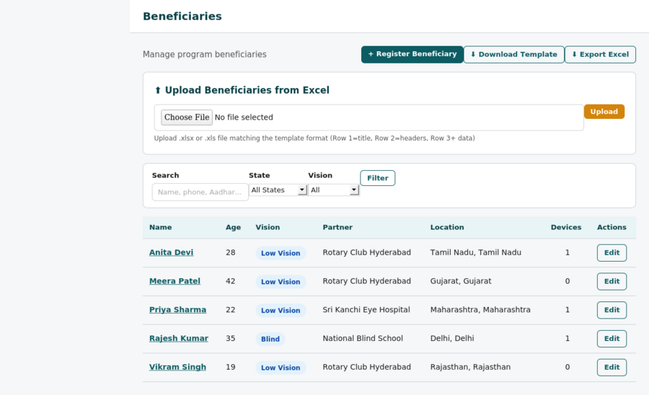

Registering a Beneficiary
Step 1: Click "Beneficiaries" in the left sidebar.
Step 2: Click "+ Register Beneficiary".
Step 3: Fill in the form. The fields match the official data collection template:
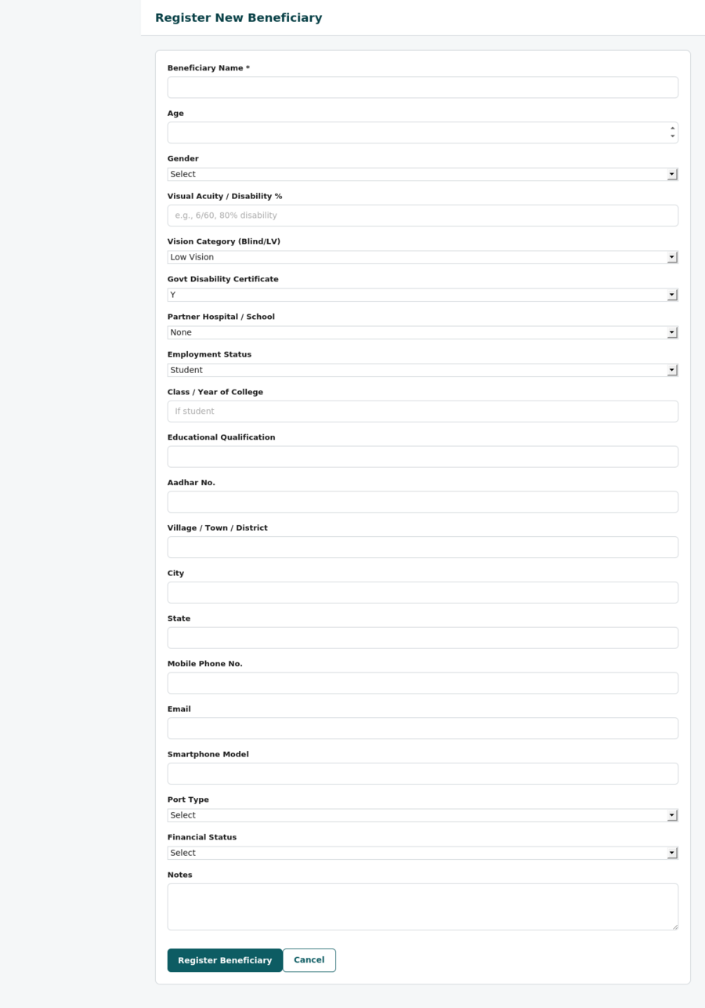

- • Beneficiary Name (required)
- • Age
- • Gender
- • Visual Acuity / Disability Percentage (Blind/LV)
- • Government Disability Certificate (Y/N)
- • Partner Hospital/School Name (select from partners)
- • Employment Status (Employed/Unemployed/Job Seeker/Student/Homemaker)
- • Class/Year of College (if student)
- • Educational Qualification
- • Aadhar Number
- • Village/Town/District/City
- • State
- • Mobile Phone
- • Email
- • Smartphone Model
- • Port Type (USB-C/USB-B)
Step 4: Click "Save Beneficiary".

Viewing Beneficiary Details
Click on any beneficiary name to see their full profile, including devices received, training records, and follow-up history.
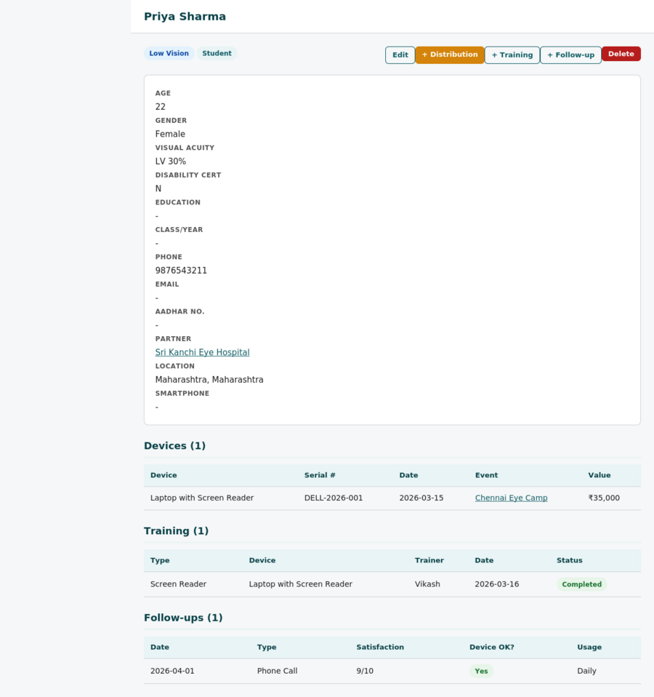

6. Uploading Beneficiary Data from Excel
You can bulk-upload beneficiaries from an Excel spreadsheet that matches the official template format.

Download the Template
Step 1: Go to Beneficiaries page.
Step 2: Click "Download Template" to get a blank .xlsx file with the correct column headers.
Step 3: Fill in the data in Excel. Row 1 is the title, Row 2 has headers, and data starts from Row 3.

Upload Data
Step 4: On the Beneficiaries page, you will see the "Upload Beneficiaries from Excel" section.
Step 5: Click "Choose File" and select your filled-in .xlsx or .xls file.
Step 6: Click "Upload". The system will import all rows and show how many were imported.

Important: If the "Partner Hospital/School Name" column in your Excel matches an existing partner name in the system, the beneficiary will automatically be linked to that partner.

Export Existing Data
Click "Export Excel" on the Beneficiaries page to download all current beneficiary data in the same template format. This is useful for sharing data with partners or for backup.

7. Managing Events
Events are distribution camps, awareness drives, training sessions, and other activities.
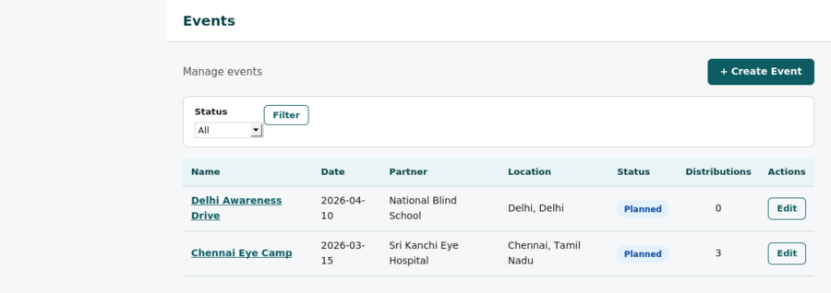

Creating an Event
Step 1: Click "Events" in the sidebar, then "+ Add Event".
Step 2: Enter event details: Name, Type (Distribution/Awareness/Training/Meeting), Partner, Date, Location, City, State, Status, Expected Beneficiaries, Chief Guest.
Step 3: Click "Save Event".
After the event is completed, you can edit it to update the Actual Beneficiaries count and change the status to "Completed".

8. Recording Distributions
Track every device given to every beneficiary with serial numbers and event linkage.
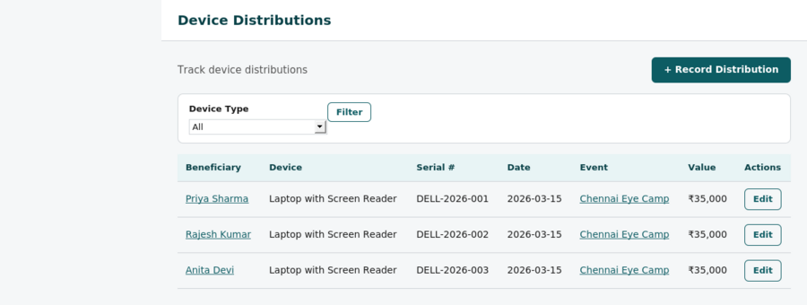

Recording a Distribution
Step 1: Click "Distributions" in the sidebar, then "+ Record Distribution".
Step 2: Select the Beneficiary (search by name).
Step 3: Select the Device Type.
Step 4: Optionally link to an Event.
Step 5: Enter the Serial Number, Distribution Date, and Device Condition.
Step 6: Click "Save Distribution".

9. Inventory Management
Track procurement batches and stock levels for all device types.
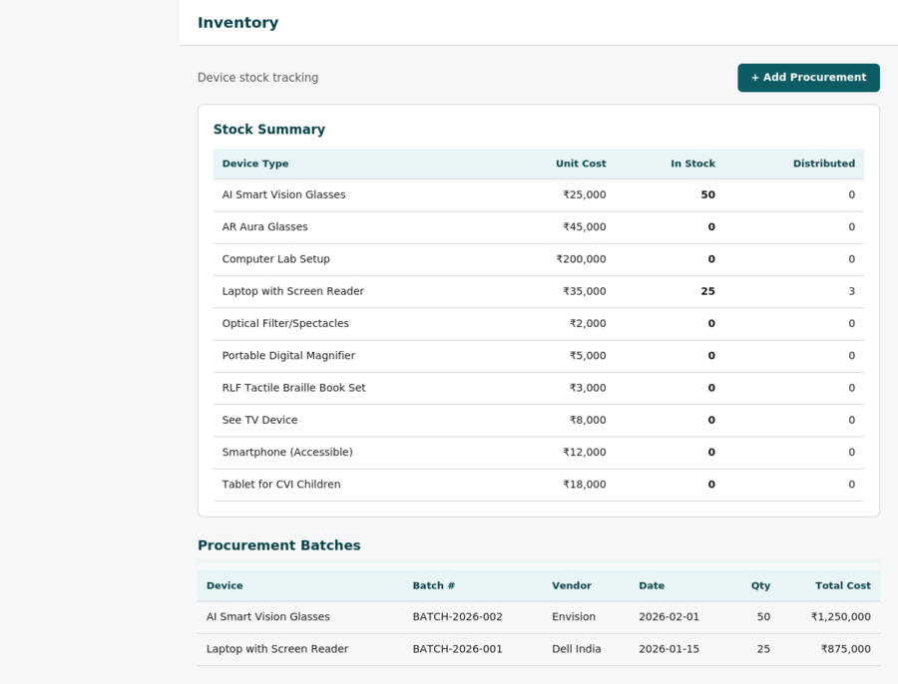

Adding a Procurement Batch
Step 1: Click "Inventory" in the sidebar, then "+ Add Procurement".
Step 2: Select the Device Type, enter Batch Number, Quantity, Unit Cost, Vendor, and Date.
Step 3: Click "Save". The stock summary at the top automatically updates.

The inventory page shows a summary of all device types with total procured vs. distributed counts, so you can always see your current stock at a glance.

10. Training Records
Record training sessions provided to beneficiaries on how to use their devices.
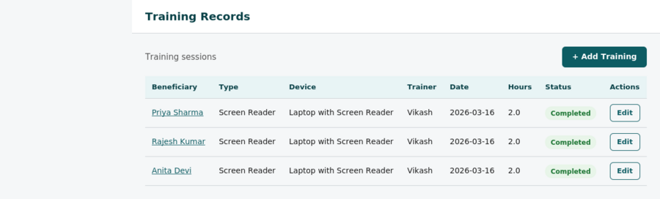
Step 1: Click "Training" in the sidebar, then "+ Add Training".
Step 2: Select Beneficiary, Device Type, Training Type, Trainer Name, Date, Duration, and Status.
Step 3: Mark "Certificate Issued" if applicable.
Step 4: Click "Save".

11. Follow-up & Impact Tracking
Record post-distribution follow-ups to measure impact and collect success stories.
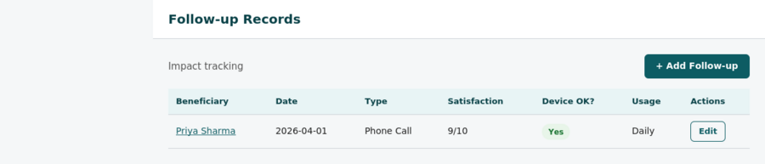
Step 1: Click "Follow-ups" in the sidebar, then "+ Add Follow-up".
Step 2: Select the Beneficiary and fill in: Date, Type (Phone Call/Home Visit/Online), Device Working status, Usage Frequency, Satisfaction Rating (1-10), any Challenges, Success Story, and whether the beneficiary Needs Support.
Step 3: Click "Save".

Tip: Success stories entered here appear in the Impact Assessment report and can be included in quarterly reports to donors.

12. Budget Management
Track all program expenditures by category, quarter, and vendor.
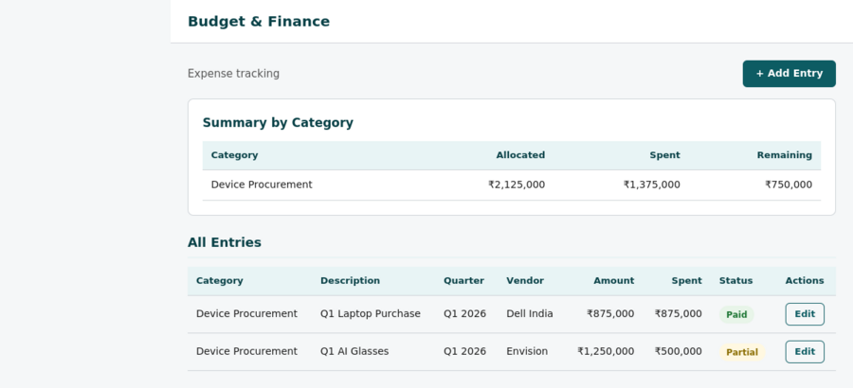
Step 1: Click "Budget" in the sidebar, then "+ Add Budget Entry".
Step 2: Select Category (Device Procurement/Training/Operations/Travel/Events), enter Description, Quarter, Allocated Amount, Spent Amount, Vendor, Payment Status, Invoice Number.
Step 3: Click "Save".
The budget page shows a summary at the top with allocated, spent, and remaining amounts by category.

13. Milestones Tracking
Track progress against 2026 annual targets. The system comes pre-loaded with 8 milestones.
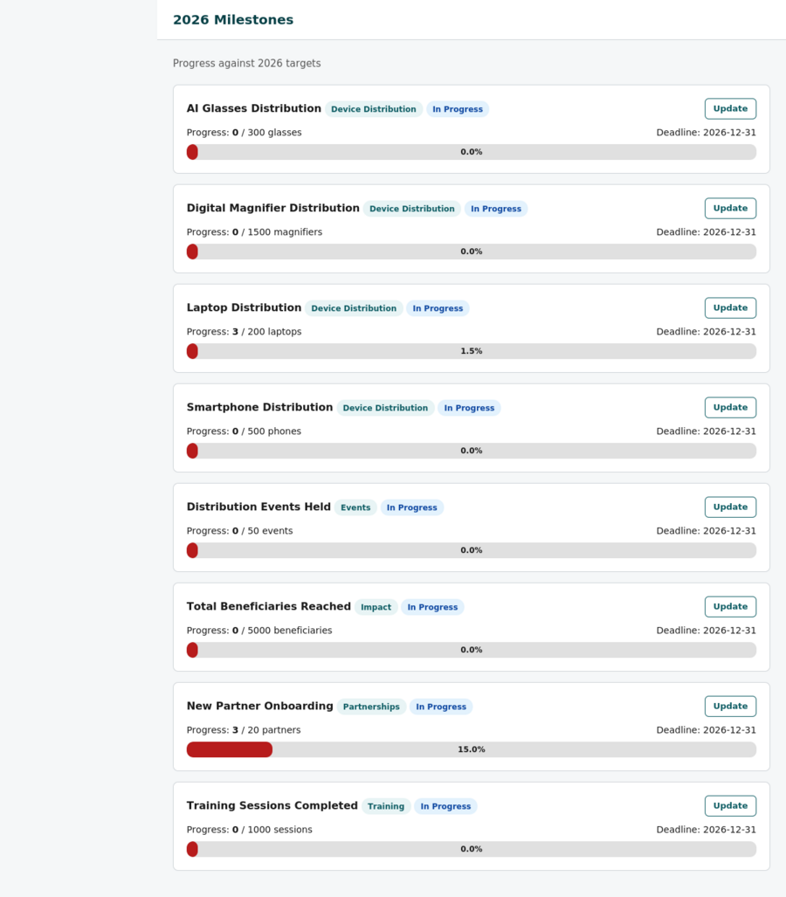
Step 1: Click "Milestones" in the sidebar.
Step 2: You will see all milestones with visual progress bars.
Step 3: Click "Update" on any milestone to update the current value.
Step 4: The progress bar and percentage update automatically.

Pre-loaded 2026 milestones: 200 Laptops, 500 Smartphones, 300 AI Glasses, 1500 Digital Magnifiers, 20 New Partners, 1000 Training Sessions, 50 Events, 5000 Beneficiaries.

14. Reports & Data Export
Generate professional reports and export data in multiple formats.
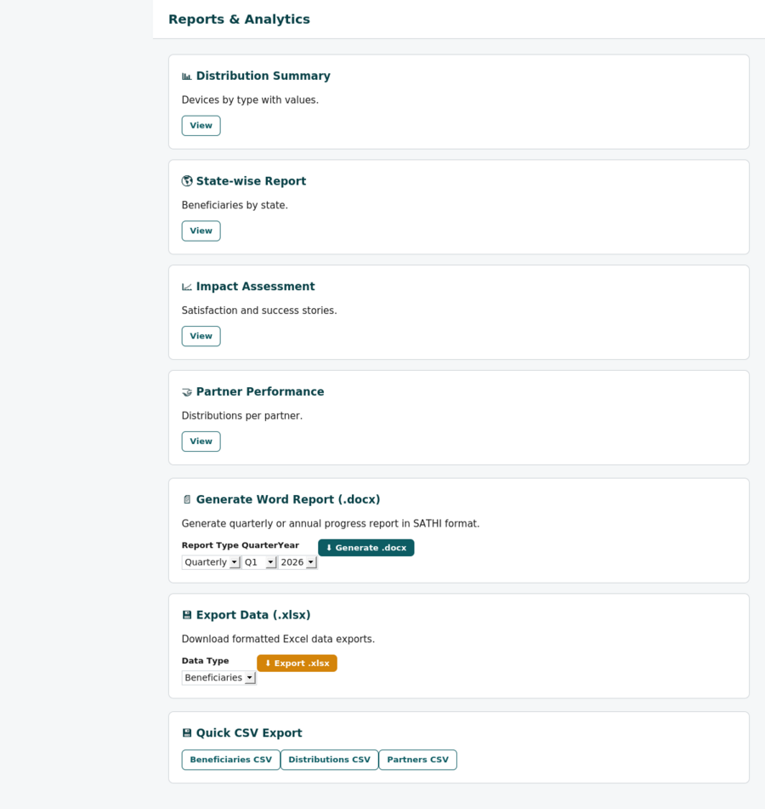

Online Reports
Click any report card to view it in the browser:
- • Distribution Summary - Devices by type with counts and values
- • State-wise Report - Beneficiaries and distributions by state
- • Impact Assessment - Satisfaction ratings, usage data, and success stories
- • Partner Performance - Distributions and beneficiaries per partner

Generate Word Report (.docx)
Step 1: On the Reports page, find the "Generate Word Report" section.
Step 2: Select Report Type (Quarterly or Annual), Quarter, and Year.
Step 3: Click "Generate .docx". A Word document will download in the SATHI report format with title page, summary, device tables, beneficiary data, partner info, impact assessment, milestones, and budget sections.

Export Data to Excel (.xlsx)
Step 1: On the Reports page, find the "Export Data" section.
Step 2: Select Data Type: Beneficiaries, Distributions, Partners, Inventory, or Budget.
Step 3: Click "Export .xlsx". A formatted Excel spreadsheet will download.

Quick CSV Export
For quick data exports, use the CSV buttons at the bottom of the Reports page for Beneficiaries, Distributions, or Partners data.

15. Activity Log
Every action in the system is automatically logged for audit purposes.
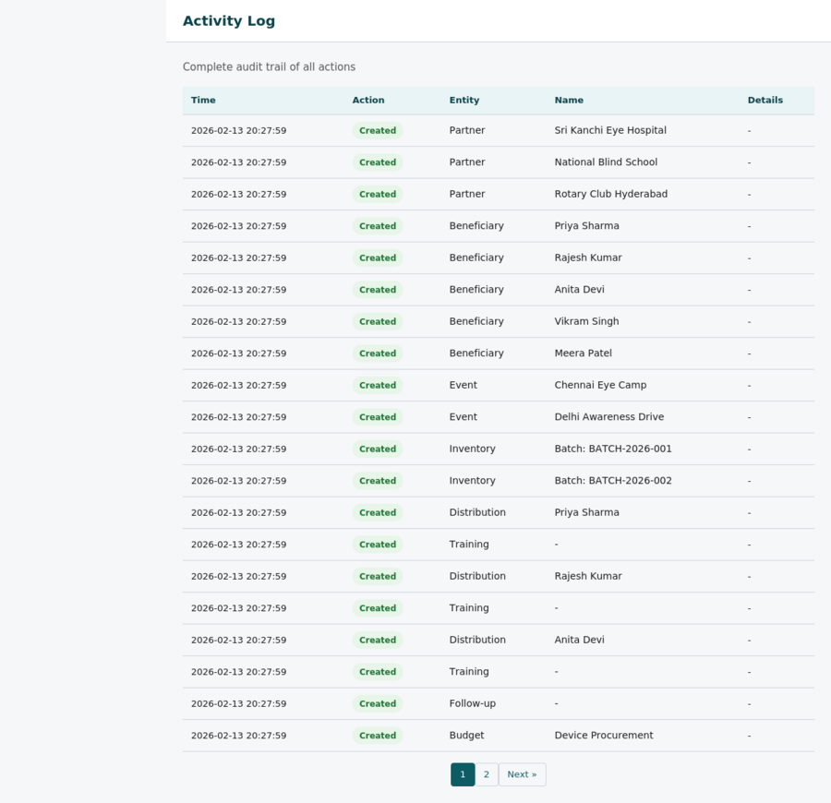

The activity log shows: timestamp, action type (Created/Updated/Deleted/Uploaded), entity type (Partner/Beneficiary/Event etc.), entity name, and details. This is useful for tracking who did what and when.

16. Tips & Best Practices
Data Entry Order: Add Partners first, then Beneficiaries (so you can link them), then Events, then Inventory, and finally Distributions.
Bulk Upload: Use the Excel upload feature for large batches of beneficiaries. Download the template first, fill it in, then upload.
Regular Updates: Update milestone current values regularly to keep the dashboard progress bars accurate.
Follow-ups: Record follow-ups within 30 days of distribution to capture early impact data.
Success Stories: Collect detailed success stories during follow-ups — they appear in reports and are valuable for donor communications.
Backups: The database is stored in sathi.db in the application folder. Copy this file regularly for backups.
Password: Change the default password in config.py before sharing the system with others.
Reports: Generate quarterly reports at the end of each quarter. The Word report follows the same format used in previous SATHI reports to the Janki Foundation.

Getting Help
For technical support or feature requests, contact the Vision-Aid technology team.

