BATTERY MANAGEMENT SYSTEM IN ELECTRIC VEHICLE

VOLTAGE DIVIDER CIRCUIT - (HEART OF THE PROJECT)

ARDUINO UNO BOARD - (BRAIN OF THE PROJECT)

WHAT IS VOLTAGE DIVIDER CIRCUIT ?

The Circuit

The circuit used is a simple two-resistor voltage divider. The circuit will take the input voltage from the battery pack and convert it to a lower voltage that can be read by a microcontroller, in this case an Arduino.

This is a schematic of the circuit used:

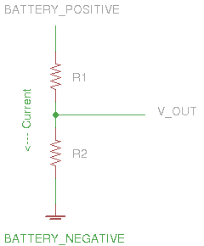

Circuit Operation

This circuit is called a voltage divider. This is because the total voltage applied to the circuit is divided between two resistors. The amount of voltage that each resistor sees is determined by the resistor value. The voltage across each resistor is called voltage drop and is determined by the following formula:

VR2 = (R2/(R1+R2)) * Vin

Where:

VR2 is the voltage "dropped" across R2 from the node labeled "V_OUT" to ground

R2 is the value of R2 is Ohms

R1 is the value of R1 in Ohms

Vin is the battery voltage

The above formula that the amount of voltage across R2 is determined by it's value as a ratio of R1 and R2 combined. If both of the resistors are the same value then the voltage drop on R2 will be the same as the voltage drop on R1. As the battery voltage varies, the output voltage will vary proportionately. This is the property of the voltage divider that will be used to safely read a battery voltage. measure voltage of multiple batteries connected in string/array in series or parallel combination with microcontrollers.

Measuring an individual battery voltage or a whole bank of battery using any microcontroller(arduino, microship pic, Avr, Atmega, Intel, NXP, stm32)is an easy task. You can find many tutorials on internet on how to do so. But what about if we want to measure an individual battery connected to a cluster of batteries in series or parallel combination. Now its a hard task to accomplish. But still their are some cleaver ways to do so. In this post i am going to enlist some of the ways through which we can measure individual battery voltage which is a part of series or parallel connected string/array of batteries.

DIAGRAMS

