CHAPTER 1: DESIGN APPROACH

1.1 Objectives
- To design and synthesis a CPU using Verilog HDL and state-of-art CAD techniques.
- To perform system level design, applying the hierarchical modular methodology.
- To carry out independent study and experience team work dynamics.

1.2 Specifications
The CPU is a simple 8-bit processor with 8-bit address bus. The architecture is based on accumulator-based design. The instruction set is grouped into few categories which is shown as below:

1. Data manipulation
a. | ADD X | Add the value in memory to the accumulator.
b. | SUB X | Subtract the value in memory to the accumulator.
c. | XOR X | Perform Exclusive-OR logic operation on the value in memory to the accumulator.
d. | AND X | Perform AND logic operation on the value in memory to the accumulator.
e. | ADR | Add between registers.

2. Data transfer
a. | MVI | Move the immediate data to the specified register.
b. | MVD | Move the specified memory data to the specified register.
c. | MOV | Move data between registers.
d. | LDA X | Load the memory data to the accumulator.
e. | STA X | Load the accumulator to the memory data.

3. Program control
a. | BRN X | Branch if the value in the accumulator is negative.
b. | JMP X | Jump to a specified address.

6. Shifting
a. | SHR | Shift one bit of the register to the right.
b. | SHL | Shift one bit of the register to the left.

5. Miscellaneous
a. | HALT | Stay no operation.
b. | NOP | No operation until next instruction.

1.3 Machine’s Memory and Registers.
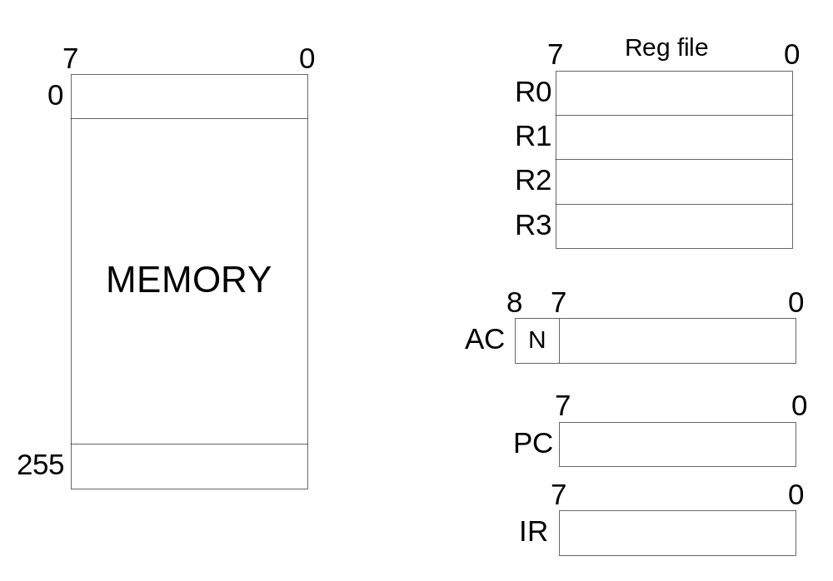
1.4 Instruction Set and Format
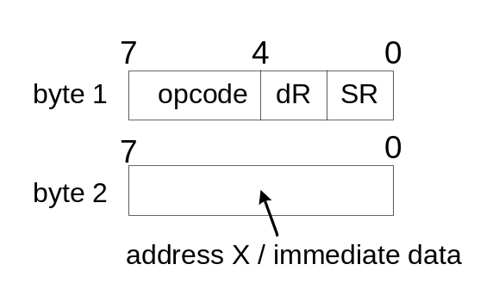
Bits | Description
Bit 7-4 of byte 1 | The bit 7-4 of the byte 1 is the opcode. The opcode determines the operations to be done.
Bit 3-2 of byte 1 | The bit 3-2 of the byte 1 is the destination register, dR. The destination register is register that store the value after the specified operation.
Bit 1-0 of byte 1 | The bit 1-0 of the byte 1 is the source register, SR. The value in source register is used as source for certain operations.
Byte 2 | Byte 2 is the address of X or immediate data depends on the operation.

1.5 Instruction Table
Instruction Byte |  |  | Instruction | dR | sR | Operation
Opcode | dR | SR
0000 | 00 | 00 | ADR | R0 | R0 | R0 | ← | R0 | + | R0
0000 | 00 | 01 | ADR | R0 | R1 | R0 | ← | R0 | + | R1
0000 | 00 | 10 | ADR | R0 | R2 | R0 | ← | R0 | + | R2
0000 | 00 | 11 | ADR | R0 | R3 | R0 | ← | R0 | + | R3
0000 | 01 | 00 | ADR | R1 | R0 | R1 | ← | R1 | + | R0
0000 | 01 | 01 | ADR | R1 | R1 | R1 | ← | R1 | + | R1
0000 | 01 | 10 | ADR | R1 | R2 | R1 | ← | R1 | + | R2
0000 | 01 | 11 | ADR | R1 | R3 | R1 | ← | R1 | + | R3
0000 | 10 | 00 | ADR | R2 | R0 | R2 | ← | R2 | + | R0
0000 | 10 | 01 | ADR | R2 | R1 | R2 | ← | R2 | + | R1
0000 | 10 | 10 | ADR | R2 | R2 | R2 | ← | R2 | + | R2
0000 | 10 | 11 | ADR | R2 | R3 | R2 | ← | R2 | + | R3
0000 | 11 | 00 | ADR | R3 | R0 | R3 | ← | R3 | + | R0
0000 | 11 | 01 | ADR | R3 | R1 | R3 | ← | R3 | + | R1
0000 | 11 | 10 | ADR | R3 | R2 | R3 | ← | R3 | + | R2
0000 | 11 | 11 | ADR | R3 | R3 | R3 | ← | R3 | + | R3
0001 | 00 | 01 | MOV | R0 | R1 |  | R0 | ← | R1
0001 | 00 | 10 | MOV | R0 | R2 |  | R0 | ← | R2
0001 | 00 | 11 | MOV | R0 | R3 |  | R0 | ← | R3
0001 | 01 | 00 | MOV | R1 | R0 |  | R1 | ← | R0
0001 | 01 | 10 | MOV | R1 | R2 |  | R1 | ← | R2
0001 | 01 | 11 | MOV | R1 | R3 |  | R1 | ← | R3
0001 | 10 | 00 | MOV | R2 | R0 |  | R2 | ← | R0
0001 | 10 | 01 | MOV | R2 | R1 |  | R2 | ← | R1
0001 | 10 | 11 | MOV | R2 | R3 |  | R2 | ← | R3
0001 | 11 | 00 | MOV | R3 | R0 |  | R3 | ← | R0
0001 | 11 | 01 | MOV | R3 | R1 |  | R3 | ← | R1
0001 | 11 | 10 | MOV | R3 | R2 |  | R3 | ← | R2
0010 | 00 | xx | SHR | R0 |  | R0 | ← | R0 | >> | 1
0010 | 01 | xx | SHR | R1 |  | R1 | ← | R1 | >> | 1
0010 | 10 | xx | SHR | R2 |  | R2 | ← | R2 | >> | 1
0010 | 11 | xx | SHR | R3 |  | R3 | ← | R3 | >> | 1
0011 | 00 | xx | SHL | R0 |  | R0 | ← | R0 | << | 1
0011 | 01 | xx | SHL | R1 |  | R1 | ← | R1 | << | 1
0011 | 10 | xx | SHL | R2 |  | R2 | ← | R2 | << | 1
0011 | 11 | xx | SHL | R3 |  | R3 | ← | R3 | << | 1
0100 | xx | xx | ADD X |  |  | AC ← AC + M[X]
0101 | xx | xx | SUB X |  |  | AC ← AC - M[X]
0110 | xx | xx | XOR X |  |  | AC ← AC XOR M[X]
0111 | xx | xx | AND X |  |  | AC ← AC AND M[X]

Instruction Byte |  |  | Instruction | dR | sR | Operation
Opcode | dR | SR
1000 | 00 | xx | MVI dR,# | R0 |  | R0 ← immDATA
1000 | 01 | xx | MVI dR,# | R1 |  | R1 ← immDATA
1000 | 10 | xx | MVI dR,# | R2 |  | R2 ← immDATA
1000 | 11 | xx | MVI dR,# | R3 |  | R3 ← immDATA
1001 | 00 | xx | MVD dR,X | R0 |  | R0 ← M[X]
1001 | 01 | xx | MVD dR,X | R1 |  | R1 ← M[X]
1001 | 10 | xx | MVD dR,X | R2 |  | R2 ← M[X]
1001 | 11 | xx | MVD dR,X | R3 |  | R3 ← M[X]
1010 | xx | xx | LDA X |  |  | AC ← M[X]
1011 | xx | xx | STA X |  |  | M[X] ←AC
1100 | xx | xx | BRN X |  |  | AC[8]=1, PC ← AR
1101 | xx | xx | JMP X |  |  | PC ← AR
1110 | xx | xx | HALT
1111 | xx | xx | NOP |  |  | PC ← PC + 1

  - RTL Control Algorithm (top-level) of CPU

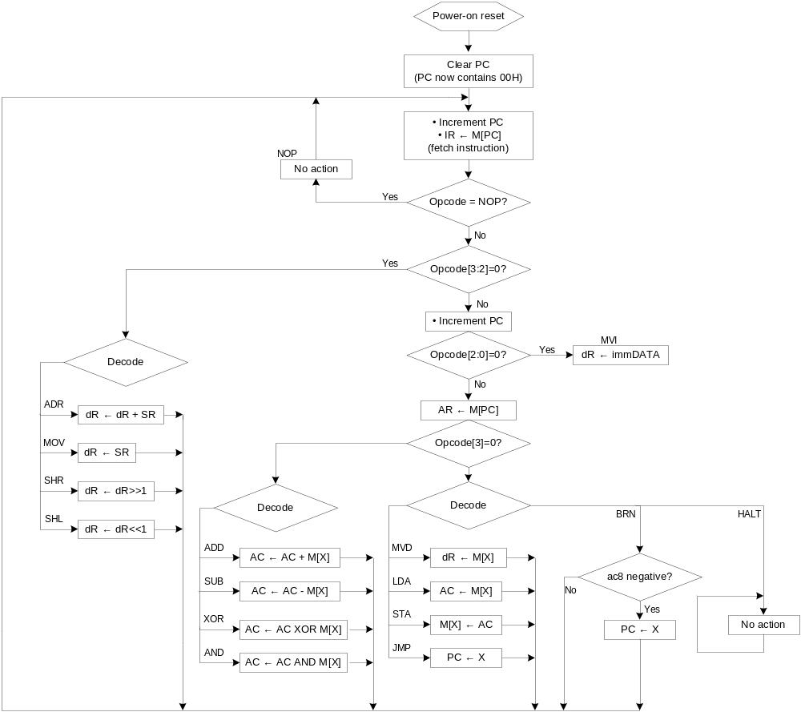

  - RTL Control Algorithm (functional level)

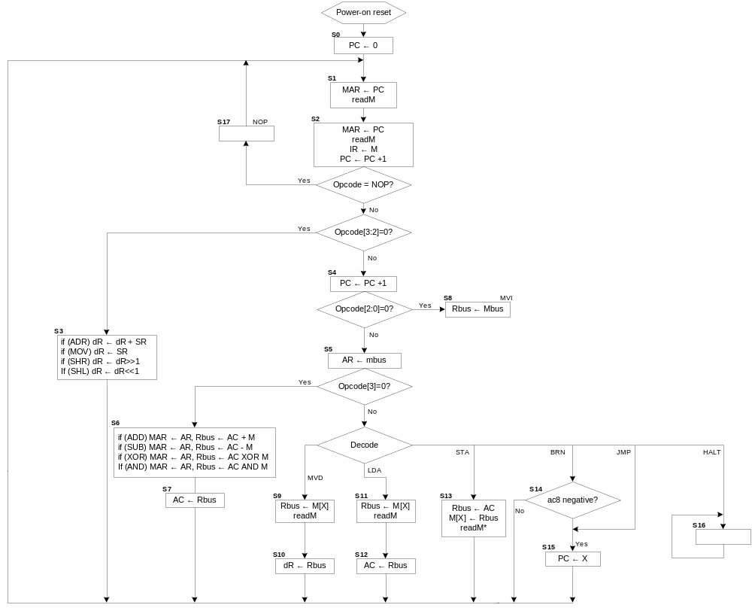

1.8 RTL Architecture of CPU
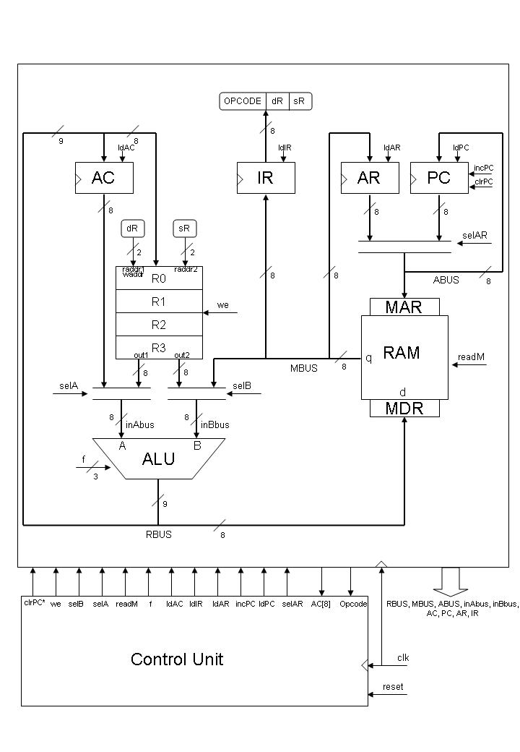
1.9 RTL-CS table
