CHAPTER 2: SUBMODULE DESIGN

  - PC Counter Module

    - Specification
The PC counter is build of the ordinary counter module. The number that PC counter can count is N-bits of numbers. The length of the count can be set by defining the parameter of N. This PC counter can load new count by giving the data and the load signal. In order to increase the number of counter, the input inc need to be asserted high. In order to reset the counter, an input of rst is created.

2.1.2 I/O Block Diagram
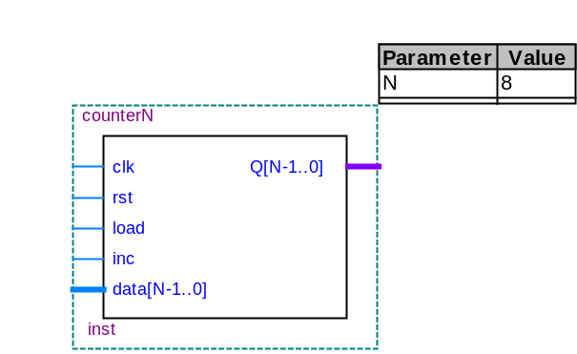

2.1.3 Functional Block Diagram

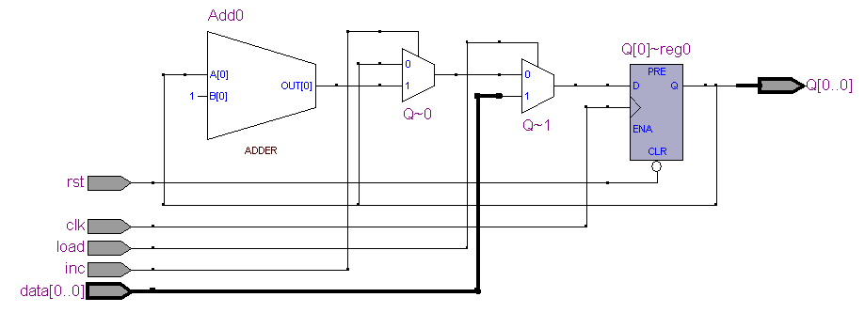

    - Verilog HDL Code

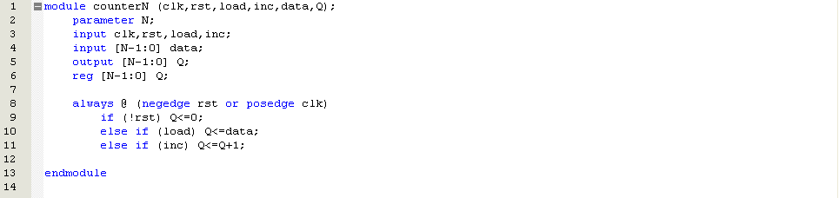

    - Timing Simulation

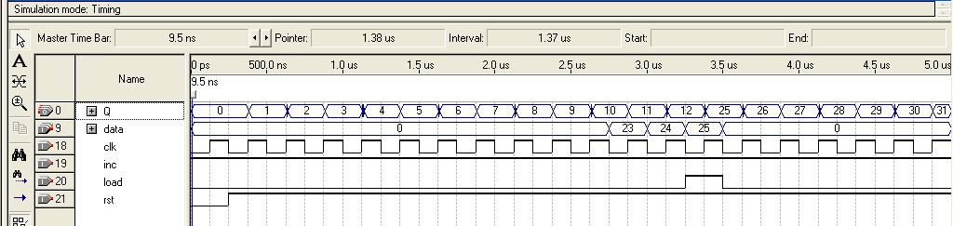
The PC Counter count when inc is asserted high

Load new counter value when load is asserted high
Reset, counter start with ‘0’

    - Conclusion

For simulation purpose, the N is set at 8. The PC Counter is created and compile successfully. It is a part of the Data Path Unit.

  - Arithmetic Logic Unit Module

    - Specification
The Arithmetic Logic Unit will perform several arithmetical and logical functions. This module will receive input from input A and input B in 8 bits format. The result will be in 9 bits format because it is to detect the negative of value after arithmetical or logical function. This module can produce function of Adder, Subtractor, AND get, XOR get, pass B, pass A, Shift Left and Shift Right. The Shift Left and Shift Right function is for input A. The functions of this module are controlled by the control signal f which consists of 3 bits.

    - I/O Block Diagram
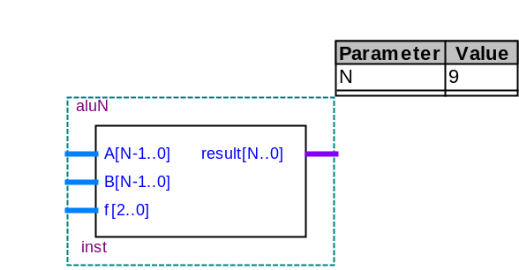

    - Functional Block Diagram

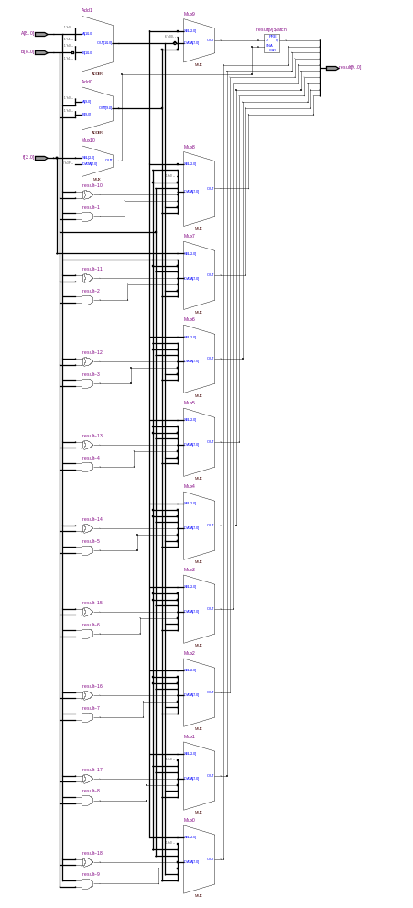
    - Verilog HDL Code

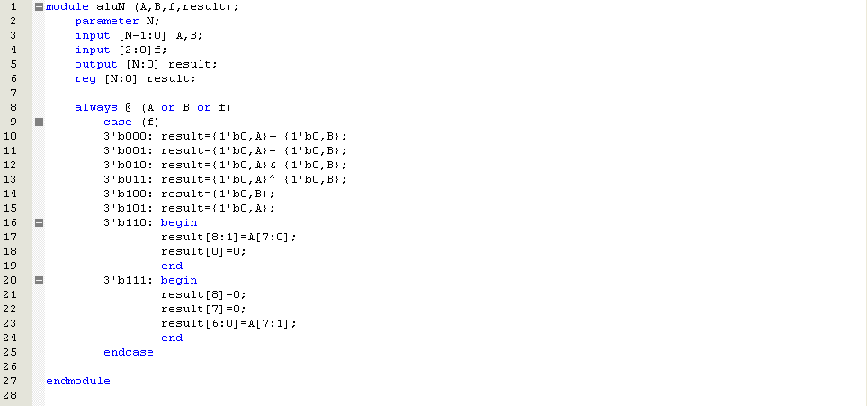

    - Timing Simulation

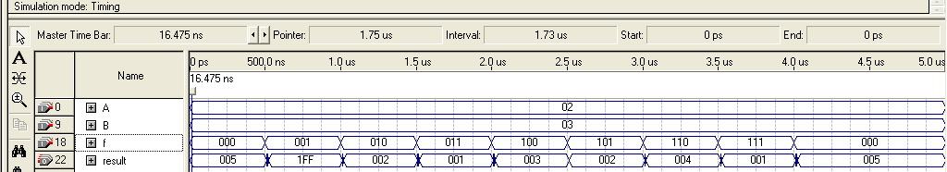

f₂ | Functions | A₁₆ | B₁₆ | Result₁₆ | Condition
000  001  010  011  100  101  110  111 | A+B  A-B  A AND B  A XOR B  Pass B  Pass A  SHL A  SHR A | 02  02  02  02  02  02  02  02 | 03  03  03  03  03  03  03  03 | 005  1FF (-1₁₀)  002  001  003  002  004  001 | Correct  Correct  Correct  Correct  Correct  Correct  Correct  Correct

    - Conclusion
For simulation purpose, the N is set for 8. The Arithmetic Logic Unit is build, compiled and simulated successfully. This module will be joined with other modules to create the Data Path unit.

  - Register Module

    - Specification
The register is needed to create the Accumulator Register, Instruction Register and Address Register. The register will hold the pervious value until a signal is sent to load the value. In order to load the new value to the register, the signal load needs to be asserted high. Then, the new data is connected to the input data. The output will be at the signal Q. There are signal rst and pst which stands for reset and preset. Both of the signal is active-low.

    - I/O Block Diagram
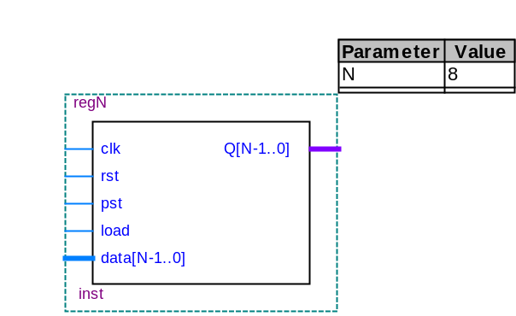

    - Functional Block Diagram

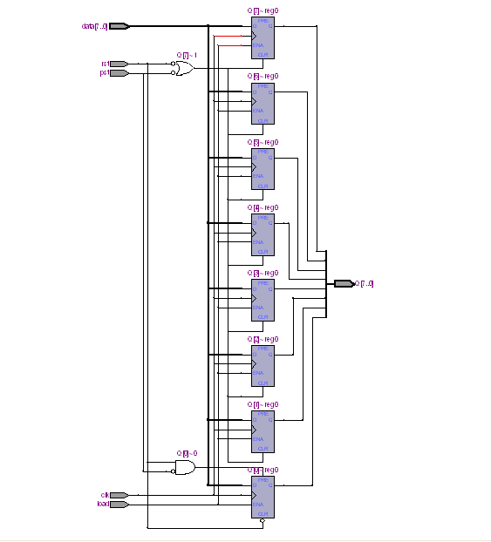

    - Verilog HDL Code

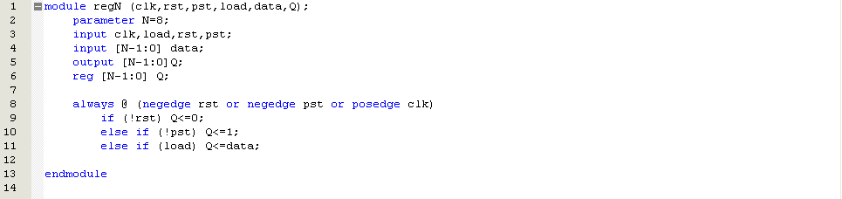

    - Timing Simulation

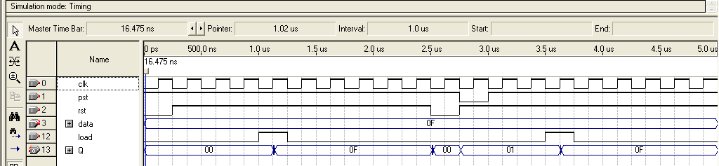
New data loaded and hold
New data loaded and hold
Reset the register
Data hold as 00
Signal to load new data
Reset and preset register
Signal to load new data
Data hold as 01

    - Conclusion
For simulation purpose, the N has been set as 8. The result of the register is as expected with little glitches. The circuit work as desired.

  - Register File Module

    - Specification
The regfile is similar to a Random-Access-Memory (RAM). The regfile can read or write data to a particular address. This regfile contains 4 addresses. The regfile is used to store data of Destination Register (dR) and Source Register (sR). In order to write data, the signal ‘we’ needs to be asserted high. The signal waddr will determine the address of data to be written. The signal raddr1 will determine the address of the data to send to Dout1 while signal raddr2 will select the address for the output data of Dout2.

2.4.2 I/O Block Diagram
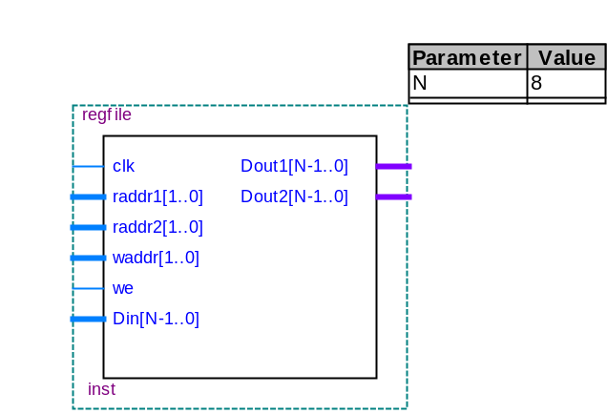

2.4.3 Functional Block Diagram

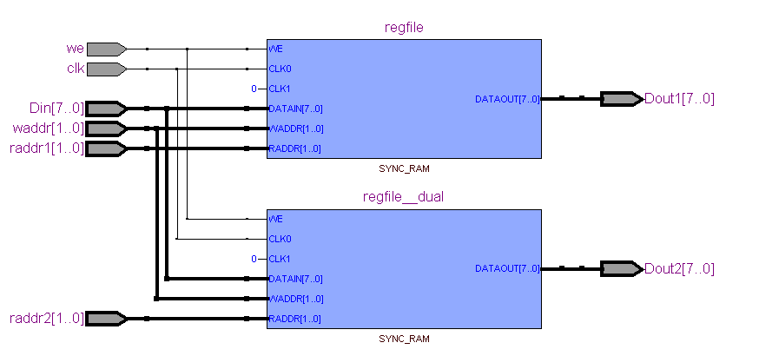

    - Verilog HDL Code

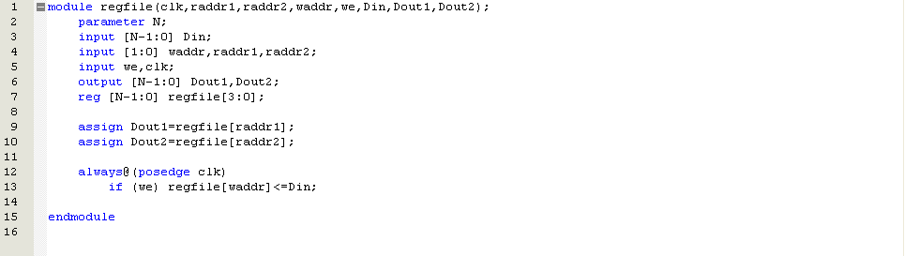

    - Timing Simulation

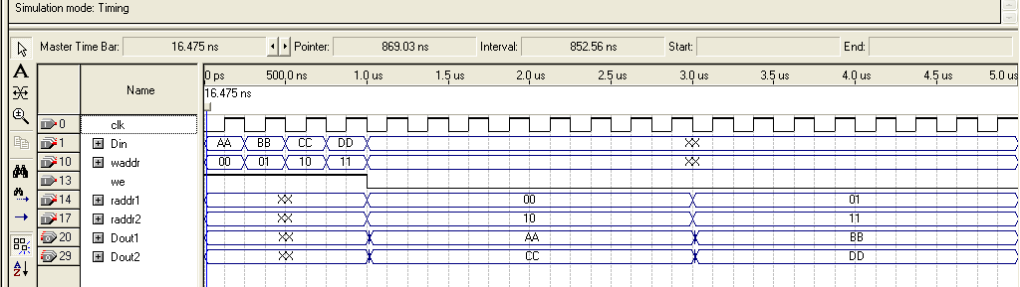
Data is read
Data is stored

Write/Read | Waddr₂ Address |  | Raddr1₂ Address |  | Raddr2₂ Address |  | Value₁₆
Write  Write  Write  Write  Read  Read  Read  Read | 00  01  10  11  xx  xx  xx  xx | R0  R1  R2  R3  xx  xx  xx  xx | xx  xx  xx  xx  00  01  xx  xx | xx  xx  xx  xx  R0  R1  xx  xx | xx  xx  xx  xx  xx  xx  10  11 | xx  xx  xx  xx  xx  xx  R2  R3 | AA  BB  CC  DD  AA  BB  CC  DD

    - Conclusion

For simulation purpose, the N is set at 8. The regfile is created and compile successfully. The simulation result is as expected. The regfile is a part of Data Path Unit.

  - Random-Access-Memory (RAM) Module

    - Specification
The Random-Access-Memory (RAM) can read or write data to a particular address. The RAM contains Memory Data Register (MDR) and Memory Address Register (MAR). This RAM contains 8 bits of data register and address register. So, the address is from 00₁₆-FF₁₆. In order to load a data, the address of the data needed to be determined. In order to write data, the signal ‘we’ needs to be asserted high. The signal ‘addr’ will determine the address of data to be written or read. The input signal ‘D’ work as the input to store data into memory. The output of RAM is signal ‘Q’. The RAM module utilizes the Memory Library of Altera and read/write data into .mif file.

    - I/O Block Diagram

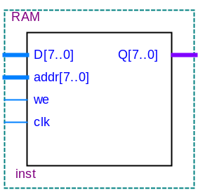

2.4.3 Functional Block Diagram

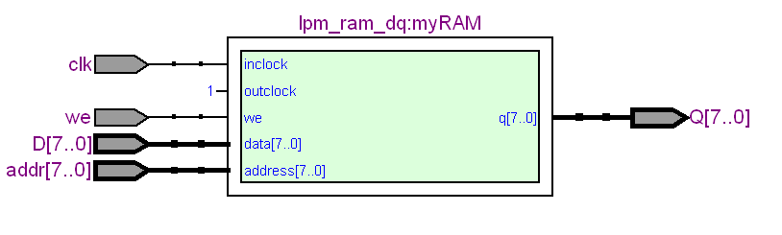

    - Verilog HDL Code

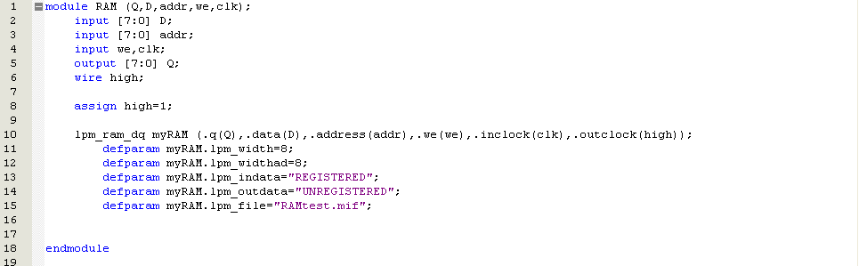

    - Timing Simulation

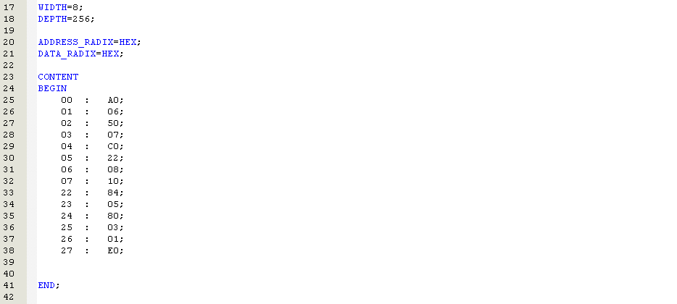

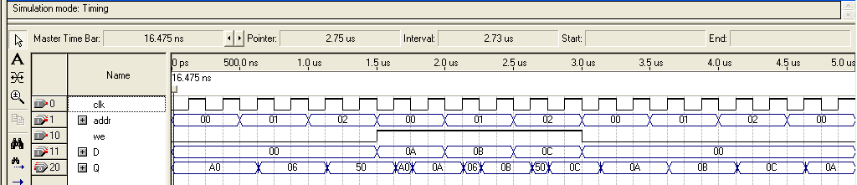
Data is read from $00,$01,$02
Data is stored into $00,$01,$02
Data is read again from $00,$01,$02

Write/Read | Address₁₆ | Value₁₆
Read  Read  Read  Write  Write  Write  Read  Read  Read | 00  01  02  00  01  02  00  01  02 | A0  06  50  0A  0B  0C  0A  0B  0C

    - Conclusion

The RAM module is created and compiled successfully. The simulation result is as expected. The RAM can read and store data as desired.

- DATA PATH UNIT AND CONTROL UNIT MODULE DESIGN

  - Data Path Unit Module

    - Specification
The Data Path Unit is built of PC Counter, Accumulator, Instruction Register, Address Register, Register File, Random-Access-Memory and Arithmetic Logic Unit. Besides, there are MBUS, RBUS, ABUS, inAbus and inBbus. The BUSes are for determining the appropriate data to load. The MBUS is the memory bus from RAM, RBUS is the result bus from ALU and ABUS is the address bus from AR and PC Counter. The inAbus can load data from AC or Regfile while the inBbus load data from MBUS or Regfile. The RTL Architecture can be viewed at the beginning of this report.
The Data Path Unit receives Control Vector from Control Unit and start to process the data. The AC is sent to Control Unit to process the negative value condition.

3.1.2 I/O Block Diagram

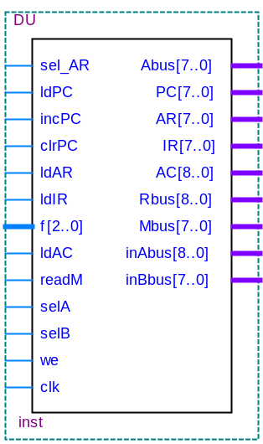

3.1.3 Functional Block Diagram

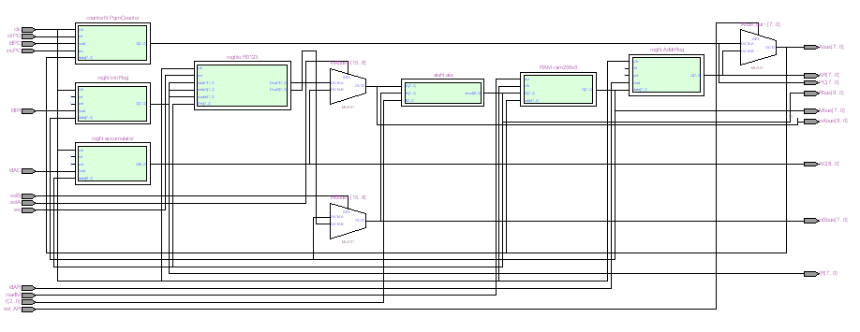
    - Verilog HDL Code

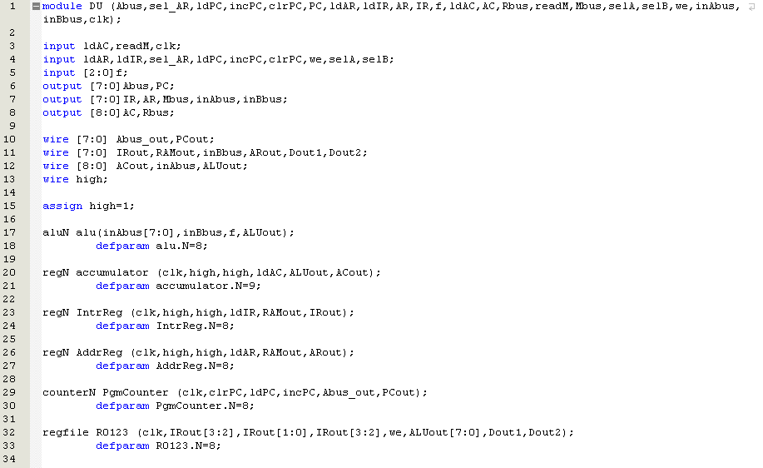
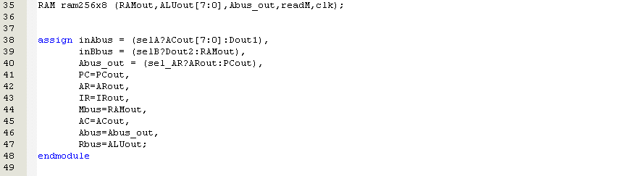

    - Timing Simulation

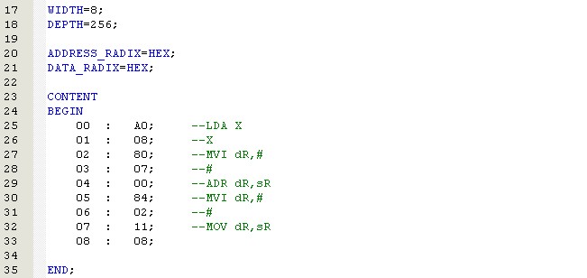
Value to retrieve for LDA $08
IR
AC
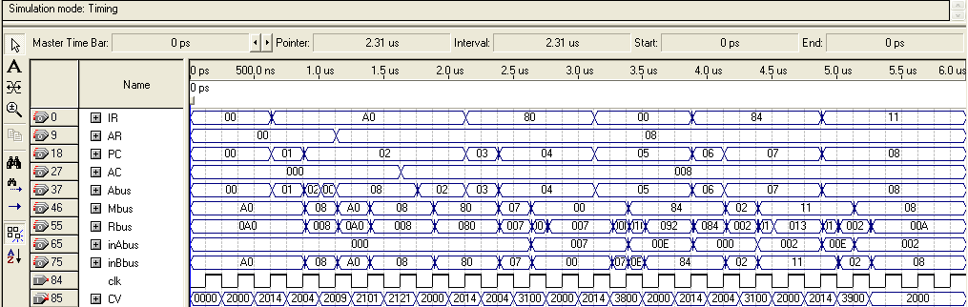
LDA X
MVI dR,#
ADR dR,SR
MOV dR,SR
MVI dR,#
Final result of R0

IR | AR/# | Command | AC | R0 R1 R2 R3
$A0  $80  $00  $84  $11 | $08  $07  -  $02  - | LDA $08  MVI R0, #$07  ADR R0, R0  MVI R1, #$02  MOV R0, R1 | $08  $08  $08  $08  $08 | $00 $00 $00 $00  $07 $00 $00 $00  $0E $00 $00 $00  $0E $02 $00 $00  $02 $02 $00 $00

    - Conclusion

The Data Path Unit is created and compile successfully. The simulation result is as expected. This Data Path Unit module will then connect to the Control Unit module in order to create the Central Processing Unit.

  - Control Unit Module

    - Specification
The Control Unit, CU determines the sequence of data processing and operations performed by the data path. The CU consists of 17 states and is designed to control the 14 bits control vector. The function of each control bits is shown below:

No | Control bit | function
 | clrPC | Clear the program counter (active low).
 | we | Write enable for the register file.
 | selB | Selector for the multiplexer
 | selA | Selector for the multiplexer
 | readM | Read enable for the memory block (active low).
 | f[2:0] | Control of the ALU.
 | ldAC | Load accumulator.
 | ldIR | Load the instruction register.
 | ldAR | Load the address register.
 | incPC | Increase the program counter by 1.
 | ldPC | Load the program counter.
 | selAR | Selector for the multiplexer

3.2.2 I/O Block Diagram

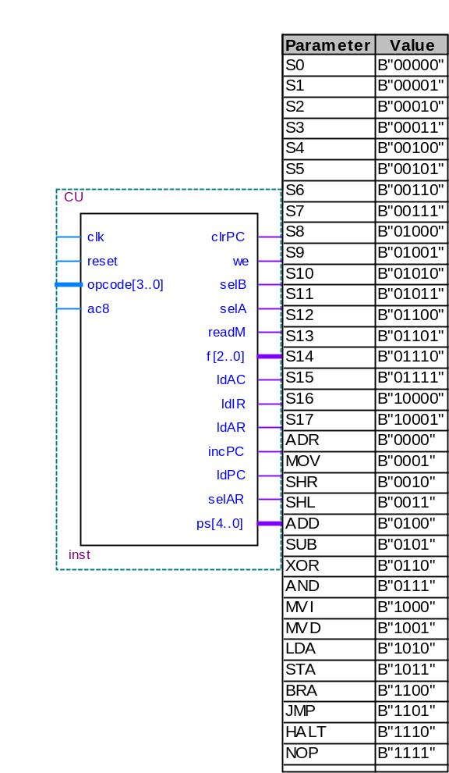
3.2.3 Functional Block Diagram

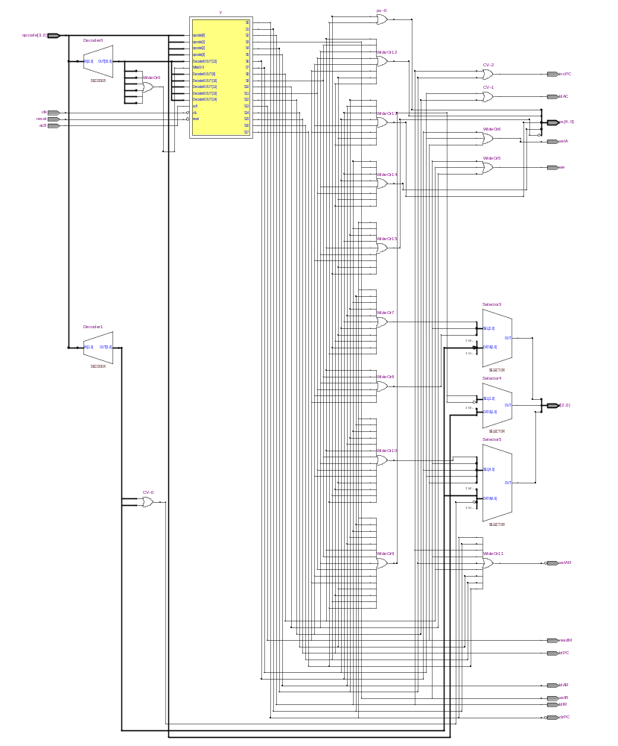

    - Verilog HDL Code

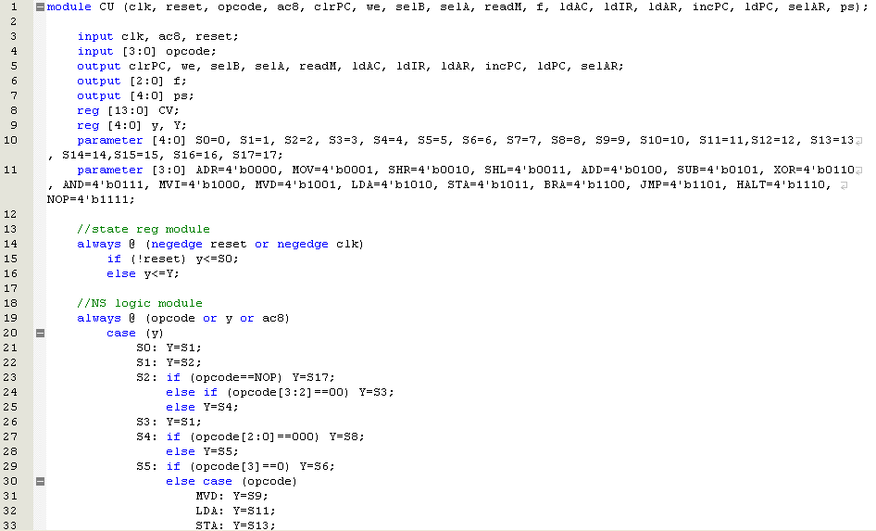
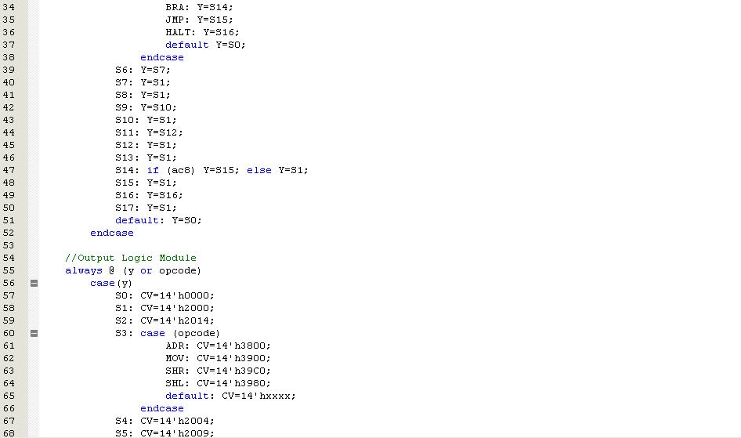
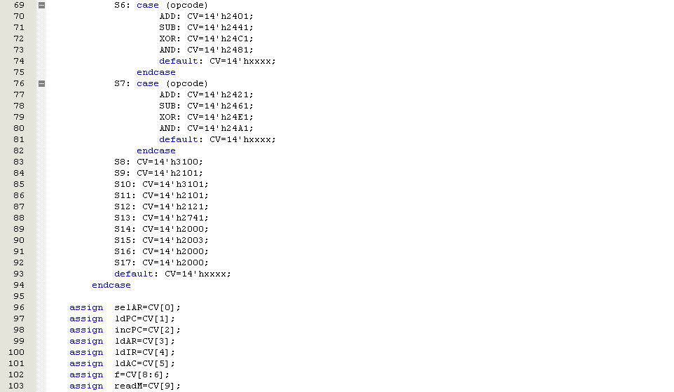
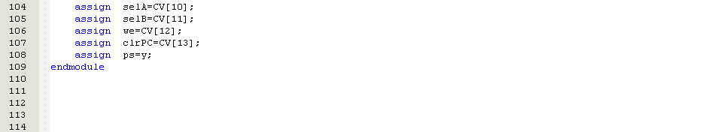

    - Timing Simulation

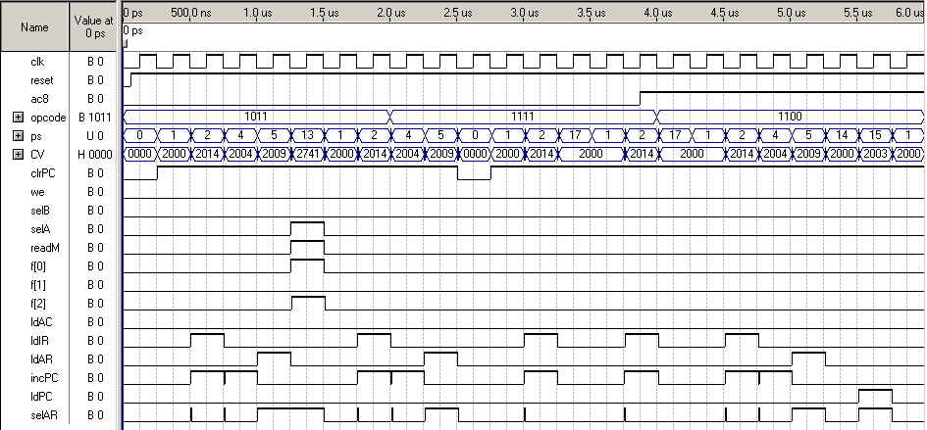
When the opcode is 1011, the operation is STA. So, the state flow is S1→S2→S4→S5→S13. When it is in S13, the CV is 14’h2741.
When the opcode is 1111, the operation is NOP. So, the state flow is S1→S2→S17 and go back to S1 again.
When the opcode is 1100, the operation is BRN. So, the state flow is S1→S2→S4→S5→S14. At S14, ac8 is checked. Since ac8 is high or AC is negative, it will come to S15 with CV 14’h2003.

    - Conclusion

The Control Unit is created and compile successfully. The simulation result is as expected. This Control Unit module will then connect to the Datapath Unit module to control it. Combination of the Datapath Unit and Control Unit forms the Central Processing Unit.

  - Central Processing Unit Module

    - Specification
The Central Processing Unit (CPU) consists of Data Path Unit module and Control Unit module. The CPU will receive clock and the Power-On-Reset as the input signal. A program is preloaded in the RAM. Once the Power-On-Reset is asserted, it will run the program starting at address $00. The output cpuAC will display the Accumulator value while cpuPC will display the Program Counter value. In addition, the cpuAR and cpuIR will display the Address Register and Instruction Register respectively when the program runs. The output signal cpuMBUS and cpuRBUS will display the Memory Bus of RAM and Result Bus of ALU. Besides, the cpuinAbus will display the value of AC or Regfile. Similarly, cpuinBbus will display the value of MBUS or Regfile.

3.3.2 I/O Block Diagram

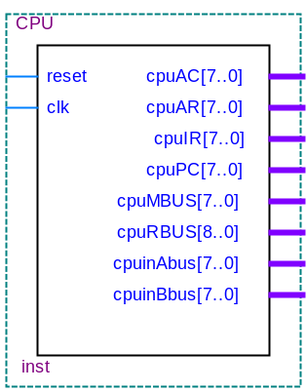

3.3.3 Functional Block Diagram

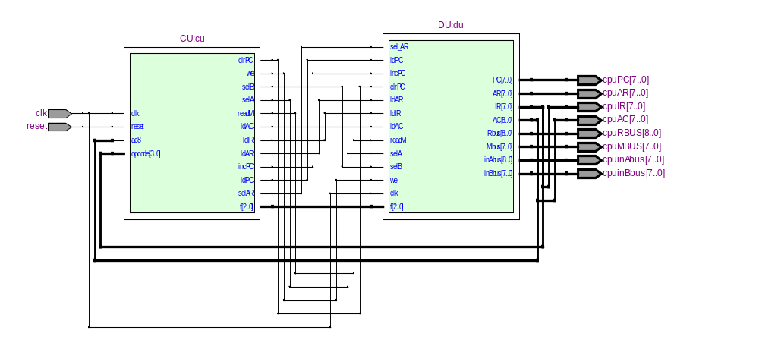

    - Verilog HDL Code

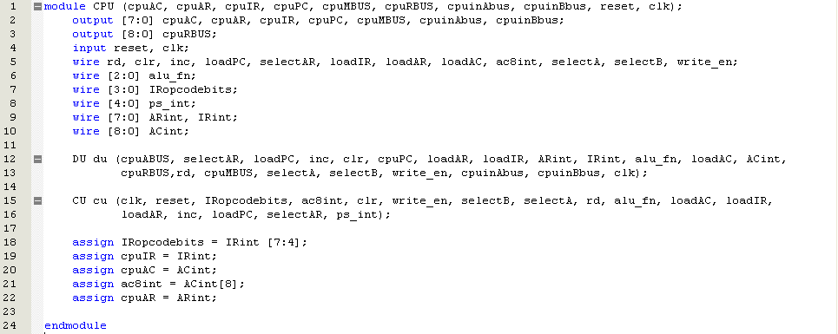

    - Timing Simulation
PC jump to $22 when detect negative
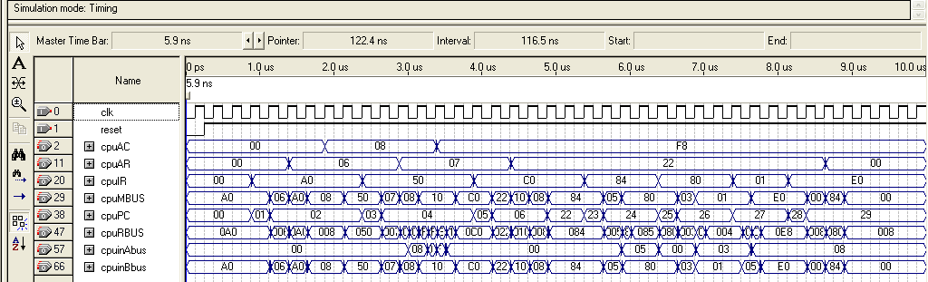
HALT
Final result of R0

PC | IR | AR/# | Command | AC | R0 R1 R2 R3
$00  $02  $04  $22  $24  $26  $27 | $A0  $50  $C0  $84  $80  $01  $E0 | $06  $07  $22  $05  $03  -  - | LDA $06  SUB $07  BRN $22  MVI R1, #$05  MVI R0, #$03  ADR R0, R1  HALT | $08  $F8  $F8  $F8  $F8  $F8  $F8 | $00 $00 $00 $00  $00 $00 $00 $00  $00 $00 $00 $00  $00 $05 $00 $00  $03 $05 $00 $00  $08 $05 $00 $00  $08 $05 $00 $00
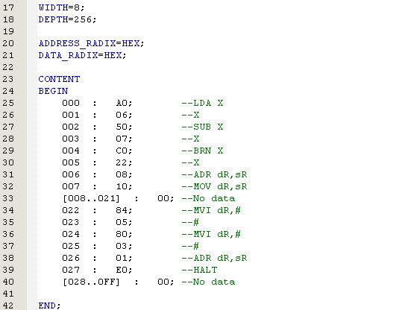
Value to retrieve for LDX $06
Value to retrieve for SUB $07
SUB $07 : 1) AC=$08
2) M[X]=$10
3) $08-$10=$F8 (-8)
4) AC=$F8
    - Conclusion

The Central Processing Unit is created and compile successfully. The simulation result is as expected. The CPU can run several operations without any problems.

