1. **Introduction**

**What is the Food Supply Chain Management (FCSM) ?**

• A food supply chain or food system refers to the processes that describe how food from a farm ends up on our tables. The processes include production, processing, distribution, consumption and disposal.

• Once harvested or produced, the food should be stored, delivered, and retailed so that they could reach to the final customers by due date.

• The food we eat reaches us via food supply chains through which food moves systematically in domino-like motion from producers to consumers while the money consumers pay for food goes to people who work at various stages along the food supply chain in the reverse direction.

• Every step of the supply chain requires human and/or natural resources.

• Because a food supply chain is domino-like, when one part of the food supply chain is affected, the whole food supply chain is affected, which is often manifested through changes in price.

**Background**

In the food supply chain, food moves from producer to consumer via the processes of production,  processing, distribution, retailing and consumption;

 thus, food moves from farmer to consumer in a  dominolike fashion.

At the same time, money that consumers pay for food moves from consumers to  producers in the reverse process, again in a dominolike fashion from  consumer to retailer to  distributor to processor to farmer.

Thus, the twosided causality that connects farmers and  consumers is mediated by these two sets of domino causalities

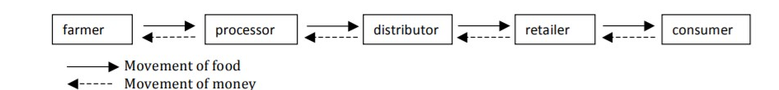

Movements of food and money in a simple food supply chain