**Theoretical Analysis:**

The front-end is connected to the back-end using smart contracts which are written in solidity to verify the blocks in the private ethereum network we have created. This is called Ganache. Ganache is responsible for storing the details of farmers, logistics and consumers into the blocks and mine them. We have kept our workspace on auto-mine mode to avoid ambiguity. The smart contracts are used to verify and store the balance ethers. Inturn, they return the remaining funds and store the variables that are given as input. The storage contract is used to store all data given and later displays for the end consumer to view.

Ganache is connected to Metamask locally. A metamask is added as an extension to chrome and an account is created. Ganache workspace is setup with the same port number as metamask to connect them. The private key is copied to import account in metamask and we obtain default of 100 ethers which are used for approving details in a blockchain.

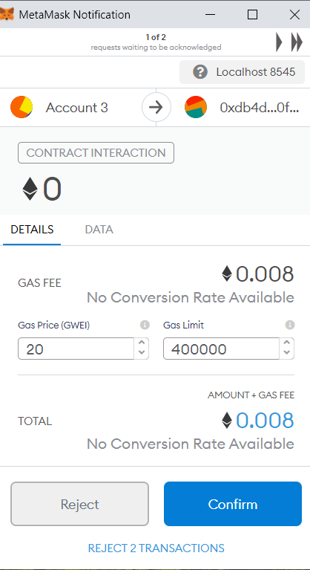

Farmer page takes in all the details and ensures that the farmer has not used any harmful fertilizers and thus remains contamination-free. A metamask pop-up ensures is used to mine blocks in the ganache and verify the details of the block. Only after confirmation, we can proceed to logistics page which shows the authorities farmer details and then these details get approved. The product which will further be sent to storage is taken into consideration and the details are taken in and stored in ganache block and mined. The end-consumer sees all these procedures and is able to understand every step of the way as all the details are furnished- from the farmer to retail to consumer.