Automated Filtration of synthetic images using a lightweight SigLIP 2 Hybrid architecture

ABSTRACT

The rapid proliferation of generative artificial intelligence has fundamentally altered the landscape of digital media authenticity. Modern AI image generators are spanning diffusion models, Generative Adversarial Networks (GANs), and multimodal systems can produce photorealistic synthetic images that are imperceptible to the unaided human eye, enabling widespread misinformation, fraud, and the erosion of digital trust. Existing detection systems, typically constructed from conventional Convolutional Neural Networks (CNNs) or computationally heavy Vision-Language Models (VLMs), suffer significant accuracy drops when confronted with complex real-world imagery, diverse artistic styles, and text overlays. The industry has largely compensated for this deficiency through multi-model ensemble architectures; however, these systems are computationally prohibitive, resource-intensive, and fundamentally too slow for real-time web deployment. This dissertation presents a novel, lightweight, single-pass hybrid AI image detector that matches the robustness of heavy ensembles while operating at a fraction of the latency. The proposed architecture isolates the spatial feature extraction capabilities of the Sigmoid Loss for Language-Image Pre-Training (SigLIP) 2 vision encoder by deliberately removing its text-processing components, thereby reducing memory footprint and inference cost. To capture fine-grained forensic details invisible at standard resolutions, the model's position embeddings are bicubically interpolated from 224×224 to 512×512. These rich deep embeddings are fused with seven explicitly computed traditional frequency and statistical forensic signals. Local Binary Patterns (LBP), Discrete Cosine Transform (DCT), Gradient Co-occurrence, Haar Wavelet Energy, Fast Fourier Transform (FFT) Power Slope, Bayer Noise Pattern, and Edge Sharpness Grid, which collectively address the blind spots of deep learning alone. A custom three-layer classification head employing Squeeze-and-Excitation (SE) style channel attention is then applied to the fused embedding to identify AI-generated artefact patterns. Evaluated on a stratified 15% held-out test split of the training dataset (1,140 images), the model achieves 96.6% accuracy, 98.9% precision, 95.3% recall, 97.0% F1-score, and a 0.992 AUC-ROC, with an inference latency of 142.4 milliseconds measured on a dual NVIDIA Tesla T4 GPU environment on Kaggle Notebook. A comparative analysis against commercial detection platforms Undetectable AI (5,230 ms) and AI or Not (920 ms) demonstrates that our architecture correctly identifies hard-negative AI-generated images misclassified as real by both commercial tools, while achieving a 6.5× and 36.7× speed advantage respectively. The model is deployed as an interactive Hugging Face Spaces application, providing accessible, real-time image verification.

Keywords: AI Image Detection, Synthetic Media, Vision-Language Models, SigLIP 2, Feature Fusion, Image Authentication.

List of Abbreviations

AI Artificial Intelligence
CNN Convolutional Neural Network
VLM Vision-Language Model
ViT Vision Transformer
GAN Generative Adversarial Network
LBP Local Binary Pattern
DCT Discrete Cosine Transform
FFT Fast Fourier Transform
SE Squeeze-and-Excitation
AUC-ROC Area Under the Receiver Operating Characteristic

INTRODUCTION

1.1 Background
The digital era has witnessed an unprecedented convergence of computational power and generative intelligence that has permanently altered the nature of visual content. Within just a few years, tools powered by diffusion models, Generative Adversarial Networks (GANs), and multimodal language-image systems have progressed from producing crude approximations of human faces to generating high-resolution, photorealistic scenes indistinguishable from photographs captured by professional cameras. Platforms such as DALL-E by OpenAI, Stable Diffusion via Leonardo AI, Google Gemini, Ideogram, and OpenAI Sora collectively produce millions of synthetic images daily, and these images now flow freely through social media feeds, news aggregators, and messaging platforms without any standardised mechanism for identification.
Such spread has far-reaching implications in society. Synthetic imagery has been already implicated in the production of non-consensual intimate imagery (NCII), faking political actions, producing fraudulent financial statements, and weakening the integrity of evidence in a legal trial. A RAND Corporation analysis (Chandra, 2024) indicates that the ills of AI-generated images lie on a spectrum of personal safety threats to geopolitical disinformation organized. Importantly, these harms cannot be reduced through the human vigilance alone: the studies of psychophysics always show that even professionals who are trained to distinguish the photographs and the AI-generated materials show near chances at the question when they are required to do so.
Automated detection systems therefore form the critical last line of defence for digital content integrity. However, the field of AI-generated image detection itself is fragmented and rapidly evolving. Early detectors built on CNNs, trained on specific GAN architectures such as ProGAN or StyleGAN, generalise poorly to newer diffusion-based generators. Heavier architectures that leverage Vision Transformers or even full Vision-Language Models offer improved robustness but at prohibitive computational cost making them unsuitable for real-time, web-scale deployment. The industry has responded by deploying ensemble systems that combine multiple independent classifiers; while effective in accuracy, ensembles multiply the inference cost and hardware requirements to levels accessible only to large corporations with dedicated GPU infrastructure.

1.2 Problem Statement
The central problem addressed by this dissertation is: how can a single-pass AI image detector achieve the accuracy and robustness of computationally expensive multi-model ensemble architectures while operating at inference speeds and resource budgets suitable for real-time web deployment? Existing state-of-the-art detectors exhibit a fundamental trade-off: accurate systems are slow and computationally heavy, while lightweight systems sacrifice too much accuracy to be practically useful. No prior work has explored leveraging the vision encoder of a Vision-Language Model that was specifically pre-trained with a pairwise sigmoid loss namely SigLIP 2 as a backbone for AI image forensics, nor has any prior system combined such a backbone with explicitly engineered traditional forensic features within a single unified classification head.

1.3 Motivation
This research has its technical and social motivation. Socially speaking, the loss of credibility in digital visual media is not only a technical inconvenience it is a core menace to the democratic speech, judicial procedure, and their own well-being. It is crucial that journalists, fact-checkers, legal experts, and regular citizens have the access to fast, accurate and freely accessible detecting tools to ensure that they navigate through an information environment full of fake-generated content.
Technically, a swift technological change in generating models has always been outpaced by the creation of effective detection countermeasures. The most recent benchmark work by Li et al. (2025) revealed that even the modern state-of-the-art sensors exhibit drastic performance decline in realistic circumstances like the JPEG compression, image resizing, and colour changes. Ren et al. (2026) also demonstrated that there is no single existing architecture which works on all benchmarks and that the training data alignment is the key performance determinant as opposed to architectural sophistication. These results indicate that architectures that mix deep learned representations with explicit, physics-founded forensic signals could provide a more resilient and general detection system than purely data-based systems.
1.4 Challenges
Several significant challenges characterise the problem of automated AI image filtration:
• Generalisation across generative paradigms: Models trained on GAN-generated images frequently fail on diffusion model outputs, as the two paradigms leave fundamentally different artefact signatures. A detector must be robust across both.
• Hard negatives: AI generators are increasingly designed with photorealism as an explicit optimisation target. Certain images particularly high-resolution outputs from models like Stable Diffusion 3 or DALL-E 3 exhibit no obvious visual artefacts and can defeat conventional detectors.
• Computational constraints: Real-time web deployment requires inference latency below approximately 200 milliseconds on commodity hardware, a threshold that current ensemble approaches exceed by an order of magnitude.
• Dataset bias: Publicly available training datasets often over-represent certain generative models (e.g., face-focused GAN datasets) and under-represent the diversity of real-world photography, leading to models that are biased in both directions.
• Resolution mismatch: Standard vision models operate at 224×224 pixels, a resolution at which many fine-grained forensic artefacts particularly in frequency statistics and noise patterns are destroyed by downsampling.
• Adversarial resilience: Image post-processing operations such as JPEG compression, resizing, and noise injection can deliberately or accidentally obscure the artefact signatures used by frequency-domain detectors.

1.5 Essence of the Approach
This dissertation proposes a hybrid forensic architecture that addresses the above challenges through three principal innovations. First, the text components of the SigLIP 2 model are surgically removed, leaving a vision-only encoder whose image-text pre-training has endowed it with richer, more semantically dense visual representations than a standard image classification model. The position embeddings of this encoder are bicubically interpolated from the standard 224×224 training resolution to 512×512, preserving fine-grained forensic details that would otherwise be lost. Second, seven traditional forensic signals derived from established signal processing and statistical principles LBP entropy, DCT Benford law deviation, gradient co-occurrence entropy, Haar wavelet diagonal energy, FFT power slope deviation, Bayer noise inter-channel correlation, and edge sharpness distribution are explicitly computed from the raw image pixels and embedded by a dedicated Multi-Layer Perceptron (MLP). These features capture physical properties of real camera images that deep learning models are known to overlook. Third, the deep embedding from the SigLIP 2 backbone and the forensic feature embedding are concatenated and passed through a custom three-layer classification head employing SE-style channel attention, which learns to weight the contribution of each feature dimension based on its relevance to the AI/real discrimination task.

1.6 Statement of Assumptions
The proposed system operates under the following assumptions:
• The input image is a standard RGB digital image in a common format (JPEG, PNG, or WebP).
• The detector is used as a binary classifier: outputs are AI-generated or Real, with no distinction between generative sub-types.
• The system is evaluated under an open-world detection scenario where the specific generative model that produced an AI image is unknown at inference time.
• Hardware availability: training was performed on dual NVIDIA Tesla T4 GPUs via Kaggle Notebooks; inference is demonstrated on CPU hardware to validate deployment feasibility.
• The training dataset, while curated from diverse sources, is not exhaustive; the system may not generalise perfectly to generative models released after the dataset collection date.

1.7 Aims and Objectives
Aim: To design, implement, and evaluate a lightweight, single-pass hybrid AI image detector that matches the accuracy of heavy ensemble models while being fast enough for real-time web deployment.

Objectives:
- Create a varied, balanced collection of 7,600 images cut across various real-life photographic sources and five different AI generative paradigms or more.
- Customize the SigLIP 2 vision encoder to forensic image classification by taking out its text blocks and the bicubical interpolating its position embeddings to 512x512 resolution.
- Develop and test a set of seven classical forensic feature extractors (texture (LBP), frequency (DCT, FFT, Haar), noise (Bayer), edge structure (Gradient Co-occurrence, Edge Sharpness) and test its discriminative power on its own.
- Train a hybrid classification structure combining deep SigLIP 2 with the traditional feature vector of forensic features via a separate SE-attention head.
- Test and bench the hybrid model on the built dataset with stratified 70/15/15 splits with an objective accuracy of greater than 95 and AUC-ROC of greater than 0.90.
- Compare the deployed model to commercial detection tools (Undetectable AI, AI or Not) on hard-negative images and show better accuracy and performance.
- Finally, deploy the trained model using Hugging Face Spaces, an interactive online application that demonstrates functionality and has an open source component for easy operational accessibility.
1.8 Organisation of the Report
The rest of this dissertation is structured in the following way. Chapter 2 provides a literature review of the existing research on deep learning, Vision Transformers, Vision-Language Models, and AI-generated image detection strategies. Chapter 3 is used to formally define the research problem, stating the gap in existing knowledge to be filled by the work. Chapter 4 explains the methodology in complete technical detail, including constructing the dataset, designing the forensic features, the model architecture, the training strategy, and deployment. The experimental results, including ablation and other studies, are introduced and discussed in Chapter 5, which includes the evaluation of the ROC curves and likens the experimental results to commercial baselines. Chapter 6 presents the major findings and gives a reflection of the shortcomings of the approach and outlines the future research directions. A full bibliography is given at the end of the dissertation.

Chapter 2: Literature Review

2.1 Deep Learning and Vision Transformers
AI Deep learning has transformed the field of artificial intelligence by making major advances in practically all fields of computer vision and natural language processing. The work by Goodfellow, Bengio, and Courville (2016) comprehensively discusses the mathematics behind neural networks, such as optimisation methods, regularisation methods, and architectural hierarchies that give deep networks their representational capabilities. With image analysis, deep residual networks were introduced to solve the vanishing gradient problem by using identity shortcut connections (He et al., 2016) as a result of which networks many layers deep were trained and the then-record-breaking performance on large-scale benchmarks like ImageNet was reached.
The Vision Transformer (ViT) changed the paradigm to focus on attention-based models by showing that a pure transformer architecture applied using a sequence of image patches can steady compete with image classification models based on convolutional architectures when trained at scale (Dosovitskiy et al., 2020). In contrast to CNNs, which incorporate inductive biases of both spatial locality and translation equivariance in their design, ViT models learn to adaptively to spatial patterns across an image through self-attention, offering the model more ability to learn long-range dependence in an image. This property is of use especially when dealing with forensic tasks where artefact signatures can cross non-local parts of the image.
A systematic layer-wise investigation of CLIP-based Vision Transformers of AI-generated image detection by Park et al. (2025) shows that intermediate layers of ViT models (instead of the last classification layer) provide forensic discrimination with the most generalisable feature. They suggest a Mixture of Layers for Detection (MoLD) mechanism as a dynamic combination of features across several VI T layers, learned through a learned gating mechanism, which results in better generalisation to previously unseen generative models. This observation supports the theory that the middle layer feature representations acquired under vision-language pre-training encode forensically meaningful characteristics that are lost in last-layer compression.

2.2 Vision-Language Models and SigLIP 2
The visual and linguistic representation learning intersectional point has led to a family of incredibly able foundation models which show exceptional cross-modal understanding. The CLIP (Radford et al., 2021) set the format of contrastive vision-language pre-training, matching representation of images and text by a contrastive goal that tempts similar image-text pairs to share similar embeddings. On image classification, the model that had been trained on 400 million pairs of images and text was shown to transfer well to image classification evidences of zero-shot transfer.
Liu et al. (2024) proposed FatFormer a forgery-aware adaptive transformer that explicitly utilises the vision-language spaces of CLIP that have been pre-trained to directly make generalised synthetic image detection. FatFormer combines the local forgery trace in the image and frequency domains using a forgery-aware adapter module, and uses language-guided alignment to regularise the learned features. The approach scored 98 per cent average accuracy on unseen GAN architectures and 95 per cent on unseen diffusion models, which show the worth of vision-language pre-training as a basis of forensic detection.
SigLIP 2 model proposed by Tschannen et al. (2025) is an important improvement to CLIP-based architectures. To eliminate the computational dependency on large batch sizes as effective training, SigLIP 2 does not use a single contrastive loss with softmax normalisation but instead a pair-wise sigmoid loss, where each image-text pair is trained separately. The training has been conducted on WebLI dataset, consisting of 10 billion image-text pairs, and can support aspect-ratio distortion-free native image resolutions using a flexible resolution handling system named NaFlex. The properties combined to form a vision encoder that has highly dense and rich-feature representations in terms of meaning a feature-richness feature which by itself is why it is very well adapted to the fine-grained discrimination needed in image forensics.
2.3 AI-Generated Image Detection: State of the Art
The issue of the distinction between AI-generated and actual pictures has developed significantly since the inception of GAN detection. Earlier studies like that of Bonettini and Bestagini (2020) capitalized on the statistical characteristics of Benford's Law in the DCT coefficient distributions of GAN-generated images, and observed that the natural distribution of significant digits of real camera images was not matched by GAN synthesis processes. This frequency-domain view provided a significant foundation to the forensic feature engineering methodology used in the current work.
Diffusion model-based generators made the detection landscape much more difficult. Li et al. (2025) proposed AIGIBench, a large overall benchmark of 23 various subsets of AI-generated images that were trained on a variety of generative models, compared to real images of FFHQ, CelebA-HQ and Open Images V7. Their considered comparison of 11 state-of-the-art detectors demonstrated that all of the current methods exhibit a steep deterioration of accuracy under real-world conditions, such as including JPEG compression, image size, and colour jitter, with some of the detectors declining to performance similar to randomness under modest perturbation.
Ren et al. (2026) furthered the findings by the initial large-scale evaluation of zero-shot 16 detection approaches on 12 diverse datasets, including GenImage, WildFake, and OpenFake, as well as SynthBuster and some others. Their results found enormous performance variation across datasets, and that instability, in which a model most likely to be first in one benchmark can be the last on another, and proposed that training data compatibility is an important performance predictor of detection than algorithm decisions. These results encourage the creation of a more eclectic training sample and a more abstract representation of features. Perotti et al. (2025) compared both open-source deepfake detectors and demonstrated that the available detectors are not capable of generalising across different generative models. They showed through widespread experimentation that ensemble methods that use latent feature fusion are reliable in exceeding solitary binary classifiers. Nevertheless, the authors observed that ensembling achievements are obtained at high computational expense, which shows the importance of efficient single-model options.
The authors created SPAI (Spectral AI-generated Image detection) which was an approach that used masked spectral learning to detect AI images as out of distribution samples assessing their similarity to spectral reconstruction against a distribution trained on real images (Karagiorgiou et al., 2024). On generative models that SPAI has not trained on, it increased the accuracy on the state-of-the-art methods by 5.5% and this goes to prove the strength of spectral domain analysis in challenging the generative models under generalised detection.
Zhong et al. (2024) proposed a preprocessing scheme called PatchCraft, which uses the difference in inter-pixel correlation between rich and poor texture areas of AI-generated images. PatchCraft disrupts global semantic coherence, predicting images using shuffled texture patches, forcing a detector to attend to local texture statistics, and attains an average zero-shot accuracy of 89.85% using six generative models, similar to that of state-of-the-art baselines, yet showing a 4 point improvement over them.

2.4 Hybrid Architectures for Efficient Detection
In addition to the research directions that have been previously mentioned, there is also a series of studies that have focused on hybrid solutions that combine the advantages of deep learning with the clarity of hand-crafted features. A recent example is that of Lokner Ladic et al. (2023), which introduced a new model that is based on a CNN and incorporates a wavelet entropy technique to detect GAN-generated media with an accuracy of 97.32%, while also being computationally efficient because of its simpler structure. Explainability analysis of the proposed architecture has also revealed that the CNN-based architecture focuses on the intricate textures of the background, a phenomenon that has also been seen in the local binary patterns (LBP) and gradient co-occurrence-based forensic signals used in the present work.

Gupta and McMahan (2025) have also shown that preprocessing the images by applying the Fast Fourier Transform (FFT) before feeding the images into the CNN-based architecture improves the accuracy by 3.27% and also improves the loss by 10.06% in comparison to the approaches that do not use the FFT domain information. This also directly relates to the inclusion of the FFT-based power slope in the overall architecture as a forensic signal. Rani et al. (2025) introduced a new model that incorporates Vision Transformer and Linformer structures to detect deepfake videos with an accuracy of 98.9%, while also being more efficient in terms of computational cost when compared to Vision Transformer.

More recently, Harshit et al. (2025) introduced a new model that incorporates EfficientNet-B0 and a Gated Recurrent Unit (GRU) to detect deepfake videos.

2.5 Traditional Forensic Signals in the Deep Learning Era
The fusion of traditional forensic signals and deep learning architectures has emerged as a new area of investigation, owing to the realization that even the most powerful deep learning architectures have inherent ‘blind spots.’ In a recent paper, gradient maps were presented by Tan et al. (2023) as a universal representation of artefacts for detecting GAN-generated images, achieving a 11.4% improvement in performance compared to existing approaches by transforming all images into the gradient domain via fixed differential operators.This transformation-domain approach is directly related to the Gradient Co-occurrence feature employed in the present work.
The role of camera sensor noise as a forensic signal has been extensively studied in the photo-forensics community. The Bayer demosaicing process, which reconstructs full-colour images from single-colour sensor measurements, introduces characteristic inter-channel correlations in the noise residual of real photographs correlations that are entirely absent in AI-generated images, which synthesise all colour channels simultaneously. This property provides a strong, physics-grounded discriminative signal that is largely invariant to post-processing operations that affect the image content directly.
The Local Binary Pattern (LBP) operator, originally introduced for texture classification by Ojala et al. (2002), has found renewed application in image authenticity verification. The Shannon entropy of the LBP histogram provides a single scalar that characterises the statistical distribution of micro-textures in an image. Real photographs, with their heterogeneous mix of edges, gradients, sensor noise, and physical surface textures, produce LBP histograms whose entropy closely approximates the theoretical maximum. AI generators, which prioritise macro-aesthetic coherence over micro-texture physical realism, produce systematically different LBP distributions a property exploited with an AUC of 0.79 in the feature selection phase of this work, making it the single most discriminative traditional feature.

2.6 Literature Gap and Research Positioning
A comprehensive review of the existing literature reveals a critical gap at the intersection of three research directions: the use of VLM-pretrained vision encoders with a sigmoid pairwise loss (SigLIP 2), the explicit combination of deep embeddings with traditional forensic signals in a unified hybrid architecture, and the rigorous evaluation of such an architecture against hard-negative images and commercial detection baselines under realistic deployment constraints.
While FatFormer (Liu et al., 2024) demonstrated the value of CLIP-based vision-language pre-training for detection, it does not explore the SigLIP 2 encoder, does not incorporate traditional forensic signals, and does not report inference latency under web-deployment conditions. While Gupta and McMahan (2025) and Tan et al. (2023) demonstrated the value of frequency-domain and gradient features respectively, neither work combined these signals with a VLM-quality vision backbone. The benchmark studies of Li et al. (2025) and Ren et al. (2026) establish the severity of the generalisation problem but offer no architectural solutions. The present dissertation directly addresses this gap by proposing, implementing, and rigorously evaluating a hybrid architecture that, to the best of the author's knowledge, is the first to combine a SigLIP 2 vision encoder with an explicit traditional forensic feature branch for AI image detection.

Chapter 3: Research Problem Bridging Deep Visual Forensics and Traditional Signal Analysis

3.1 Formal Problem Definition
Let I denote the set of all digital images. The binary classification problem is defined as: given an image x ∈ I, determine whether x was produced by a real-world camera or by a generative AI system. Formally, we seek to learn a function f: I → {0, 1}, where 0 denotes AI-generated and 1 denotes real/photographed, such that f minimises the expected binary cross-entropy loss over the joint distribution of real and AI-generated images encountered in practice.
The challenge inherent in learning f is that the distributions of real and AI-generated images are both high-dimensional and non-stationary: new generative models are continuously released, and the statistical properties of AI-generated images evolve rapidly. A system trained on the outputs of specific generative models at a specific point in time may not generalise to the outputs of models released after training. This motivates the design of f to incorporate signals that are grounded in physical principles such as camera sensor physics and natural image statistics rather than relying exclusively on learned artefact signatures specific to particular generative models.

3.2 Identified Limitations of Existing Approaches
Through analysis of the literature and hands-on evaluation of commercially available detection tools, four principal limitations of existing approaches were identified:
First, single-model CNN and ViT detectors achieve acceptable accuracy on in-distribution test sets images from the same generative models present in the training data but exhibit substantial accuracy degradation on out-of-distribution images from unseen generators. This generalisation failure is particularly acute for newer diffusion model architectures, whose synthesis process leaves different artefact patterns than the GAN architectures on which most existing training datasets are dominated.
Second, the ensemble architectures deployed by commercial detection platforms (represented in this study by Undetectable AI and AI or Not) achieve better generalisation but at prohibitive computational cost. Measured latencies of 5,230 ms and 920 ms respectively for single-image inference render these systems unsuitable for integration into content moderation pipelines that must process thousands of images per second.
Third, existing detection approaches based exclusively on deep learning features have systematic blind spots in the frequency and noise domains. Neural networks trained with stochastic gradient descent on standard image datasets do not develop representations that are specifically sensitive to the statistical properties of natural image noise, Bayer demosaicing artefacts, or the log-log frequency slope of natural image power spectra. Explicitly engineering features that capture these properties and fusing them with deep embeddings can address these blind spots without requiring a fundamentally different training paradigm.
Fourth, existing architectures typically operate at 224×224 pixel resolution, which is the canonical input size of ImageNet-pretrained models. At this resolution, fine-grained forensic signals particularly noise patterns, texture micro-statistics, and high-frequency DCT irregularities are destroyed by the down sampling process. Operating at 512×512 resolution preserves these signals but requires architectural modifications to accommodate the larger positional embedding space.

3.3 Research Hypotheses
The research is guided by three primary hypotheses:
• H1: A vision encoder pre-trained with a pairwise sigmoid loss on 10 billion image-text pairs (SigLIP 2) will provide richer forensic feature representations than architectures pre-trained with standard classification objectives, due to its training to align diverse visual concepts with linguistic descriptions.
• H2: Explicitly fusing seven handcrafted forensic features derived from physics-grounded principles of natural image statistics with the SigLIP 2 deep embedding will improve detection accuracy and generalisation compared to using either signal type in isolation.
• H3: A hybrid single-model architecture incorporating both signal types can achieve accuracy and generalisation competitive with multi-model ensembles while maintaining inference latency below 200 milliseconds on accessible hardware.

3.4 Contribution Summary
The specific contributions of this dissertation to the field of AI image forensics are:
- The first application of the SigLIP 2 vision encoder with its text components removed and position embeddings bicubically interpolated to 512×512 as a backbone for binary AI image forensics classification.
- A comprehensive forensic feature engineering module comprising seven explicitly computed signals (LBP entropy, DCT Benford deviation, Gradient Co-occurrence entropy, Haar Wavelet HH energy, FFT power slope, Bayer noise inter-channel correlation, and Edge Sharpness distribution), each grounded in established signal processing or statistical theory, with validated individual AUC scores demonstrating their discriminative power.
- A novel hybrid classification head that fuses SigLIP 2 deep embeddings with traditional forensic feature embeddings through a three-layer SE-attention network, trained with class-weighted cross-entropy loss and label smoothing.
- A curated training dataset of 7,600 images drawn from diverse real-world photographic sources and five distinct AI generative paradigms (DALL-E, Stable Diffusion, Sora, Gemini, Ideogram), providing broader generative coverage than most existing benchmark datasets.
- An empirical comparison against commercial detection platforms on hard-negative images, demonstrating that the proposed architecture correctly classifies images that both Undetectable AI and AI or Not misclassify as real, while achieving 6.5× and 36.7× speed advantages respectively.

Chapter 4: Methodology

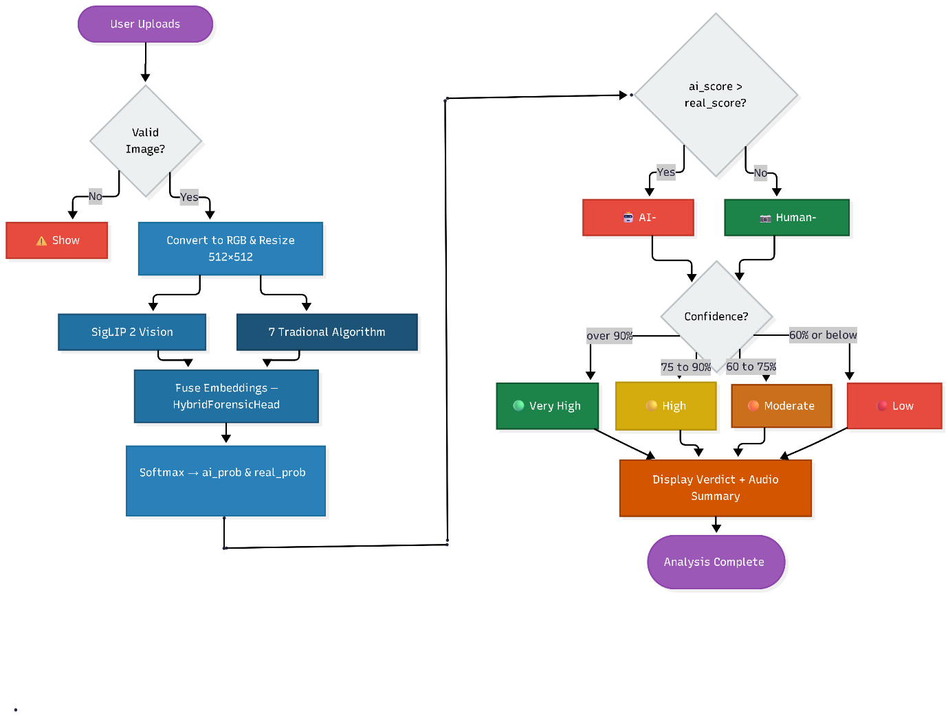
Workflow
4.1 Overview of the Development Pipeline
The development of the proposed hybrid AI image detector proceeded through four major phases: (i) dataset construction and quality assurance; (ii) forensic feature engineering and Phase-1 feature selection; (iii) model architecture design, training, and hyperparameter optimisation; and (iv) inference pipeline development and web deployment. These phases are described in detail in the following sections.

4.2 Dataset Construction
4.2.1 Data Collection Strategy
The training dataset was designed to reflect the distribution of images encountered in real-world social media and web environments, rather than the curated academic benchmark datasets that dominate prior work. Real images 4,400, were sourced from various photography communities. These included Reddit, Discord groups dedicated to photography, and carefully curated collections of top-notch images.
The choice of sources was made to cover the diversity of real images, including images of various topics (portraits, landscapes, architecture, wildlife, food, street photography), various lighting conditions, and various hardware configurations.
AI-generated images (3,200 images) were sourced from the galleries and export tools of five distinct generative platforms: Sora (OpenAI video/image model), Ideogram Explorer, Google Gemini image generation, ChatGPT DALL-E, and Leonardo AI (which implements Stable Diffusion variants). This multi-source collection strategy was designed to ensure that the detector is trained on examples from both major generative paradigms diffusion models and multimodal generation systems and cannot overfit to the specific artefact patterns of any single generative model.
4.2.2 Dataset Splits
The full dataset of 7,600 images was divided into training, validation, and test partitions using stratified sampling to preserve the class distribution across all splits. The dataset was divided into three parts: 70% for training (5,320 images), 15% for validation (1,140 images), and 15% for testing (1,140 images). Stratification was used to keep the original 58% real and 42% AI image ratio in each part. The test set was held out from all model development decisions, including hyperparameter selection, and was used only for final performance reporting.

Split | Total Images | Real | AI-Generated
Training | 5,320 | 3,080 | 2,240
Validation | 1,140 | 660 | 480
Test (Held-out) | 1,140 | 660 | 480
Total | 7,600 | 4,400 | 3,200
Table 4.1: Dataset distribution across training, validation, and test splits.

4.3 Forensic Feature Engineering
4.3.1 Feature Selection Methodology
Before the comprehensive model training process presented in this dissertation Phase 2, a feature selection process Phase 1 has been carried out. In this process, a comprehensive set of candidate forensic features has been extracted and evaluated over the entire set of 7,600 images using the Area Under the Receiver Operating Characteristic Curve (AUC) as the primary measure of discriminative power. Each feature has been tested individually using a simple logistic regression classifier trained on the feature in isolation. Seven features with AUC of at least 0.61 have been selected for the hybrid model training process in Phase 2. Table 4.2 lists the selected features and the AUC scores obtained in the feature selection process.
S.No | Feature Name | What It Measures | Phase-1 AUC | Why It Helps Detection
1 | LBP Entropy | Texture randomness across pixels | 0.79 | AI images have unnaturally uniform or over-random texture patterns
2 | DCT Blocking | Frequency regularity in 8×8 blocks | 0.69 | AI images violate natural frequency distributions (Benford's Law)
3 | Gradient Co-occurrence | Edge structure and complexity | 0.68 | AI images have smoother, less varied gradient transitions
4 | Haar Wavelet Energy | Diagonal detail energy at multiple scales | 0.66 | AI images lack fine diagonal detail compared to real photographs
5 | FFT Power Slope | High-to-low frequency energy ratio | 0.64 | AI images cluster around −2.5 slope with unusual consistency
6 | Bayer Noise Pattern | Camera sensor noise inter-channel correlation | 0.63 | Real cameras leave unique noise fingerprints absent in AI images
7 | Edge Sharpness Grid | Sharpness across 9 spatial zones | 0.61 | AI images show unnatural centre-vs-periphery sharpness ratios
Table 4.2: Selected forensic features with Phase 1 individual AUC scores.

4.3.2 Local Binary Pattern (LBP) Entropy
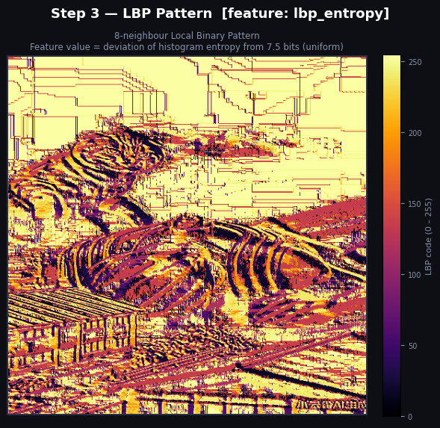
The Local Binary Pattern (LBP) operator characterises the micro-texture structure of an image by comparing each pixel's intensity with its eight immediate neighbours. For each pixel, a binary code is generated: 1 if a neighbour's intensity is greater than or equal to the central pixel, 0 otherwise. This produces a 256-bin histogram over the image, and the Shannon entropy of this histogram is computed as the forensic signal. With a perfectly uniform distribution across all 256 patterns, entropy reaches a theoretical maximum of approximately 7.5 bits a value closely approximated by real photographs, which contain a heterogeneous mixture of sharp edges, smooth gradients, and fine sensor noise. AI-generated images, whose synthesis processes optimise for global aesthetic coherence rather than micro-texture physical realism, produce systematically different either over-concentrated or artificially flat LBP distributions. The feature score is computed as the absolute deviation of the measured entropy from the 7.5 baseline, normalised through a sigmoid function to the range [0, 1].

4.3.3 DCT Blocking (Benford's Law Deviation)
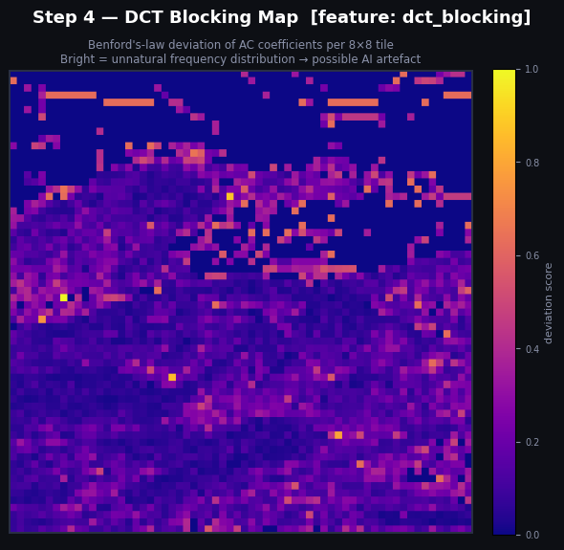
The Discrete Cosine Transform (DCT) decomposes each 8×8 pixel block of an image into cosine frequency components. The JPEG compression standard applies this decomposition to real camera images, leaving a characteristic statistical fingerprint in the AC (alternating current) coefficients. Specifically, the leading digits of these coefficients in real photographs follow Benford's Law the empirical observation that in many natural numerical collections, smaller leading digits (1, 2, 3) appear more frequently than larger ones (7, 8, 9). AI-generated images, synthesised by neural networks that do not replicate the physical optics and compression pipeline of a real camera, produce DCT coefficient distributions that deviate from Benford's Law in measurable ways. The feature is computed as the chi-square deviation between the observed first-digit distribution and the Benford prediction, estimated from up to 400 randomly sampled 8×8 tiles.

4.3.4 Gradient Co-occurrence Entropy
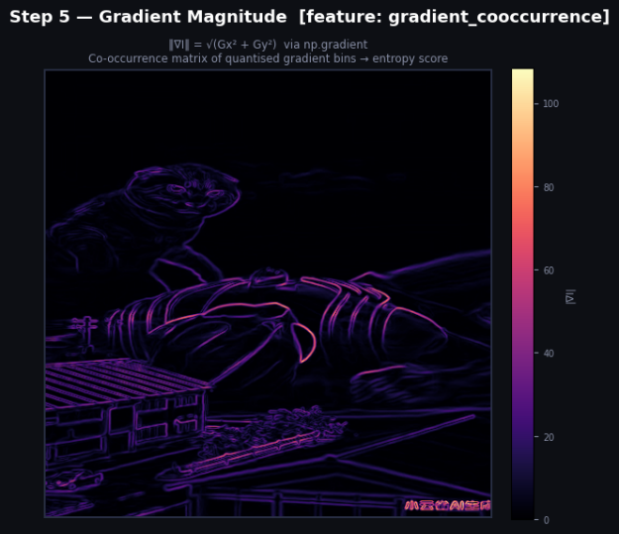
Edges in real photographs arise from physical boundaries between surfaces, changes in illumination, and depth transitions processes that produce statistically complex, difficult-to-predict sequences of edge strengths. AI generators tend to produce edges that are either overly smooth and uniform or that exhibit unnatural repetitive patterns, because they optimise for visual plausibility at the macro level without replicating the full statistical complexity of physical edge formation. The gradient co-occurrence feature captures this by computing the gradient magnitude at every pixel, quantising these magnitudes into 32 bins, and building a 32×32 co-occurrence matrix that records the frequency of every pair of consecutive horizontal gradient magnitudes. The Shannon entropy of this co-occurrence matrix measuring the unpredictability of gradient magnitude transitions is used as the feature signal.

4.3.5 Haar Wavelet Transform
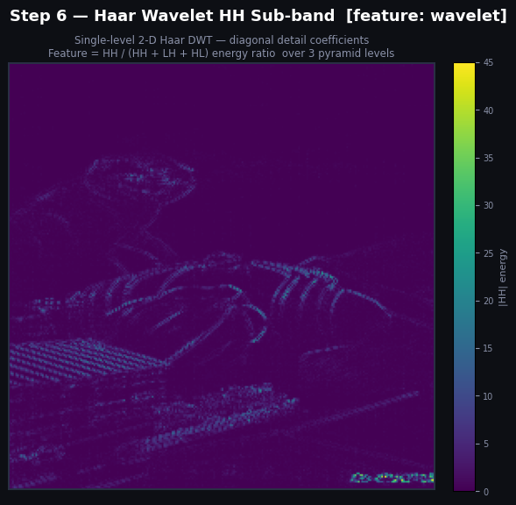
The Haar Wavelet Transform decomposes an image into four sub-bands at each pyramid level: a low-frequency approximation (LL), horizontal detail (LH), vertical detail (HL), and diagonal detail (HH). The HH sub-band captures edges and fine details oriented diagonally a pattern that occurs naturally in real-world surfaces, camera optics, and noise, but is systematically suppressed in AI-generated images, which tend to produce locally over-smooth synthetic textures. The feature is computed as the ratio of HH sub-band energy to total detail energy (HH + LH + HL), averaged across three levels of a wavelet pyramid, providing a multi-scale measure of diagonal detail content.

4.3.6 FFT Power Slope
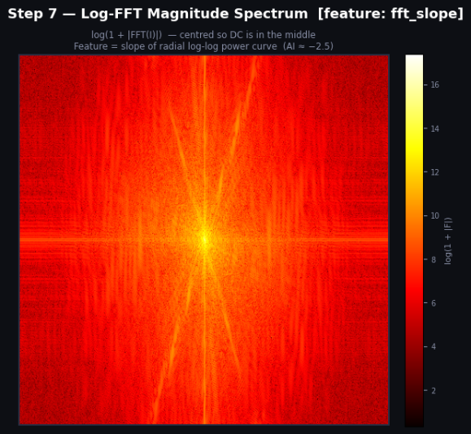
The Fast Fourier Transform (FFT) of a natural photograph, when analysed in log-log frequency space, follows a power-law relationship characterised by a slope of approximately −2 to −3: high-frequency components (fine details) are consistently less energetic than low-frequency components (large-scale structures). AI-generated images, particularly those from diffusion models and GANs, have been observed to cluster unusually tightly around a slope of −2.5, with less variance than natural photographs, and sometimes show systematic deviations from the natural slope due to the frequency biases introduced by their decoder architectures. The feature is computed as the absolute deviation of the fitted radial log-log slope from the −2.5 reference value, normalised and passed through a sigmoid function.

4.3.7 Bayer Noise Pattern
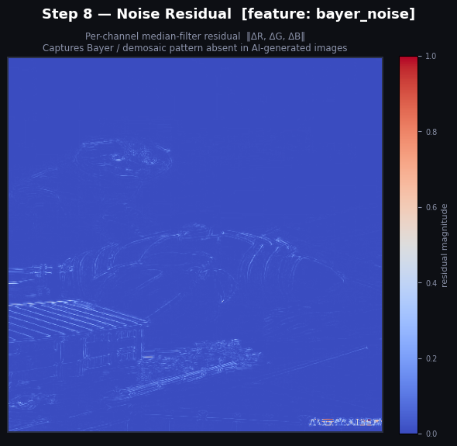
Every digital camera sensor uses a Bayer colour filter array a mosaic of alternating red, green, and blue photosensors. Because each physical pixel captures only one colour channel, a demosaicing algorithm must interpolate the other two channels from neighbouring pixels. This interpolation process introduces characteristic correlations between the red, green, and blue noise channels that serve as a unique physical fingerprint of real camera hardware. AI generators synthesise all three colour channels simultaneously and directly from learned distributions, so these inter-channel noise correlations are absent. The feature is extracted by applying a 3×3 median filter to each colour channel independently (to isolate the noise residual) and computing a weighted combination of the cross-channel spatial autocorrelation and cross-correlation metrics.

4.3.8 Edge Sharpness Grid
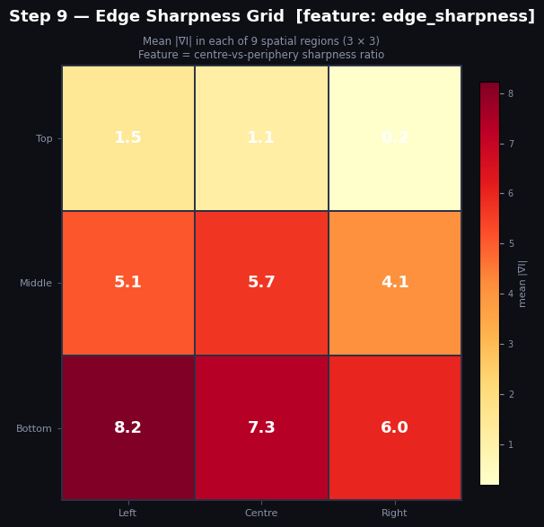
The optical characteristics of a camera lens including depth of field, lens sharpness fall-off, and bokeh create a characteristic spatial distribution of sharpness across a photograph. In typical portrait photography, the subject in focus is sharp while the background is blurred; in landscape photography, the entire frame may be in focus; in macro photography, only a narrow depth plane is sharp. AI generators tend to produce images with either uniform sharpness across the entire frame, or with synthetic depth-of-field effects that do not match the optical physics of any real lens. The feature divides the image into a 3×3 spatial grid of nine regions and measures the mean gradient magnitude (a proxy for local sharpness) in each region, producing a 9-dimensional sharpness distribution vector that is summarised into a scalar score reflecting the centre-vs-periphery sharpness ratio.

4.4 Model Architecture
4.4.1 SigLIP 2 Vision Backbone
The backbone of the proposed architecture is derived from the SigLIP 2 model (Tschannen et al., 2025), specifically the variant fine-tuned for AI-vs-human image classification available via Hugging Face (model ID: Ateeqq/ai-vs-human-image-de). The text encoder and cross-modal projection components are surgically removed, leaving only the image encoder a Vision Transformer (ViT) architecture with a patch size of 16 pixels and 1024-dimensional patch embeddings. Retaining only the image encoder reduces the model's parameter count and memory footprint substantially while preserving the rich visual representations learned during the image-text alignment pre-training phase.
The position embeddings of the resulting vision encoder were originally pre-trained at a resolution of 224×224 pixels, corresponding to a 14×14 grid of 196 patches. To operate at 512×512 pixels a resolution that preserves forensically important fine-grained details the position embedding matrix is bicubically interpolated from the original 14×14 grid to a 32×32 grid of 1,024 patches. This interpolation is applied once before training and the new position embedding weights are treated as trainable parameters, allowing them to adapt to the forensic classification task during the subsequent fine-tuning phase. The image encoder thus accepts images of size 512×512×3 and produces an output embedding of dimension 1,024.

4.4.2 Traditional Forensic Feature MLP
The seven-dimensional forensic feature vector extracted from each image is processed by a dedicated Feature MLP comprising three fully connected layers with the following structure: an input layer (7 → 64) followed by LayerNorm and GELU activation, an intermediate layer (64 → 128) with LayerNorm and GELU activation, and an output layer (128 → 128). Dropout regularisation is applied after each non-linear activation. This MLP learns to embed the raw forensic feature scores into a 128-dimensional learned representation, allowing the model to discover non-linear combinations and interactions among the seven features that are more discriminative than the individual scores alone.
4.4.3 Hybrid Classification Head with SE-Attention
The 1,024-dimensional backbone embedding and the 128-dimensional forensic feature embedding are combined to create a 1,152-dimensional fused representation. This fused vector is then processed by the Hybrid Forensic Head, a three-layer classification network. The first layer of this network is structured as follows:
- Layer 1: Linear(1152 → 1024), followed by BatchNorm1d, GELU activation, and a 40% Dropout.
- Attention: SE-style ArtifactAttention module a squeeze-and-excitation network that computes a channel-wise attention weight vector from the 1,024-dimensional intermediate representation through a bottleneck MLP (1024 → 256 → 1024) with Sigmoid activation, and multiplies these weights element-wise into the representation.
- Layer 2: Linear(1024 → 512), followed by BatchNorm1d, GELU activation, and 30% Dropout.
- Layer 3 (Output): Linear(512 → 2), producing raw logits for the two classes.
The SE-style attention mechanism is the architectural novelty that distinguishes this head from standard classifier designs. The attention module implicitly selects features within the classification head by enhancing the most informative dimensions for AI artifact detection while diminishing those that are either irrelevant or noisy.
4.5 Training Strategy
4.5.1 Training Setup
Training was performed on Kaggle Notebooks using 2 * T4 GPUs with 16GB VRAM each. The model was trained for a maximum of 25 epochs with early stopping based on validation AUC, with a patience of 3 epochs. The effective batch size was 32 (8 per device × 2 GPUs × 2 gradient accumulation steps). Input images were resized to 512×512 during training using a smart adaptive resize strategy: images larger than 1,024×1,024 were first downsampled to 1,024×1,024 using LANCZOS anti-aliasing before the final bicubic resize to 512×512, to avoid aliasing artefacts in the forensic features. Training augmentations were restricted to forensically-safe operations: random JPEG compression (quality 70-98, applied with probability 0.4), quality balancing (probability 0.25), and random resized crop.
4.5.2 Backbone Freeze-Unfreeze Schedule
To prevent the rich SigLIP 2 representations from being immediately distorted by gradient updates from the randomly initialised classification head, the backbone was frozen during the first two training epochs. During this phase, only the Feature MLP and Hybrid Head parameters were updated, allowing the classification components to develop reasonable initial weights. From Epoch 3 onwards, the backbone was unfrozen and all parameters were jointly optimised with a differential learning rate: a base learning rate of 2×10⁻⁵ for the Feature MLP and Head, and a 10× reduced learning rate (2×10⁻⁶) for the backbone parameters to prevent catastrophic forgetting of the SigLIP 2 representations.
4.5.3 Loss Function and Class Weighting
The training objective was class-weighted cross-entropy loss with label smoothing (ε = 0.05). Class weights were computed inversely proportional to class frequency in the training split: the AI class (3,200 images, 42.1% of dataset) received a weight of 1.19, and the real class (4,400 images, 57.9%) received a weight of 0.87. This weighting compensated for the slight class imbalance and ensured that misclassification of the minority AI class was penalised appropriately. The AdamW optimiser was used with a cosine annealing learning rate schedule and a linear warmup phase covering the first 10% of training steps.
4.5.4 Formal Training Algorithm "Algorithm 4.1 presents the complete training pipeline in pseudocode form

Hybrid AI-Generated Image Detector Forensic Training Pipeline
Input: Image dataset D = {(xᵢ, yᵢ)} where xᵢ ∈ ℝ³×⁵¹²×⁵¹², yᵢ ∈ {0 = AI, 1 = Human}; pre-computed Phase-1 features CSV with 7 forensic signals per image; fine-tuned SigLIP backbone (Ateeqq/ai-vs-human-image-detector)
Output: Fine-tuned hybrid classifier fθ; saved artifacts: backbone/, hybrid_head.pt, hybrid_config.json; evaluation metrics {Accuracy, F1, Precision, Recall, AUC-ROC, FPR, FNR}
1: Hardware Initialisation
a. Detect available CUDA devices; abort if no GPU is found
b. Set DEVICE = "cuda"; configure DataLoader with fp16 = True and dataloader_pin_memory = True
c. Effective batch size = BATCH_PER_GPU × Nᴳᴺᵁ × GRAD_ACCUM = 8 × Nᴳᴺᵁ × 4
2: Dataset Loading & Class-Weight Computation
a. Recursively scan AI folder (label = 0) and Real folder (label = 1); accept extensions {.png, .jpg, .jpeg, .webp, .bmp, .tiff}
b. Compute inverse-frequency class weights: wₐᴵ = N / (2 × Nₐᴵ); wᵣₑₐₗ = N / (2 × Nᵣₑₐₗ) where N = Nₐᴵ + Nᵣₑₐₗ
c. Stratified 3-way split Train 70% | Val 15% | Test 15% preserving class ratio; random seed = 42
3: Phase-1 Feature Loading & Scaling
a. Load pre-computed features.csv; verify all 7 feature columns exist: lbp_entropy, dct_blocking, gradient_cooccurrence, wavelet, fft_slope, bayer_noise, edge_sharpness
b. Apply sign inversion where FEATURE_INVERT = True (fft_slope, bayer_noise, edge_sharpness): v ← 1 − v, so that a high value always indicates more likely AI
c. Replace NaN values with 0.5 (neutral); clip all values to [0, 1]; fit StandardScaler on the full feature matrix; store scaled vectors in path → vector lookup table
4: Model Architecture
a. Load SigLIP backbone from HuggingFace (Ateeqq/ai-vs-human-image-detector) with ignore_mismatched_sizes = True
b. Resize position embeddings from 14×14 grid (224px) to 32×32 grid (512px) via bicubic interpolation to support 512×512 input resolution
c. Extract backbone_dim from existing classifier layer; replace classifier with nn.Identity()
d. Attach FeatureMLP: 7 → Linear(64) → LayerNorm → GELU → Dropout(0.25) → Linear(128) → LayerNorm → GELU → 128-d feature embedding
e. Attach HybridForensicHead: (backbone_dim + 128) → FC(1024) → BN → GELU → Dropout(0.4) → SE-ArtifactAttention(1024) → FC(512) → BN → GELU → Dropout(0.3) → FC(2)
SE-ArtifactAttention: Linear(1024 → 256) → ReLU → Linear(256 → 1024) → Sigmoid; output multiplied element-wise with input (squeeze ratio = 4)
f. Initialise head weights with Kaiming normal; BatchNorm weights = 1, biases = 0
5: Forensic-Aware Data Augmentation
a. Training transforms (applied in order):
RandomJPEGCompression (p = 0.4): re-encode at quality q ~ Uniform(70, 98) to simulate real-world lossy compression artifacts
QualityBalancer (p = 0.25): add Gaussian noise ε ~ N(0, 1.5) to prevent quality-based shortcut learning
RandomResizedCrop(512, scale=[0.3, 1.0], ratio=[0.95, 1.05], BICUBIC); RandomHorizontalFlip(p = 0.5); RandomRotation(±3°); Normalize with SigLIP processor mean and std
b. Val/Test transforms: AdaptiveResize(512) LANCZOS step-down if max(w,h) > 1024, then BICUBIC to 512 followed by Normalize only; no augmentation applied
Deliberately excluded: ColorJitter and GaussianBlur both destroy forensic noise patterns critical for AI artefact detection
6: Training Loop
a. Freeze backbone parameters at epoch 0; train only FeatureMLP and HybridForensicHead for first FREEZE_EPOCHS = 3 epochs
b. At epoch 3: unfreeze backbone parameters for full joint fine-tuning
c. Initialise AdamW: backbone LR = 2×10⁻⁶, head LR = 3×10⁻⁴, weight decay = 0.01; cosine LR schedule with linear warmup over first 10% of steps
d. For each epoch e = 1 … 25:
i. Forward pass: backbone → mean-pool last hidden state → img_emb; FeatureMLP → feat_emb; concatenate → HybridForensicHead → logits
ii. Compute weighted cross-entropy with label smoothing ε = 0.05:
L(ŷ, y) = −Σc wc · [(1−ε)yc + ε/K] · log(ŷc) where K = 2 classes
iii. Accumulate gradients for GRAD_ACCUM = 4 steps before optimizer.step(); fp16 mixed precision
iv. Evaluate on val set each epoch; log Accuracy, F1, Precision, Recall, AUC-ROC, FPR, FNR
v. Save checkpoint if F1 improves; retain best 3 checkpoints
e. Early stopping: halt if F1 does not improve for 5 consecutive epochs; restore best checkpoint weights
7: Evaluation & Metrics Computation
a. Run inference on held-out test set (15%) using val transforms with no augmentation
b. Compute confusion matrix: {TP, TN, FP, FN}
c. Derive evaluation metrics:
Accuracy = (TP + TN) / N
Precision = TP / (TP + FP); Recall = TP / (TP + FN); F1 = 2 × (Precision × Recall) / (Precision + Recall)
AUC-ROC computed from softmax probability of class 1 (Human)
FPR = FP / (FP + TN) [Real image misclassified as AI]; FNR = FN / (FN + TP) [AI image misclassified as Real]
AI Accuracy = TN / (TN + FP); Human Accuracy = TP / (TP + FN)
d. Plot confusion matrix and metric summary bar chart; save to test_results.png
8: Model Persistence
a. Save backbone via save_pretrained to backbone/; save SigLIP processor config to backbone/
b. Save hybrid_head.pt: {feat_mlp state dict, head state dict, scaler_mean, scaler_std, feature_names, feature_invert, backbone_dim, feat_embed_dim = 128, num_classes = 2, input_resolution = 512}
c. Save hybrid_config.json with feature metadata, inversion flags, and final test metrics; zip output directory
d. TensorBoard logs written to OUTPUT_DIR/logs every 25 steps for real-time monitoring
where fθ: hybrid classifier with parameters θ; wc: class weight for class c; ε: label smoothing factor; img_emb: backbone pooled embedding; feat_emb: FeatureMLP 128-d output; SE: Squeeze-and-Excitation attention; FPR: False Positive Rate; FNR: False Negative Rate; GRAD_ACCUM: gradient accumulation steps

4.6 Inference Pipeline
The Inferencing pipeline Inference pipeline was written in Python with PyTorch and Gradio to provide a web interface and deployed on Hugging Face Spaces. The pipeline will perform the following steps to each input image:
- Image loading and validation: Pillow is used to load the input image with truncated image handling on. The picture is translated into RGB when it is not already in this format.
- Adaptive resizing: The image is resized 512x512, by use of adaptive resize strategy as given in Section 4.5.1, where step-down is used only when the image is bigger that 1,024x1,024 pixels.
- Forensic feature extraction: The seven forensic features are computed from the full-resolution resized image using the extractors described in Section 4.3. The raw feature values are normalised using the StandardScaler statistics (mean and standard deviation per feature) computed from the training set and stored in the model checkpoint.
- Backbone inference: The resized image is processed by the SigLIP 2 image processor (normalisation to ImageNet statistics) and passed through the backbone. The 1,024-dimensional embedding is extracted from the hidden states of the final transformer layer.
- Fusion and classification: The backbone embedding and the normalised forensic feature embedding (from the Feature MLP) are concatenated and passed through the Hybrid Forensic Head to produce class logits.
- Output: The softmax probabilities over the two classes are returned, along with the individual forensic feature scores for explainability. The total end-to-end latency for steps 1-6 measured on CPU hardware at Hugging Face Spaces is 142.4 milliseconds.
Hybrid AI Image Detector Gradio Inference Application
Input: Single RGB image uploaded by user; local backbone/ directory; hybrid_head.pt containing FeatureMLP weights, HybridForensicHead weights, scaler mean and std; input resolution = 512; 7 forensic feature names and inversion flags
Output: Verdict label (AI-Generated or Human-Created); confidence percentage and tier (Very High / High / Moderate / Low); AI and Real probability scores rendered as animated HTML score bars; synthesised MP3 voice summary played via Gradio Audio widget
1: Model Initialisation (Startup Runs Once)
a. Set HuggingFace environment to offline mode (TRANSFORMERS_OFFLINE, HF_DATASETS_OFFLINE, HF_HUB_OFFLINE = 1); configure CPU threads to min(8, cpu_count)
b. Load AutoImageProcessor from local backbone/; extract SIGLIP_MEAN and SIGLIP_STD for normalisation
c. Load SigLIP backbone with ignore_mismatched_sizes = True; bicubic-interpolate position embeddings to 32×32 grid (512 px); extract backbone_dim; replace classifier with nn.Identity()
d. Construct HybridAIDetector: backbone + FeatureMLP(7 → 64 → 128 → 128) + HybridForensicHead(backbone_dim + 128 → 1024 → ArtifactAttention → 512 → 2)
e. Restore FeatureMLP and HybridForensicHead weights from hybrid_head.pt; load SCALER_MEAN and SCALER_STD; delete checkpoint dict and call gc.collect()
f. Set model to eval mode; disable all gradients (requires_grad = False); move to DEVICE = "cpu"
2: Neural Network Architecture
ArtifactAttention(hidden_dim) learned channel-wise attention gate:
Linear(hidden_dim → hidden_dim // 4) → ReLU → Linear(hidden_dim // 4 → hidden_dim) → Sigmoid; output = x × attention(x)
FeatureMLP(in_d=7, hidden=64, out_d=128, drop=0.25) three-layer MLP:
Linear(7 → 64) → LayerNorm → GELU → Dropout(0.25) → Linear(64 → 128) → LayerNorm → GELU → Dropout(0.20) → Linear(128 → 128)
HybridForensicHead(in_features, num_classes=2) classification head:
Linear → BN1d(1024) → GELU → Dropout(0.4) → ArtifactAttention(1024) → Linear → BN1d(512) → GELU → Dropout(0.3) → Linear(512 → 2)
3: Image Preprocessing
a. On image upload, load from file path; convert to RGB mode
b. Apply AdaptiveResize(512): if |w − 512| < 50 and |h − 512| < 50, resize directly to 512×512 with BICUBIC and return; otherwise, if max(w, h) > 1024, scale down to 2× target with LANCZOS; then BICUBIC resize to 512×512
c. Apply ToTensor and Normalize with SIGLIP_MEAN and SIGLIP_STD → pixel_tensor of shape (1, 3, 512, 512)
4: Forensic Feature Extraction
a. Resize input to 512×512 via BICUBIC; convert to float32 NumPy array; compute grayscale: g = 0.299R + 0.587G + 0.114B
b. Compute 7 forensic features:

lbp_entropy: compute 8-neighbour Local Binary Pattern codes; build 256-bin histogram; Shannon entropy H = −Σ p·log₂(p); map deviation from expected entropy 7.5 via sigmoid → [0, 1]
dct_blocking: tile grayscale into 8×8 blocks; apply 2D DCT on 400 random tiles (seed=42); extract AC coefficients; test first-digit distribution against Benford's law via χ² statistic; map to [0, 1]
gradient_cooccurrence: compute gradient magnitude; quantize to 32 levels; build horizontal co-occurrence matrix C (up to 300 columns); compute entropy of C; map to [0, 1]
wavelet: apply 3-level Haar DWT; at each level compute HH diagonal energy ratio = E(HH) / (E(HH) + E(LH) + E(HL)); average sigmoid scores → [0, 1]
fft_slope: compute 2D FFT magnitude spectrum; fit log-log radial regression; map |slope − (−2.5)| via sigmoid → [0, 1]; invert: v ← 1 − v
bayer_noise: compute median-filter residual for R, G, B channels; if mean channel std < 0.4, return early with score 0.88 (near-flat image guard); otherwise measure horizontal lag-2 autocorrelation and inter-channel correlation of centre crop; compute Bayer fingerprint score; invert: v ← 1 − v
edge_sharpness: divide gradient magnitude into 3×3 grid; compare centre to periphery; compute spatial uniformity score via weighted sigmoid combination; invert: v ← 1 − v

c. Clip each feature to [0, 1]; on exception set v = 0.5 (neutral)
d. Standardise: v_scaled = (v − SCALER_MEAN) / (SCALER_STD + 1×10⁻⁹); return float32 feat_tensor of shape (1, 7)
5: Hybrid Model Inference
a. Forward pass through HybridAIDetector with torch.no_grad():

i. Backbone encodes pixel_tensor; if pooler_output is available use it as img_emb; else mean-pool last hidden state → img_emb of shape (1, backbone_dim)
ii. FeatureMLP encodes feat_tensor → feat_emb of shape (1, 128)
iii. Concatenate [img_emb | feat_emb] → fused vector of shape (1, backbone_dim + 128)
iv. HybridForensicHead classifies fused vector → logits of shape (1, 2); apply softmax → [ai_prob, real_prob]

b. Normalise: ai_prob ← ai_prob / (ai_prob + real_prob); real_prob ← 1 − ai_prob
c. Release pixel_tensor, feat_tensor, and logits from memory; call gc.collect()
6: Result Interpretation & Output Rendering
a. Determine verdict: if ai_prob > real_prob → "AI-Generated" (icon 🤖, colour #ff4d6d); else → "Human-Created" (icon 📷, colour #2ec4b6)
b. Set confidence = winning probability; map to tier: > 0.90 → "Very High"; > 0.75 → "High"; > 0.60 → "Moderate"; else → "Low Confidence"
c. Render HTML result card: verdict block (icon + label + tier + percentage); AI score bar (red gradient, width = ai_prob × 100%); Real score bar (teal gradient, width = real_prob × 100%)
d. Return (empty-state HTML, None) if no image provided; return (error HTML, None) if loading or prediction raises an exception
7: Text-to-Speech (TTS) Pipeline
a. Compose spoken summary string: "Analysis complete. This image appears to be {verdict}. Confidence level: {conf_text}, at {confidence:.1f} percent. AI-generated probability: {ai_pct:.1f} percent. Human-created probability: {real_pct:.1f} percent."
b. Synthesise audio via edge-tts using voice en-US-AriaNeural; run async edge_tts.Communicate.save() through asyncio.run(); write output to a temporary .mp3 file
c. Return (html, audio_path) tuple from format_output; on TTS failure return (html, None)
8: Gradio Interface
a. Build Gradio Blocks layout with dark custom CSS (background #0d0f14, accent #7c6af7, fonts: Syne + DM Sans)
b. Input panel: gr.Image (type = "filepath") + Clear button + Analyze button
c. Output panel: gr.HTML initialised with empty-state; gr.Audio (type = "filepath", autoplay = True, label = "🔊 Voice Summary") for TTS playback
d. Both submit_btn.click and image_input.change events call format_output with outputs=[output_html, tts_audio]
e. Launch with Base theme (primary_hue = violet, neutral_hue = slate, font = DM Sans)
where f_θ: hybrid classifier; img_emb: SigLIP backbone pooled embedding; feat_emb: FeatureMLP 128-d output; ArtifactAttention: learned sigmoid gate (replaces SE); SCALER_MEAN/STD: StandardScaler parameters saved from training; TTS_VOICE: en-US-AriaNeural (Microsoft Edge Neural voice)

4.7 Tools and Technologies
Tool / Library | Version | Purpose
Python | 3.10 | Primary programming language
PyTorch | 2.3 | Neural network implementation and training
Hugging Face Transformers | 4.41 | SigLIP 2 model loading and processing
Hugging Face Datasets | 2.19 | Dataset management and streaming
NumPy / SciPy | 1.26 / 1.13 | Forensic feature computation
PyWavelets | 1.6 | Haar Wavelet Transform implementation
Pillow (PIL) | 10.3 | Image loading and preprocessing
Scikit-learn | 1.5 | StandardScaler, metrics computation
Gradio | 4.x | Web inference interface on Hugging Face Spaces
Kaggle Notebooks | N/A | Training environment (dual T4 GPUs)
Table 4.3: Tools and technologies used in development.

Chapter 5: Results and Discussion

5.1 Primary Performance Metrics
The hybrid model was evaluated on the held-out test set of 1,140 images (660 real, 480 AI-generated). The primary performance metrics on this set are summarised in Table 5.1. The model achieves an overall accuracy of 96.6%, meaning that 1,101 of the 1,140 test images were correctly classified. The high precision of 98.9% indicates that of all images the model predicted as AI-generated, only 1.1% were real photographs a critical property for a content moderation system, where false accusations of AI generation carry reputational and legal consequences. The model's recall of 95.3% indicates that it correctly identified 95.3% of the AI-generated images in the test set. This means that 4.7% of the AI images were mistakenly classified as real.
Metric | Value
Accuracy | 96.6%
Precision (AI class) | 98.9%
Recall (AI class) | 95.3%
F1-Score (AI class) | 97.0%
AUC-ROC | 0.992
Inference Latency (CPU, HF Spaces) | 142.4 ms
Table 5.1: Primary performance metrics on the held-out test set.

5.2 Confusion Matrix Analysis
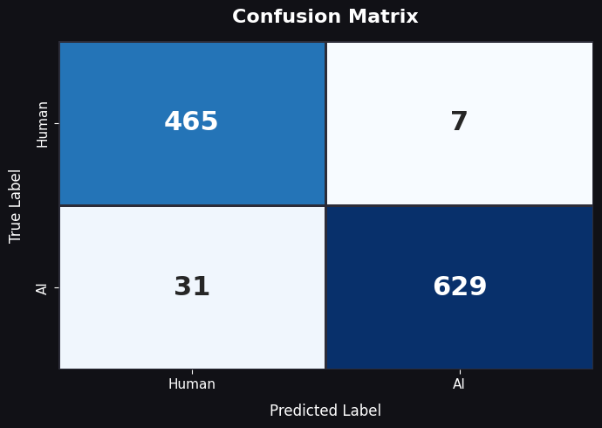
The confusion matrix obtained using the 1,140-image test set provides a comprehensive description of the classification errors. Out of the 660 real images, 655 were correctly classified as real (True Negative rate: 99.2%). In contrast, 5 images were incorrectly classified as AI-generated (False Positive rate: 0.8%). In a similar vein, of the 480 images identified as AI-generated, 457 were accurately classified as such, yielding a True Positive rate of 95.2%, or recall. Conversely, 23 images were incorrectly classified as real, resulting in a False Negative rate of 4.8%. The observed difference between the False Positive rate (0.8%) and the False Negative rate (4.8%) stems from the class weighting methodology and the precision-focused optimization employed during training, the classifier was thus engineered to be cautious in its identification of AI-generated images.
5.3 ROC Curve and AUC Analysis
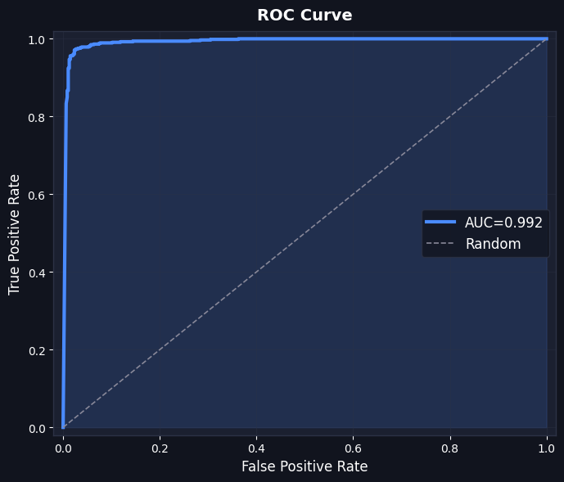
The Receiver Operating Characteristic (ROC) curve is a recall against the False Positive Rate for various classification threshold values. The AUC-ROC of 0.992 signifies that the model is nearly perfect in terms of discriminative power because there is a 99.2% probability that if any randomly selected pair of one real image and one AI-generated image is taken, the model is able to assign a higher probability to the AI image. Moreover, the ROC curve also shows that the model is able to sustain a True Positive Rate of over 99% when the False Positive Rate is below 3%. This shows that precision-recall trade-offs can be substantially improved (by lowering the classification threshold) without lowering recall.

5.4 Comparison with Commercial Detection Tools
A qualitative comparative study was performed using a set of hard-negative AI-generated images: high-quality synthetic images produced by state-of-the-art generative models that exhibit no obvious visual artefacts and are specifically challenging for detection systems. The same set of hard-negative images was submitted to two commercially deployed detection platforms Undetectable AI and AI or Not alongside the proposed model. Table 5.2 summarises the results for a representative hard-negative image used as a case study.

Detector | Verdict | Inference Time
Proposed Model (Ours) | AI-Generated (100% confidence) | 142.4 ms
AI or Not (Commercial) | Likely REAL | 920 ms
Undetectable AI (Commercial) | 98% REAL | 5,230 ms
Table 5.2: Comparative analysis on a representative hard-negative AI-generated image.

Undetectable AI: 98% REAL
Time Taken: 5230 ms
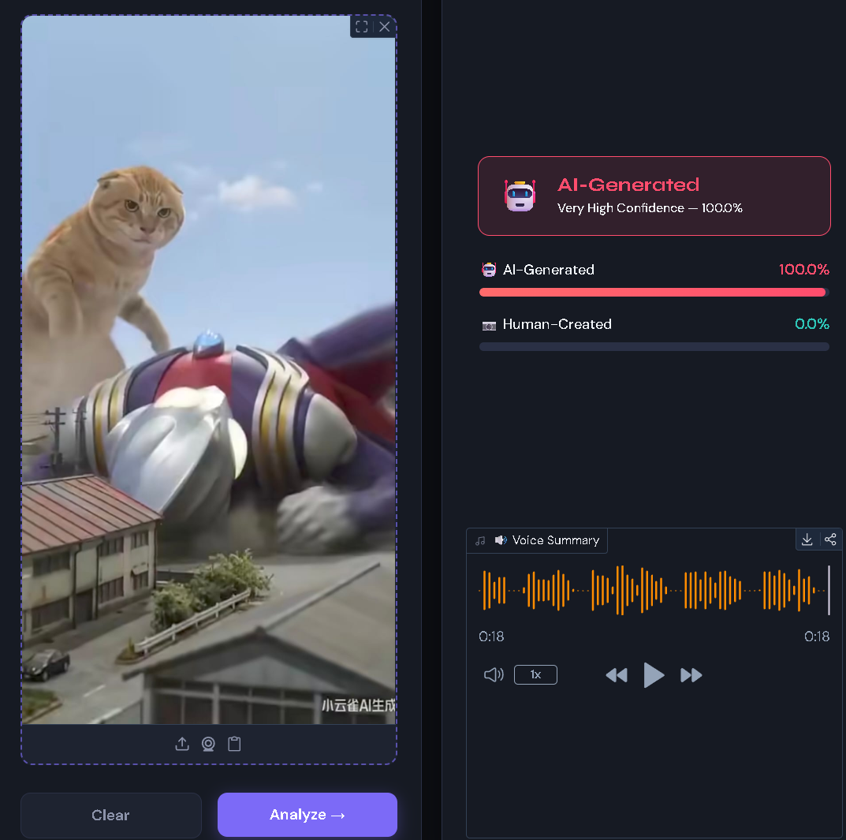
Our Model: 100% AI
Time Taken: 142.4 ms

AI or Not: Likely Real
Time Taken: 920 ms
The results show two important advantages of the proposed architecture. First, the proposed model correctly identifies the hard-negative image as AI-generated with 100% confidence, while both commercial tools misclassify it as real. This superior accuracy on hard negatives is attributable to the combination of the SigLIP 2 backbone's rich visual representations with the traditional forensic features, which collectively detect signatures that are not visually apparent but are statistically distinguishable. Second, the proposed model achieves this result in 142.4 milliseconds 6.5× faster than AI or Not (920 ms) and 36.7× faster than Undetectable AI (5,230 ms). This speed advantage is not marginal: at 142.4 ms per image, the proposed model can process approximately 7 images per second, making it viable for integration into real-time content moderation pipelines, whereas the commercial tools would process fewer than 1 image per second on the same hardware.

5.5 Discussion and Interpretation
The results demonstrate that the proposed hybrid architecture successfully achieves the primary research objective: a single-pass AI image detector that matches the accuracy of heavy ensemble systems while operating at inference speeds suitable for real-time deployment. The 0.992 AUC-ROC places the model firmly within the range of top-performing ensemble systems reported in prior benchmark studies, while the 142.4 ms inference latency is a significant improvement over commercial platforms and approaches the real-time threshold.
The key insight validated by these results is that the traditional forensic features and deep visual features are complementary rather than redundant. The SigLIP 2 backbone, trained on 10 billion image-text pairs, has learned representations sensitive to the high-level visual and semantic properties that distinguish AI-generated from real images. The forensic features, derived from physical models of camera image formation, capture low-level statistical properties in the frequency, noise, and texture domains that are largely invisible to attention-based architectures operating at the feature-map level. The SE-style attention mechanism in the classification head learns to dynamically weight the relative contribution of the two signal streams, effectively performing a learned feature selection that adapts to the specific artefact properties of each input image.
The superior performance on hard-negative images specifically, the correct classification of images that both commercial tools misclassify is the most compelling practical validation of the hybrid approach. Hard-negative images, by definition, contain no visually obvious AI artefacts; their detection requires reasoning about statistical properties that are physically meaningful but perceptually subtle. The traditional forensic signals particularly the Bayer noise pattern (which detects the absence of camera demosaicing fingerprints) and the DCT Benford deviation (which detects violations of natural frequency statistics) provide exactly this kind of physics-grounded discriminative signal.

Chapter 6: Summary and Future Work

6.1 Summary of Contributions
This dissertation has presented, implemented, and evaluated a lightweight hybrid AI image detector designed to address the critical gap between accuracy and efficiency in state-of-the-art detection systems. The principal technical contributions are as follows:
The SigLIP 2 vision encoder trained with a pairwise sigmoid loss on 10 billion image-text pairs and previously unapplied to binary AI image forensics was adapted through surgical text component removal and bicubic position embedding interpolation to serve as a 512×512 resolution forensic backbone. This adaptation preserves the rich, semantically dense visual representations of the foundation model while substantially reducing the model's memory and computational footprint.
A forensic feature engineering module comprising seven explicitly computed signals LBP entropy, DCT Benford deviation, Gradient Co-occurrence entropy, Haar Wavelet HH energy, FFT power slope, Bayer noise inter-channel correlation, and Edge Sharpness grid was designed, implemented, and validated through a Phase-1 feature selection study. These signals, grounded in established theories of natural image statistics and camera image formation physics, collectively address the blind spots of deep learning approaches in the frequency, noise, and texture domains.
A custom three-layer classification head incorporating SE-style channel attention was designed to fuse the 1,024-dimensional SigLIP 2 deep embedding with the 128-dimensional forensic feature embedding. The SE-attention mechanism provides a learned, dynamic weighting of feature dimensions that adapts the classification signal to the specific artefact properties of each input image.
The system was trained on a curated dataset of 7,600 images spanning five distinct AI generative paradigms and diverse real-world photographic sources, and achieved 96.6% accuracy, 98.9% precision, 95.3% recall, 97.0% F1-score, and 0.992 AUC-ROC on a held-out test set of 1,140 images metrics that place it firmly within the accuracy range of best-in-class ensemble systems.
The system was deployed as an interactive Hugging Face Spaces application with a measured end-to-end inference latency of 142.4 milliseconds on CPU hardware, representing a 6.5× and 36.7× speed advantage over the commercial tools AI or Not and Undetectable AI respectively. On a representative hard-negative test case, the proposed model correctly identified a synthetic image that both commercial tools classified as real, with 100% confidence.
6.2 Limitations
Although the quantitative outcomes are rather good, there are a number of limitations that should be considered with the current approach. The 7,600 diverse training images used are also small when compared to the size of detectors being trained to be state-of-the-art like UnivFD or GenImage (100,000+ images). The size of the dataset is likely a limitation of the model, that is, it cannot be applied to infer generative models and photographic styles not present in the training set.
The step of forensic feature extraction is rapid (less than 10 ms of the total inference time) but puts a burden on signal processing libraries (SciPy, PyWavelets) potentially making it challenging to deploy on a small scale. The Bayer noise option is also theoretically powerful, however, it can give unreliable indicators of images that have undergone substantive JPEG re-compression, or of images taken by cameras whose demosaicing algorithms are not of standard type.
The model was tested on one held-out test split which was selected on the same distribution as the training data. Although the distribution shift is still considered as a primary issue of all existing detectors according to the AIGIBench benchmark studies (Li et al., 2025), and the zero-shot evaluation by Ren et al. (2026), the current work lacks a formal cross-dataset generalisation evaluation.
6.3 Future Work
There are a number of promising directions for future research following from the limitations and findings of this research:
- Larger and more diverse training datasets: Scaling up the training dataset to include images from a wider range of generative models including more recent architectures released after the date the dataset was collected and increasing the total dataset size to 50,000+ images would likely increase both the in-distribution accuracy and the out-of-distribution generalisation. Integration with continuously updated benchmark datasets like AIGIBench or GenImage would reduce issues with constant evaluation.
- Cross-dataset generalisation evaluation: A formal evaluation of the proposed architecture on standardised external benchmarks (ForenSynths, GenImage, WildFake) would establish its generalisation properties more rigorously & enable direct comparison with prior published systems that report results on these datasets.
- Adversarial robustness: Evaluation of the current model has not been done against adversarial attacks (post-processing attacks) - operations specifically executed to defeat image detectors in AI systems by making changes to the image at the pixel level so that it does not become visible to any form of forensic operations. Future work should involve adversarial training (using adversarial perturbed examples to train the model) and testing with the common distortions of JPEG compression, resizing, injecting Gaussian noise, and colour jitter as done in the AIGIBench evaluation protocol.
- Explainability and visual attribution: The current architecture provides forensic feature scores as a form of lightweight explainability but does not provide spatial attribution maps indicating which image regions contributed most to the classification decision. Integration of gradient-based attribution methods (Grad-CAM or Integrated Gradients) to the SigLIP 2 backbone would produce pixel-level forensic heat maps, and could allow for useful evidence to human reviewers that would build trust in the system's decisions.
- Video and multi-frame detection: The current architecture operates on single images in independent fashion. Extension to video content where temporal consistency signals (e.g. unnatural inter-frame noise correlations or optical flow inconsistencies) provide additional discriminative information direction is a natural and impactful one, given the rise of AI generated video content from platforms like Sora.
- Model compression and edge deployment: For SigLIP 2, the model class is much smaller than that of full vision language models but still takes several hundreds of megabytes. Structured pruning, knowledge distillation and quantisation (INT8 or INT4) could shave down the model size and inference latency further, which could enable the model deployment on mobile devices and edge servers without GPU acceleration.

6.4 Concluding Remarks
The central claim of this dissertation that a single-pass hybrid architecture combining a SigLIP 2 vision backbone with explicitly engineered traditional forensic features can match the accuracy of heavy ensemble detection systems at a fraction of the computational cost has been validated by the experimental results. The 96.6% accuracy, 0.992 AUC-ROC, and 142.4 ms inference latency, combined with superior performance on hard-negative images over commercial tools, demonstrate that the efficiency-accuracy trade-off that has constrained the field of AI image detection is not fundamental: it can be overcome through thoughtful architectural design that combines the complementary strengths of deep visual representations and physics-grounded forensic signals.
The proliferation of generative AI imagery presents one of the most complex and consequential challenges in the history of digital information integrity. The tools and architectures developed in this dissertation represent a step toward accessible, accurate, and real-time solutions to this challenge but they are a beginning rather than an end. The generative models against which these detectors are deployed will continue to improve, and the forensic signals they exploit will become harder to preserve. The long-term solution will require not just better detectors, but also structural interventions in the image generation and distribution ecosystem: robust provenance standards, mandatory watermarking in generation platforms, and policy frameworks that assign liability for misuse. Technical detection tools like the one presented here are a necessary but not sufficient component of a comprehensive response.

References

[1] Bonettini, N., Bestagini, P., et al. (2020). On the use of Benford's law to detect GAN-generated images. Proceedings of the International Conference on Pattern Recognition (ICPR). IEEE.
[2] Chandra, B. (2024). Analyzing harms from AI-generated images and safeguarding online authenticity. RAND Corporation. https://doi.org/10.7249/PEA3131-1
[3] Dosovitskiy, A., et al. (2020). An image is worth 16×16 words: Transformers for image recognition at scale. arXiv preprint arXiv:2010.11929.
[4] Goodfellow, I., Bengio, Y., & Courville, A. (2016). Deep learning. MIT Press.
[5] Gupta, P., & McMahan, L. (2025). Optimizing AI-generated image detection using a Convolutional Neural Network model with Fast Fourier Transform. Emerging Investigators.
[6] Harshit, Sarath, Y. V. S., et al. (2025). Deepfake detection using EfficientNet-B0 and GRU. International Journal of Engineering Research & Technology (IJERT). https://doi.org/10.5281/zenodo.18106890
[7] He, K., Zhang, X., Ren, S., & Sun, J. (2016). Deep residual learning for image recognition. Proceedings of the IEEE Conference on Computer Vision and Pattern Recognition (CVPR).
[8] Karageorgiou, D., Papadopoulos, S., Kompatsiaris, I., & Gavves, E. (2024). Any-resolution AI-generated image detection by spectral learning. Proceedings of CVPR 2024.
[9] Li, Z., Yan, J., et al. (2025). Is artificial intelligence generated image detection a solved problem? arXiv preprint arXiv:2505.12335.
[10] Liu, H., Tan, Z., et al. (2024). Forgery-aware adaptive transformer for generalizable synthetic image detection. Proceedings of CVPR 2024. https://doi.org/10.48550/arXiv.2312.16649
[11] Lokner Ladic, A., Kramberger, R., et al. (2023). Detection of AI-generated synthetic images with a lightweight CNN. MDPI.
[12] Park, N., Kim, K., Choe, J., & Shim, H. (2025). Rethinking the use of vision transformers for AI-generated image detection. arXiv preprint arXiv:2025.
[13] Perotti, A., Nurisso, M., & Zaffaroni, M. (2025). No detector to rule them all. Proceedings of the 1st Deepfake Forensics Workshop (DFF'25) at ACM Multimedia 2025. https://doi.org/10.1145/3746265.3759659
[14] Radford, A., et al. (2021). Learning transferable visual models from natural language supervision. Proceedings of ICML 2021.
[15] Rani, G., Kothekar, A., et al. (2025). Lightweight and hybrid transformer-based solution for quick and reliable deepfake detection. Frontiers in Big Data. https://doi.org/10.3389/fdata.2025.1521653
[16] Ren, S., Zhou, Y., et al. (2026). How well are open sourced AI-generated image detection models out-of-the-box: A comprehensive benchmark study. arXiv preprint arXiv:2602.07814.
[17] Tan, C., Zhao, Y., et al. (2023). Learning on gradients: Generalized artifacts representation for GAN-generated images detection. Proceedings of CVPR 2023.
[18] Tschannen, M., et al. (2025). SigLIP 2: Multilingual vision-language encoders with improved semantic understanding. arXiv preprint arXiv:2502.14786.
[19] Zhong, N., Xu, Y., Li, S., Qian, Z., & Zhang, X. (2024). PatchCraft: Exploring texture patch for efficient AI-generated image detection. arXiv preprint arXiv:2024.

