SPARK STANALONE APPLICATION IN LOCAL MACHINE
USING COMMAND LINE METHOD
----------------------------------------------------------------------------------------------------------------------------

1. Install Spark in local machine from http://spark.apache.org/downloads.html
Useful commands:
wget http://d3kbcqa49mib13.cloudfront.net/spark-1.1.0-bin-hadoop2.4.tgz
gzip -d spark-1.1.0-bin-hadoop2.4.tgz
tar xvf spark-1.1.0-bin-hadoop2.4.tar

2. Check the Installation by launching the spark shell

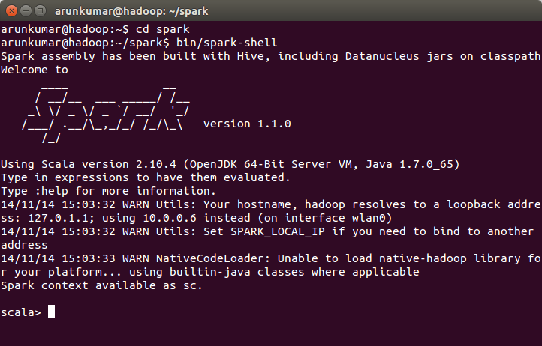

3. Install sbt-scala from http://www.scala-sbt.org/
It is a interactive build tool to compile and create create jar from scala code
Useful commands:
wget https://dl.bintray.com/sbt/debian/sbt-0.13.6.deb
sudo dpkg --install sbt-0.13.6.deb

4. Go to http://spark.apache.org/docs/latest/quick-start.html#standalone-applications and read about running standalone applications

5. create simple.sbt with the following content

name := "Simple Project"
version := "1.0"
scalaVersion := "2.10.4"
libraryDependencies += "org.apache.spark" %% "spark-core" % "1.1.0

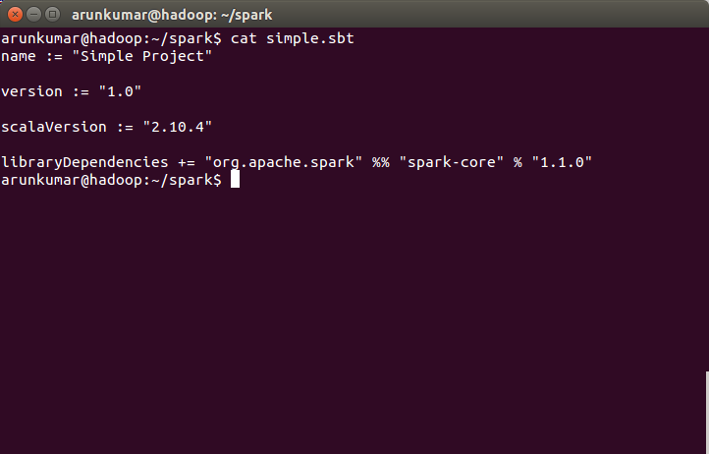

6. Create a directory structure as follows:
src/main/scala/
Useful command : mkdir -p src/main/scala

We have to write all the scala code in this directory.

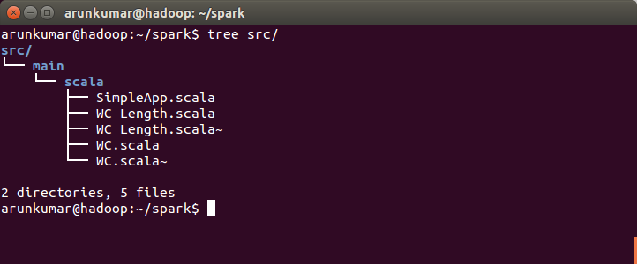

7. Use the below template word count scala programs

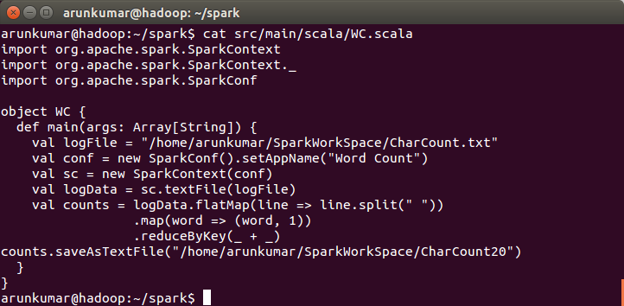

8. Build package using 'sbt package' commad. At first time, it takes a while to build the package.

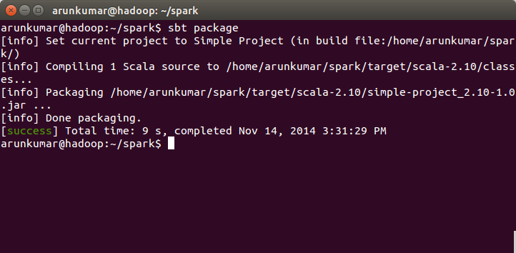

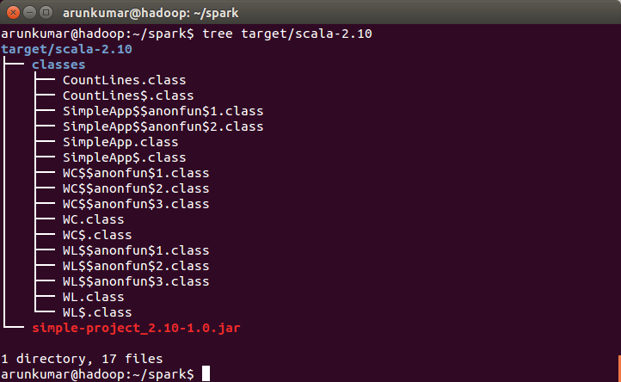

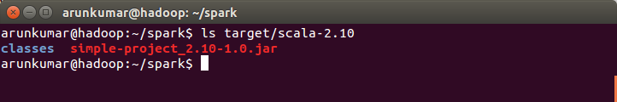

9. Run the application in standalone mode by using the below command

bin/spark-submit --class "WC" --master local target/scala-2.10/simple-project_2.10-1.0.jar

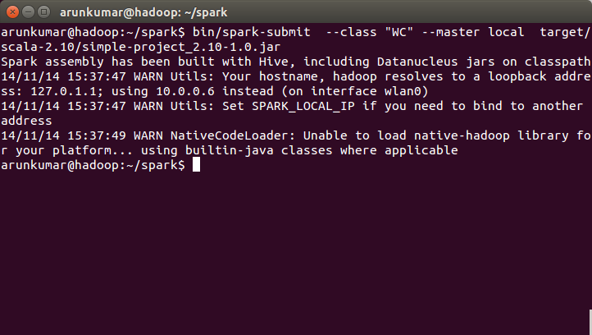

10. Check the output in the location specified in the program

