Hadoop Single node Pseudo distributed mode installation

1. Open Terminal

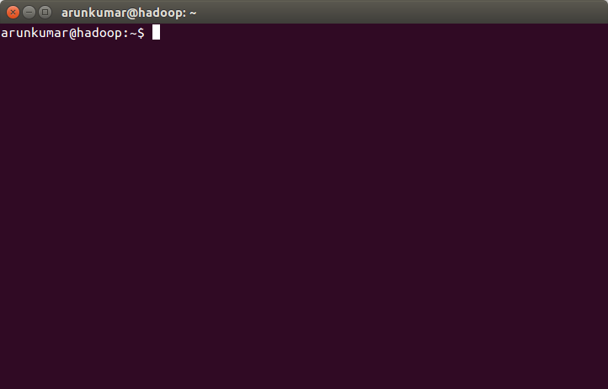

2. Install open SSH server

sudo apt-get install openssh-server

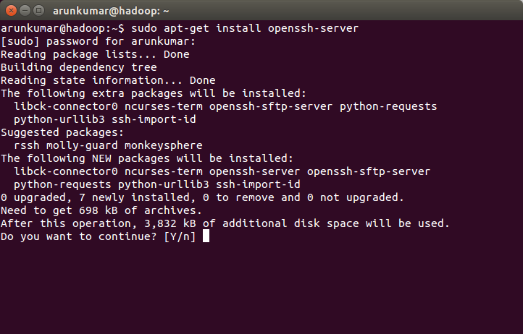

3. Yes to continue. You will end up in a similar screen

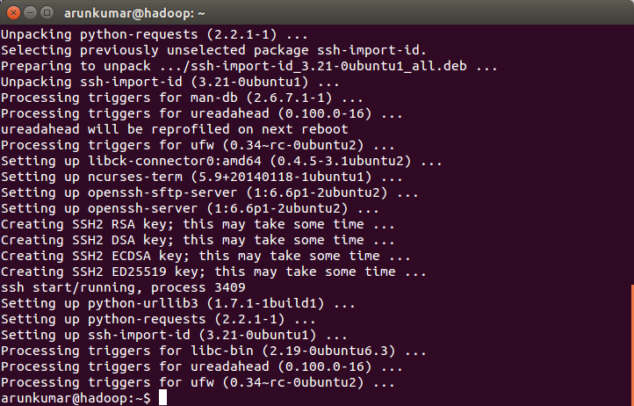

4. Generate SSH Key pair

commands : ssh-keygen

Enter file in which to save the key (/home/arunkumar/.ssh/id_rsa): leave as default – do not enter anything

Enter passphrase (empty for no passphrase) : leave it as empty as it required for automatic login

Enter same passphrase again: again no input required. Just enter.

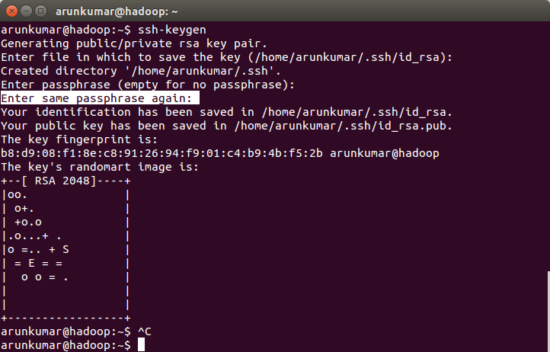

5. Add the generated key to the authorized key file to use as a password-less login.

cat ~/.ssh/id_rsa.pub >> ~/.ssh/authorized_keys

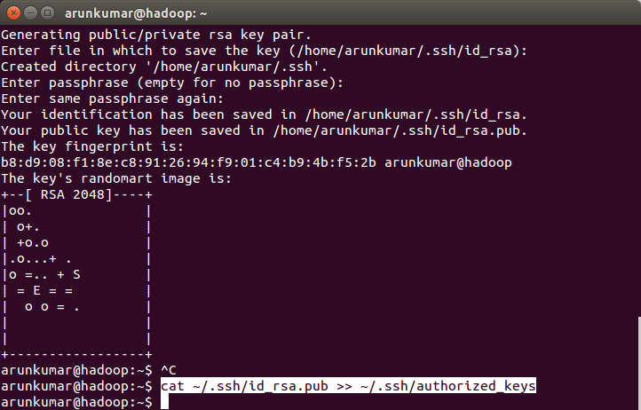

6. try logging in to localhost

ssh localhost

type 'yes' for the question about connection

Now you can login without a password-less

7. Now install java

sudo apt-get install openjdk-7-jdk

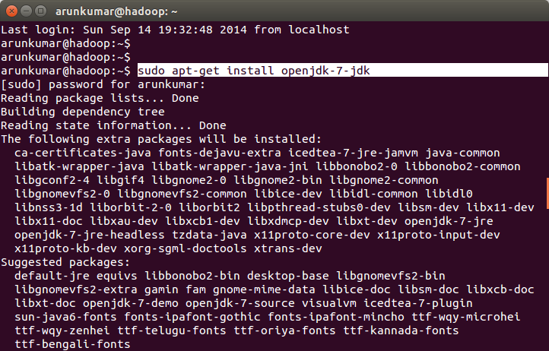

Yes to any question asked. Final screen after installation.

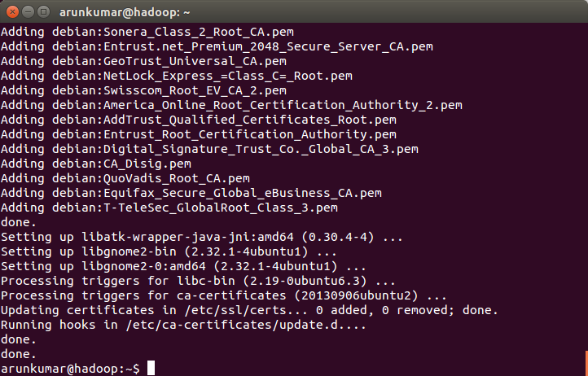

8. check the java version

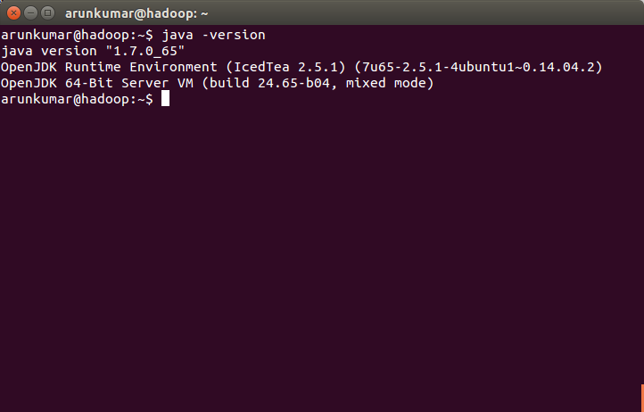

10. Now its the time to download hadoop. I am going to install hadoop 1.2.0

Download a stable version from the link :

http://archive.apache.org/dist/hadoop/core/hadoop-1.2.0/

11. You can also use command line to download the file.

sudo wget http://archive.apache.org/dist/hadoop/core/hadoop-1.2.0/hadoop-1.2.0-bin.tar.gz

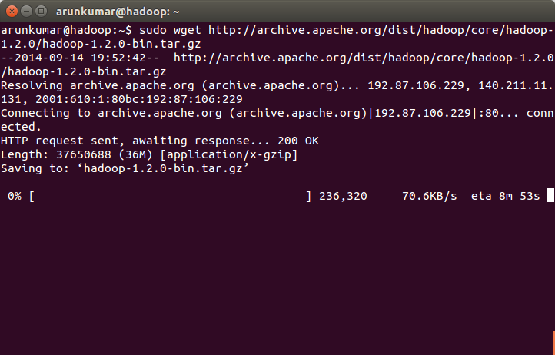

12. unzip the downloaded file

tar -zxvf hadoop-1.2.0-bin.tar.gz

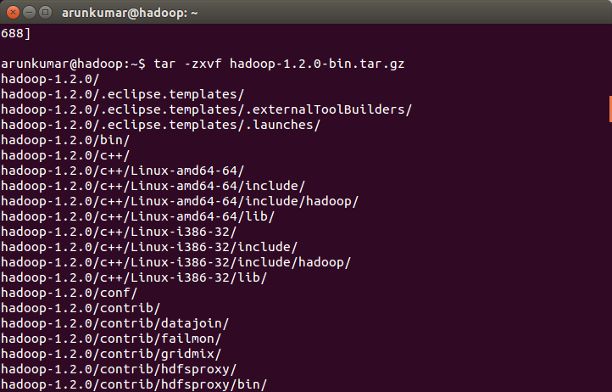

13. type 'dir' and make sure the file is unzipped correctly.

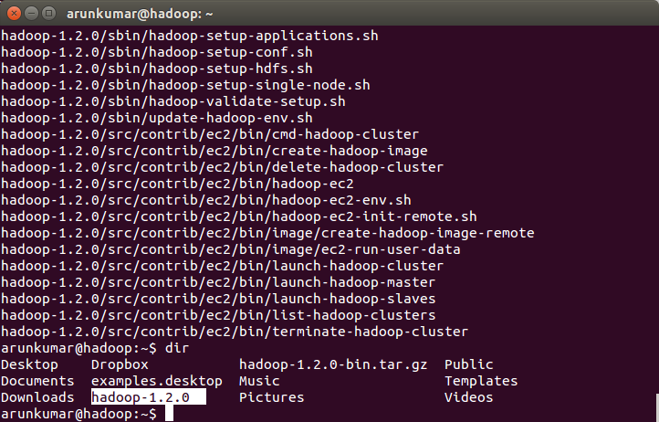

14. copy the file to user directory and rename to 'hadoop'

sudo cp -r hadoop-1.2.0 /usr/local/hadoop

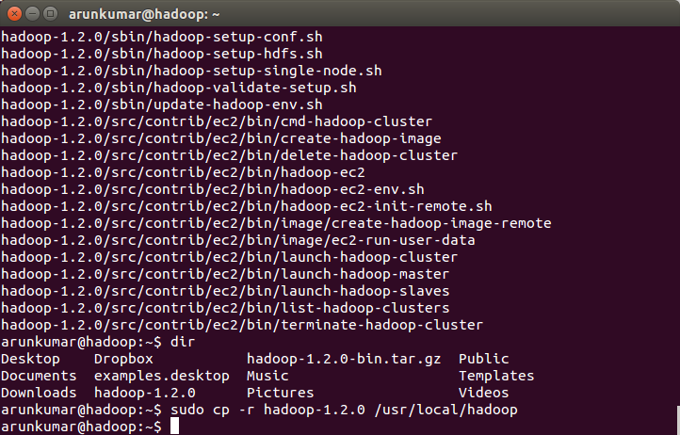

15. Check the content of the file

dir /usr/local/hadoop

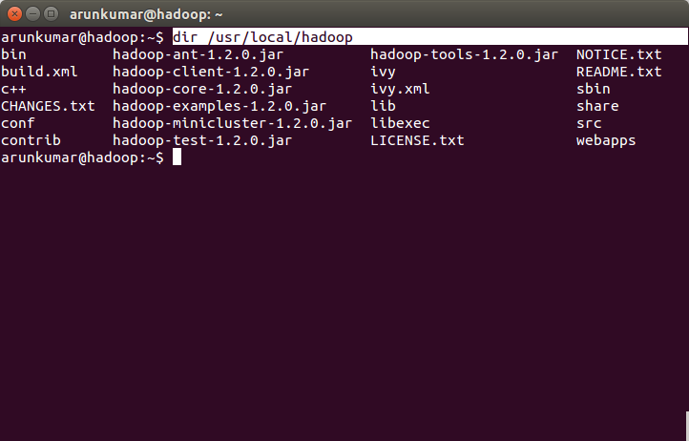

16. Add the HOME location (local HADOOP directory) to the PATH variable in bashrc file.

sudo vi $HOME/.bashrc

Add the below lines at the end of the file

export HADOOP_PREFIX=/usr/local/hadoop

export PATH=$PATH:$HADOOP_PREFIX /bin

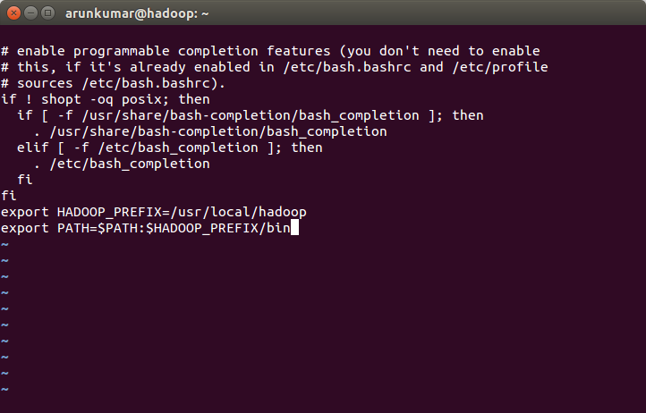

17. Execute the bash once to make the changes in bashrc

exec bash

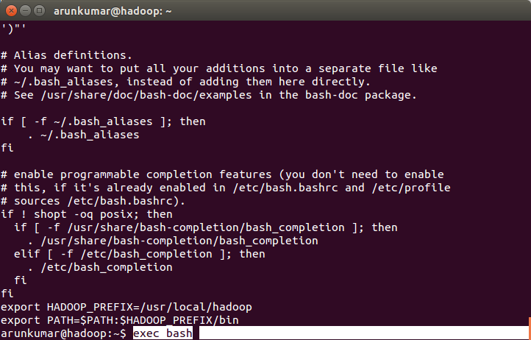

18. check the $PATH for updated path

$PATH

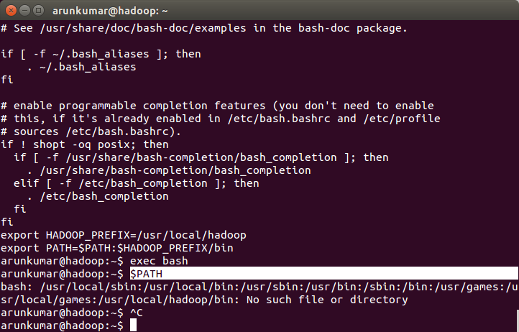

19. Now we can start configuring the hadoop. All the configuration files are located in the conf folder as shown below

dir /usr/local/hadoop/conf

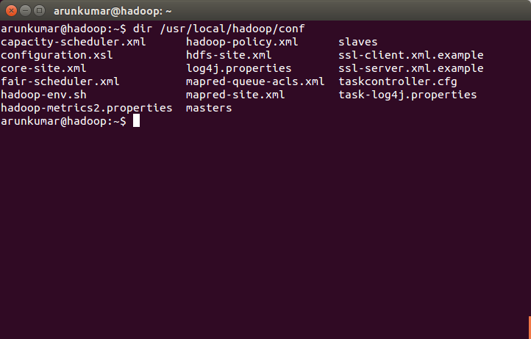

20. we can setup java and disable IPV6. This can be achieved by modifying the hadoop-env.sh file.

sudo vi /usr/local/hadoop/conf/hadoop-env.sh

uncomment the exporting of JAVA_HOME variable :

export JAVA_HOME=/usr/lib/jvm/java-1.7.0-openjdk-amd64

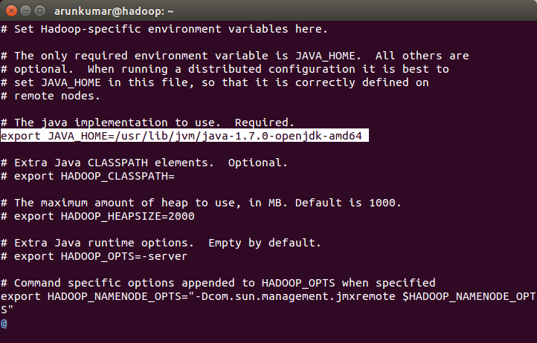

21. Disable ipv6

export HADOOP_OPTS=-Djava.net.preferIPv4Stack=true

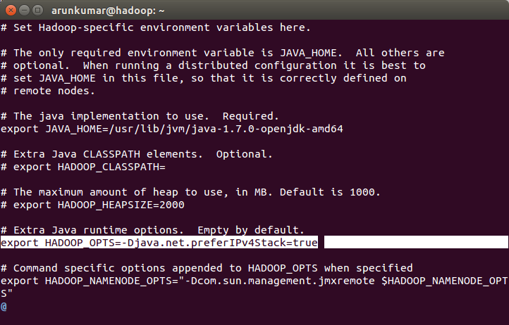

22. Configure the name node (core-site.xml)

sudo vi /usr/local/hadoop/conf/core-site.xml

Add the below property and values

<configuration>

<property>

<name>fs.default.name</name>

<value>hdfs://hadoop:10001</value>

</property>

<property>

<name>hadoop.tmp.dir</name>

<value>/usr/local/hadoop/tmp</value>

</property>

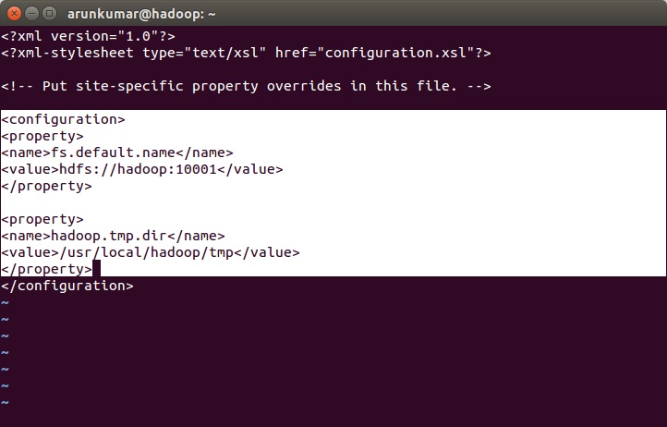

23. Configure the mapred-site.xml (job tracker)

sudo vi /usr/local/hadoop/conf/mapred-site.xml

<configuration>

<property>

<name>mapred.job.tracker</name>

<value>hadoop:10002</value>

</property>

</configuration>

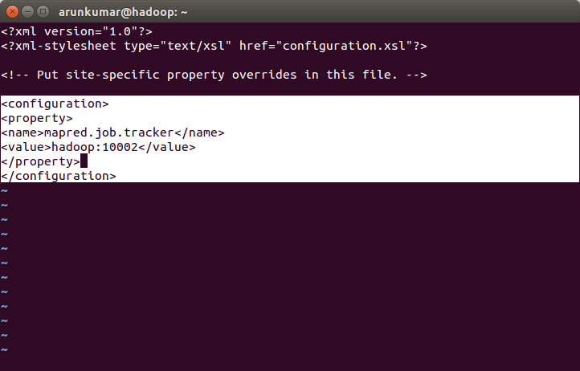

24. Create temporary directory for hadoop

sudo mkdir /usr/local/hadoop/tmp

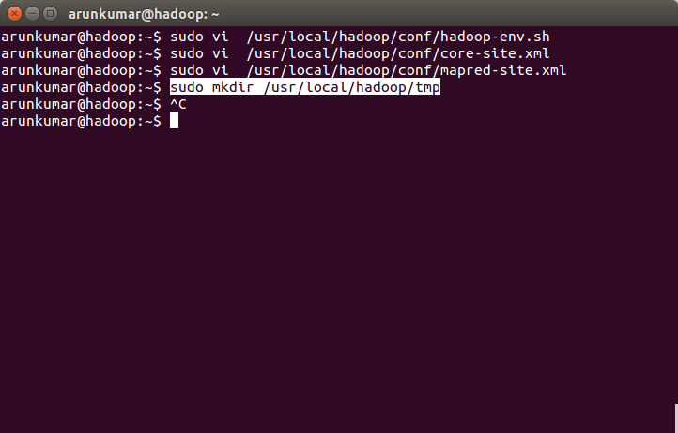

25. change ownership and permission of the directory

sudo chown arunkumar /usr/local/hadoop/tmp

sudo chmod 777 /usr/local/hadoop/

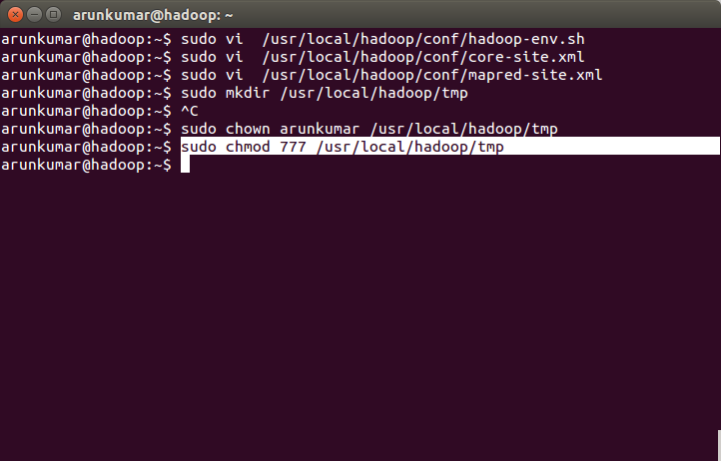

26. Format namenode

hadoop namenode -format

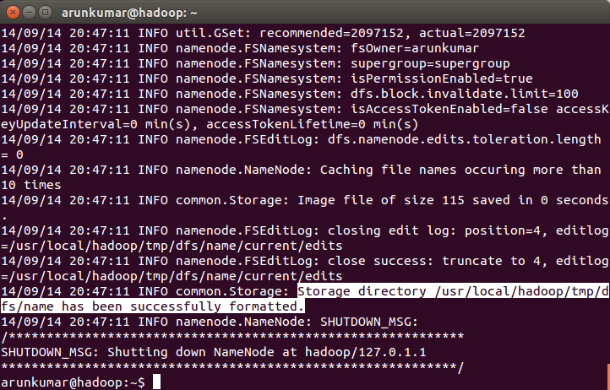

27. start the hadoop

start-all.sh

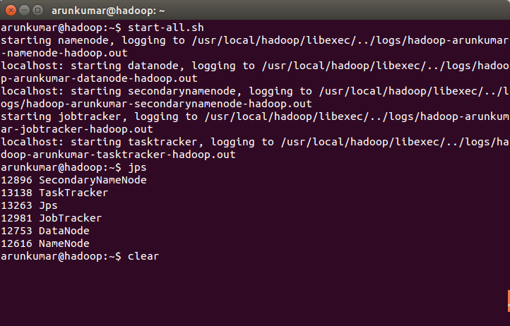

28. Check whether all the daemons are running correctly!

jps

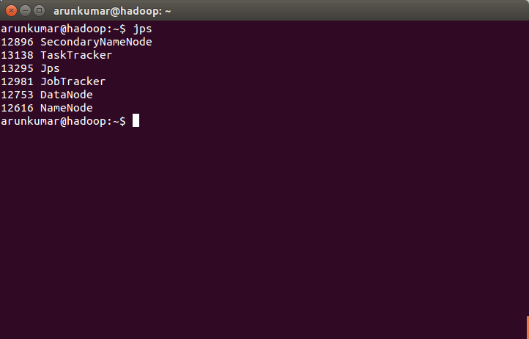

29. Stopping all the daemons

stop-all.sh

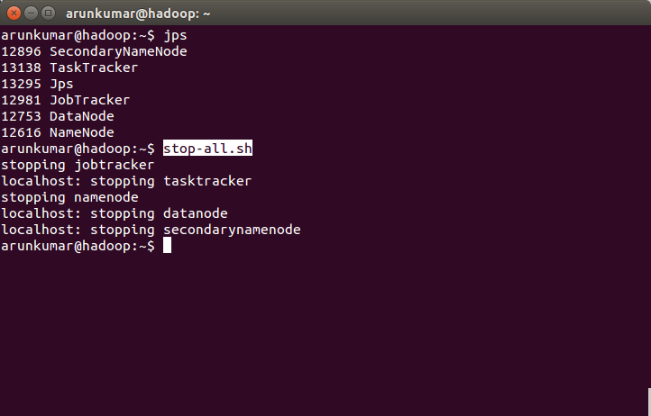

30. Now let see the web UI. Start all the daemons - start-all.sh

Namenode : <http://hadoop:50070/dfshealth.jsp>

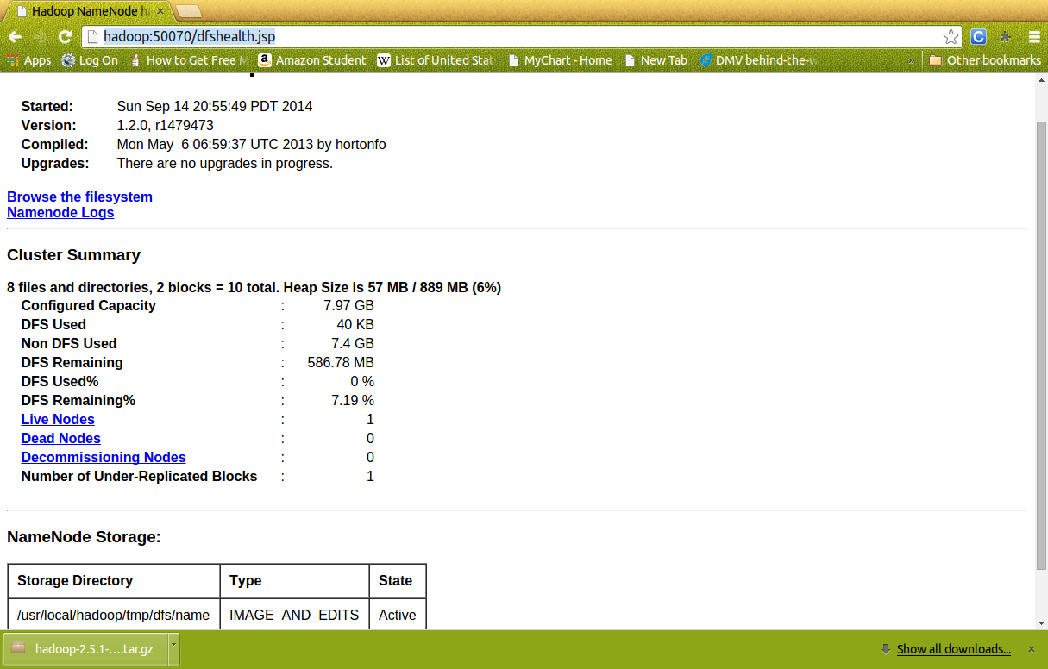

31. UI for jobtracker – map reduce

<http://hadoop:50030/jobtracker.jsp>

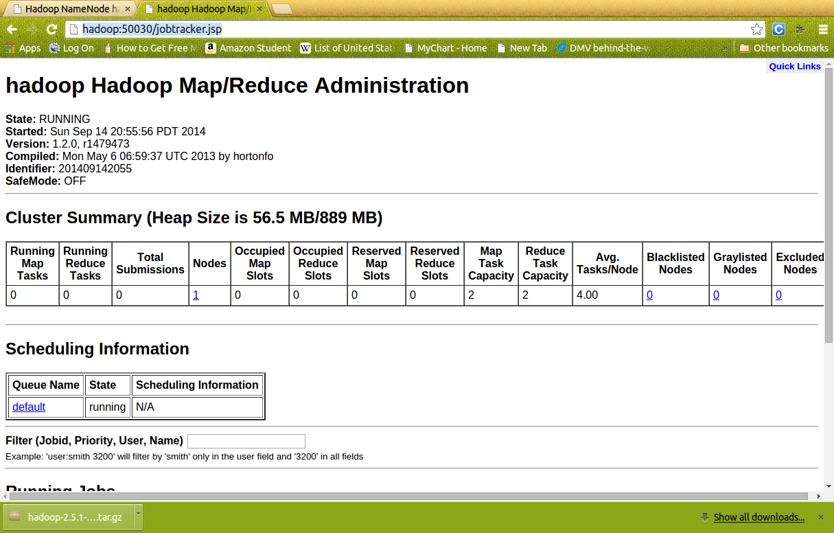

32. UI for tasktracker

<http://hadoop:50060/tasktracker.jsp>

