**From within NocoDB Web App**

Open the ‘App Store’

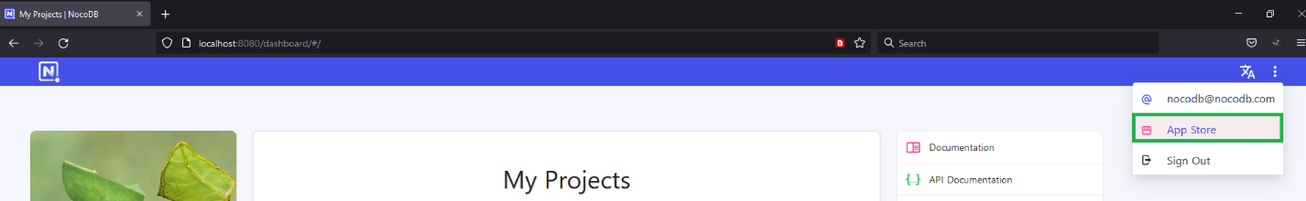

Select Microsoft Teams – Install

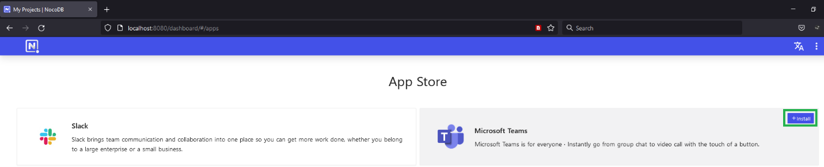

Under ‘Microsoft Teams **Configure Microsoft Teams’**

**Get ready to provide your Teams space:**

**Chanel Name**

**Webhook URL**

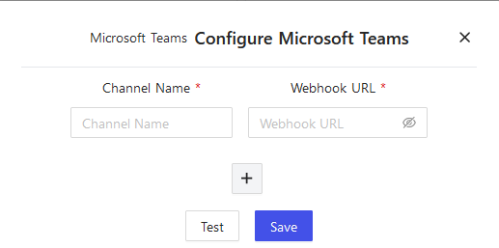

**From within Microsoft Teams**

**Click on your channel and select ‘Connectors’**

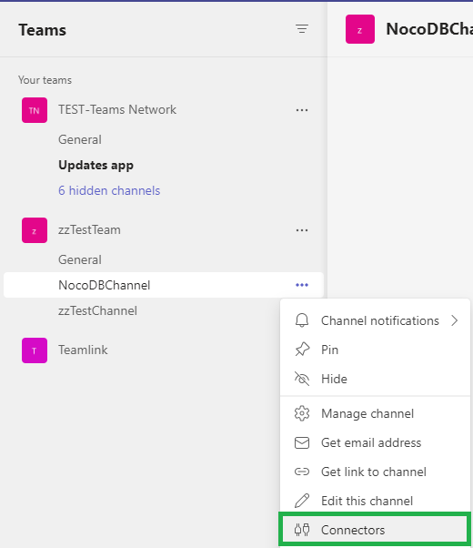

**Choose ‘Incoming Webhook’ and click on ‘Configure’**

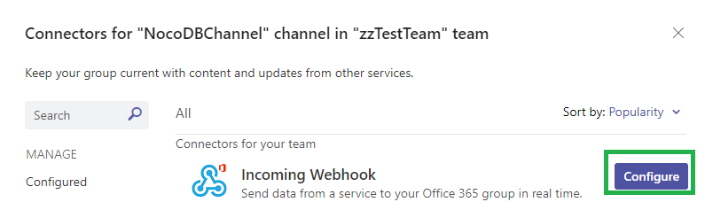

**Provide a Webhook name and click on ‘Create’**

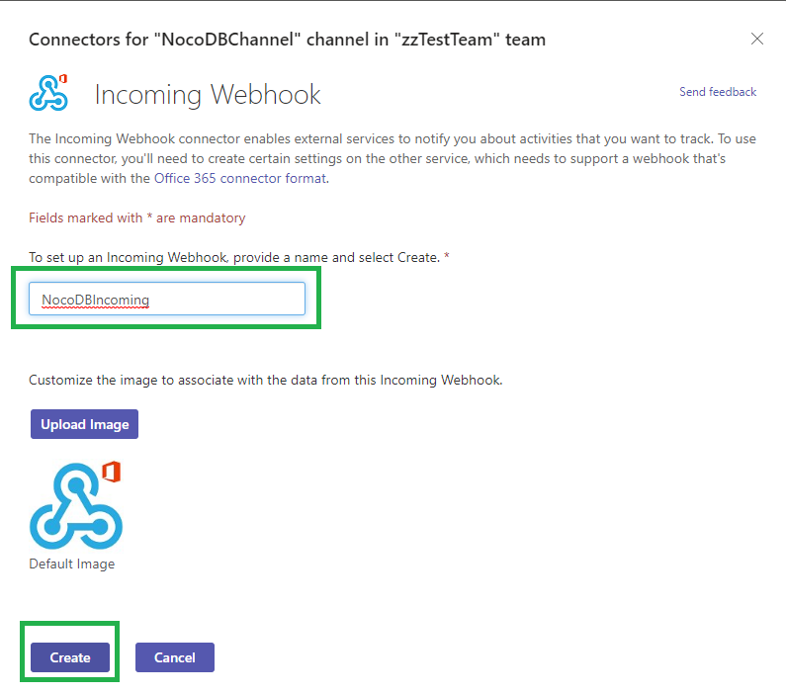

**Important: Copy the URL property and click on ‘Done’ to save your Incoming Webhook configuration**

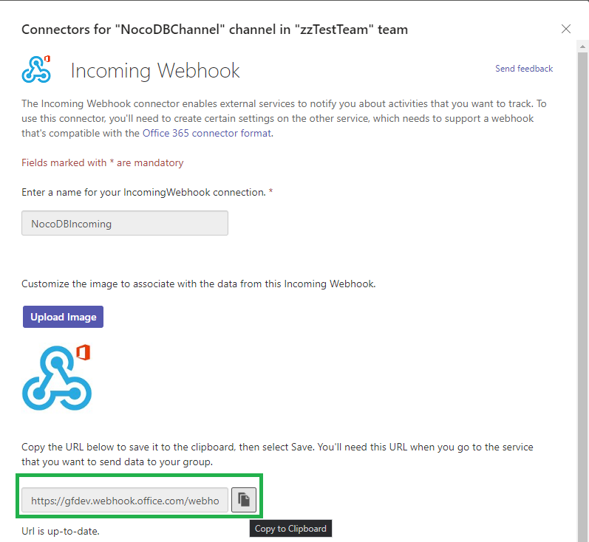

**From within NocoDB Web App**

**Complete the Microsoft Teams configuration by providing:**

**Channel Name = Microsoft Teams Channel Name**

**Webhook URL = Microsoft Teams Channel Webhook URL**

**Click on ‘Save’**

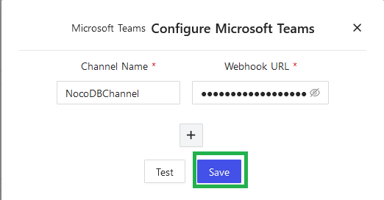

**Go to the relevant table in NocoDB and select the table options - select ‘Webhooks’**

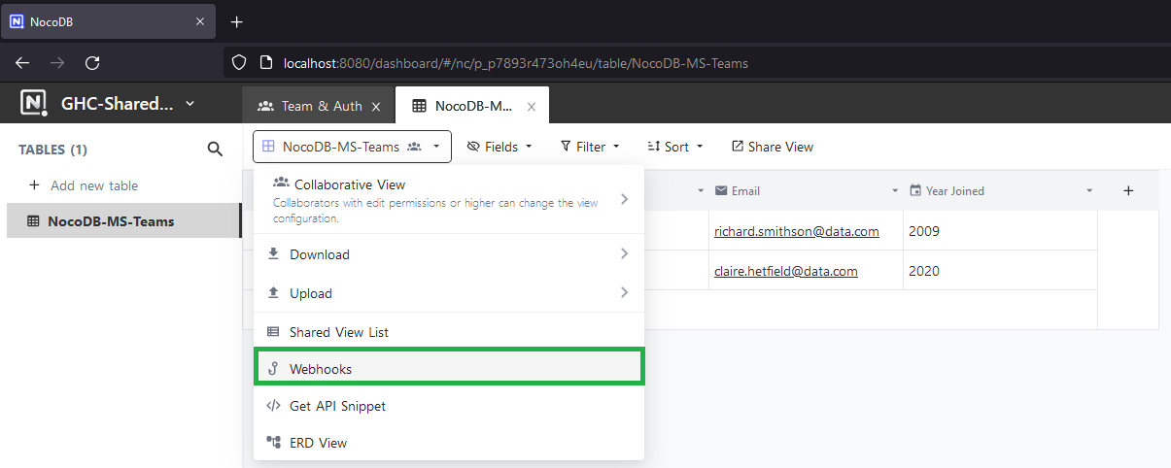

**Select ‘Add New Webhook’**

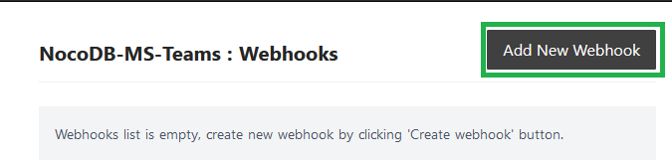

**Provide a name for the Webhook and under ‘URL’ select the ‘Microsoft Teams’ option**

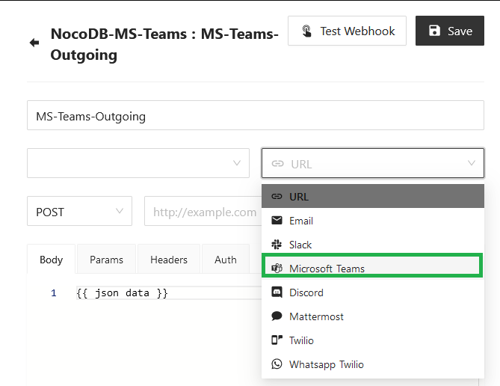

**Provide a name for the Webhook and select your ‘trigger’ options**

**After Insert**

**After Update**

**After Delete**

Important**: Selecting the ‘After Update’ option appears to work best with variable data and MS Teams!**

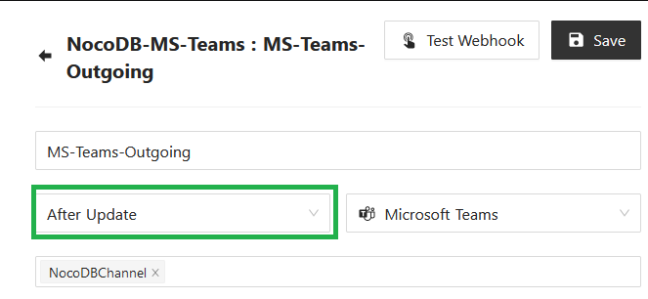

**Select the Microsoft Teams Channel name under ‘Select Microsoft Teams channels’**

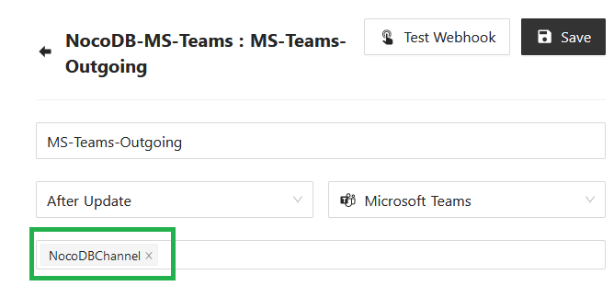

**Populate the ‘Body’ field with data (you can use variable data from your table columns here)**

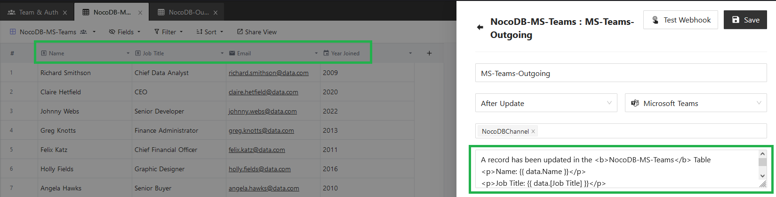

**Example of variable data:**

**A record has been updated in the <b>NocoDB-MS-Teams</b> Table**

**<p>Name: {{ data.Name }}</p>**

**<p>Job Title: {{ data.[Job Title] }}</p>**

**<p>Email: {{ data.Email }}</p>**

**<p>Year Joined: {{ data.[Year Joined] }}</p>**

**Tip: Use {{ json data }} to dump complete data & user information available in JSON format**

**Now test the Webhook connection by selecting ‘Test Webhook’**

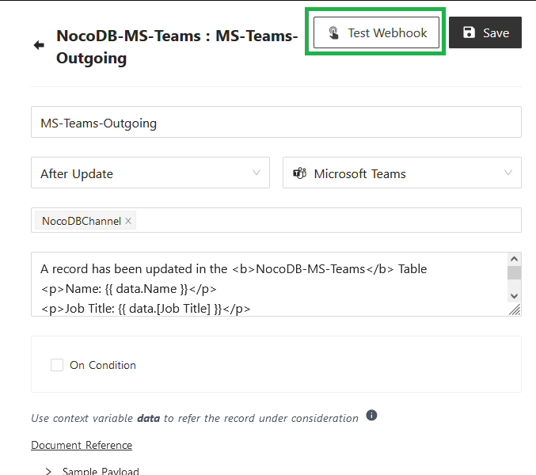

**If connectivity is successful you should see a message saying ‘Webhook tested successfully’**

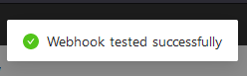

**Click on ‘Save’ to save the Webhook configuration**

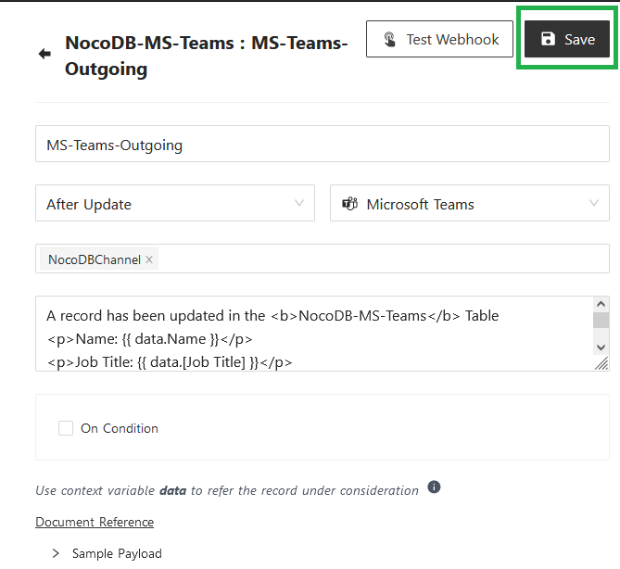

**If you select Webhooks once again from the Table Options you should see your MS Teams Webhook configuration**

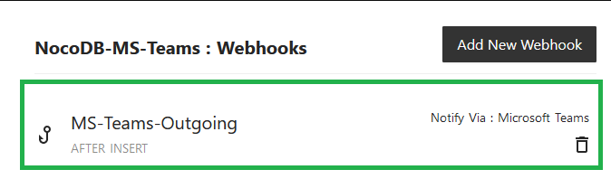

**Test Adding / Editing records in your NocoDB table and you should see the results pushed via the Webhook to your MS Teams Channel**

