Yolov8 model was trained on MOT20 dataset, converted to YOLO format using cvat tool.

**Training:**

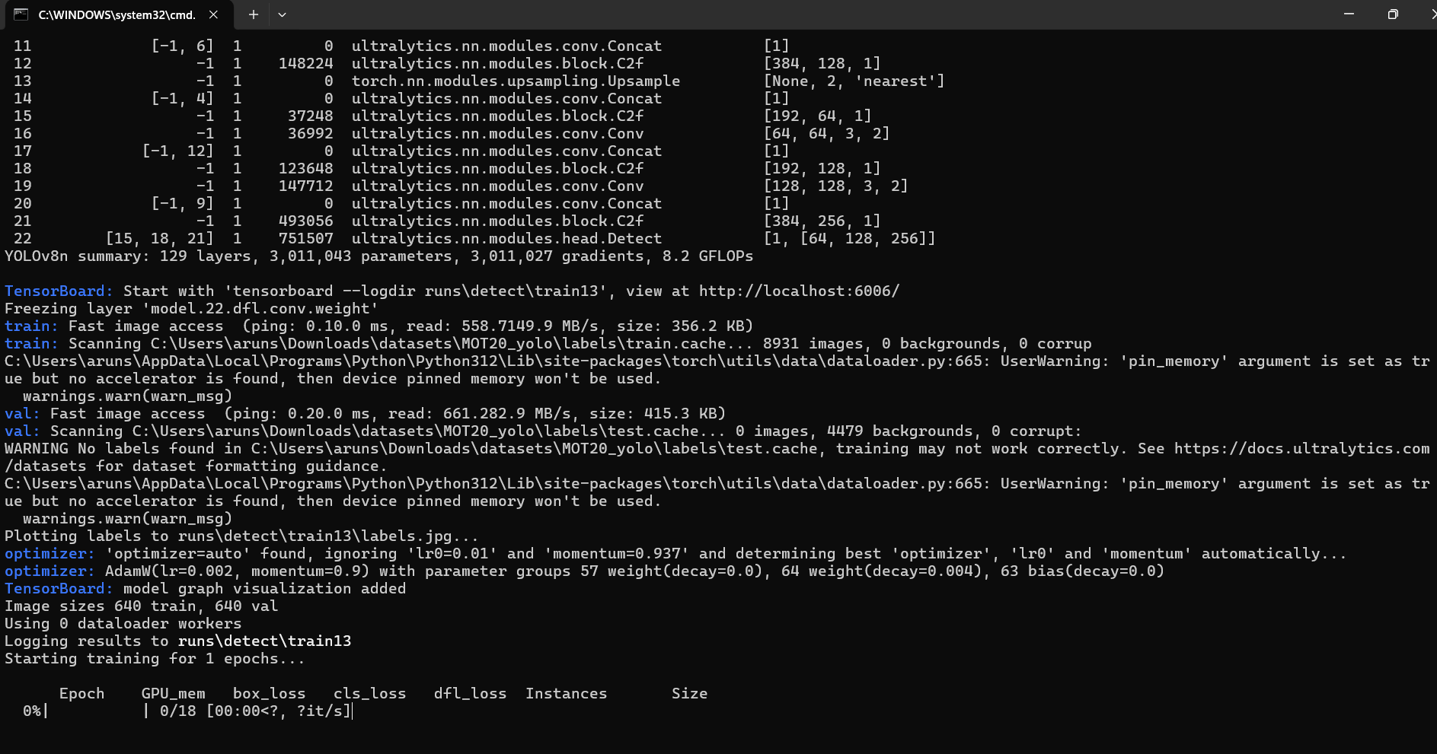

**Dockerization:**

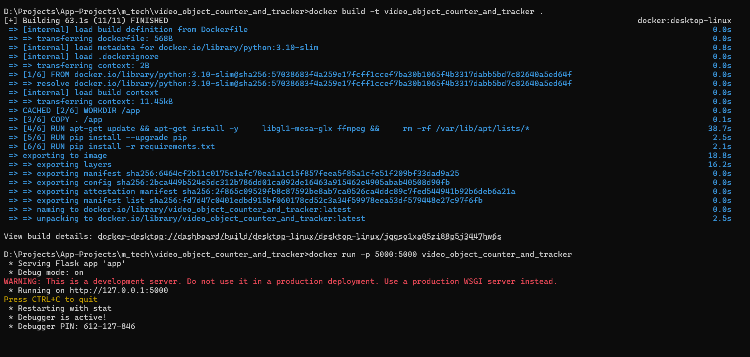

**UI:**

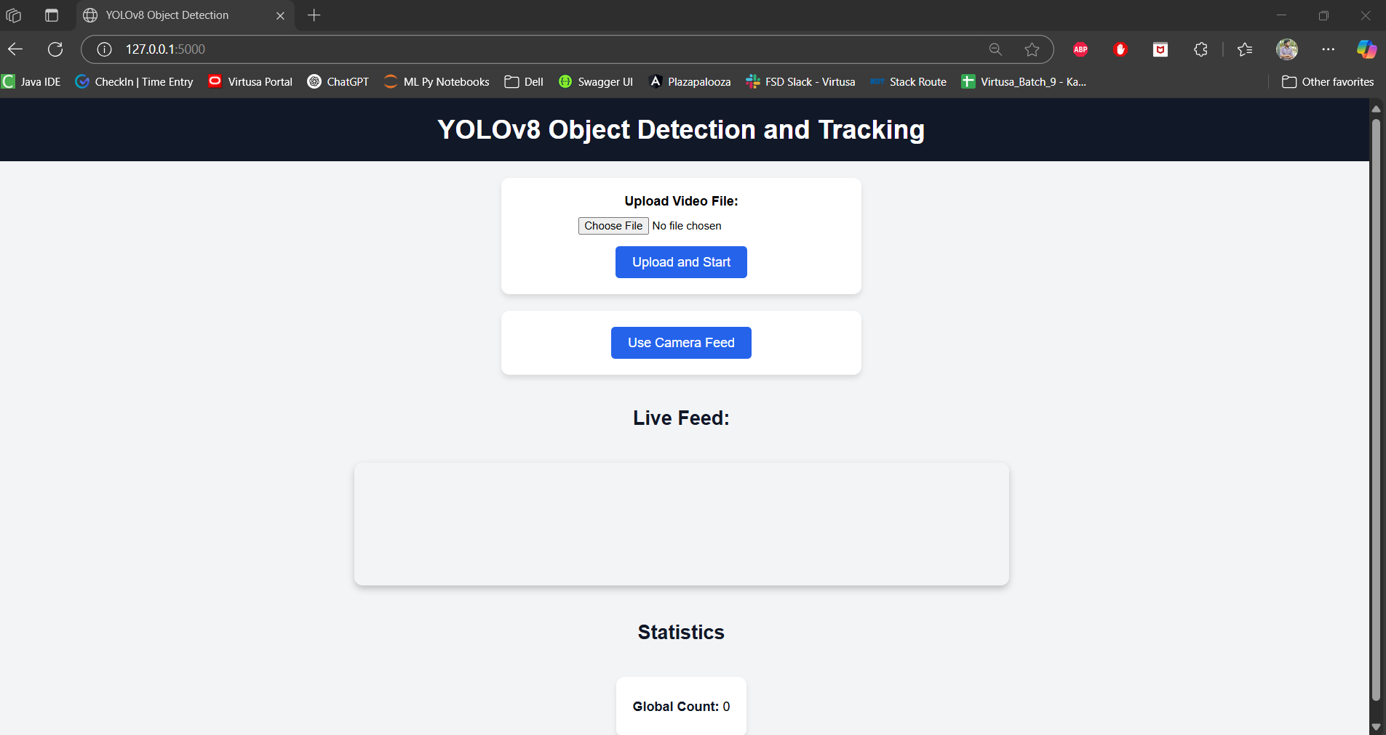

**Testing through uploaded Video:**

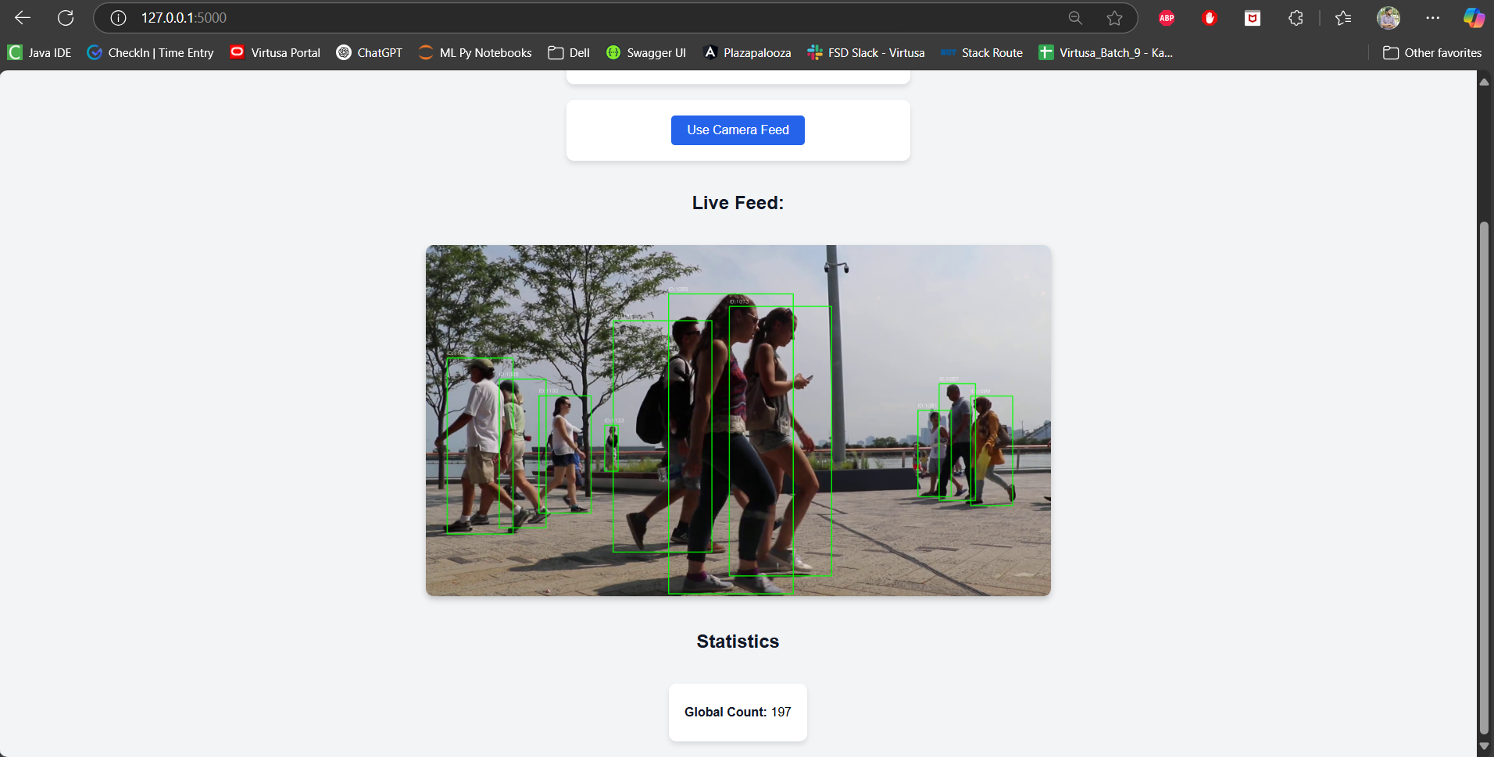

**Testing through camera feed:**

