Ansible Version: Ansible 2.4

Expects CentOS/RHEL 7

This example is an extension of the simple LAMP deployment. Here we'll install and configure a web server with an HAProxy load balancer in front,and mysql-master-slave replica at database.A nagios server setup is also there to monitor all lamp and db servers.

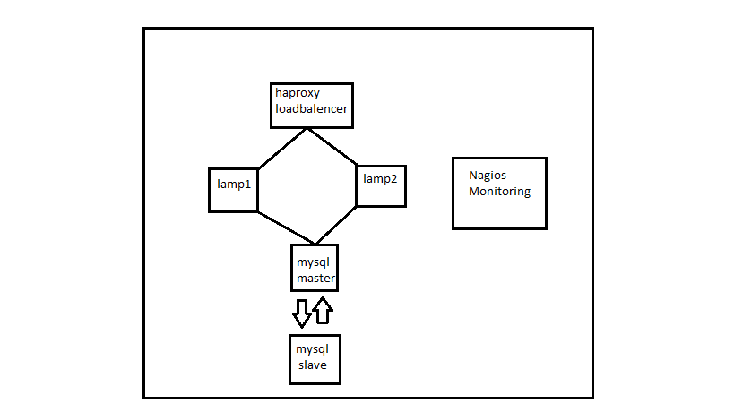

My setup has the following ip.We can change it under group_vars as per requirement:

mysql-master ip: 10.4.0.4

mysql_slave ip: 10.4.0.5

lamp1 ip: 10.4.0.6

lamp2 ip: 10.4.0.7

haproxy ip: 10.4.0.8

nagios server ip: 10.4.0.9

Initial Setup:

First we have to configure host file correctly.replace my host file with proper public ip, username and password.(use root user for convineience).If we are using ssh_encryption we can also use that.

Execute following command to run my playbook

#ansible-playbook -i host main.yml

Note:

Haproxy should have 9600 port at frontend which is mentioned in configuration

So to check haproxy from webserver http://haproxy_public_ip:9600

The Nagios web interface can be reached at http:///nagios_server_ip/nagios/

The default username and password are "nagiosadmin" / "nagiosadmin".