Document Attributes

| Attribute | Value |
| --- | --- |
| Application ID /  Application Name | • OPUS- MOTS ID: 18257  • OPUS Mobile- MOTS ID: 18257 |
| Owner | Arun Kumar Madas |
| Owner Contact Information | (972) 479 8486, am6489 |
| Other Attribute | Arun Saju (as9922)  Pradeep Kodakandla (pk4159) |

## 

Revision History

The following table lists the revision history of this document:

| Author | Date | Version # | Revision Description |
| --- | --- | --- | --- |
| am6489 | 12/3/2014 | 0.1 | Initial Draft |
| As9922 | 12/15/2014 | 0.2 | Updated with design for OPUS Terminal Network ISC250 |
| am6489 | 12/18/2014 | 0.3 | Updated comments from Neetha (NK4747). Added 279095_OPUS_HLD_17. Added Neetha as approver. Updated HLD Elements to include OPUS/OM labels appropriately.  Updated Skip button on/off via Retail location type and project flag based on Pavan Kandi Comments. |
| am6489 | 12/19/2014 | 0.4 | Updated with new enterprise config value WCA_TC_VERBIAGE_ENG_LEGAL_MANDATE for the English wording. WCA_TC_VERBIAGE_SPN_LEGAL_MANDATE for Spanish wording. |
| am6489 | 12/19/2014 | 0.5 | HLD Walk through Notes :   1. Incorporated changes from Jennifer (including Page in the wording for buttons) 2. Incorporating recommendations from Neetha (nk4747) to update the Opus mobile sequence diagram to explicitly show the “print” process. Printing is asynchronous java script call. Updated Opus network ISC250 sequence diagram to show BAU/NEW against the wording. Enhanced Network ISC250 diagram to show overlay and auto re-engaging mechanism |
| am6489 | 12/23/2014 | 0.6 | * Updated HLD elements 279095_OM_HLD_03, 279095_OPUS_HLD_16 for SKIP button after getting confirmation from Business. |
| am6489 | 1/2/2015 | 0.7 | * Business wanted SR element FR -050.SC to be removed as it was duplicate of FR -090.OPUS-T. Updated 279095_OPUS_HLD_10 to reflect the mapping of SR element. Change will not impact code/flag requirement. Same Store flag will be used to control two devices USC ISC250/NW ISC250 as recommended. |
| am6489 | 1/12/2015 | 0.8 | * Removed the name “Neetha” from 279095_OPUS_HLD_10 and made it generic. It was a suggestion to keep the same project flag for both USB ISC250 and NW ISC250 in HLD walk through. |

Table of Contents

Overview 3

Problem Statement 3

Design Decisions 3

Functional Overview 6

Middleware Design 7

External Interfaces 8

Component Diagram 8

Performance Design 9

Security Design 9

UI Design 9

UI Design - Wireframe 9

UI Design - Screen Element Definition and Data Mapping 10

UI Action Processing - Sequence Diagram 11

Asynchronous/Batch Processing - Sequence Diagram 13

Externalized Configuration 13

Database Tier Design 14

Logical Data Model 14

Database Interfaces 14

Batch Interfaces 14

Replication 14

Alternative Designs 14

Assumptions/Risks 14

Pre-Production Disaster Recovery Planning 14

Other Plans and References 14

Acceptance & Approvals 15

## Overview

The High Level Design (HLD) describes how an application will implement the architectural concept and meet the requirements allocated to that application. The High Level Design describes the functionality the application will provide, the overall design for providing that functionality and meeting the nonfunctional requirements, and the rationale for choosing that design. The High Level Design also describes how the application will cooperate and interface with other applications to provide an integrated solution that achieves the architectural concept.

The High Level Design covers these topics:

* Problem Statement
* Design Decisions
* Alternative Designs
* Assumptions/Risks
* Other Plans/References

## Problem Statement

## The purpose of this project is to implement enhancements to the Wireless Customer Agreement (WCA) flow in OPUS Mobile and OPUS. These enhancements were requested by Legal and impact the WCA acceptance and Print functionality, providing more flexibility in the flow and a better experience for the customer and user. This project also includes updated labels and minimal updates to the acceptance text. This document

## Design Decisions

|  |  |  |
| --- | --- | --- |
| **Req. ID** | **Design Element** | **Trace-To** |
| 279095_OM_HLD_01 | ON/OFF flag “OM_279095_WCASIGCAP_LEGAL_MANDATE“ will be created for OM to turn-on/turn-off project level changes introduced by this project Default value of this FLAG will be OFF | FR -001.OPUS-M |
| 279095_OM_HLD_02 | When flag OM_279095_WCASIGCAP_LEGAL_MANDATE is turned-on, clicking on the “Customer Signature” button that shows the overlay for wireless customer agreement will have the overlay header text changed from “Customer Signature” to “Wireless Customer Agreement Acceptance”.  Application currently invokes the overlay using window.location.href='opusmobiletcsignaturepanel'; this need to be changed to accommodate a panel overlay with new header text. We will pass the new header title based on the project flag into the peripheral tag and the overlay will display it accordingly. So far the header title was hardcoded in the native overlay. | FR -005.OPUS-M |
| 279095_OM_HLD_03 | The existing “Skip” button at the top of the Wireless Customer Agreement Acceptance page which currently allows the user skip the signature step shall be hidden.  When Project flag is turned on, (SKIP button will be hidden for all retail channels in OM), we will pass a Boolean parameter “false” to hide the Skip button in the native overlay. | FR -010.OPUS-M |
| 279095_OM_HLD_04 | The next paragraph of the legal terms shall be modified to read:  I understand that this Wireless Customer Agreement ***and Customer*** ***Service Summary*** apply to the following wireless numbers:  (xxx) xxx-xxxx  A new enterprise config variable will be created to include the new wording. The new enterprise config value will be used when project flag is turned on. Existing flag = select * from enterprise_config where vp_key_name = 'WCA_TC_VERBIAGE_ENG’  A new enterprise config variable will be created to include the new wording – “WCA_TC_VERBIAGE_ENG_LEGAL_MANDATE” / “WCA_TC_VERBIAGE_SPN_LEGAL_MANDATE” | FR -020.OPUS-M |
| 279095_OM_HLD_05 | A new “Wireless Customer Agreement:” label in bold shall be added to the Wireless Customer Agreement Acceptance page following the legal terms.  This will be opus mobile native app change. But OPUS application code will invoke the logic to bring up a new native overlay with new label when project flag is turned on. The change is part of the native overlay changes. We will pass a new Boolean value (true) if project flag is turned on as part of the peripheral utility tag to have the native overlay display the new wording. | FR -025.OPUS-M |
| 279095_OM_HLD_06 | A new “View” button shall be added to the Wireless Customer Agreement Acceptance page to the right of the just added” Wireless Customer Agreement:” label.  The function of this new View button on the Acceptance page is to return the user to the WCA document. We will pass a new Boolean value (true) if project flag is turned on as part of the peripheral utility tag to have the native overlay display the new wording. | FR -030.OPUS-M |
| 279095_OM_HLD_07 | The “Previous” button currently located on the WCA document will be hidden from view when the user returns to the WCA document from the Acceptance page via the new View button.  The existing options “Print” and “Go to Acceptance” will remain visible and BAU on the WCA document. Native overlay has to set a property in session to be able to identify that user was navigating from the overlay to the WCA to hide the previous button. | FR -035.OPUS-M |
| 279095_OM_HLD_08 | A new “Print” button shall be added to the Wireless Customer Agreement Acceptance page to the right of the just added” View” button.  The function of this new “Print” button is to send the WCA document to the printer and generate the display of a Sent to Printer confirmation alert that shall read: “The Wireless Customer Agreement has been sent to printer: ‘*Printer Name Here’*”. The WCA document will not be opened in this case, instead a silent print request will be sent to the printer. | FR -040.OPUS-M |
| 279095_OM_HLD_09 | Sent to printer alert message will contain the OK button, clicking on which will close the alert overlay. | FR -045.OPUS-M |
|  | **Network Sigcap ISC250 & USB ISC250 Changes for opus desktop** |  |
| 279095_OPUS_HLD_10 | ON/OFF flag “OPUS_279095_WCASIGCAP_LEGAL_MANDATE“ will be created for OPUS to turn-on/turn-off project level changes introduced by this project. Default value of this FLAG will be OFF. Turning off this flag should turn off the entire functionality implemented for this project.  Do we need two project flags for USB ISC250 VS NW ISC250. Since this project is having globally applicable changes to all sigcaps, we can use only one project flag for both devices. | FR -090.OPUS-T |

|  |  |  |
| --- | --- | --- |
| 279095_OPUS_HLD_11 | On the Wireless Customer Agreement displayed on the sigcap, replace the “<” button to “< Prev Page” and “>” button to “> Next Page”  This will be a change in the images used on the sigcap forms. We need to use equivalent Spanish verbiage for Spanish forms.  No Functional changes will be made.  Changes affect all forms used in the display of Wireless Customer Agreements. We will pass the new apiKey when project flag is turned on to appropriate new buttons and new forms will be used on the device.  Impacts: Network and USB ISC250 | FR -055.SC |
| 279095_OPUS_HLD_12 | Network Sigcap : ISC250  The existing Print button will be replaced with a new “**Print WCA**” button only in the acceptance/signature form. Other forms will contain Print wording only.  Clicking Print/ Print WCA button on the WCA form will display a new form with disabled background and overlay that will have an “OK” button and a message that reads  “Your print request has been received. Click OK to notify your sales consultant and proceed.”  Clicking OK will then initiate the print request message from device framework to the OPUS Terminal for the Print functionality which is BAU (An alert message will be displayed on the desktop that says – “Customer choose to print, click OK to proceed”, Clicking OK on the desktop terminal will then open up the WCA in a new window and then auto print the WCA).  USB ISC250 :  Clicking OK on the message “Your print request has been received. Click OK to notify your sales consultant and proceed.” will show the first page of the WCA page. (while window opens and prints the WCA). | FR -060.SC  FR -075.SC |
| 279095_OPUS_HLD_13 | AutoEngage Device After Print  In the event that the user requests for a print by clicking on the Print WCA button on the WCA form, a print request will be sent to the OPUS terminal (279095_OPUS_HLD_11). After this request, OPUS terminal will try to reengage the same sigcap device by internally calling processUseStation() javascript method.  The processUseStation method will try to connect to the same device sigcap device that performed the previous transaction. The wca window PDF pop-up (printing) and device network overlay will be seen at the same time in this case. | FR -060.SC  FR -075.SC |
| 279095_OPUS_HLD_14 | Failure during AutoEngage Device After Print  In the event that the auto engage operation fails, the OPUS terminall will display an error message and the list of available devices for that store ( BAU) | FR -060.SC  FR -075.SC |
| 279095_OPUS_HLD_15 | A new “**View WCA**” button and a new “**Print WCA**” button will be added to the SigCap bottom left of the Acceptance page / signature page. The existing buttons “Accept”/”Clear”/”Decline” will be moved to the bottom right as shown in the wireframe. | FR -065.SC |
| 279095_OPUS_HLD_16 | Clicking on the “**View WCA**” button on the signature page will return the user to the first page of the WCA document. (form1/page1)  Network ISC250 :  Clicking the “View” in the network ISC250 will take the user back to the page1 of the WCA document (without loosing the connectivity with the opus terminal / device).  USB ISC250 :  Clicking the “View” button in USB ISC250, will take the user back to the page1 of the WCA document. | FR -070.SC |
| 279095_OPUS_HLD_17 | Clicking on the “**Print WCA**” button on the signature page will have the same action as the Print WCA button in 279095_OPUS_HLD_11 | FR -070.SC |
| 279095_OPUS_HLD_18 | I understand that this Wireless Customer Agreement ***and Customer*** ***Service Summary*** apply to the following wireless numbers:  (xxx) xxx-xxxx  A new enterprise config variable will be created to include the new wording. The new enterprise config value will be used when project flag is turned on. This content is same for both opus and opus mobile. | FR -085.SC |
| 279095_OPUS_HLD_19 | SKIP button shall be hidden for OPUS COR stores and BAU for Non-COR stores.  When Project flag OPUS_279095_WCASIGCAP_LEGAL_MANDATE is turned on, and if Network ISC250 store flag ENABLE_NW_SIGCAP_ISC250_OPUS is turned on (SKIP button will be hidden), otherwise Skip button will be visible.  For Network ISC250, if the device is not available, and if the rep wants to use another station, he can connect to another sigcap station (BAU). Use station will always be enabled (BAU) on the network isc250.  USB ISC250 (BAU) 🡪 onPageLoad() we will engage the device for displaying WCA on the USB ISC250 in LD stores (BAU). USB ISC250 will not be initialized when the project store flag for Network sigcap ISC250 ENABLE_NW_SIGCAP_ISC250_OPUS is turned ON (BAU). | FR -095.OPUS-T |
| 279095_OPUS_HLD_20 | The header label on the signature page of the SigCap Wireless Customer Agreement shall be modified to read “**Wireless Customer Agreement** **(WCA)**”.  Equivalent Spanish change will also be made in the wordings. This change is present in NwActivationSessionData.java for network sigcap. | FR -063.SC |

The [SRT_RM_ReqPro_Auto_Tagging](https://cps.web.att.com/CPSWorkplace/getContent?id=current&vsId=%7B67070CE6-CDED-4932-8F1D-F6073BA40DF8%7D&objectStoreName=IT-Architecture.__.Planning.__.and.__.Integration&objectType=document&guestId=servicesguest) Reference Document provides information on how to use auto-tagging within SRT ReqPro.

If the table is not used to capture requirements, please remove it from document.

## Functional Overview

|  |  |  |
| --- | --- | --- |
| **Module Name** | **New/Existing** | **Functional description** |
| OM : WCA Signature page | Update | Add two new buttons “View WCA” and “Print WCA” on the Signature page. |
| OM : WCA PDF Document buttons | Update | Remove button “Previous” from the WCA PDF document when navigating from “Signature” overlay page via “View” button. |
| OPUS : WCA Sigcap display | Update | Show button labels are “< Prev” / “> Next” instead of “<” / “>” |
| OPUS : WCA Sigcap –Signature display | Update | Display two additional buttons “View WCA” and “Print WCA” at the bottom of the signature page and move the existing buttons “Accept” / “Clear” / “Decline” to the bottom right corner. Clicking “View” |
| OPUS : WCA Sigcap display | Update | Update the Print button to Print WCA. |
| OPUS : WCA Sigcap –Print overlay display | Update | Clicking “Print WCA” button on the sigcap device will display an overlay message “The print request has been received” |

## Middleware Design

* Not Applicable. All interactions are at the frontend (jsp->action / BAU) and applet client level events only.

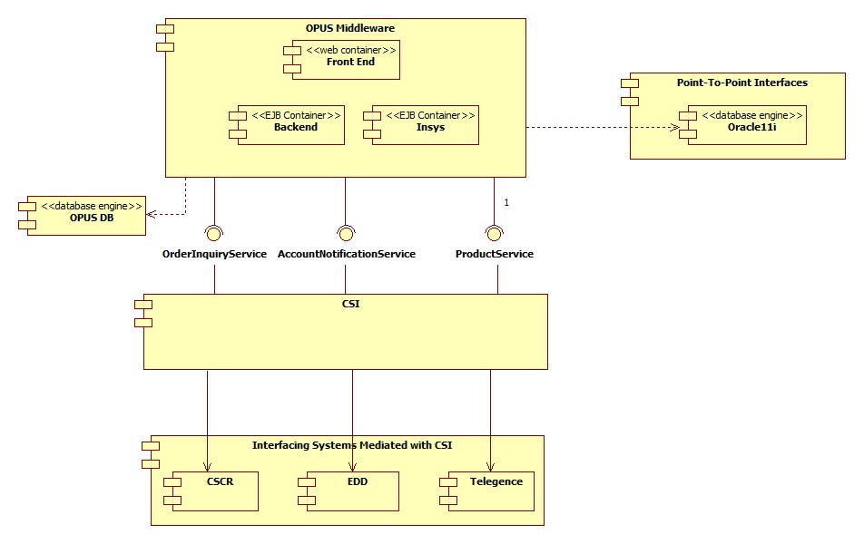

**External Interfaces**

* Not Applicable. All interactions are at the frontend (jsp->action / BAU) and applet client level events only.

### Component Diagram

|  |  |  |
| --- | --- | --- |
| **Change Summary** | | |
| **Component Name** | **Change type** | **Change Description** |
| Opus Mobile : Signature overlay | Update | Update the signature acceptance page to display two new buttons “View” / “Print” and update labels on the native overlay. Clicking “View” will show the WCA Document with “Previous” button hidden and “Print” will send the WCA Document to the printer. |
| Opus : Network ISC 250, WCA display | Update | Based on the project flag, we need to display new forms on the network ISC250, which will show new buttons “< Prev” , “> Next” instead of “<” / “>”. In addition on the signature acceptance page it will show new buttons at the bottom left “View” / “Print” and move the existing buttons to the bottom right (Accept / Clear / Decline) |
| Opus : USB ISC 250, WCA Display | Update | Based on the project flag, we need to display new forms on the USB ISC250, which will show new buttons “< Prev” , “> Next” instead of “<” / “>”. In addition on the signature acceptance page it will show new buttons at the bottom left “View” / “Print” and move the existing buttons to the bottom right (Accept / Clear / Decline) |

High Level – Component Diagram for Opus Mobile:

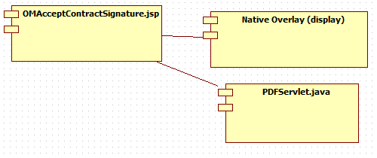

High Level – Component Diagram for Opus Desktop : Network Sigcap ISC250 :

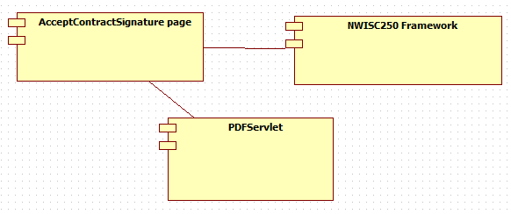

High Level – Component Diagram for Opus Desktop : USB Sigcap ISC250 :

* Not Applicable : All the interaction for the USB ISC250 is on the client side only (Please see sequence diagram)

**Performance Design**

NA

### 

### Security Design

*Create an inventory of all SPI/PCI data elements that will require special handling with encryption and watermarking at each architecture layer.*

* **NA**

|  |  |  |
| --- | --- | --- |
| **SPI/PCI Data Element Inventory** | | |
| **Screen Elements** | | |
| **#** | **Element Name** | **Handling** |
| *1* | *NA* | *NA* |
|  |  |  |
| **External Interface Elements (Service/EJB calls)** | | |
| **#** | **Element Name** | **Handling** |
| 1 | *NA* | *NA* |
|  |  |  |
| **Database Elements** | | |
| **#** | **Element Name** | **Handling** |
| *1* | *NA* | *NA* |
|  |  |  |

|  |  |  |  |
| --- | --- | --- | --- |
| **Watermarking Inventory** | | | |
| **#** | **SPI/PCI Entity/Attribute Name** | **Logging Injection Point** | **Watermarking utility** |
| 1 | NA | NA | NA |

### UI Design

### UI Design - Wireframe

<http://alhoov1uvinda01:8600/OPUS/OPUS_Launcher_DEV/pdfs/OPUS/OPUSMobile_279095_IndividualActivation.pdf>

<http://alhoov1uvinda01:8600/OPUS/OPUS_Launcher_DEV/pdfs/OPUS/OPUS_279095_IndividualActivation.pdf>

### UI Design - Screen Element Definition and Data Mapping

|  |  |  |  |  |  |  |  |  |  |
| --- | --- | --- | --- | --- | --- | --- | --- | --- | --- |
| **Screen : OM WCA** (OMAcceptContractSignature.jsp) | | | | | | | | | |
| **Change Summary** | | | |  | | | | | |
| **Element Label** | **Required?** | **Element Type** | **Table column?** | **SPI/PCI** | **Default Value** | **Format** | **Data Source/Target** | **Tab Order** | **Init. Focus** |
| Previous | No | Button | No | No | N/A | N/A | Hide button when coming from native overlay | First | N/A |
| Skip | No | Button | No | No | N/A | N/A | Hide button when project flag is on | Second | N/A |

|  |  |  |  |  |  |  |  |  |  |
| --- | --- | --- | --- | --- | --- | --- | --- | --- | --- |
| **Screen :** WCA (AcceptContractSignature.jsp) | | | | | | | | | |
| **Change Summary** | | | |  | | | | | |
| **Element Label** | **Required?** | **Element Type** | **Table column?** | **SPI/PCI** | **Default Value** | **Format** | **Data Source/Target** | **Tab Order** | **Init. Focus** |
| Skip | No | Button | No | No | N/A | N/A | Hide button when project flag is on | Second | N/A |

|  |  |  |  |  |  |  |  |  |  |
| --- | --- | --- | --- | --- | --- | --- | --- | --- | --- |
| **Screen :** OM WCA Native Overlay (opusmobiletcsignature) | | | | | | | | | |
| **Change Summary** | | | |  | | | | | |
| **Element Label** | **Required?** | **Element Type** | **Table column?** | **SPI/PCI** | **Default Value** | **Format** | **Data Source/Target** | **Tab Order** | **Init. Focus** |
| View | No | Button | No | No | N/A | N/A | Navigate to WCA page | First | N/A |
| Print | No | Button | No | No | N/A | N/A | Print WCA Page | Second | N/A |

### UI Action Processing - Sequence Diagram

Sequence Diagram for Opus Mobile Changes:

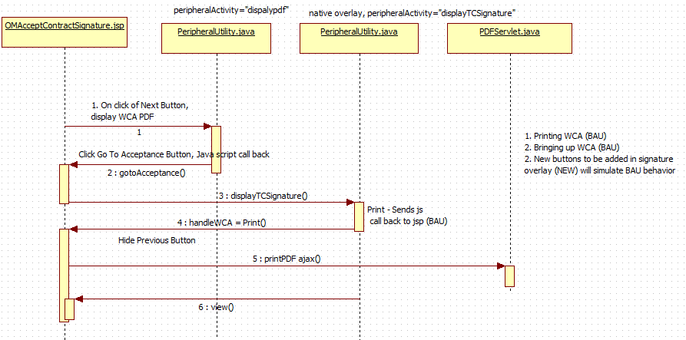

Sequence Diagram for Network Sigcap ISC250 :

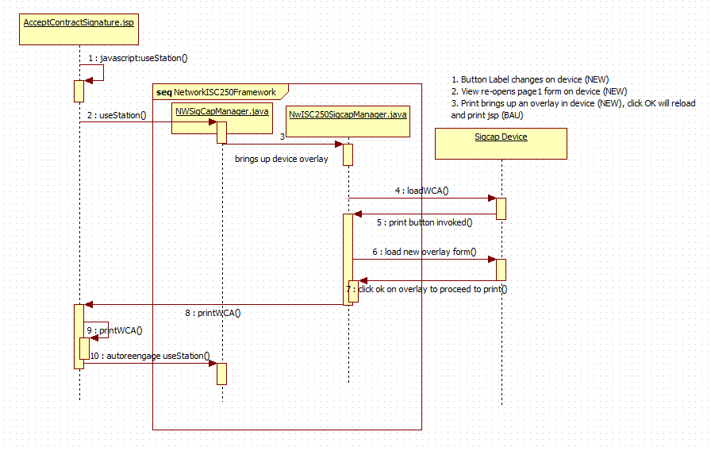

Sequence Diagram for USB Sigcap ISC250 :

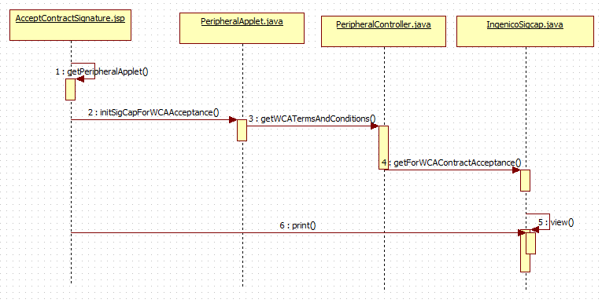

### Asynchronous/Batch Processing - Sequence Diagram

*NA*

**Externalized Configuration**

*All application configuration parameters (table filled out with examples).*

|  |  |  |
| --- | --- | --- |
| **Application Configuration Parameters** | | |
| **Parameter Type** | **Parameter name** | **Description** |
| Store Level configuration | OM_279095_WCASIGCAP_LEGAL_MANDATE | This store configurations provide ability to turn off project level changes for opus mobile |
| Store Level configuration | OPUS_279095_WCASIGCAP_LEGAL_MANDATE | This store configurations provide ability to turn off project level changes for opus desktop for (network isc250 & USB isc250) |
| Enterprise Config | WCA_TC_VERBIAGE_ENG_LEGAL_MANDATE | Contains the new legal wordings -- *I understand that the Wireless Customer Agreement* ***and Customer******Service Summary*** *apply to the following wireless numbers* |
| Enterprise Config | WCA_TC_VERBIAGE_SPN_LEGAL_MANDATE | Contains Spanish equivalent wording. |

## Database Tier Design

*NA*

### Logical Data Model

|  |  |  |
| --- | --- | --- |
| **Change Summary** | | |
| **Entity Name** | **Change type** | **Change Description** |
| NA | NA | NA |
|  |  |  |
|  |  |  |

*Sample diagram shown below.*

NA

### Database Interfaces

* *NA*

### Batch Interfaces

*NA*

### Replication

*NA*

## Alternative Designs

NA

## Assumptions/Risks

* Project level store flags to control the functionality implemented for this project to mitigate the risk.

## Pre-Production Disaster Recovery Planning

### NA

## Other Plans and References

NA

|  |
| --- |
|  |

## 

## Acceptance & Approvals

Overview

Use this section to capture approvals in the event that electronic approvals via the PRISM Project Workflow Module will not be used.

The Approvers of this work product agree that this document is acceptable and complete to the best of their knowledge and will be used by the project team as an official deliverable for the project. It is further agreed that this document can now be baselined and any changes to these sections from this point forward must follow the Managing Change in the Technology Development Unified Process.

Embed evidence of approval in the review table below, or use the PRISM Approval Functionality in the Project Workflow Module Workflow Template View.

Approvers

|  |  |  |  |
| --- | --- | --- | --- |
| **ATTUID and Name** | **Role** | **Group/Application** | **Version Approved, Approval Date and Approval Evidence** |
| Kandi, Pavan | PTA | OPUS / OM |  |
| Manchikalapudi, Ram | PTA | OPUS / OM |  |
| Kasuganti, Neetha | Retail Functional Architecture | OPUS / OM |  |
| Gunna, Moapal | STD | OPUS / OM |  |
| Jadhav, Sharad | STD | OPUS / OM |  |
|  |  |  |  |
|  |  |  |  |
|  |  |  |  |