Document Attributes

| Attribute | Value |
| --- | --- |
| Application ID /  Application Name | • OPUS- MOTS ID: 18257  • OPUS Mobile- MOTS ID: 18257 |
| Owner | Madas, Arun (am6489) |
| Owner Contact Information | 972-479-8478 |
| Other Attribute |  |

## 

Revision History

The following table lists the revision history of this document:

| Author | Date | Version # | Revision Description |
| --- | --- | --- | --- |
| am6489 | 10/30/2015 | 0.1 | Initial Draft |
| am6489 | 11/02/2015 | 0.2 | HLD Walk through recommended changes. Removed static pre-text wca verbiage. Added clarity on LD printing on opus mobile. Added text about sigcap print. |
| am6489 | 11/12/2015 | 0.3 | Added new HLD element 287506_OPUS_OM_HLD_16 to address doc only CR#136787 |

Table of Contents

Overview 3

Problem Statement 3

Design Decisions 3

Functional Overview 6

Middleware Design 7

External Interfaces 8

Component Diagram 8

Performance Design 9

Security Design 9

UI Design 9

UI Design - Wireframe 9

UI Design - Screen Element Definition and Data Mapping 10

UI Action Processing - Sequence Diagram 11

Asynchronous/Batch Processing - Sequence Diagram 13

Externalized Configuration 13

Database Tier Design 14

Logical Data Model 14

Database Interfaces 14

Batch Interfaces 14

Replication 14

Alternative Designs 14

Assumptions/Risks 14

Pre-Production Disaster Recovery Planning 14

Other Plans and References 14

Acceptance & Approvals 15

## Overview

The High Level Design (HLD) describes how an application will implement the architectural concept and meet the requirements allocated to that application. The High Level Design describes the functionality the application will provide, the overall design for providing that functionality and meeting the nonfunctional requirements, and the rationale for choosing that design. The High Level Design also describes how the application will cooperate and interface with other applications to provide an integrated solution that achieves the architectural concept.

The High Level Design covers these topics:

* Problem Statement
* Design Decisions
* Alternative Designs
* Assumptions/Risks
* Other Plans/References

## Problem Statement

## Legal team is seeking enhancement to Retail channel ordering systems (OPUS, OPUS Mobile) to ensure that the Wireless Customer Agreement (WCA) is included with all Transfers of Billing Responsibility (TOBR) transactions.

## Currently the TOBR flow in OPUS and OPUS Mobile includes a dynamically generated "TOBR Agreement Form", but does not directly display the Wireless Customer Agreement. The WCA is a legal requirement This is a gap in current system that must be closed.

## Design Decisions

|  |  |  |
| --- | --- | --- |
| **Req. ID** | **Design Element** | **Trace-To** |
| 287506_OPUS_OM_HLD_01 | HLD18 OPUS/OM shall support single 'on/off' project flag TRANSFER_WCA_ENABLED that enables/disables all 287506 functionality. Default value of the flag will be "OFF". "OFF" will be pre-1511 functionality where no WCA will be shown in Transfer Mobile flow. | 287506-OPUS.SR.010 |
| 287506_OPUS_OM_HLD_02 | HLD4 The current WCA document that OPUS/OM uses for Activations will be leveraged for TOBR flow. OPUS shall not retrieve a combined TOBR & WCA document from EDP instead using the existing documents and append them.  SELECT *  FROM WCA_OBJECTS  WHERE LANGUAGE_INDICATOR='E' AND IS_CURRENT='Y'  AND WCA_TYPE like 'WIRELESS%';  SELECT WCA_DATA  FROM WCA_OBJECTS  WHERE LANGUAGE_INDICATOR='E' AND FORMAT='txt' AND IS_CURRENT='Y' AND WCA_TYPE= 'TOBRTNC';  TOBR and WCA documents will be rendered in sequence(for OPUS mobile)/concatenated format(for LD/OPUS Desktop terminal sigcap devices, USB ISC250 / NW ISC250 sigcap devices) when presented for the signature capture. | 287506-OPUS.SR.020 |
| 287506_OPUS_OM_HLD_03 | HLD5 During the Transfer Mobile flow from customer summary, along with ToBR agreement, WCA agreement will be displayed to the end user.  When using opus mobile (iPad or windows8 Tablet), ToBR agreement and WCA agreement will both be displayed in respective order.  When using opus COR Desktop terminal with Network ISC250 signature capture or when using eopus LD Desktop terminal with USB ISC250 signature capture - Both devices will show concatenated ToBR and WCA documents on the device and ask customer to sign one signature acceptance for concatenated agreements.  Single signature will be captured for both agreements. | 287506-OPUS.SR.030 |
| 287506_OPUS_OM_HLD_04 | **HLD6 OPUS Desktop Terminal / Opus Mobile : Signature Prompt Screen**  Following Legal Approved verbiage will be shown to the end user on the signature prompt screen of the USB ISC250/NW ISC250 sigcap devices. Same Text is also displayed on the Opus Mobile signature prompt screen. If message does not fit on the device or ipad, scrollbar will be shown to scroll below:  I have reviewed and agree to the rates, terms, and conditions for the wireless products and services described in the Wireless Customer Agreement (including limitation of liability and arbitration provisions), the Transfer of Billing Responsibility Agreement, and if applicable the AT&T NEXT Retail Installment Agreement, all of which were made available to me prior to my signing.||I understand that these agreements apply to the wireless numbers ##MOBILENUMBER||Transfer Date: ##TRANSFERDATE  New enterprise config variables TOBRWCA_ACKNOWLEDGEMENT_EN & TOBRWCA_ACKNOWLEDGEMENT_SP shall be created to accomplish for english and spanish verbiages.  On Opus Desktop terminal, a hyperlink will be provided to print "Wireless Customer Agreement" (on demand) upon clicking it will open the WCA agreement in a new popup window and automatically send to the printer for printing.  On the signature capture device, when customer touches Print button, ToBR agreement will be printed. | 287506-OPUS.SR.040  287506-OPUS.SR.110 |
| 287506_OPUS_OM_HLD_05 | **HLD7 OPUS Desktop terminal for COR - T&C Signature Screen :-**  Skip button will be removed mandating the rep to hit the use station button and select a sigcap device to have customer review and sign on the signature capture device. If one network sigcap device is busy or down, another station can be selected to aquire customer signature.  **OPUS Mobile - T&C Signature Screen :-**  Skip button will be removed to allow rep to aquire customers signature. Customer can sign on the tablet directly.  **OPUS Desktop terminal for LD - T&C Signature Screen / Manager Override :-**   * Skip button will be provided to allow the rep to skip with a manager over-ride in the event device attached via USB ISC 250 is un-responsive. * Manager over-ride screen will have additional message modifications according to the WF. * Provides additional checkbox with messaging : "Check here to acknowledge that the customer has been informed that the Wireless Customer Agreement applied to their transfer of billing responsibility and that they have been offered the WCA booklet to review." * Link to Wireless customer agreement shall be provided to print WCA | 287507-OPUS.SR.050 |
| 287506_OPUS_OM_HLD_06 | **HLD8 OPUS Desktop - Sig-cap Device Screens (COR - NW ISC250 & LD - USB ISC250):**  Opus shall support modified pre-text for ToBR and additional verbiages to accommodate the merging of ToBR and WCA to be displayed on the sigcap device. New enterprise configurables TOBR_WCA_RECAP_PAGE_ENG & TOBR_WCA_RECAP_PAGE_SP shall be created to accomplish the variables in English and Spanish for display on devices.  Select > to review TOBR & WCA agreements.|Transfer Fee: $##TRANSFERFEE|Deposit: $##DEPOSIT|Mobile Number: ##MOBILENUMBER|Account Number (Source): ##SOURCEBAN|Account Number (Target): ##TARGETBAN|Target Customer Name: ##TARGETCUSTOMERNAME|Remaining Contract Length: ##REMCONTRACTLENGTH|Rate Plan: ##RATEPLAN||I understand and acknowledge the details of my Transfer of Billing Responsibility (ToBR) Agreement, and that i must review and accept the TOBR and Wireless Customer Agreement (WCA) on the following pages. The TOBR and WCA apply to the Mobile Number and Account being transferred to me. Select > to review the ToBR/WCA. Press PRINT for a copy of the TOBR. Ask your AT&T agent for a copy of the WCA. | 287506-OPUS.SR.060 |
| 287506_OPUS_OM_HLD_07 | **HLD9 TOBR Recap Screen: OPUS Mobile**  Review page will have additional text as approved by legal (shown in WF) to depict customer has opportunity to review both ToBR and WCA agreements in next screens and can also get a print as needed.  Touch Next will show ToBR agreement PDF in scrollable format followed by WCA agreement PDF in scrollable format. | 287506-OPUS.SR.070  287506-OPUS.SR.080 |
| 287506_OPUS_OM_HLD_08 | **HLD10 Opus Mobile - Agreements :**  ToBR agreement shall display buttons at the bottom:   * Print - Prints ToBR agreement * Previous - Takes the user to ToBR Review screen * Go To WCA - Takes the user to the WCA Agreement PDF screen   WCA Agreement shall display buttons at the bottom:   * Print - Prints WCA agreement * Previous - Takes the user to ToBR Agreement PDF screen * Go To Acceptance - Takes the user to the signature page.   No Spanish Translations for the buttons of agreements (BAU all other agreements) | 287506-OPUS.SR.090  287506-OPUS.SR.100 |
| 287506_OPUS_OM_HLD_09 | **HLD11 Account Change Complete Screen: OPUS Mobile, OPUS Desktop**  OPUS shall add new messages as approved by legal -  If the customer would like to print a copy of the Transfer of Billing Responsibility and/or Wireless Customer Agreement, please touch the links below:  and show separate links to print the TOBR Agreement and the WCA Agreement on the account.  **OPUS Desktop :** Clicking on the links will pop-up respective agreement windows and automatically send the agreement to the printer for printing.  **OPUS Mobile :** Touching the respective link will open up Agreement PDF in scrollable format and provide two buttons at the bottom:   * **Done :** Takesthe user back to the Account complete screen * **Print : (COR)** Sends the agreement to the printer and returns to the Account complete screen. **(LD)** Print opens the LD Wifi printing dialog. | 287506-OPUS.SR.120 |
| 287506_OPUS_OM_HLD_10 | HLD12 OPUS / OM does not auto print WCA | 287506-OPUS.SR.130 |
| 287506_OPUS_OM_HLD_11 | HLD13 OPUS/OM will add a note in TLG on the target BAN with acceptance of WCA. Existing verbiage in WCA flow shall be leveraged. | 287506-OPUS.SR.140 |
| 287506_OPUS_OM_HLD_12 | **HLD14 Signature acknowledgement for the combined acceptance: EDP**  OPUS shall send two distinct acknowledgement records to EDP, one for TOBR and another for WCA, with respective document version numbers on the target BAN.  *Sample ToBR EDP Acknolwedgement:*  <TOS xmlns="<http://att.com/edp/interfaces/tos>"><PROCESS_INFO><POSSYS>OPUS</POSSYS><LAN  GUAGE>E</LANGUAGE><MARKET>DLS</MARKET><SUBMARKET></SUBMARKET><ORDERDATE>10/21/2015 18:00:14</ORDERDATE><UNAME>DO NOT USE TWO ZERO NINE</UNAME><MPHON>214  6790077</MPHON><CACCT>177054626849</CACCT><VER>12389</VER></PROCESS_INFO></TOS>  *Sample WCA EDP Acknolwedgement:*  <TOS xmlns="<http://att.com/edp/interfaces/tos>"><PROCESS_INFO><POSSYS>OPUS</POSSYS>  <LANGUAGE>E</LANGUAGE><MARKET>DLS</MARKET><SUBMARKET>DFW</SUBMARKET><ORDERDATE>10/21/2015 18:00:14</ORDERDATE><UNAME>DO NOT USE TWO ZERO NINE</UNAME><MP  HON>2146790077</MPHON><CACCT>177054626849</CACCT><VER>12383</VER></PROCESS_INFO></TOS> | 287506-OPUS.SR.150 |
| 287506_OPUS_OM_HLD_13 | **HLD15 Signature acknowledgement for the combined acceptance: Optical**  OPUS shall send one acknowledgement to Optical with legal verbiage displayed on the sig cap screen and the signature, to show both TOBR and WCA acceptance.  Verbiages shall be leveraged based on project flag and enterprise config variables TOBRWCA_ACKNOWLEDGEMENT_EN & TOBRWCA_ACKNOWLEDGEMENT_SP. | 287506-OPUS.SR.160 |
| 287506_OPUS_OM_HLD_14 | HLD16 Correct spelling and grammar shall be used on any new/modified verbiage for any new or modified verbiage to screens, reporting, peripherals, or wireframes | 287506-OPUS.SR.NF.010 |
| 287506_OPUS_OM_HLD_15 | HLD17 Spanish Translations shall be used as applicable. | 287506-OPUS.SR.NF.020 |
| 287506_OPUS_OM_HLD_16 | OPUS & OM - Unified (Titan) Account, Transfer flow from customer summary did not show ToBR agreement in the past. With this enhancement we will enable Transfer flow for unified account to show ToBR and WCA agreements and all of the above requirements for non-unified account should still remain same for unified account. New enterprise level configurable will be added to turn off unified transfer not to show ToBR + WCA agreements and behave as BAU (transfer completes without T&C). Enterprise config name = TITAN_TOBR_WCA_TNC (Values possible are Y and N. Default value = Y. Y = Enable to display ToBR + WCA, N = BAU, does not display ToBR and WCA) | 287506-OPUS.SR.170 |

The [SRT_RM_ReqPro_Auto_Tagging](https://cps.web.att.com/CPSWorkplace/getContent?id=current&vsId=%7B67070CE6-CDED-4932-8F1D-F6073BA40DF8%7D&objectStoreName=IT-Architecture.__.Planning.__.and.__.Integration&objectType=document&guestId=servicesguest) Reference Document provides information on how to use auto-tagging within SRT ReqPro.

If the table is not used to capture requirements, please remove it from document.

## Functional Overview

|  |  |  |
| --- | --- | --- |
| **Module Name** | **New/Existing** | **Functional description** |
| Transfer Mobile | Existing | Adding WCA into the Transfer mobile flow |

## Middleware Design

**External Interfaces**

### Component Diagram :

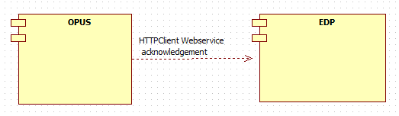

### Performance Design

NA

### 

### Security Design

*Create an inventory of all SPI/PCI data elements that will require special handling with encryption and watermarking at each architecture layer.*

* **NA**

|  |  |  |
| --- | --- | --- |
| **SPI/PCI Data Element Inventory** | | |
| **Screen Elements** | | |
| **#** | **Element Name** | **Handling** |
| *1* | *NA* | *NA* |
|  |  |  |
| **External Interface Elements (Service/EJB calls)** | | |
| **#** | **Element Name** | **Handling** |
| 1 | *NA* | *NA* |
|  |  |  |
| **Database Elements** | | |
| **#** | **Element Name** | **Handling** |
| *1* | *NA* | *NA* |
|  |  |  |

|  |  |  |  |
| --- | --- | --- | --- |
| **Watermarking Inventory** | | | |
| **#** | **SPI/PCI Entity/Attribute Name** | **Logging Injection Point** | **Watermarking utility** |
| 1 | NA | NA | NA |

### UI Design

### UI Design - Wireframe

### <http://alhoov1uvinda01:8600/OPUS/OPUS_Launcher_DEV/pdfs/OPUS/OPUSMobile_287506_TransferMobile_WCAForToBR.pdf> <http://alhoov1uvinda01:8600/OPUS/OPUS_Launcher_DEV/pdfs/OPUS/OPUS_287506_TransferMobile_ToBRTermsAndServices.pdf>

### UI Design - Screen Element Definition and Data Mapping

|  |  |  |  |  |  |  |  |  |  |
| --- | --- | --- | --- | --- | --- | --- | --- | --- | --- |
| **Screen :** | | | | | | | | | |
| **Change Summary** | | | |  | | | | | |
| **Element Label** | **Required?** | **Element Type** | **Table column?** | **SPI/PCI** | **Default Value** | **Format** | **Data Source/Target** | **Tab Order** | **Init. Focus** |
|  |  |  |  |  |  |  |  |  |  |
|  |  |  |  |  |  |  |  |  |  |

|  |  |  |  |  |  |  |  |  |  |
| --- | --- | --- | --- | --- | --- | --- | --- | --- | --- |
| **Screen :** | | | | | | | | | |
| **Change Summary** | | | |  | | | | | |
| **Element Label** | **Required?** | **Element Type** | **Table column?** | **SPI/PCI** | **Default Value** | **Format** | **Data Source/Target** | **Tab Order** | **Init. Focus** |
|  |  |  |  |  |  |  |  |  |  |

|  |  |  |  |  |  |  |  |  |  |
| --- | --- | --- | --- | --- | --- | --- | --- | --- | --- |
| **Screen :** | | | | | | | | | |
| **Change Summary** | | | |  | | | | | |
| **Element Label** | **Required?** | **Element Type** | **Table column?** | **SPI/PCI** | **Default Value** | **Format** | **Data Source/Target** | **Tab Order** | **Init. Focus** |
|  |  |  |  |  |  |  |  |  |  |
|  |  |  |  |  |  |  |  |  |  |

### UI Action Processing - Sequence Diagram

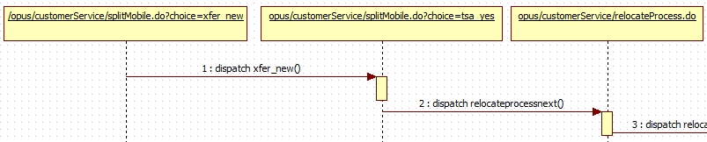

*Contd..*

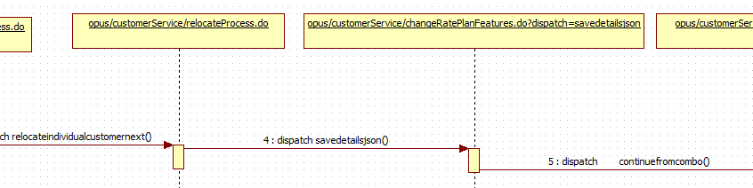

*Contd..*

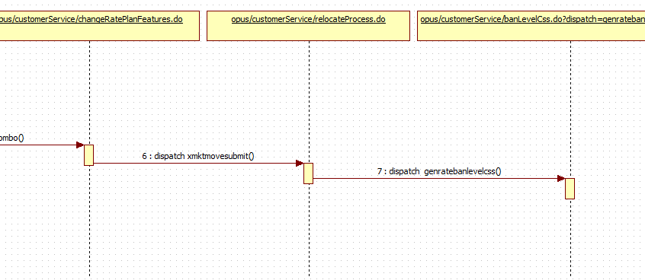

### Asynchronous/Batch Processing - Sequence Diagram

*NA*

**Externalized Configuration**

*All application configuration parameters (table filled out with examples).*

|  |  |  |
| --- | --- | --- |
| **Application Configuration Parameters** | | |
| **Parameter Type** | **Parameter name** | **Description** |
| Store Level configuration | TRANSFER_WCA_ENABLED | This store configurations provide ability to turn on/off project level changes for 287506 for both opus and opus mobile combined. Default value = OFF |
| Enterprise Level configuration | TOBRWCA_ACKNOWLEDGEMENT_EN | Verbiage displayed in final signature panel Acknowledgement of TransferWCA integrated - English |
| Enterprise Level configuration | TOBRWCA_ACKNOWLEDGEMENT_SP | Verbiage displayed in final signature panel Acknowledgement of TransferWCA integrated - Spanish |
| Enterprise Level configuration | TOBR_WCA_RECAP_PAGE_ENG | Verbiage displayed on ToBR agreement on the sigcap device along with WCA integrated content - English |
| Enterprise Level configuration | TOBR_WCA_RECAP_PAGE_SP | Verbiage displayed on ToBR agreement on the sigcap device along with WCA integrated content - Spanish |

## Database Tier Design

*NA*

### Logical Data Model

|  |  |  |
| --- | --- | --- |
| **Change Summary** | | |
| **Entity Name** | **Change type** | **Change Description** |
| NA | NA | NA |
|  |  |  |
|  |  |  |

*Sample diagram shown below.*

NA

### Database Interfaces

* *NA*

### Batch Interfaces

*NA*

### Replication

*NA*

## Alternative Designs

## Assumptions/Risks

* Project level store flags to control the functionality implemented for this project to mitigate the risk.

## Pre-Production Disaster Recovery Planning

### NA

## Other Plans and References

NA

|  |
| --- |
|  |

## 

## Acceptance & Approvals

Overview

Use this section to capture approvals in the event that electronic approvals via the PRISM Project Workflow Module will not be used.

The Approvers of this work product agree that this document is acceptable and complete to the best of their knowledge and will be used by the project team as an official deliverable for the project. It is further agreed that this document can now be baselined and any changes to these sections from this point forward must follow the Managing Change in the Technology Development Unified Process.

Embed evidence of approval in the review table below, or use the PRISM Approval Functionality in the Project Workflow Module Workflow Template View.

Approvers

|  |  |  |  |
| --- | --- | --- | --- |
| **ATTUID and Name** | **Role** | **Group/Application** | **Version Approved, Approval Date and Approval Evidence** |
| Thakrar, Praveen | PTA | OPUS / OM |  |
| Kasuganti, Neetha | Retail Functional Architecture | OPUS / OM |  |
| Gunna, Moapal | STD | OPUS / OM |  |
|  |  |  |  |
|  |  |  |  |
|  |  |  |  |
|  |  |  |  |