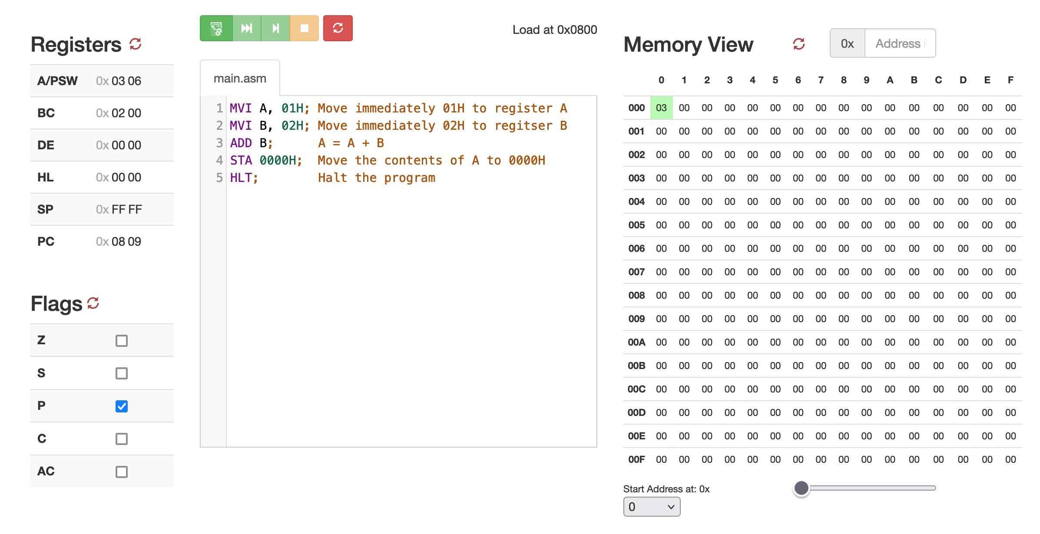

Figure 1: 8-bit immediate mode addition

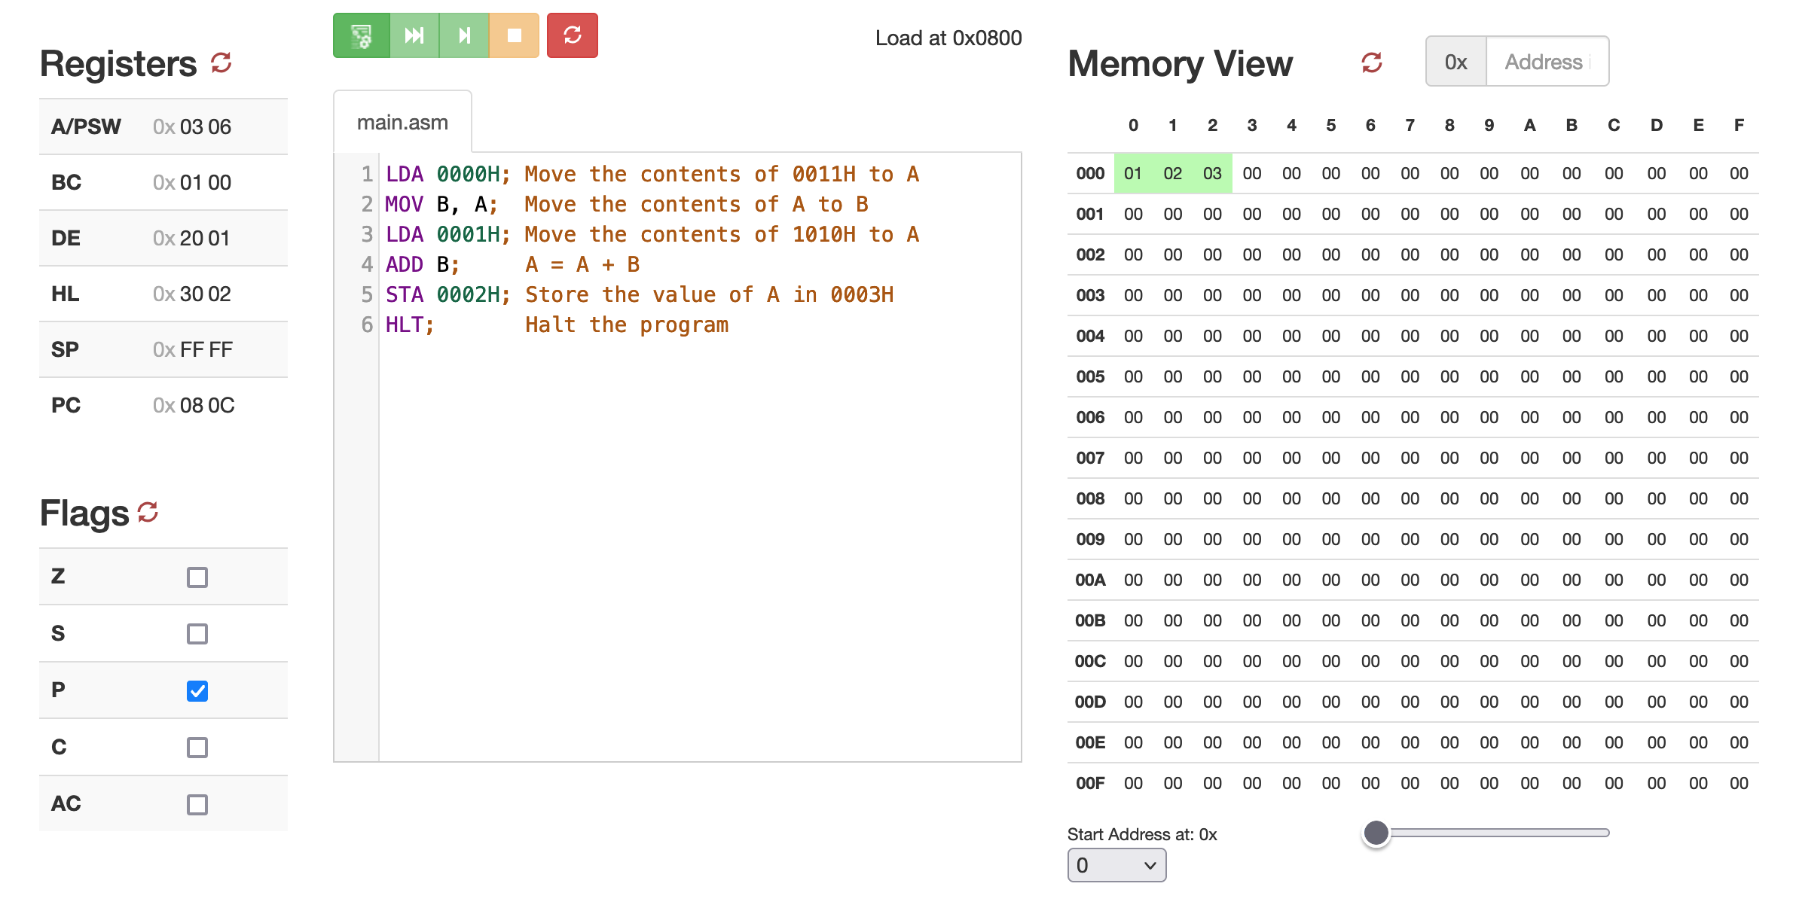

Figure 2: 8-bit direct mode addition

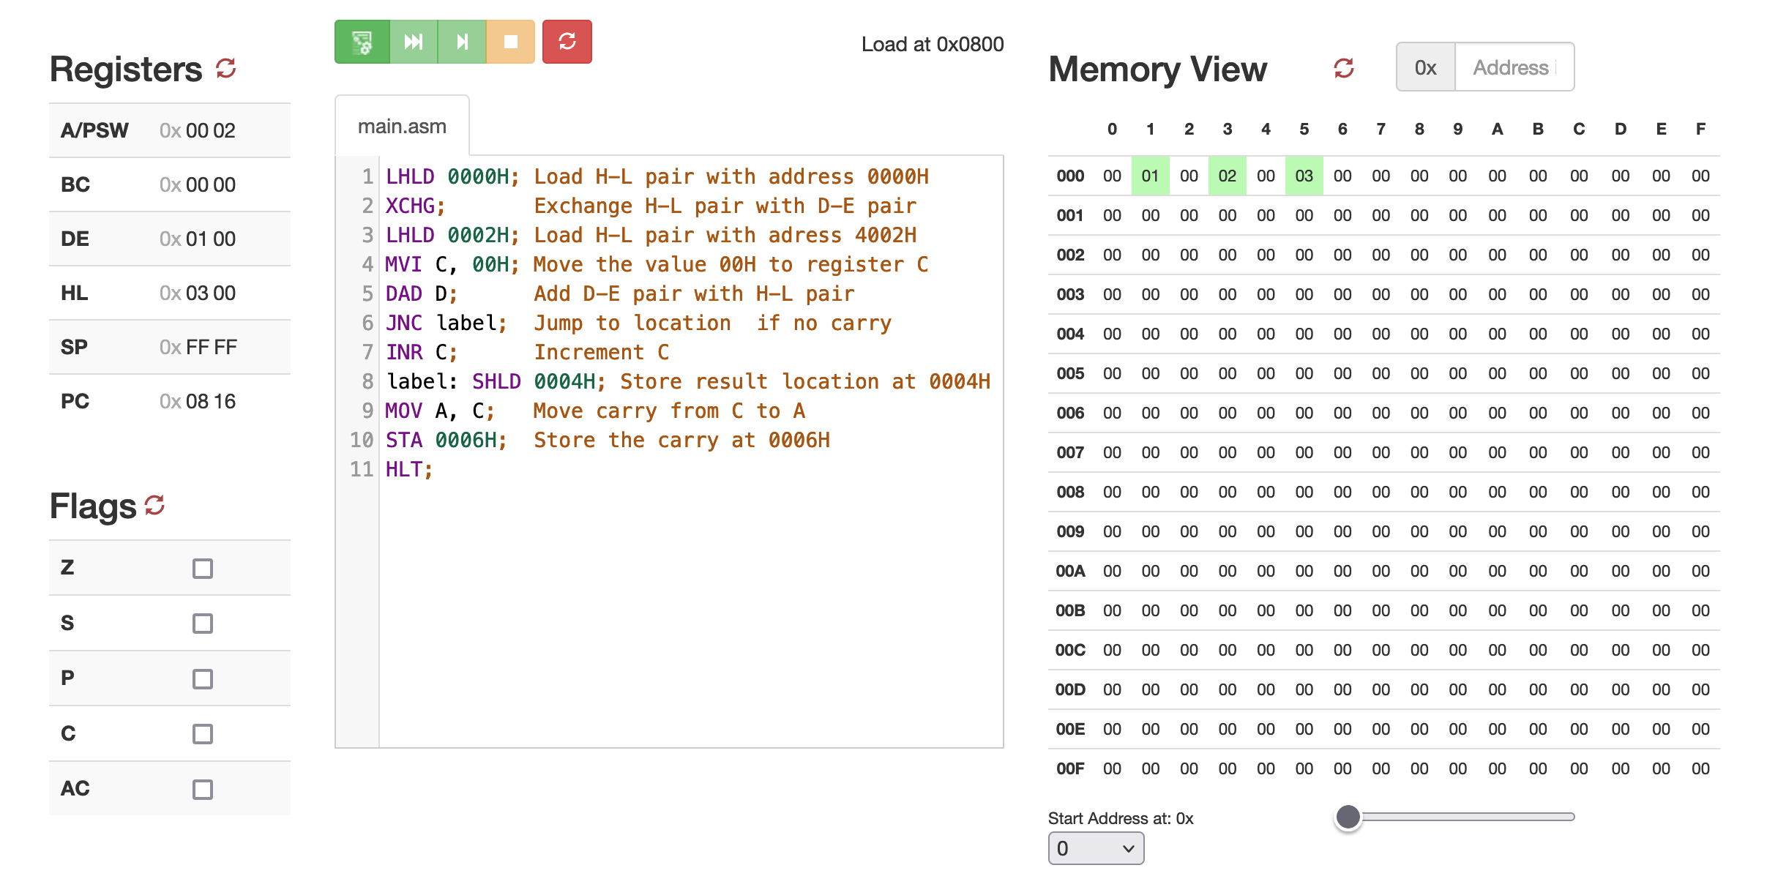

Figure 3: 16-bit direct addition

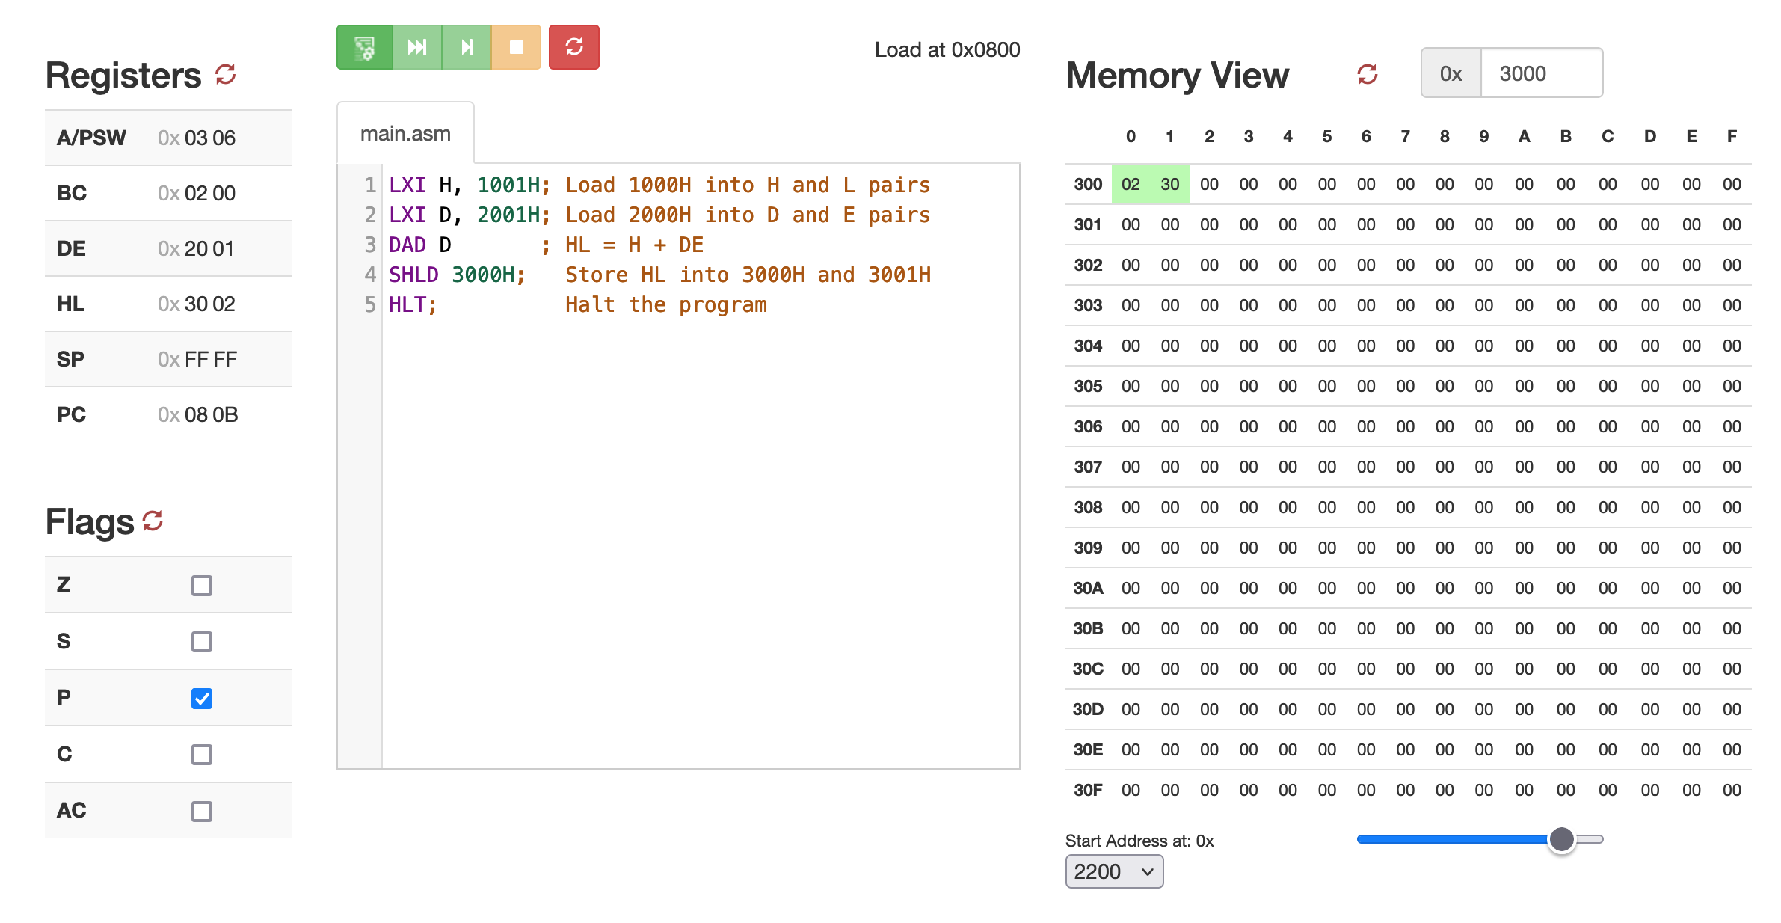

Figure 4: 16-bit immediate mode addition

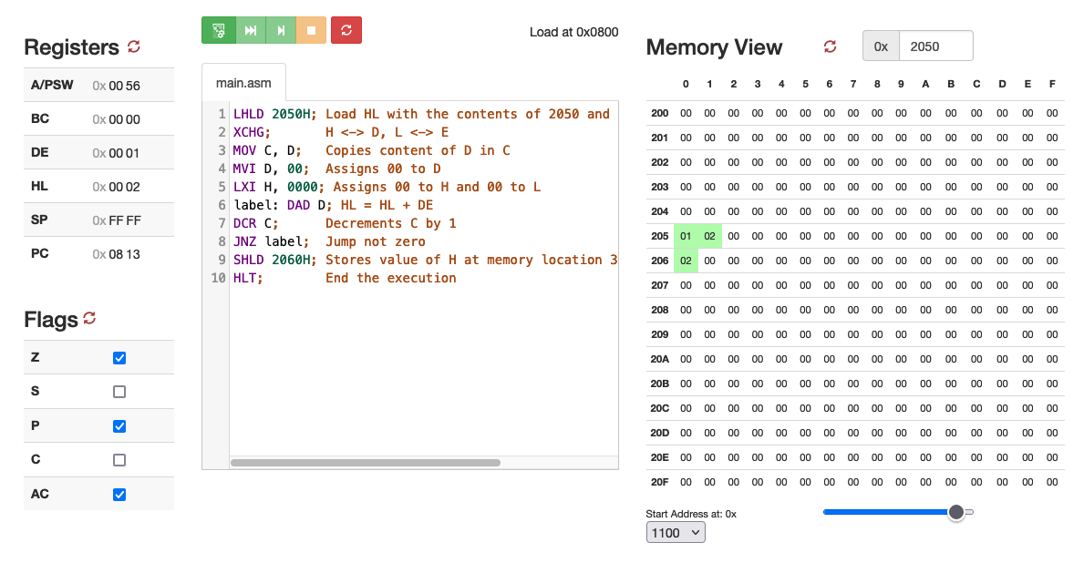

Figure 5: 8-bit direct mode multiplication

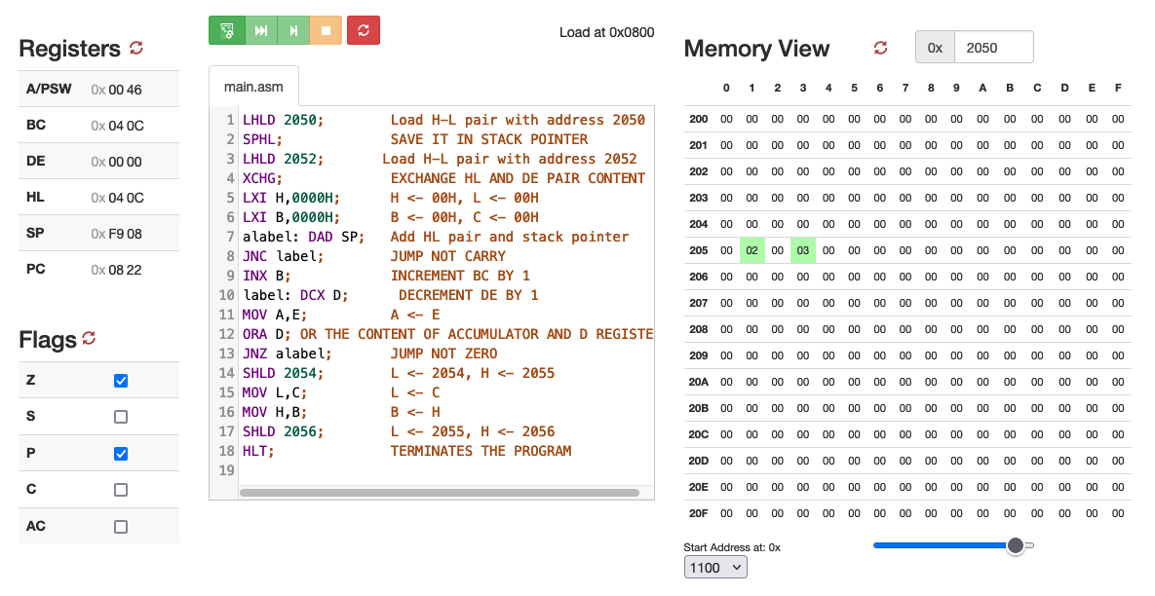

Figure 6: 16-bit direct mode multiplication

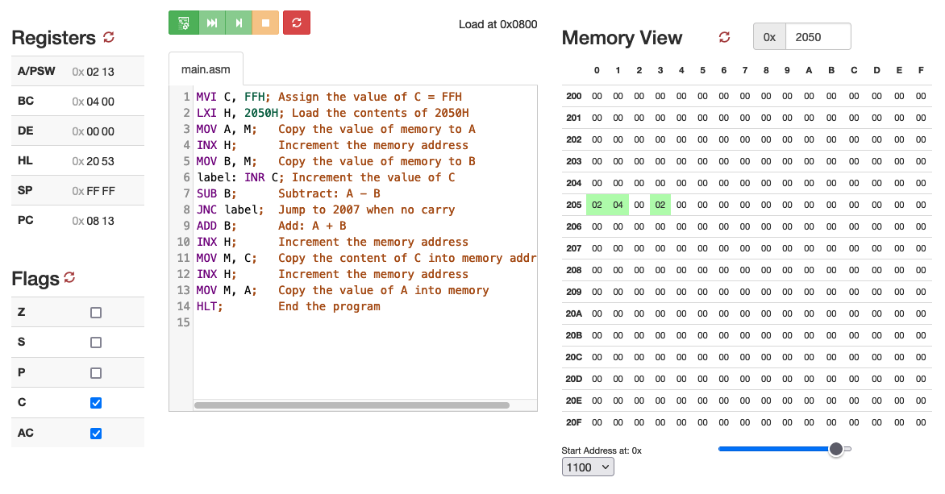

Figure 7: 8-bit direct mode division

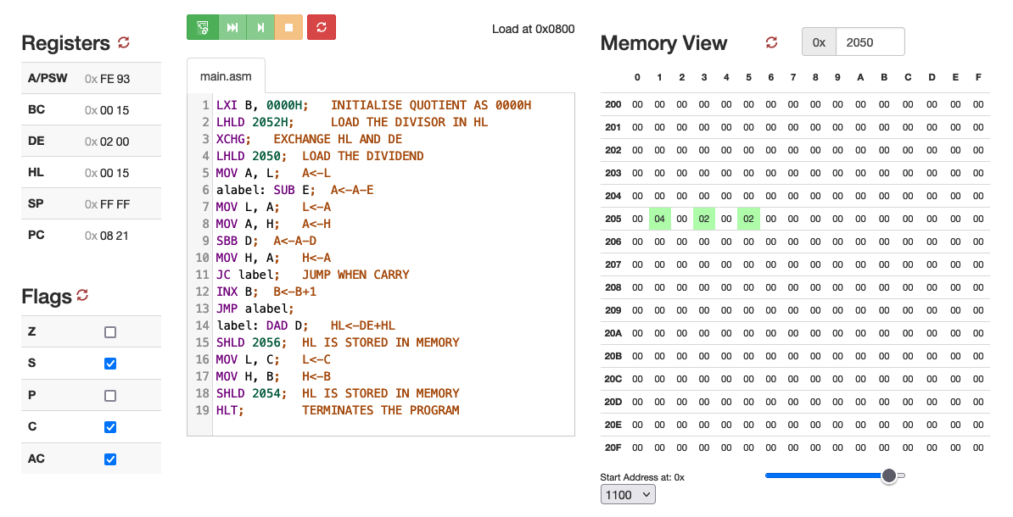

Figure 8: 16-bit direct mode division

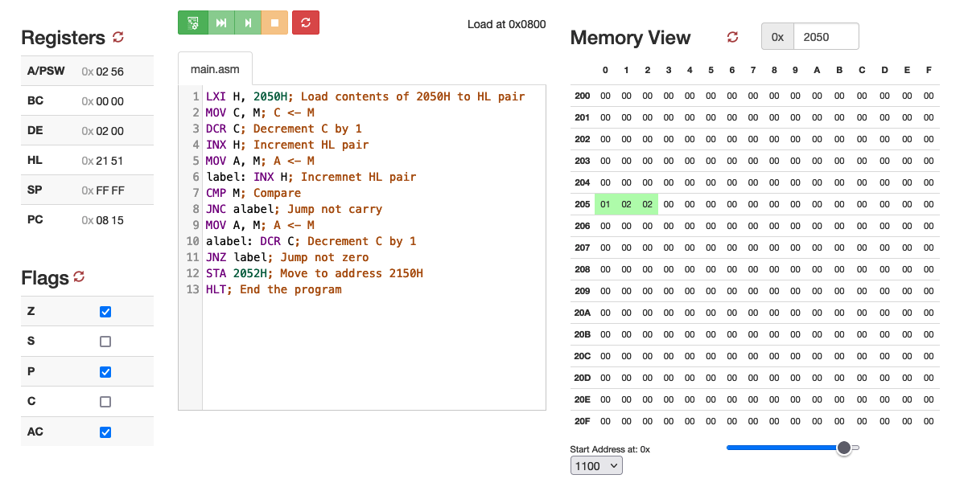

Figure 9: Find the larger among two 8-bit numbers