# Magento 2.0

## **Basics**

<https://www.youtube.com/watch?v=h-_gFbNF80s>

Magento is a framework used to create eCommerce application.

Comes in three edition –

* Community – Free for developers
* Enterprise – Paid Version
* Magneto Go - Cloud Community

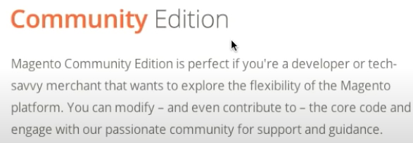

Tech – PHP Language

## Magento Sample Code Structure:

<https://www.youtube.com/watch?v=3nAjh_64X30>

<https://www.youtube.com/watch?v=GYfGeV3Emyk>

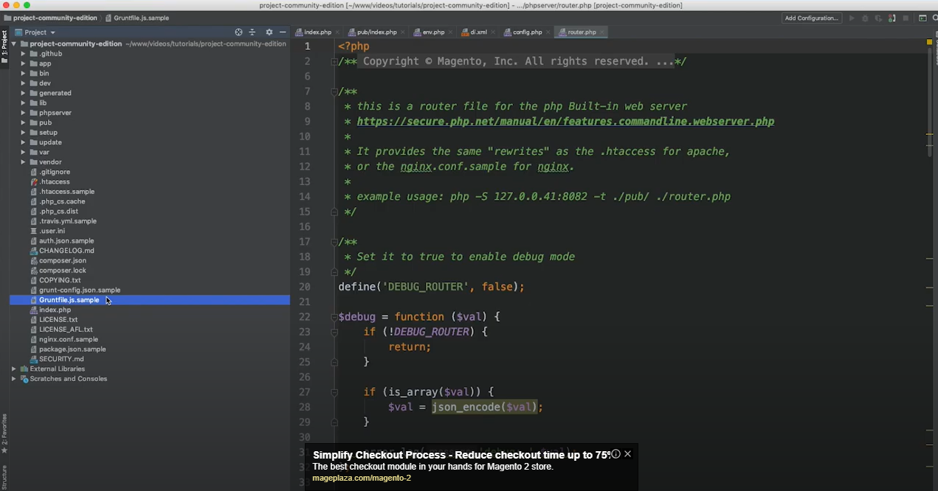

|  |  |
| --- | --- |
|  | App – This is used when you develop custom code.  Dev – Used for test cases  Generated – Contains all generate code when code base is compiled.  Lib – Contains all libraries.  Phpserver – Need to be used  Pub – Used when application need to run in production. Here index.php is used  Setup – Contains magento installation kit  Var – Contains Cache, Log Folders. Can be used to log instrumentation data.  Vendor – Contains Magento Core modules. Also contains if any third-party are installed by composers (NPM Kind of). This folder does not goes in Git. |

## Magento Local Environment Setup:

<https://devdocs.magento.com/cloud/setup/first-time-setup.html>