Q1: Write an SQL statement to find the total number of user sessions each page has each day.

ANS:

Select

Page_ID,

Visit_date,

Count(user_id)

from [dbo].[Samplepageviews]

group by Page_ID, Visit_Date

order by Page_ID, Visit_Date

Q2.1: Which month has the highest sales? Is there any seasonality effect?

ANS: Irrespective of the year the highest sales in 2016 Feb. There is no seasonality effort. But the sales is always high in Auguest.

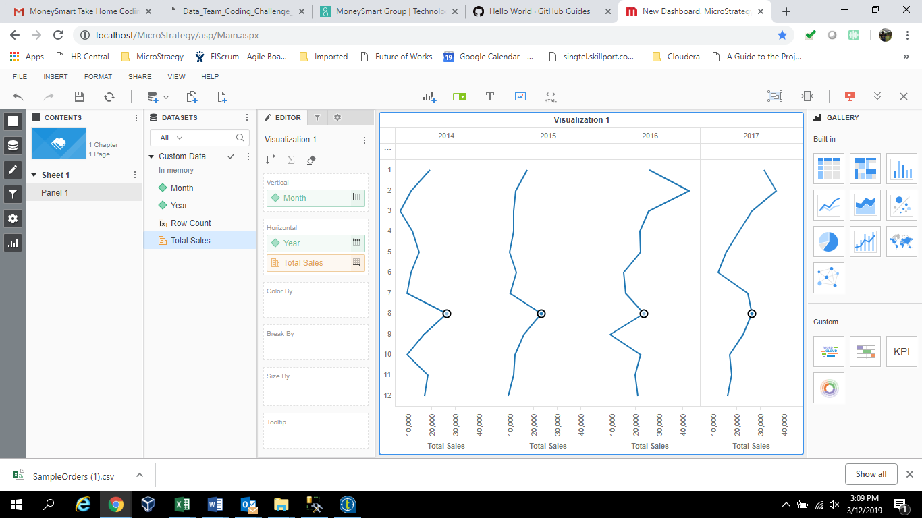

Q2.2: Which product is the recent best seller?

ANS: Canon imageCLASS 2200 Advanced Copier is the best seller in the last two years.

Q2.3. Is there any group of products which are often bought together?

ANS: Yes. The product before ‘@’ and after ‘@’ are sold together.

FUR-CH-10003379@TEC-PH-10003885

FUR-FU-10004053@TEC-AC-10002006

FUR-FU-10004270@TEC-AC-10002006

FUR-FU-10004351@TEC-AC-10002006

OFF-AR-10003856@TEC-AC-10002006

OFF-BI-10001634@OFF-BI-10004001

OFF-BI-10002160@OFF-PA-10001970

OFF-BI-10002735@TEC-PH-10001448

OFF-BI-10004728@OFF-ST-10003208

OFF-BI-10004995@OFF-PA-10001970

OFF-FA-10002780@TEC-PH-10002293

OFF-PA-10001776@OFF-PA-10004039

OFF-PA-10001970@TEC-AC-10000290

OFF-PA-10002246@TEC-AC-10002006

OFF-PA-10002262@OFF-ST-10002214

OFF-ST-10002554@TEC-AC-10002637

OFF-ST-10003208@TEC-AC-10004666

OFF-SU-10004782@TEC-AC-10002006

TEC-AC-10002049@TEC-PH-10000702

select ProductId, count(*) as 'basket' from

(

select Concat(x.productID,'@',y.ProductID) ProductID from [dbo].[SampleOrders] x

JOIN [dbo].[SampleOrders] y ON x.ProductId <> y.ProductId and

x.orderdate = y.orderdate and x.CustomerID = y.CustomerID

)A

group by ProductId

having Count(*) > 1

order by 2 desc

Q2.4. Is there any other insight you can get to help to improve sales number?

ANS

* The overall sales increased year over year
* The number of customers increased year over year
* There is no patern in the selling. Can investiogate why.
* There are 90 over producs sold only once in the past 4 years. Need to incerease the demand.

Q2.5. Based on the data we have, what kind of BI dashboards you would build in order to help the sales

team monitoring the performance?

**Product Analysis**

What are all the top 10 selling products (by year,Quarter, Month)

Whar are all the bottom 10 selling products (by year,Quarter, Month)

**Customer Analysis**

What are all the top 20 selling products (by year,Quarter, Month)

Whar are all the bottom 20 selling products (by year,Quarter, Month)

**Sales Trend Analysis**

Sales Trend by year,

Sales Trend by Month

**Market baseket analysis**

what are all the product sold together

**What-if analysis**

If we increase the average spedning of the customer how the total sales will increase