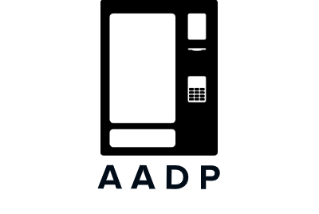

New 93, Old 45 Appar Swamy Koil Street Mylapore Chennai - 4

9962 240 340 | 8220768049

arunmca111@gmail.com

Vending Solutions | Software Development Manpower.

Aadp Solutions Private Limited.