Context Graph
(Engram)
High-Level Design Document
Traceability-First Memory Infrastructure for AI Agents

Version | 2.0
Date | March 2, 2026
Author | Arun Menon
Status | Active Development — Hardening Phase
Classification | Confidential — Stakeholder Distribution
Companion | Low-Level Design Document (LLD) v1.0

Table of Contents

1. Executive Summary
Context Graph (codenamed Engram) is a traceability-first context graph service that provides structured, provenance-annotated memory for AI agents. The system captures immutable event records of agent and tool actions, projects them into a knowledge graph for lineage queries, and returns scored context with full provenance to consuming agents.
The architecture is grounded in the Complementary Learning Systems (CLS) theory from cognitive neuroscience: Redis Stack serves as the hippocampal fast-encoding store (immutable event ledger), while Neo4j serves as the neocortical slow-learning store (derived knowledge graph). Four asynchronous consumer workers implement systems consolidation — progressively transforming raw event traces into structured, scored, and interconnected knowledge.
This document describes the strategic architecture, core design patterns, component responsibilities, data flow, retrieval strategy, and deployment topology. Implementation-level details (schemas, algorithms, queries, configuration) are covered in the companion Low-Level Design Document.
Design Principles (ADR-0001)
(1) Traceability over memory — every context piece has provenance back to source events. (2) Immutable events — append-only ledger, never mutate. (3) Derived projection — Neo4j is disposable and rebuildable from Redis. (4) Framework-agnostic domain — zero web framework imports in core logic. (5) Bounded queries — depth, node count, and timeout limits enforced on all traversals. (6) System-owned retrieval — the system infers intent, selects seeds, and surfaces proactive context.

2. System Context and Boundaries

2.1 Problem Statement
Production AI agents require persistent, structured memory that goes beyond conversation history. They need to trace why a piece of context was surfaced, how it relates to prior interactions, and whether it is still relevant. Existing approaches — flat vector stores, simple key-value caches, raw conversation logs — lack the provenance, structure, and principled forgetting that production deployments demand.

2.2 System Boundaries
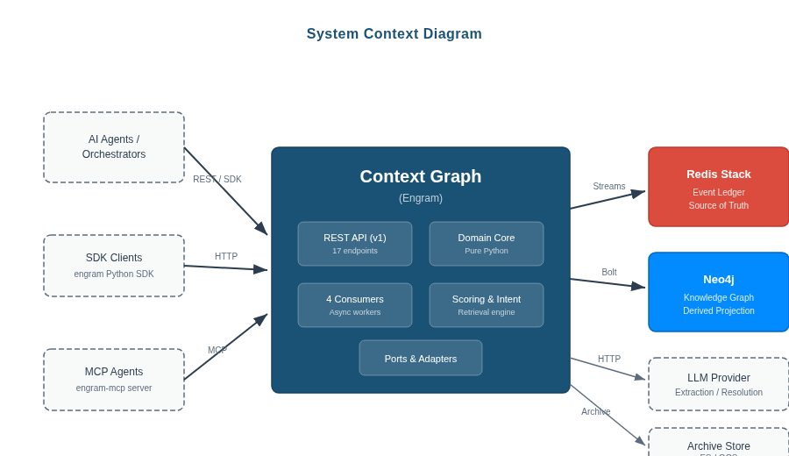
Figure 1: System context diagram — external actors, core service, and data stores.
Context Graph sits between AI agents/orchestrators and the knowledge they need to operate effectively:
External Actor | Interaction | Protocol
AI Agent / Orchestrator | Ingest events, query context, retrieve lineage | REST API (v1) / SDK / MCP
Redis Stack | Immutable event storage, stream processing, search | Redis Protocol (Streams, JSON, Search)
Neo4j Community | Graph projection, traversal, entity queries | Bolt Protocol (Cypher)
LLM Provider | Session extraction, entity resolution arbitration | HTTP (litellm / instructor)
Embedding Model | Text embeddings for semantic search | In-process (sentence-transformers)
Archive Store | Long-term event storage | Filesystem I/O or GCS API
Table 1: External actors and system boundaries.

2.3 Stakeholders
Stakeholder | Primary Concern | HLD Section
Agent Developers | Simple SDK integration, reliable context retrieval, transparent scoring | Sections 3, 6, 9
Platform Engineers | Operational health, deployment simplicity, scaling characteristics | Sections 7, 8
Security / Compliance | GDPR erasure, audit trails, authentication, data classification | Section 8
Product Leadership | Differentiation vs. competitors, time-to-value, extensibility | Sections 9, 10
Table 2: Stakeholder concerns with document cross-references.

3. Core Architecture Patterns
Context Graph is built upon seven foundational architecture patterns. Each pattern is motivated by a specific architectural decision record (ADR) and manifests consistently throughout the codebase. This section is the architectural heart of the HLD.

3.1 Hexagonal Architecture (Ports and Adapters)
The system follows a strict hexagonal (ports-and-adapters) architecture. The domain core — encompassing 11 modules (models, validation, projection, scoring, intent classification, lineage, consolidation, forgetting, extraction targets, entity resolution) — has zero imports from any web framework, database driver, or external library. This purity enables testing, evolution, and portability without infrastructure coupling.
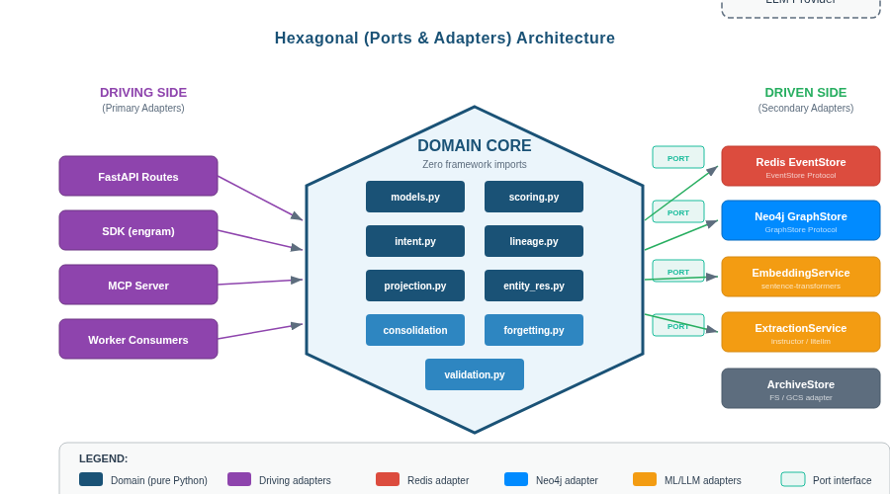
Figure 2: Hexagonal architecture — pure domain core with driving and driven ports.
Driving Side (Inbound)
Four driving adapters invoke the domain core:
- FastAPI REST API: Event ingestion, context retrieval, subgraph queries, lineage traversal, entity lookup, admin operations.
- Python SDK (engram): Three-function simple API (record, recall, trace) plus full typed client. SessionManager chains events via parent_event_id.
- MCP Server (engram-mcp): 7 tools for Model Context Protocol agents (record, recall, search, trace, profile, entities, forget).
- Consumer Workers: 4 async workers that transform events into graph structure — they are driving adapters for the domain projection, scoring, and extraction logic.
Driven Side (Outbound)
External infrastructure is abstracted behind four typing.Protocol interfaces:
Port (Protocol) | Responsibility | Concrete Adapter
EventStore | Append events, query by session/field, search composite filters | RedisEventStore — Lua-scripted atomic ingestion, RediSearch
GraphStore | Merge nodes/edges, subgraph/lineage/context queries | Neo4jGraphStore — MERGE-based Cypher, intent-weighted traversal
EmbeddingService | Text-to-vector (384-dimensional embeddings) | SentenceTransformerEmbedding — all-MiniLM-L6-v2
ExtractionService | Session-to-structured-knowledge extraction | LLMExtractionClient — instructor/litellm
Table 3: Port interfaces with concrete adapter implementations.
Structural subtyping: Ports use typing.Protocol (PEP 544), not ABCs. Any class with matching method signatures satisfies the protocol — no inheritance required. This enables test doubles (in-memory implementations) and future adapter swaps without modifying the domain.
Pattern Invariant
The domain/ package must have zero imports from FastAPI, redis, neo4j, or any web framework. This is enforced by architectural review and import auditing. Currently, 10 of 11 domain modules have zero external imports; models.py depends only on pydantic (a deliberate exception for the data contract layer).

3.2 Event Sourcing (Immutable Ledger)
Context Graph implements event sourcing as its foundational data pattern (ADR-0004, ADR-0010). Every agent action, tool execution, LLM call, and observation is captured as an immutable event with 14 fields, appended to a Redis Stream via an atomic Lua script. Events are never updated or deleted from the ledger — all state is derived by replaying the event stream.
Key Properties
- Immutability: Once appended, an event record is never modified. The Lua ingestion script performs an atomic dedup-check + XADD + JSON.SET + ZADD operation — all four succeed or none do.
- Idempotent Ingestion: Duplicate event_ids are detected via a sorted set (dedup:events). The Lua script returns the previously-assigned global_position for duplicates, making ingestion safely retryable.
- Global Ordering: Redis Stream entry IDs provide monotonically-increasing timestamps, establishing total ordering across all events regardless of origin agent or session.
- Causal Ancestry: The parent_event_id field enables explicit causal chains. When present, Consumer 1 creates CAUSED_BY edges, allowing root-cause traversal across arbitrarily deep causal trees.
Rebuildability Guarantee
Because Redis is the source of truth and Neo4j is a derived projection, the entire graph can be rebuilt from scratch by replaying all events through Consumer 1 (projection). This decouples graph schema evolution from data durability.

3.3 CQRS (Command-Query Responsibility Segregation)
The dual-store architecture naturally implements CQRS (ADR-0005, ADR-0009):
Concern | Store | Pattern | Characteristics
Commands (Writes) | Redis Stack | Lua-scripted atomic append | Sub-millisecond, append-only, idempotent
Queries (Reads) | Neo4j Community | Intent-weighted Cypher traversal | MERGE-based projection, traversal-optimized
Search (Filtered Reads) | Redis Stack (RediSearch) | Composite tag + numeric filters | Field-level queries on event metadata
Table 4: CQRS separation across dual stores.
Write and read paths are fully decoupled. Event ingestion never blocks on graph queries. Consumer workers bridge the two stores asynchronously — processing events from Redis Streams and projecting into Neo4j. This allows the API to serve queries from the graph while ingestion continues at full throughput.

3.4 Complementary Learning Systems (Dual-Store Pattern)
The dual-store design directly implements the Complementary Learning Systems (CLS) theory from cognitive neuroscience (ADR-0003):
Store | CLS Analogy | Data | Characteristics
Redis Stack | Hippocampus (fast encoding) | Immutable event streams, JSON docs, search indexes, dedup sets | Sub-ms writes, append-only, source of truth, 90-day retention
Neo4j Community | Neocortex (slow learning) | 8 node types, 16 edge types, embeddings, decay scores | Derived projection, rebuildable, query-optimized, traversal
Table 5: Dual-store architecture mapped to CLS theory.
Four consumer workers implement systems consolidation — the biological process by which hippocampal traces are progressively transformed into structured neocortical knowledge:
- Consumer 1 (Projection): Immediate structural mapping. Each event becomes a node; temporal and causal edges emerge. Analogous to initial hippocampal encoding.
- Consumer 2 (Extraction): Session-level knowledge extraction via LLM. Entities, preferences, skills, and patterns are distilled. Analogous to overnight memory consolidation.
- Consumer 3 (Enrichment): Keyword extraction, embedding computation, and semantic edge creation. Analogous to cortical integration of related memories.
- Consumer 4 (Consolidation): Hierarchical summarization, pattern detection, decay enforcement, and archival. Analogous to long-term memory stabilization with active forgetting.
Invariant: Source-of-Truth Hierarchy
Redis is always authoritative. Neo4j is always a subset of what Redis contains. No data enters Neo4j without first being persisted in Redis. If the two stores diverge, Redis wins — the graph is rebuilt.

3.5 Async Consumer Group Pattern
The four consumer workers use Redis Streams' XREADGROUP protocol (ADR-0005, ADR-0013) with a carefully designed resilience model:
Consumer | Stream Group | Trigger | LLM | Function
1: Projection | graph-projection | Per-event | No | Event → Neo4j nodes + FOLLOWS/CAUSED_BY edges
2: Extraction | session-extraction | Session end | Yes | LLM extracts entities, preferences, skills, patterns
3: Enrichment | enrichment | Per-batch | No* | Keywords, embeddings, SIMILAR_TO edges, importance
4: Consolidation | consolidation | Scheduled (6h) | Yes | Summaries, pattern detection, decay, archival
Table 6: Consumer workers with group assignment and triggers (* embedding model, not LLM).
Resilience Model
Three mechanisms ensure no event is lost or processed incorrectly:
- Pending Entry List (PEL): Messages stay in the PEL until explicitly acknowledged (XACK). A consumer crash leaves messages pending; they are automatically redelivered on restart.
- XAUTOCLAIM (Orphan Recovery): Idle messages exceeding 300 seconds are automatically claimed by active consumers, preventing orphaned messages from blocking the pipeline.
- Dead-Letter Queue (DLQ): Messages exceeding 5 retry attempts are moved to a dead-letter stream (suffix :dlq), preventing poison messages from blocking the main processing pipeline.

3.6 Atlas Response Pattern
All graph query endpoints return the standardized Atlas response pattern (ADR-0006) — a self-describing JSON envelope that provides nodes with provenance and scores, edges with properties, keyset pagination, and query diagnostics:
Component | Contents | Purpose
nodes | Map of node_id → {node_type, attributes, provenance, scores, retrieval_reason} | Enriched nodes with full traceability
edges | Array of {source, target, edge_type, properties} | Relationships between returned nodes
pagination | {cursor, has_more} | Stateless keyset pagination
meta | {query_ms, nodes_returned, truncated, inferred_intents, seed_nodes, seed_strategy, proactive_nodes_count, scoring_weights, capacity} | Query diagnostics and capacity tracking
Table 7: Atlas response pattern components.
Every returned node carries three provenance fields: event_id (source event), global_position (Redis Stream ordering), and source (always 'redis'). Three score fields — decay_score, relevance_score, importance_score — explain why the node was ranked at its position. The retrieval_reason field ('direct' or 'proactive') and optional proactive_signal explain how the node was discovered.

3.7 System-Owned Retrieval Pattern
Context Graph implements system-owned retrieval (ADR-0009): the caller provides a natural-language query, session context, and agent identity. The system then:
- Infers intent from query text (8 intent types with confidence scores)
- Selects seed nodes via strategy dispatch (7 named strategies mapped to intents)
- Traverses the graph with intent-weighted edge boosting (16 edge types × 8 intents)
- Scores candidates using a 4-factor composite formula (recency, importance, relevance, user affinity)
- Surfaces proactive context beyond the explicit query (entity connections, causal chains, recurring patterns)
- Assembles a bounded response with full provenance, scores, and capacity tracking
This contrasts with caller-driven systems where the consumer must specify what to retrieve. The system infers what is relevant and explains its reasoning through the Atlas response metadata.

4. Component Architecture

4.1 Layer Overview
The system comprises five cleanly separated layers, each with clear ownership boundaries:
Layer | Location | Responsibility | Dependencies
API | api/ | HTTP endpoints, auth, rate limiting, dependency injection | Domain, Ports
Domain | domain/ | Business logic: validation, projection, scoring, intent, lineage, extraction, resolution | None (zero external imports)
Ports | ports/ | Protocol interfaces (structural subtyping) | Domain models only
Adapters | adapters/ | Infrastructure implementations (Redis, Neo4j, LLM) | Ports, external drivers
Workers | worker/ | Async event processing via consumer groups | Domain, Adapters
Table 8: Five architectural layers with dependency direction.

4.2 Domain Layer — Zero Framework Dependencies
The domain layer is the architectural centerpiece. It contains 11 modules, all pure Python with no framework imports:
Module | Responsibility | Key Pattern
models.py | Event, Node, Edge, Query, Atlas models (Pydantic v2, frozen) | Data contracts, enum taxonomies
validation.py | Event envelope validation (5 rules, accumulator pattern) | Guard clause + error accumulation
projection.py | Event → graph transform (EventNode + FOLLOWS/CAUSED_BY edges) | Pure function, O(1) per event
scoring.py | 4-factor Ebbinghaus decay (recency, importance, relevance, affinity) | Scoring engine, graceful fallbacks
intent.py | Query → 8 intents + seed strategy dispatch + edge weight matrix | Rule-based classification
lineage.py | Bounded traversal (Cypher query builders, parameter clamping) | Query construction, bounds enforcement
consolidation.py | Episode grouping, summary creation, pruning selection | Temporal clustering, deterministic hashing
forgetting.py | Retention tier classification, warm/cold pruning predicates | Tier-based policy enforcement
extraction.py | Extraction target models (entity, preference, skill, persona) | Instructor-compatible Pydantic models
entity_resolution.py | 3-tier resolution cascade (exact, fuzzy, semantic) | Progressive confidence cascade
Table 9: Domain layer modules — all pure Python.

4.3 Adapter Layer — Infrastructure Bindings
Three adapter families implement the port interfaces:
Redis Adapter
The Redis adapter implements EventStore via atomic Lua scripting. A single Lua script performs dedup check, stream append (global + session), JSON document write, and dedup set update — all atomically. RediSearch provides composite field-level event search. Batch operations use Redis pipelines to reduce O(n×RTT) to O(RTT).
Neo4j Adapter
The Neo4j adapter implements GraphStore via MERGE-based Cypher. All writes use MERGE for idempotency — replaying the same projection produces the same graph. Intent-weighted traversal queries use the domain-computed edge weights to boost relevant relationship types during BFS expansion. 8 uniqueness constraints and 2 indexes (session lookup, vector similarity) ensure performance and integrity.
LLM Adapter
The LLM adapter implements ExtractionService via instructor/litellm for structured output. It constructs ontology-aware prompts, validates extractions via fuzzy quote matching (three-tier: exact substring, word overlap, sliding window), and applies confidence priors based on source type (explicit, implicit, inferred — each with a different ceiling).

5. Data Architecture

5.1 Event Model
Events are the atomic unit of the system. Each event captures a single agent or tool action with 14 fields: 8 required (event_id, event_type, occurred_at, session_id, agent_id, trace_id, payload_ref, global_position) and 6 optional (tool_name, parent_event_id, ended_at, status, schema_version, importance_hint). Event types follow a dot-namespaced taxonomy (15 types across 6 categories: agent, tool, LLM, observation, system, user).

5.2 Knowledge Graph Schema
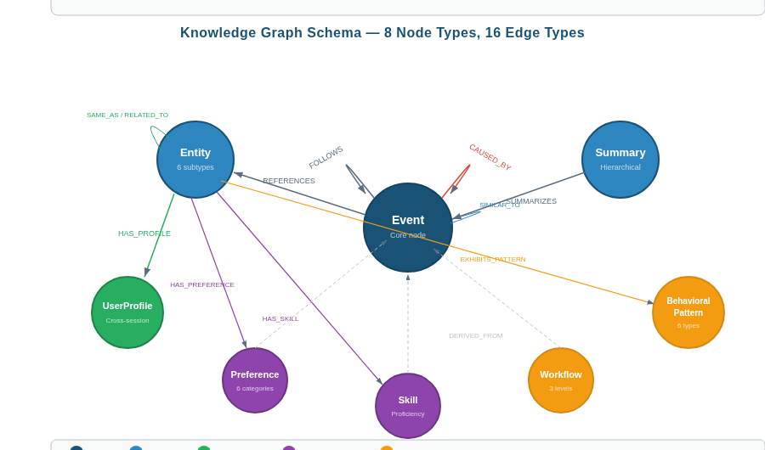
Figure 3: Knowledge graph schema — 8 node types with 16 edge types across five views.
The graph comprises 8 node types and 16 edge types organized into five orthogonal views:
View | Node Types | Edge Types | Purpose
Temporal | Event | FOLLOWS | Session-scoped event sequencing with delta_ms
Causal | Event | CAUSED_BY | Causal lineage via parent_event_id
Semantic | Event, Entity | SIMILAR_TO, REFERENCES | Embedding similarity and entity extraction
Hierarchical | Summary, Event | SUMMARIZES | Episode compression and hierarchical summarization
User | Entity, UserProfile, Preference, Skill, Workflow, BehavioralPattern | HAS_PROFILE, HAS_PREFERENCE, HAS_SKILL, DERIVED_FROM, EXHIBITS_PATTERN, INTERESTED_IN, ABOUT, ABSTRACTED_FROM, PARENT_SKILL | User personalization and behavioral modeling
Resolution | Entity | SAME_AS, RELATED_TO | Entity disambiguation and coreference
Table 10: Five graph views with node and edge types.

5.3 Data Flow
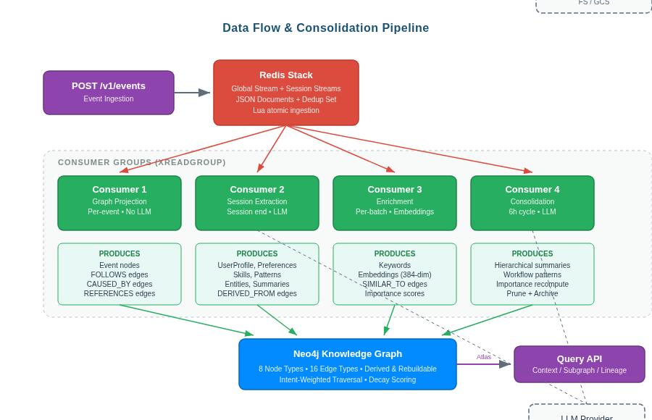
Figure 4: End-to-end data flow — from event ingestion through consumer groups to the knowledge graph.
The data flow proceeds through four stages:
- Ingestion: Events arrive via REST API or SDK, are validated against domain rules, and atomically persisted to Redis (global stream + session stream + JSON document + dedup set).
- Structural Projection: Consumer 1 reads from the global stream, deserializes events, and MERGEs nodes and edges into Neo4j. FOLLOWS edges link temporal neighbors; CAUSED_BY edges trace causal chains.
- Enrichment & Extraction: Consumer 3 adds keywords, embeddings, and semantic edges. Consumer 2 triggers at session end, using an LLM to extract entities, preferences, skills, and behavioral patterns with provenance.
- Consolidation & Forgetting: Consumer 4 runs on a 6-hour cycle: grouping events into episodes, creating summaries, detecting patterns, enforcing retention tiers, and archiving cold data.

6. Retrieval Architecture

6.1 Intent Classification
The system classifies queries into 8 intent types. Each intent maps to a seed strategy and edge-weight profile:
Intent | Trigger Keywords | Seed Strategy | Primary Edge (5.0×)
why | cause, reason, because, led to | causal_roots | CAUSED_BY
when | timeline, before, after, sequence | temporal_anchors | FOLLOWS
what | identify, define, describe | entity_hubs | REFERENCES
related | similar, associated, connected | similar_cluster | SIMILAR_TO
who_is | person, user, profile, about | user_profile | HAS_PROFILE
how_does | process, method, workflow | workflow_pattern | EXHIBITS_PATTERN
personalize | prefer, style, adapt | user_profile | HAS_PREFERENCE
general | (default fallback) | recency | All (1.0×)
Table 11: Eight intent types with seed strategies and edge weight profiles.
Multi-intent decomposition: queries expressing multiple intents receive confidence-weighted edge weight sums. The system also supports explicit intent override via API parameter for programmatic use.

6.2 Retrieval Pipeline
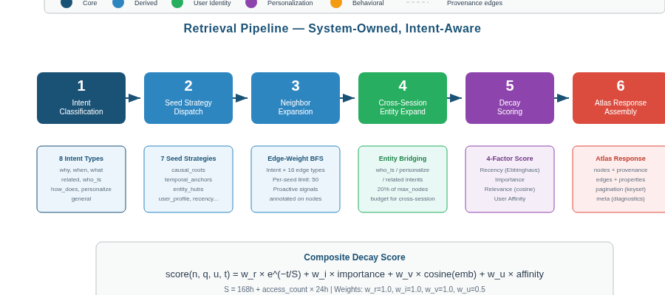
Figure 5: Six-stage retrieval pipeline from intent classification to Atlas response.
The six-stage pipeline:
- Intent Classification: Keyword matching against 8 intent vocabularies. Returns confidence scores per intent. Threshold: 0.3.
- Seed Strategy Dispatch: Maps dominant intent to a named strategy. Executes optimized Cypher query to find starting nodes (e.g., highest CAUSED_BY in-degree for 'why' queries).
- Neighbor Expansion: BFS from seed nodes with intent-weighted edge boosting. Per-seed neighbor limit (default 50) prevents fan-out explosion.
- Cross-Session Entity Expansion: For who_is, personalize, and related intents, 20% of max_nodes budget allocated to events from other sessions referencing the same entities.
- Composite Decay Scoring: 4-factor scoring: recency (Ebbinghaus forgetting curve), importance (hint + access + connectivity), relevance (embedding cosine similarity), user affinity (session proximity + retrieval recurrence + entity overlap).
- Atlas Response Assembly: Truncate to bounded result set. Annotate with provenance, scores, retrieval_reason, proactive_signal, and capacity tracking.

6.3 Decay Scoring Model
Composite Score Formula
score(n, q, u, t) = w_r × recency(n, t) + w_i × importance(n) + w_v × relevance(n, q) + w_u × affinity(n, u)
The four scoring factors:
- Recency: R = e^(−t / S), where S = S_base + access_count × S_boost. Default: S_base=168h (1 week), S_boost=24h per access. Repeated access extends memory stability — a direct implementation of spaced repetition.
- Importance: Normalized importance_hint/10 + log-scaled access count boost (capped 0.2) + graph in-degree boost (capped 0.2). Range [0, 1].
- Relevance: Cosine similarity between query embedding and node embedding. Falls back to 0.5 when embeddings are unavailable.
- User Affinity: 0.4 × session_proximity + 0.3 × retrieval_recurrence + 0.3 × entity_overlap. All inputs normalized to [0, 1]. Weight: 0.5 (half the weight of other factors).

6.4 Proactive Context Surfacing
Beyond answering the explicit query, the system proactively surfaces relevant context. Each proactively-surfaced node carries a signal explaining why it was included:
Edge Traversed | Proactive Signal | Example
REFERENCES | entity_context | Same entity referenced in a different session
SIMILAR_TO | recurring_pattern | Semantically similar event from a prior interaction
CAUSED_BY | causal_chain | Upstream causal ancestor relevant to current query
FOLLOWS | temporal_sequence | Temporally adjacent event providing essential context
SUMMARIZES | summary_context | Summary compressing relevant prior episodes
Table 12: Proactive context surfacing signals.

7. Memory Lifecycle

7.1 Consolidation Pipeline
The consolidation pipeline implements the biological process by which transient episodic memories are transformed into stable, structured knowledge. Three stages operate at different timescales:
Stage 1 — Structural Projection (Per-Event, Milliseconds)
Consumer 1 immediately projects each event into Neo4j: creating an Event node and establishing FOLLOWS edges (temporal adjacency) and CAUSED_BY edges (causal lineage). Projection is idempotent — replaying the same event produces the same graph structure. No LLM required.
Stage 2 — Session Extraction (Session End, Seconds)
Consumer 2 triggers when a session ends. An LLM analyzes the full session transcript to extract structured knowledge: entities (6 types), preferences (6 categories with polarity/strength/confidence), skills (4 categories with proficiency), and behavioral patterns (6 types). Each extraction carries DERIVED_FROM provenance edges. Confidence is bounded by source type (explicit: 0.95, implicit: 0.70, inferred: 0.60).
Stage 3 — Re-Consolidation (6-Hour Cycle)
Consumer 4 executes a six-phase consolidation cycle:
- Temporal Episode Grouping: Events clustered by 30-minute gap threshold.
- Hierarchical Summarization: Episodes compressed into Summary nodes. Summaries summarize summaries, creating event → session → agent hierarchy.
- Pattern Detection: Recurring action sequences promoted to Workflow nodes (transition from episodic to procedural memory).
- Importance Recomputation: Graph centrality-based importance boosting for high-connectivity nodes.
- Active Forgetting: Retention tier enforcement: warm prunes weak edges, cold filters low-importance nodes, archive exports to long-term storage.
- Orphan Cleanup: Nodes that lost all relationships removed to prevent graph fragmentation.
Reflection Trigger
When cumulative importance of recent events exceeds the reflection threshold (default 150), an immediate consolidation cycle triggers — implementing preferential consolidation of high-salience experiences, analogous to how emotionally significant events are consolidated faster.

7.2 Retention Tiers
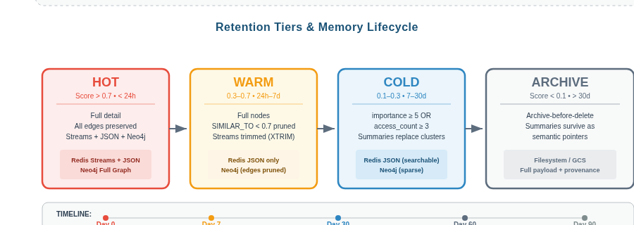
Figure 6: Four retention tiers with lifecycle timeline.
Tier | Duration | Policy | Storage
HOT | < 24h | Full detail, all edges preserved | Redis (Streams + JSON) + Neo4j
WARM | 24h – 7d | Full nodes; SIMILAR_TO edges < 0.7 pruned | Redis (JSON) + Neo4j
COLD | 7d – 30d | Only importance ≥ 5 or access ≥ 3 retained | Redis (JSON) + Neo4j (sparse)
ARCHIVE | > 30d | Exported to long-term storage; summaries survive in graph | Archive (FS/GCS)
Table 13: Four-tier retention model with progressive cost cascade.

7.3 Entity Resolution
A three-tier cascade resolves entity coreference with progressive cost:
Tier | Method | Confidence | Action | Cost
1: Deterministic | Normalization + alias dictionary (50+ entries) | 1.0 | MERGE (same type) or SAME_AS | Microseconds
2: Fuzzy/Semantic | SequenceMatcher (≥ 0.9) + Embedding cosine (≥ 0.75) | Cosine-derived | SAME_AS or RELATED_TO (never MERGE) | Milliseconds
3: LLM Arbitration | Structured coreference resolution with context | LLM-derived | SAME_AS or RELATED_TO | Seconds
Table 14: Three-tier entity resolution cascade.

8. Deployment and Operations

8.1 Container Topology
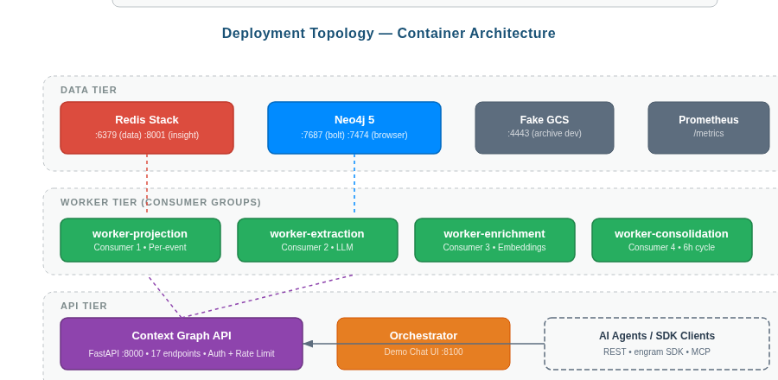
Figure 7: Container deployment topology — data, worker, and API tiers.
Tier | Services | Scaling | Purpose
Data Tier | Redis Stack, Neo4j Community, Fake-GCS (dev) | Vertical | Persistent stores, event ledger, graph projection
Worker Tier | 4 consumer workers (projection, extraction, enrichment, consolidation) | Horizontal per-group | Async event processing, each group independently scalable
API Tier | FastAPI (uvicorn), Orchestrator (demo) | Horizontal | REST endpoints, SDK integration, demo UI
Table 15: Three-tier deployment architecture.

8.2 Health Monitoring
Operational observability through three mechanisms:
- Health Endpoints: /v1/health returns 200 (healthy), 503 (degraded — one store unreachable), or 503 (unhealthy — both stores down). Detailed health at /v1/admin/health/detailed.
- Prometheus Metrics: events_ingested_total, events_batch_size, http_request_duration_seconds, http_requests_total, consolidation_lag, enrichment_lag. Exposed at /metrics.
- Structured Logging: structlog with request_id correlation (X-Request-ID propagation), method/endpoint labels, and timing annotations.

8.3 Security Architecture
Four security layers:
- Authentication: Two-tier bearer tokens — API key (standard endpoints) and admin key (privileged operations). Keys stored as SecretStr; timing-safe comparison via hmac.compare_digest().
- Input Validation: Pydantic v2 strict mode for all events. Path parameter injection prevention. Numeric range checking. Pagination cursor caps (4KB) with cycle detection.
- Rate Limiting: Token bucket per client IP. Three tiers: exempt (health/metrics), standard (120 RPM), admin (30 RPM). Returns 429 with Retry-After header.
- GDPR Compliance: Data export (GET /users/{id}/data-export), cascade erasure (DELETE /users/{id}), and archive-before-delete protocol. 205+ adversarial security tests passed.

9. API and Integration Design

9.1 REST API
Endpoint | Method | Auth | Description
/v1/events | POST | API Key | Ingest single event with optional payload
/v1/events/batch | POST | API Key | Batch ingest (up to 1000 events)
/v1/context/{session_id} | GET | API Key | Session working memory (Atlas response)
/v1/query/subgraph | POST | API Key | Intent-aware subgraph query (Atlas response)
/v1/nodes/{node_id}/lineage | GET | API Key | CAUSED_BY causal chain traversal
/v1/entities/{entity_id} | GET | API Key | Entity with connected events
/v1/health | GET | None | Service health check
/v1/admin/reconsolidate | POST | Admin | Trigger manual consolidation cycle
/v1/admin/stats | GET | Admin | Graph and stream statistics
/v1/admin/prune | POST | Admin | Retention-based pruning (with dry-run)
/v1/users/{user_id}/profile | GET | Admin | User profile retrieval
/v1/users/{user_id}/preferences | GET | Admin | Active preferences (filterable)
/v1/users/{user_id}/skills | GET | Admin | Skills with proficiency levels
/v1/users/{user_id}/patterns | GET | Admin | Behavioral patterns
/v1/users/{user_id}/data-export | GET | Admin | GDPR data export
/v1/users/{user_id} | DELETE | Admin | GDPR cascade erasure
Table 16: Complete API endpoint catalog (17 endpoints).

9.2 SDK and Framework Integration
Three integration layers provide access at different levels of abstraction:
Layer | Interface | Complexity | Use Case
Core SDK (engram) | 3-function API: record(), recall(), trace() + full typed client | Low | Direct agent integration
MCP Server (engram-mcp) | 7 tools for MCP-compatible agents | Low | Claude, MCP-native agents
Framework Adapters | LangChain, CrewAI, OpenAI Agents, LlamaIndex | Medium | Drop-in integration with existing agent stacks
Table 17: Integration layers.

10. Competitive Positioning
System | Architecture | Strengths | Context Graph Differentiator
Zep / Graphiti | Graph-based temporal knowledge | Graph traversal, temporal awareness | No provenance annotation, no cognitive decay model
Mem0 | Hybrid vector-graph | User personalization, simple API | Flat vector retrieval, no intent-awareness
Cognee | Knowledge graph enrichment | LLM extraction, enrichment | No decay scoring, no retention tiers
Microsoft GraphRAG | Community summarization | Sophisticated global queries | Static corpus only, no agent interaction model
LangMem | Lightweight LangGraph memory | Framework integration, simplicity | No graph structure, no provenance, no consolidation
Table 18: Competitive analysis.
Context Graph uniquely combines: (1) provenance-annotated retrieval, (2) intent-aware graph traversal with seed strategy dispatch, (3) cognitively-grounded decay scoring (Ebbinghaus model), (4) system-owned retrieval intelligence, (5) multi-stage consolidation with active forgetting, and (6) three-tier entity resolution. No single competing system offers this combination.

11. Retrieval Improvement Roadmap

11.1 Phase 1 — Quick Wins
- Wire embeddings into query path: Connect embedding infrastructure to scoring pipeline (relevance_score currently defaults to 0.5).
- Activate seed strategy dispatch: Use computed seed strategies to select traversal starting nodes.
- Enable cross-session entity retrieval: Remove single-session scope restriction for entity-centric queries.
- Score entity nodes: Apply composite scoring to Entity nodes discovered during traversal.

11.2 Phase 2 — Architectural
- Multi-hop PPR traversal: Replace single-hop BFS with Personalized PageRank for deeper exploration.
- Hybrid retrieval with RRF/MMR: Combine vector KNN + graph BFS + keyword BM25 with Reciprocal Rank Fusion.
- Summary-tier hierarchical retrieval: Use summaries as entry points for older event queries.
- User affinity scoring: Compute session_proximity, retrieval_recurrence, entity_overlap sub-components.

11.3 Phase 3 — Strategic
- LLM intent classification + HyDE: Replace keyword matching with learned classification and Hypothetical Document Embeddings.
- Cross-encoder re-ranking: LLM-based re-ranking after initial retrieval.
- Community detection: Leiden clustering for global reasoning queries.

Appendix A: ADR Index
ADR | Title | Status | Primary Modules
0001 | Traceability-First Context Graph | Accepted | Core principles
0002 | Service Stack: Python + FastAPI | Accepted | pyproject.toml
0003 | Dual Store: Redis + Neo4j | Accepted | adapters/redis/, adapters/neo4j/
0004 | Immutable Event Ledger | Accepted | domain/models.py, domain/validation.py
0005 | Async Projection Worker | Accepted | worker/consumer.py, worker/projection.py
0006 | MVP Query API | Accepted | api/routes/*, domain/models.py
0007 | Cognitive Memory Tiers | Accepted | settings.py
0008 | Consolidation, Decay, Forgetting | Accepted | domain/scoring.py, domain/forgetting.py
0009 | Multi-Graph Schema + Intent | Accepted | domain/models.py, domain/intent.py
0010 | Redis Stack as Event Store | Accepted | adapters/redis/store.py, lua/
0011 | Ontological Foundation | Proposed | domain/entity_resolution.py
0012 | User Personalization Ontology | Proposed | adapters/neo4j/user_queries.py
0013 | Knowledge Extraction Pipeline | Proposed | worker/extraction.py, adapters/llm/
0014 | Archival and Lifecycle | Accepted | domain/forgetting.py
0015 | SDK and Integration | Proposed | SDK package (engram)
Table A-1: Architecture Decision Record index.

Appendix B: Project Structure
src/context_graph/
- settings.py — Pydantic BaseSettings (CG_ env prefix, 11 config groups)
- domain/ — Pure Python, zero framework imports (11 modules)
- ports/ — typing.Protocol interfaces (4 core + 4 extended)
- adapters/redis/ — Redis Stack (store.py, lua/ingest.lua, indexes.py)
- adapters/neo4j/ — Neo4j (store.py, queries.py, maintenance.py, user_queries.py)
- adapters/llm/ — LLM extraction client (instructor/litellm)
- api/ — FastAPI (app.py factory, routes/, middleware.py, dependencies.py)
- worker/ — Consumers (consumer.py base, projection, extraction, enrichment, consolidation)

