Gisting a Coding Agent: Prompt Compression by Learned Tokens on a Self-Hosted Hybrid-Attention Model
Arun Menon · arumenon@paypal.com
Abstract. A coding agent asks a language model what to do at each step, and every request begins with the same large fixed block of text: the rules the agent must follow and a machine-readable description (a JSON schema) of every tool it may call. The model rereads this whole block on every turn, so it is a large cost paid again and again. We study gisting: replacing that fixed block with a handful of new gist tokens, extra entries added to the model’s vocabulary that are trained to stand in for the entire block. The training is self-distillation, meaning the model teaches itself by matching its own behaviour when it reads the short gist to its behaviour when it reads the full block; all of the model’s existing weights are frozen, so the only thing learned is the new tokens. We do this for a production coding agent (Claude Code) driving a 27B-parameter model we host ourselves (Qwen3.8-27B, a hybrid-attention design), inserting the substitution inside a proxy so that neither the client nor the serving engine is changed. Earlier work compressed plain-English instructions this way; here the block is over 90 percent tool schemas, so the open question is how much carries over.
The study runs in phases, and we report each as it came, the parts that failed included. We first measure the fixed block from real logged sessions, both to confirm it is large enough to be worth compressing and to separate the genuinely fixed text from the per-session details woven through it. We then build the gist: grow the model’s vocabulary with new tokens, start them from the block they replace, and train them by self-distillation, recording the teacher once so that each later recipe is cheap to try. With that loop in place we push the compression harder and harder to find where behaviour breaks, and stress it by moving from an easy task suite to a harder one built around rarely used tools, real repositories, and tasks that demand exact output; there we uncover a failure at the boundary between fixed and per-session content, which we diagnose, repair, and re-test. Finally we measure what the compression buys at serving time on this architecture, and we report two experiments that our own evaluation harness left unscorable. The detailed numbers and their limits are in the body; here we say only that they motivate further work rather than settle it. Because every result is a single run of small, partly reused, hand-built tasks, we present this as a development study rather than a validated benchmark, with an independent adversarial review of the whole program reconciled into it. The short version, within those limits: the method cut the tokens the model reads each turn by roughly half to two-thirds with no measured loss of task success, once session-specific values were kept out of the gist, and it added serving throughput under load; what we have not shown is that it holds on work we did not design, or why the serving gain appears.

1 Introduction
A coding agent asks a language model what to do next at every step. Each request carries a fixed preamble: the rules the agent must obey and a JSON schema for every tool it can call. In a standard transformer, every generated token attends back over that preamble, so a preamble of tens of thousands of tokens is a large recurring cost. Prior work on gist tokens [1] and prompt compression [2] compressed prose instructions; an industrial report [3] applied the idea to a production agent and observed substantial latency and hardware savings. Those results leave open how the method behaves for an agent whose preamble is dominated by tool schemas, on a model an operator hosts themselves, and on an architecture where the decode-time cost the method targets is present in only a fraction of layers.
We answer these questions for one concrete target: Claude Code 2.1.259 driving Qwen3.8-27B served by vLLM on a single 96 GB GPU. Two properties make it a demanding test. The preamble is 91 percent JSON tool schemas. And the model is a hybrid: of its 64 layers, only 16 use full attention with a per-token cache over the prefix; the other 48 fold the prefix into a fixed-size recurrent state, so a shorter prefix cannot reduce their decode cost.
Intuition. A useful mental picture: the preamble is a long instruction manual the model rereads before every action. Gisting replaces the manual with a few thousand learned shorthand symbols (2,171 at the corrected 8:1 span) that mean the same thing to this one model. We never write those symbols by hand; we let the model teach itself their meaning by matching its own behaviour with and without the manual in front of it. The symbols are then shipped as extra rows in the model’s vocabulary table, so the serving system treats them like any other token.
Contributions.
- A development study applying a frozen-model prompt-distillation recipe [3] to a schema-dominated coding-agent preamble on a hybrid linear-attention model, with the client and serving engine unmodified.
- A deployment recipe whose only trained object is a small embedding tensor: proxy-side span substitution, a conditional chat template, and a sampling mask, requiring no patch to the inference engine.
- An automated, cost-guarded experiment loop (the lab): an unattended controller that provisions a rented GPU, trains a gist, serves it, evaluates it through the same proxy, verifies every turn was swapped, syncs results, and destroys the instance, with structural spend-safety (an idle watchdog, a ledger, and sync-before-destroy). We report the harness faults that invalidated two experiments as candidly as the runs that succeeded, and stress-tested every claim with an independent adversarial review whose findings are reconciled into the paper.
- An architecture-aware characterisation: in one replay the serving gain was larger for throughput under concurrency than for single-request latency, consistent with an expectation of smaller decode-time savings formed from the layer mix beforehand; we do not establish the cause.
- A failure mode and its fix: session-specific content (a path with a session identifier) that sample invariance had classified as static was folded into the gist and reconstructed incorrectly, failing path tasks across the four tested ratios; excluding such content from the span by pattern raised an 8:1 gist from 11/16 to 16/16 (11/15 to 15/15 excluding one defective probe) on a hard suite.

2 Related work
Prompt and context compression. Mu et al. [1] introduced gist tokens, training a model with a modified attention mask so that a few tokens learn to summarise an arbitrary incoming prompt; that is amortised compression of new prompts. Our task is the narrower one of learning a reusable fixed prefix for one preamble with the backbone frozen, and calling both "gisting" is reasonable only with that distinction made explicit. The concrete recipe we use, frozen weights with new embedding rows, chunk-mean initialisation, teacher precomputation, loss normalisation, and vocabulary-row deployment, follows the industrial report [3] closely; our contribution is transferring and stress-testing it on a schema-heavy, hybrid-attention deployment, not the algorithm. Prompt tuning [8] likewise learns soft-prompt vectors with a frozen model but for task adaptation rather than compression. Discrete methods such as LLMLingua [9] select or drop actual tokens instead of learning vectors. A no-training alternative to the same schema overhead is tool selection or lazy schema loading [10], which trades a retrieval step for the training we do. Wingate et al. [2], context distillation, and the AutoCompressor and ICAE line [6,7] are related soft-prompt and context-compression methods.
Knowledge distillation. The training objective is response-level KL from a teacher [4]; here teacher and student are the same frozen network with different inputs, a self-distillation.
Efficient inference. Prefix caching removes recomputation for a shared prefix and is the baseline gisting must beat; we run it in both arms. Hybrid and linear-attention models [5] change which costs a shorter prefix can reduce, which is central to our latency analysis.

3 Method
The method has three parts, shown in Figure 1: identify the fixed span worth compressing (3.1), grow the vocabulary and train the replacement tokens (3.2 and 3.3), and serve them without patching the engine (3.4).
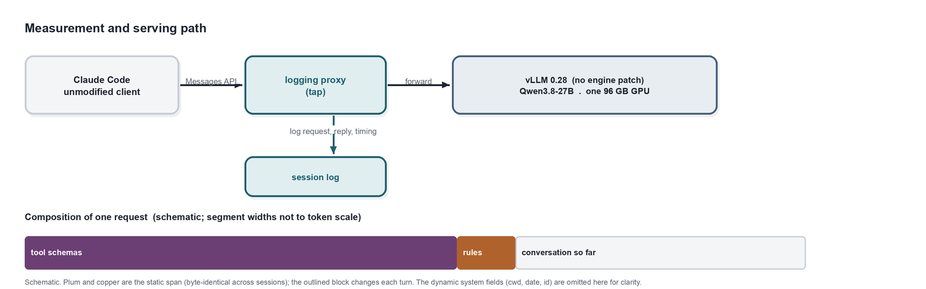
Figure 1. The measurement and serving path. A logging proxy between the unmodified client and the engine records every request; the same proxy later substitutes the gist. The static span is almost entirely tool schemas.

3.1 Defining the static span
The gistable unit is the token span that is byte-identical across sessions after the chat template renders it. We recover it by diffing the rendered system text and tool array across many logged sessions. Per-session content, the working-directory path, git status, date, and served model name, is marked dynamic and left as raw tokens. A later result (Section 5.5) forces a stronger rule: any line matching a path, identifier, date, or model-name pattern is treated as dynamic regardless of whether it varied in the sample. For the trimmed 27-tool catalogue the static span is 17,540 tokens: 15,994 of tool schemas and about 1,546 of instructions in three segments. In plain terms, almost all of what we compress is the machine-readable description of the tools, not the human-readable rules.

3.2 Growing the dictionary and training the gist
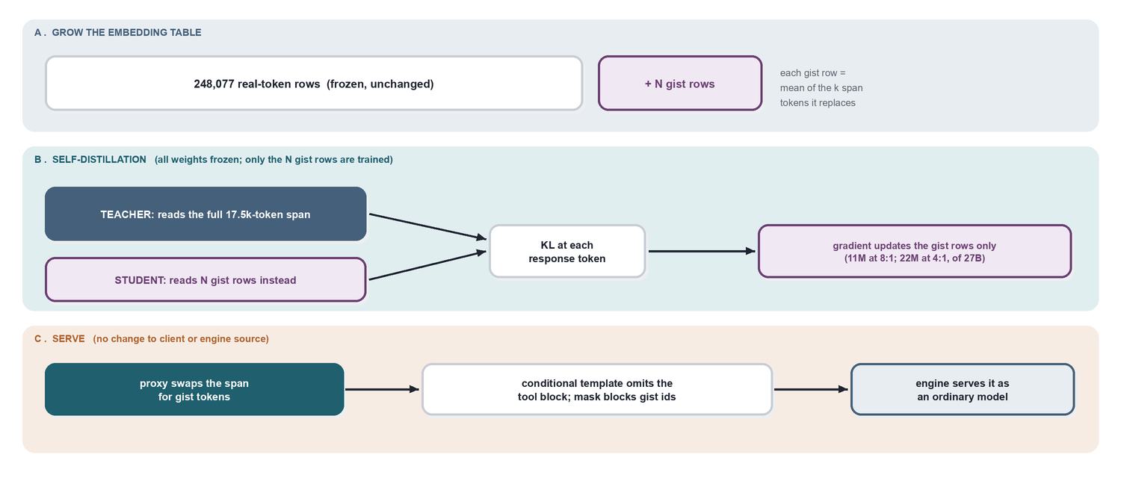
Figure 2. The method. A: the embedding table is grown with N gist rows, each initialised as the mean of the k span tokens it replaces; the output head is grown with zero rows. B: with all weights frozen, only the gist rows are trained, by KL between the full-prompt teacher and the gist-prompt student at each response position. C: serving requires no engine patch.
The tokenizer receives <gist_0> through <gist_{N-1}> as single-id special tokens. The input embedding is grown by N rows, each initialised to the mean of the k span-token embeddings it replaces at ratio k:1; this initialisation is the largest single training win reported in [3]. The output head is grown with zero rows and, because a zero logit still has nonzero softmax probability, a logits processor forbids sampling any gist id. Training minimises the KL divergence from the teacher (the frozen model reading the full span) to the student (the same model reading the gist rows) at each response token, summed over all response tokens in a step and divided by their count. Only the N-by-5120 gist tensor receives gradient.

3.3 Precomputing the teacher
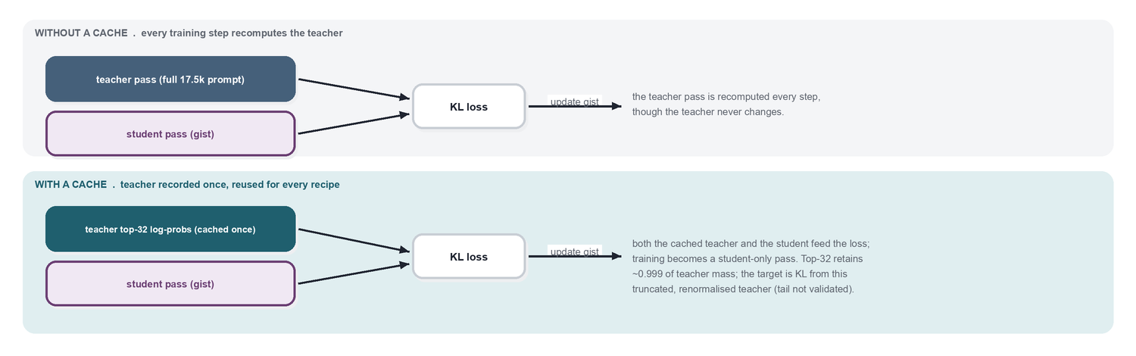
Figure 3. The teacher target never changes, so it is recorded once as top-32 log-probabilities per response position and reused for every recipe, turning training into a student-only pass.
The teacher distribution is independent of the gist rows, so we record it once (top-32 log-probabilities per response position) and reuse it across recipes. The cached objective is therefore KL from a truncated, renormalised teacher (probabilities renormalised over the retained top-32 ids) to the full-vocabulary student, not the full-teacher KL. Top-32 retained about 0.999 of the teacher’s probability mass at both the mean and the tenth percentile of response positions; high retained mass alone does not bound the omitted-tail contribution, which we did not measure.

3.4 Serving
Two components, neither touching engine source. The proxy locates the span by matching anchors in the incoming request and substitutes the gist tokens; the final proxy substitutes each segment whose anchor matches and leaves an unmatched segment raw (rather than refusing the whole request), and gates on a tool-catalogue hash so a changed catalogue is not silently gisted. Earlier runs used a stricter all-or-nothing passthrough; we distinguish the two because substitution coverage differs between them. The chat template gains one condition: when the system message contains a gist token, the tool block is not rendered, while the request still carries the tool array so the engine’s tool-call parser remains active.

4 Experimental setup

4.1 Model, engine, and client
The model is Qwen3.8-27B: 64 transformer layers, hidden size 5120, untied input and output embeddings, and a full-attention interval of 4 (one full-attention layer for every three linear-attention layers). We serve the bf16 checkpoint at a pinned snapshot with vLLM 0.28, prefix caching enabled, vision disabled, on a single 96 GB GPU. Three serving settings were necessary: a cap of 64 concurrent sequences (the default of 1024 exceeds the recurrent-state cache blocks that fit in memory and aborts startup), 80 percent memory utilisation with 4096-token prefill chunks when computing the teacher cache (the full-vocabulary log-probability tensor for a larger chunk exhausts memory), and, in the proxy, a rewrite of the client’s requested reasoning-effort value, which the model rejects. The client is Claude Code 2.1.259 with auto-update disabled, pointed at the proxy by a single environment variable; it is otherwise unmodified.

4.2 Instrumentation: the tap
All measurement flows through a small logging proxy (the tap) placed between client and engine (Figure 1). It forwards each request unchanged and records the rendered system blocks, the tool array, the full message history, the reassembled response, and per-request timing. The client never sees it. The same proxy, in a second mode, performs the span substitution at serving time and logs whether the swap was applied, which we use as a health signal.

4.3 How the span was analysed
The static span is defined operationally as the token region that is byte-identical across sessions after the chat template renders it, and we recover it empirically rather than by inspecting the client. First, we collect real sessions by running the client headless (claude -p) over prepared repositories through the tap, with a tool allowlist, so that every request the model would see is logged in exactly its served form. Second, we take the rendered system text and the tool array from every logged request and compute their longest common prefix and the dominant (most frequent) tool array; the differences localise the per-session content (working directory, git status, date, served model name). Third, we count the span exactly by submitting the candidate system text and tools to the engine’s own tokenizer endpoint and subtracting a bare user turn, so the number reflects the chat template as the model actually consumes it, not a client-side estimate. Fourth, we compute the quantity that decides whether compression is worthwhile: the integrated static share, defined as the static-span token count times the number of turns, divided by the total input tokens the model read across the session (from the engine’s own usage counts). We report this per session and by session-length class (Figure 7). Finally, we split the span into segments the trainer can address independently: the instruction text becomes several contiguous segments separated by the dynamic injections, and the tool block is its own segment. A segment shorter than a small threshold, or one matching a path, identifier, date, or model-name pattern, is marked dynamic and kept as raw tokens; Section 5.5 explains why the pattern rule is necessary.
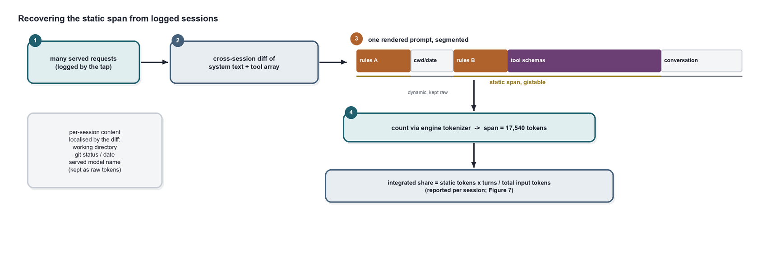
Figure 4. How the static span is recovered from data. Served requests are logged; the longest common prefix of their system text and the dominant tool array is the static span; per-session content is localised by the differences and kept raw; the span is counted through the engine tokenizer and split into instruction segments and a tool block. Copper and plum are static and gistable; outlined regions are dynamic.
Segment | What it holds | Classification | Tokens | Gist rows
Instruction segments | agent rules, harness notes, memory format | static, gisted | ~1,350 | 171
Tool schemas | JSON for the 27-tool catalogue | static, gisted | 15,994 | 2,000
Per-session values | working directory, git status, date, model name, memory path | dynamic, kept raw | ~260 | 0
Static span (gisted) |  |  | 17,343 | 2,171 (≈8:1)
Table 1. Composition of the corrected 8:1 span (the trained verbatim-rule run). Almost all of the span is the machine-readable tool schemas; the human-readable instructions are a small fraction. Per-session values are excluded from the gist by pattern and sent raw. The gisted total, 17,343 tokens, is about 200 below the 17,540 quoted in Section 3.1, which counts the same span before the verbatim rule reclassified those session-specific tokens as dynamic.

4.4 Data collection and the two arms
Training and evaluation sessions are produced by the same headless driver over a seed repository and three real open-source repositories, stratified across task types and including deliberate failure paths. Each logged turn becomes one distillation example whose reconstruction matches the engine’s request-to-prompt conversion exactly (inline system messages merged, tool results rendered as tool-role messages). The teacher arm sends the full prompt; the student arm has the tap substitute the span. Both arms run against the same served model with identical weights for every real token, so a difference between them isolates the span substitution from any weight change; single-run differences may still reflect generation, execution, and grader variability. One qualification: sub-agent (Agent-tool) child sessions carry a different prompt and a smaller tool catalogue, and the tap correctly leaves them unswapped, so a task that delegates to a child agent is served partly by the full prompt.
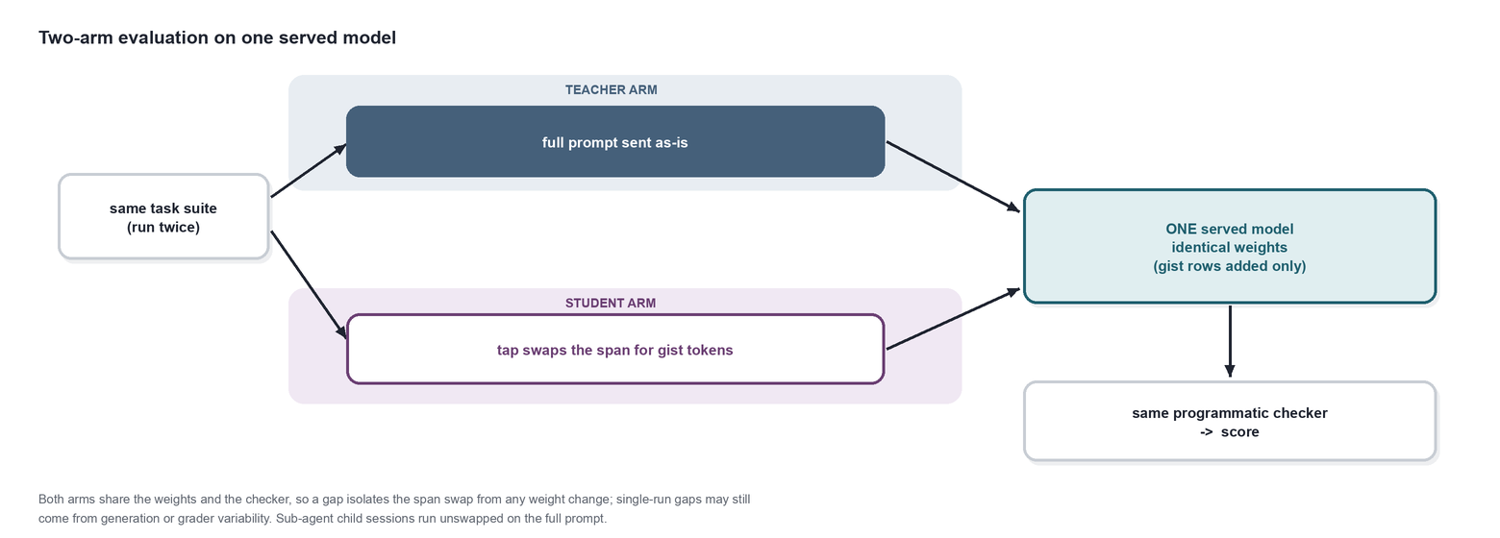
Figure 5. The two-arm evaluation. The same task suite is run twice against one served model with identical weights: the teacher arm sends the full prompt, the student arm has the tap substitute the span for gist tokens. Both arms share the model and the checker; single-run differences may still arise from generation and execution variability or grader defects. Sub-agent child sessions run unswapped on the full prompt.

4.5 Evaluation suites and scoring
An easy suite of 12 tasks on a two-file repository with programmatic checkers. A hard suite of 16 tasks stressing rarely used tools, real repositories at depth, rule adherence, and adversarial file content, scored by a log-aware checker over both the resulting files and the tool-call sequence (required tools, forbidden commands, read-before-edit ordering). A coverage suite of 16 tasks each requiring named rarely used tools, scored on whether the tool was invoked at all. All suites are author-designed; there is task overlap between training data and the easy and coverage suites, and the hard suite guided the Section 5.5 fix, so none is a fully held-out test set. Each reported score is a single run. Compute is one GPU per experiment, training one epoch, the teacher cache a one-time pass; GPU-hours are in the appendix.

4.6 The automated experiment loop (the lab)
Most experiments after the first were run by an unattended controller rather than by hand (Figure 6). Recipes are queued as rows; for each, a detached process on the workstation provisions the cheapest suitable rented GPU, copies the code, training data, and teacher cache to it, and launches one chained job under a restart-on-death supervisor: grow the checkpoint, train the gist for one epoch, serve it, and signal readiness through a state file. The controller polls that state file over SSH; on readiness it opens a tunnel, starts the tap in gist mode with the run’s segment map, runs the evaluation suite, scores it, verifies that every turn was actually swapped, syncs the artifacts down, appends a results line, and destroys the instance. Each step is idempotent per instance through state files, so a dropped connection resumes rather than repeats. Spend-safety is structural rather than vigilance-dependent: an idle watchdog on each instance stops it after a fixed idle period, a ledger records every instance the moment it exists, results are synced before any instance is destroyed, and a global deadline tears the whole sweep down. This loop is what made the ratio and per-segment sweeps affordable to attempt; it is also where the faults of Section 5.8 arose, so we treat its reliability as an object of study, not a solved tool. Code is under loop/ (controller, provisioner, per-recipe run scripts).
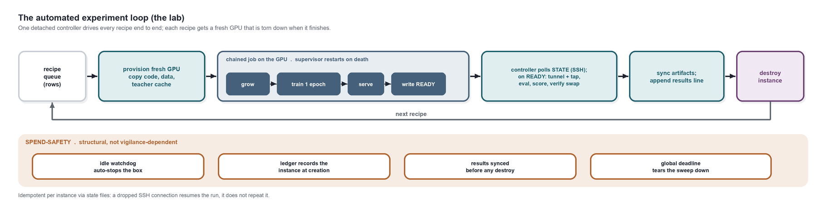
Figure 6. The unattended experiment loop. A detached controller takes each queued recipe, provisions a fresh GPU, and runs one chained job on it (grow the checkpoint, train the gist for one epoch, serve it, signal readiness); it then polls that readiness state over SSH, evaluates the served model through the tap, verifies every turn was swapped, syncs the results, and destroys the instance before taking the next recipe. Spend-safety is structural: an idle watchdog, a ledger written when the instance is created, sync-before-destroy, and a global deadline. This same loop is where the Section 5.8 faults arose.

5 Results
The results follow the phases of the study:
Section | The question it answers
5.1 | Is the block worth compressing at all?
5.2 | Can the model carry gist tokens without ever emitting them?
5.3 | Does a trained gist preserve behaviour, and can it be trained cheaply?
5.4 | How far does it compress before anything breaks?
5.5 | What breaks under a harder suite, and how do we repair it?
5.6 | What does the compression buy at serving time?
5.7 | Does a training detail change the outcome?
5.8 | What could we not score?
Because scores are single runs of small, partly reused suites, we report them as descriptive development scores and smoke tests, not estimates of parity or population success rates; Section 7 states why the usual confidence intervals do not apply.

5.1 The block is large enough to be worth compressing
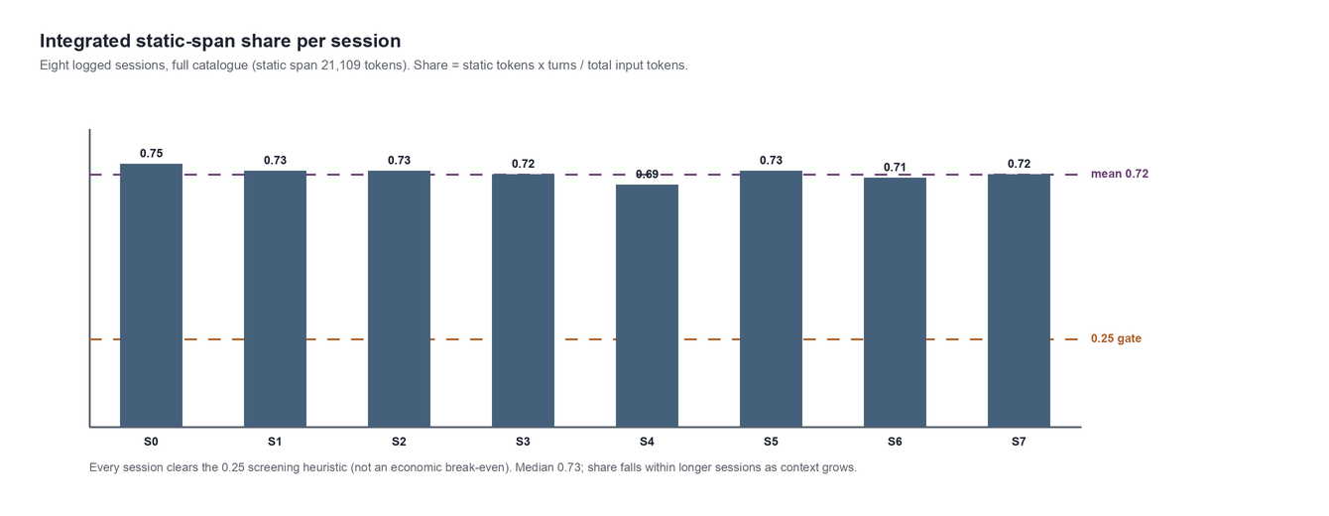
Figure 7. Integrated static-span share for eight logged sessions on the full catalogue (span 21,109 tokens): static tokens times turns, divided by total input tokens the model read. Mean 0.72, median 0.73; every session clears the 0.25 line, an author-chosen screening heuristic for when compression is worth attempting, not a measured economic break-even. The share shrinks within a longer session because the fixed span never grows while context does.
Across eight logged sessions on the full catalogue (static span 21,109 tokens) the integrated static share was 0.72 on average and 0.73 at the median, and it declines within a session as context accumulates (Figure 7). Prefix caching, the no-training baseline, served 87 percent of tokens from cache on short sessions and 60 percent on a mixed run; gisting operates over that cached baseline. Removing 24 unconnected plugin tools from the catalogue saved 4,512 tokens with no training, the largest single reduction before any gist, and gives the trimmed 17,540-token span used for the compression experiments.

5.2 The model never emits the new tokens
The checkpoint had 243 spare embedding rows, far fewer than needed, so the table must be resized. After resizing and mean-chunk initialisation, the enlarged model loads in the engine and, across 30 generations at temperatures 1.0 and 1.5 including prompts that request gist tokens by name, emitted no gist id. The guarantee rests on the sampling mask; zero output-head rows alone do not preclude sampling.

5.3 A trained gist holds up, and the loop is cheap
At 4:1 (4,386 gist tokens), held-out KL per token fell from 0.053 to 0.015 in one epoch, and the gist matched the teacher 12/12 on the easy suite while reading 11.4k tokens per turn against 24.3k. Tool-call JSON was well-formed throughout; one call named a nonexistent tool in 84. The teacher cache (Section 3.3) made subsequent training a student-only pass; top-32 retained about 0.999 of teacher probability mass in the aggregate summaries, though we did not validate the omitted-tail KL or downstream equivalence.

5.4 How far it compresses before anything breaks
Ratio | Easy suite | Tool calls | Malformed | Input tokens/turn
teacher | 12/12 | 69 | 0 | 24,258
2:1 | 12/12 | 98 | 0 | 16,083
4:1 | 12/12 | 84 | 0 | 11,410
8:1 | 12/12 | 101 | 0 | 9,395
16:1 | 12/12 | 94 | 0 | 8,245
Table 2. Compression sweep on the easy suite, each ratio trained one epoch against the shared teacher cache. No knee appears on this suite. Recovery from out-of-memory events changed sequence caps and training subsets between runs, so these are not four otherwise-identical experiments, and the easy suite is a weak instrument (Section 7).

5.5 What breaks under a harder suite, and the fix
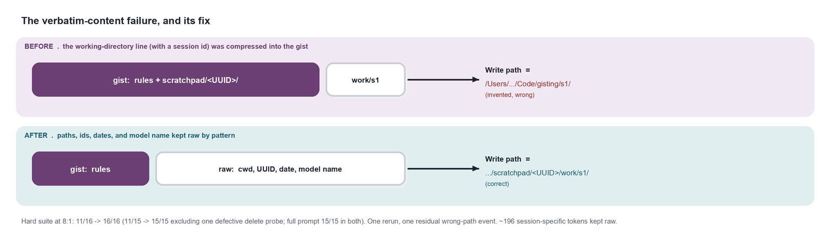
Figure 8. The dominant hard-suite failure and its repair. When the working-directory line (session identifier included) is folded into the gist, the model writes to invented directories. After excluding such lines by pattern and retraining once, the three previously failing path tasks passed; one residual invented-path event was still observed.
Run | Hard suite | Path writes correct
teacher | 15/16 | 3/3
2:1 / 4:1 / 8:1 / 16:1 | 12 / 11 / 11 / 12 | 0/3 each
8:1, verbatim rule | 16/16 | 3/3
teacher (same host) | 16/16 | 3/3
Table 3. Hard suite. Every compressed model failed the tasks requiring a write to an absolute path; the dominant cause is a session-specific value folded into the gist. One task (an explicit delete request) is a defective probe: it "fails" only if the file survives, and every arm deletes it. Excluding that probe, the corrected 8:1 gist improves 11/15 to 15/15 with the full-prompt model at 15/15 in both evaluations, so one of the five headline points is not evidence for the fix. The three path tasks account for three of the four remaining gains; one gain is unexplained. Retraining, a changed training pool, and a new evaluation host accompany the repair, so the improvement is not attributable to the rule alone.
The corrected 8:1 gist reads about 10.4k tokens per turn against the teacher’s 25.5k on this suite. One residual invented-path event was observed after the fix; we report it as an occurrence, not a rate.

5.6 What the compression buys at serving time
The result to watch. For a self-hosted agent that serves many developers from one GPU pool, the number that decides cost is how many sessions a GPU can carry at once, not how quickly a single reply returns. That is where gisting helps here: because each turn reads roughly half to two-thirds fewer input tokens, throughput rises under load, and the gain grows with concurrency, reaching about 16 percent more requests per minute at eight concurrent sessions. It does not make an individual reply meaningfully faster. The payoff is capacity, and it compounds exactly when the service is busiest, subject to the single-run caveats below.
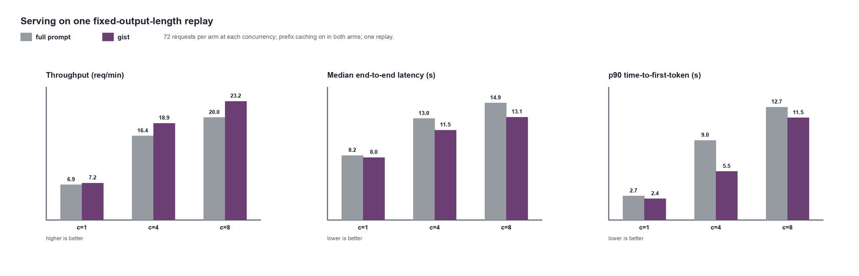
Figure 9. Serving on one fixed-output-length replay (72 requests per arm at each concurrency), gist versus full prompt, prefix caching on in both arms: throughput, median end-to-end latency, and p90 time-to-first-token by concurrency. The throughput improvement grows with load; the concurrency-1 latency change is small. One replay; the layer-mix explanation is a hypothesis, not a validated cause or an industrial reproduction.
Concurrency | Throughput full → gist (req/min) | Δ | Median E2E full → gist (s) | Δ | p90 TTFT full → gist (s) | Δ
1 | 6.87 → 7.19 | +4.7% | 8.23 → 7.97 | -3.2% | 2.69 → 2.37 | -12%
4 | 16.42 → 18.90 | +15.2% | 12.96 → 11.47 | -11.5% | 8.96 → 5.46 | -39%
8 | 20.02 → 23.18 | +15.8% | 14.95 → 13.14 | -12.1% | 12.72 → 11.52 | -9%
Table 4. Serving on one fixed-output-length replay: 12 logged sessions × 6 turns = 72 requests per arm at each concurrency, 200 generated tokens, temperature zero, prefix caching on in both arms, teacher then student, ascending concurrency without cache resets. Throughput is requests completed per minute (higher is better); median E2E is end-to-end request latency; p90 TTFT is the 90th-percentile wait before the first output token (both lower is better). Percentages are computed from unrounded measurements. One replay; direction, not precision.
Throughput rose about 5, 15, and 16 percent at concurrency 1, 4, and 8, while median end-to-end latency fell about 3, 12, and 12 percent (Table 4). The single-request (concurrency-1) end-to-end change was small. The engine counters at concurrency 1 attribute the larger absolute saving to prefill (1.56 to 1.31 seconds per request) rather than decode (7.15 to 7.03), which is consistent with a smaller decode-time opportunity on a model with full attention in only 16 of 64 layers; layer counts are not runtime fractions, however, and we do not identify the cause. The industrial report’s 38 percent median end-to-end reduction was measured at 350 requests per minute on a differently specified model, so our figures are numerically similar in a different regime rather than a reproduction of a single-request result. The replay measures serving on a fixed workload, not agent task completion, and its static allocation of sessions across workers leaves an uneven drain phase; we did not run a saturation search or measure completed sessions per GPU.

5.7 Whether the training detail changes the outcome
At the corrected 8:1 span, per-response averaging ended at held-out KL 0.0107 versus 0.0088 for batch-level and scored 14/16 versus 16/16 on the hard suite. The direction matches [3]; the magnitude here is mild and rests on a single run, so we retain batch-level averaging as the default without claiming a strong effect.

5.8 What we could not score
Two experiments did not yield trustworthy results, and we report them as such. In the coverage experiment, a gist retrained with 299 examples exercising rarely used tools scored below the teacher on a tool-reach suite; however, that evaluation run suffered an infrastructure fault (repeated request failures over roughly 99 minutes, with some tasks credited on earlier tool occurrences), so its numbers are withdrawn. A follow-up per-segment experiment, compressing the tool block less aggressively (4:1, 2:1) than the rules (8:1) to test whether rare-tool reach is capacity-bound, trained cleanly but could not be scored: the evaluation harness failed in six distinct ways across four attempts (a proxy port collision, request drops through a single overloaded tunnel, a work-directory deletion flag, brittle span anchors on a fresh host, slow-booting hosts, and an invalid reference arm). We fixed each and verified the anchor fix offline, but produced no trustworthy per-segment number. We draw no conclusion about the method from these two: infrastructure and harness failures prevented any interpretable measurement, and this evidence cannot show whether the method or the harness dominates reliability. Whether rare-tool reach is capacity-bound, and whether per-segment ratios help, remain open. The per-run operational chronology is in the appendix log rather than treated as a result.

6 Analysis
The dominant failure was a static/dynamic boundary error, not a ratio limit. On the easy suite no ratio to 16:1 failed; on the hard suite the same path tasks failed across every tested ratio until session-specific content was removed from the span. The mechanism is specific: a fixed learned prefix cannot convey a new per-session value that is not supplied anywhere else, and empirical invariance in our collection sample was mistaken for semantic invariance. This is a span-selection defect, not evidence that a learned vector can never encode an exact string, since the model already emits fixed tool names and schema keys drawn from the gist. What genuinely resists this method is unavailable session-specific information, not exact strings in general.
Architecture shapes, but does not determine, the benefit. Full attention runs in 16 of 64 layers, where decode does prefix-length-dependent work over a per-token cache; the other 48 fold the prefix into a fixed-size recurrent state. That supports expecting a smaller decode-time opportunity than on an otherwise comparable all-full-attention model, and the planning notes recorded that qualitative expectation before measurement. The observations are consistent with it: the concurrency-1 median end-to-end reduction was small and the throughput gain grew with load. But 16/64 is not the fraction of runtime saved, the MLP and projection costs remain, all layers still process uncached prefix tokens, and scheduling and memory behaviour matter, so we treat the layer-mix account as a hypothesis rather than an identified cause.
Cross-condition comparisons are weak. KL curves are not comparable across runs because held-out sets, sequence caps, hosts, and dates differ; the industrial base model is unstated, so our layer-mix explanation is a hypothesis, not a controlled comparison.

7 Limitations
- One model, one client version, one machine class. The span is a function of client version, plugin set, and tool configuration; a different configuration is a different gist.
- Every score is a single run of a small, author-designed suite. Because the tasks are selected, partly reused, and dependent, the usual binomial confidence intervals do not describe the uncertainty in these scores; we report the scores themselves and avoid implying a calibrated success rate.
- Training data overlaps the easy and coverage suites, and the hard suite guided the Section 5.5 fix; none is an untouched test set.
- The coverage result is contaminated and withdrawn; the per-segment result is inconclusive.
- Held-out KL was split by turn, not session, in most runs, permitting trajectory overlap; the trainer now splits by session.
- The latency result is one fixed-output-length replay run once, ascending concurrency without cache resets; it records one observed direction, not repeatability or saturation. The harness derives time-to-first-token from the first server-sent event without confirming it carries an output token and counts events as generated tokens, a measurement risk we note rather than one we have ruled out.
- Top-32 truncation was validated only on aggregate retained mass, not on omitted-tail KL or downstream quality.

8 Reproducibility statement
The method is specified in Section 3 and the setup in Section 4, and the code paths are named in the appendix. This is an outline, not a complete executable specification: full reproduction additionally requires, and we retain, the exact model and tokenizer repository and revision and the engine, driver, and CUDA versions; the original and corrected serialised spans with the tool-catalogue hash, segment boundaries, per-segment counts, and the pattern rule; per-run optimiser settings, datasets, split assignments, and train/evaluation overlap by suite; the loss equations and response-position masking; the teacher-cache format with its top-32 truncation and renormalisation (the trained objective is KL from a truncated, renormalised teacher, not the full-teacher KL); the task and checker code with score records; and the replay configuration with raw request measurements. Per-run source hashes were not captured, so the named scripts reflect their final state rather than the exact code of every historical run, and we distinguish final from historical behaviour where it differs (Section 3.4). These artefacts are retained but not distributed with this paper.

9 Broader impact
Prompt compression lowers the serving cost of self-hosted agents, broadening access to capable coding assistants. It also carries a specific risk: compressing behavioural rules into opaque learned tokens can make safety-relevant instructions harder to audit, and a gist that silently drops or weakens a rule would be hard to detect. Our rule-probe and path-fidelity evaluations are a first, insufficient step; any deployment should retain explicit, testable checks that compressed rules still bind, and validate write targets and tool availability at the serving boundary.

10 Conclusion
A frozen-model prompt-distillation recipe can be implemented for a schema-dominated coding agent on a self-hosted hybrid model, served without modifying the client or engine, and it achieves a large reduction in input tokens per turn. In single runs on the suites we ran, a one-epoch, embedding-only gist scored equal to the full-prompt model once session-specific content was kept outside the span; whether that reflects behavioural equivalence on unseen work is untested. In one replay the serving benefit was larger for throughput than for single-request latency, consistent with the architecture but not causally established. In deployment terms the gain is extra capacity under load, not a faster individual turn. The open questions, generalisation on an untouched task set, controls that isolate the contribution of training, whether rare-tool reach is capacity-bound, a measured path-fidelity rate, and repeated serving measurements, require a rebuilt and validated evaluation harness, which our own negative results identify as the priority.

A Appendix: experiments and compute
Exp | Question | Outcome | GPU-hours
E0/E1 | Static share, caching baseline | 8 sessions, full catalogue (span 21,109): integrated share mean 0.72 / median 0.73; gate met | 1
3.3 | Checkpoint viability | loads; 0 gist ids emitted | CPU + 4
E2 | Minimum viable gist | 12/12; KL 0.053 to 0.015 | 11
E3 | Teacher cache | top-32 mass 0.999; student-only training | in E2/E4
E4 | Ratio sweep 2/8/16:1 | 12/12 at all; no knee on easy suite | 17
E7 | Hard suite; span defect; fix | 11 to 16/16 at 8:1 with verbatim rule | 9
E8 | Latency / throughput | +16% throughput at c=8; latency flat single-session | 1
E5 | Loss reduction | batch mildly beats per-response (single run) | 6
E6 | Coverage / rare tools | contaminated, withdrawn | 11
E4-seg | Per-segment ratio | inconclusive (harness faults); rows saved | ~24
Table 5. All experiments and approximate GPU-hours on single 96 GB GPUs. The paper’s claims were stress-tested by an independent, model-assisted adversarial review over the frozen code, logs, and figures; its findings are reconciled into the text. The review is a check on our reporting, not an empirical validation of the method.
Code paths: proxy/tap.py; driver/{run_sessions_local.sh,tasks_*.txt,eval_*.py}; gist/{segments.py,prepare_checkpoint.py,dataset.py,teacher_cache.py,train.py,export_rows.py,mask_gist_logits.py}; serving vast/serve_gist.sh with the conditional template; orchestration under loop/.

R References
- J. Mu, X. Li, N. Goodman. Learning to Compress Prompts with Gist Tokens. NeurIPS 2023.
- D. Wingate, M. Shoeybi, T. Sorensen. Prompt Compression and Contrastive Conditioning for Controllability and Toxicity Reduction in Language Models. Findings of EMNLP 2022.
- Shopify Engineering. Gisting: context compression for a production coding agent. Technical report, shopify.engineering/gisting, 2025.
- G. Hinton, O. Vinyals, J. Dean. Distilling the Knowledge in a Neural Network. NeurIPS Deep Learning Workshop, 2015.
- A. Gu, T. Dao. Mamba: Linear-Time Sequence Modeling with Selective State Spaces. 2023. (Cited for linear-attention background; the served model’s own configuration, not Mamba, specifies its 16/64 full-attention layer mix.)
- A. Chevalier, A. Wettig, A. Ajith, D. Chen. Adapting Language Models to Compress Contexts (AutoCompressor). EMNLP 2023.
- T. Ge, J. Hu, L. Wang, X. Wang, S. Chen, F. Wei. In-context Autoencoder for Context Compression in a Large Language Model. ICLR 2024.
- B. Lester, R. Al-Rfou, N. Constant. The Power of Scale for Parameter-Efficient Prompt Tuning. EMNLP 2021.
- H. Jiang, Q. Wu, C.-Y. Lin, Y. Yang, L. Qiu. LLMLingua: Compressing Prompts for Accelerated Inference of Large Language Models. EMNLP 2023.
- Anthropic. Advanced tool use: tool search and programmatic tool calling. anthropic.com/engineering/advanced-tool-use, 2025.

Development study. All evaluations are single runs of small, partly reused, author-designed task sets and should not be read as validated benchmarks. Model, client, and configuration are fixed; results may not transfer to other agents or models. No individuals or private systems are identified.

