SASL

(SIMPLE AUTHENTICATION AND SECURITY LAYER)

SASL is mainly used for Authentication.We are implemetning SASL in the kafka for client authorization. Which is used for scure communiation betweeen client and brokers.
Kafka supports several authentication mechanisms via SASL and we are using PLAIN mchanism.

So we create SASL security layer in kafka in my local system .Which is similar to as creating
Ssl so here are the steps :
there are some SASL mechanisms in kafka here we are using PLAIN mechanism by which clients are authenticated by their usrname and passwds.
Other mechanisms are used for different purposes so used in production environment and enterprizes that these mechanisms uses many techniques like hashing ,encodeing etc.Here we are using just simple PLAIN (username and passswd).

First step : To edit the server.properties in local host :>
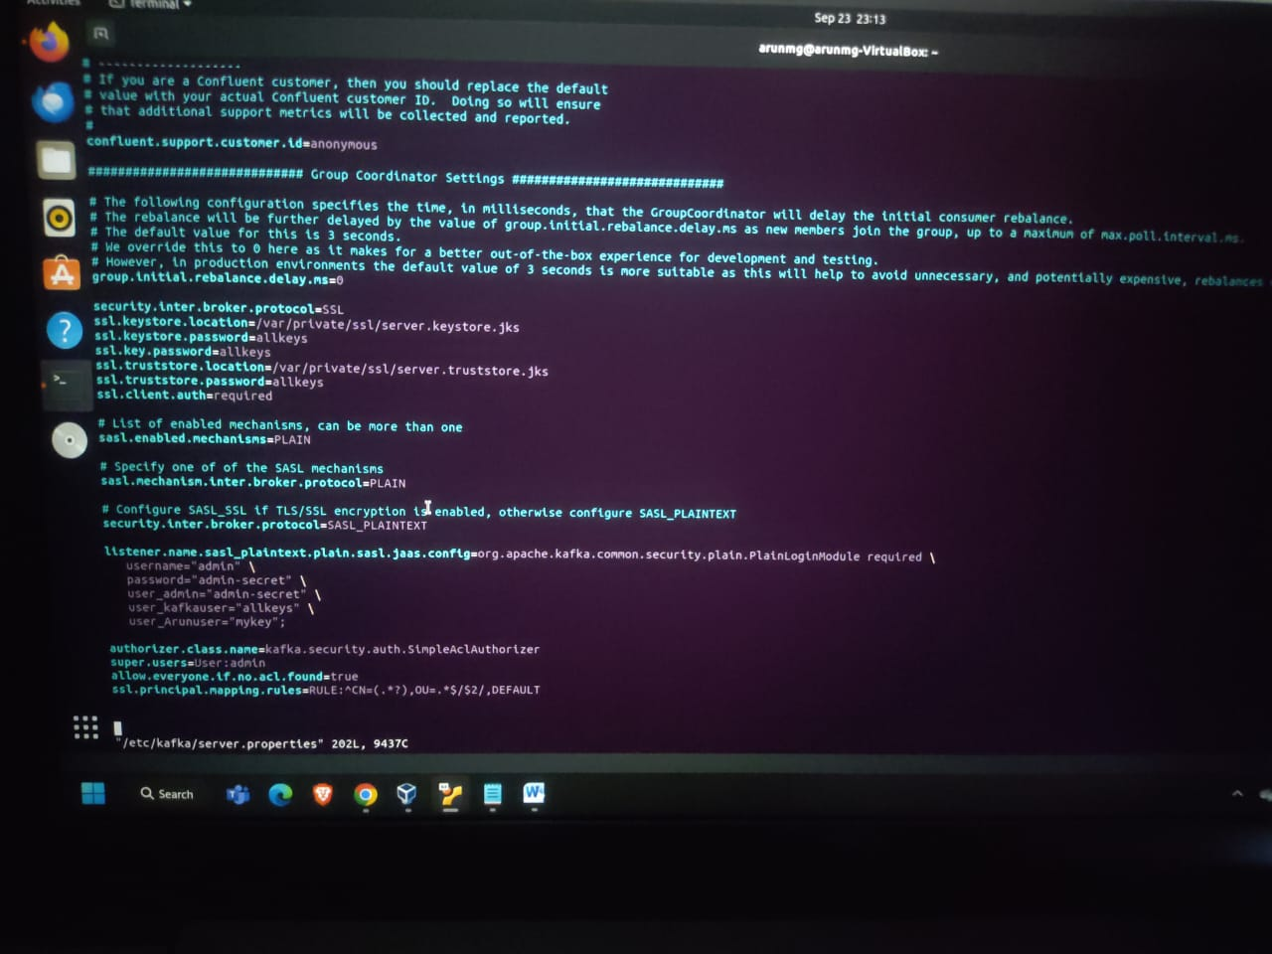
As you see in the picture there are lot of cofigertions of server there are SSL configerations , SASL configerations , and also ACL setting is there

# List of enabled mechanisms, can be more than one
sasl.enabled.mechanisms=PLAIN

# Specify one of of the SASL mechanisms
sasl.mechanism.inter.broker.protocol=PLAIN

# Configure SASL_SSL if TLS/SSL encryption is enabled, otherwise configure SASL_PLAINTEXT
security.inter.broker.protocol=SASL_PLAINTEXT

listener.name.sasl_plaintext.plain.sasl.jaas.config=org.apache.kafka.common.security.plain.PlainLoginModule required \
username="admin" \
password="admin-secret" \
user_admin="admin-secret" \
user_kafkauser="allkeys" \
user_Arunuser="mykey";

explaination : In the first property we are just enableing different mechanisms for further uscasses.
In the second property we are specifying that which mechanism we are actually going to use here that is PLAIN which is used in simple use cases like local environmnts that clients are authenticated by usernme and passwds.
In the third property setting we are mentioned that security protocol to use that is SASL_PLAINTEXT .
In fourth property that listener.name.sasl_plaintext.plain.sasl.jaas.config this specifies that jaas configeration file for SASL authentication of PLAINTEXT mechanism in which we explain that creadentials of ADMIN and USERS (clients) .
We also add t listners for SASL_PLAIN ie listeners=PLAINTEXT://localhost:9092,SSL://localhost:9093,SASL_PLAINTEXT://localhost:9094
Onwhich port kaka will hear SASL commuication

Then for client side configeration ex : client-sasl.properties
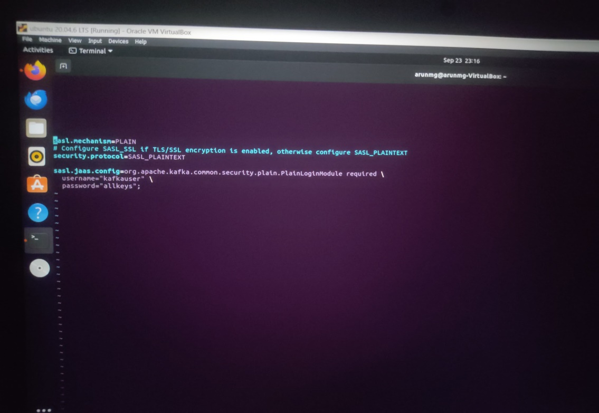

In the above picture we have seen that client—sasl.properties for kafkauser in local host
We hahve to mention authentication mechanism type that is PLAIN.
And we have to mention the Security.protocol that we are using for secure authntication SASL_PLAINTEXT.
Finally we are use the property of jaas file in that jaas file we have to mention username and passwd of user i.e
Username=”kafkauser”\
Paasswd=”allkeys” ;
This will be authenticated when we will be producing messages to topic upon our credentials
Which will be used In when ACLS are created on topic or any other resources of kafka. SASL will authenticate user and then proceed it .

SASL USE CASES :

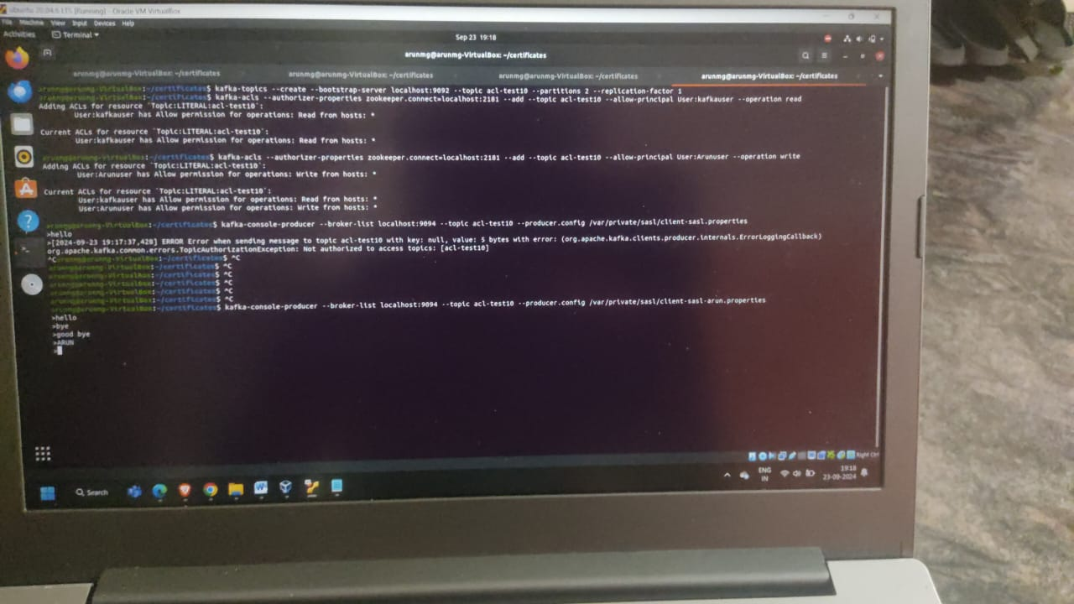
First we created two client-SASL properties in the directory of /var/private/kafka/sasl/client-sasl.properties for kafkauser and mentioned credentials for kafkauser
second we created two client-SASL properties in the directory of /var/private/kafka/sasl/client-sasl.properties for Arunuser and mentioned credentials for Arunuser
For first command : Here we are creaing acl-test10 named topic to check SASL authentication
Insecond command : we are creating acl on that topic acl-test10 topic and mentioned that principal as USER: kafkauser and mentioned operation that allowed for kafkauser to read only
In third command : we are creating another acl on sam topic acl-test10 that we are mentioned principal as USER: Arunuser and allowed operation only to write to topic
Now we are just producing messages to topic using client-sasl.properties as you seen in the above picture then it had prompted me to write when we trying to message and hit the enter it thrown the error bcz : kafka user have only allowed to read operation not to write to topic
In other hnd when we tried to produce message with client-sasl-arun.properties then it will prompted me to write message when I hit the enter it wil further prompted me to send message that’s mean Arun user hve write operation to send or pulish mssages to topic .

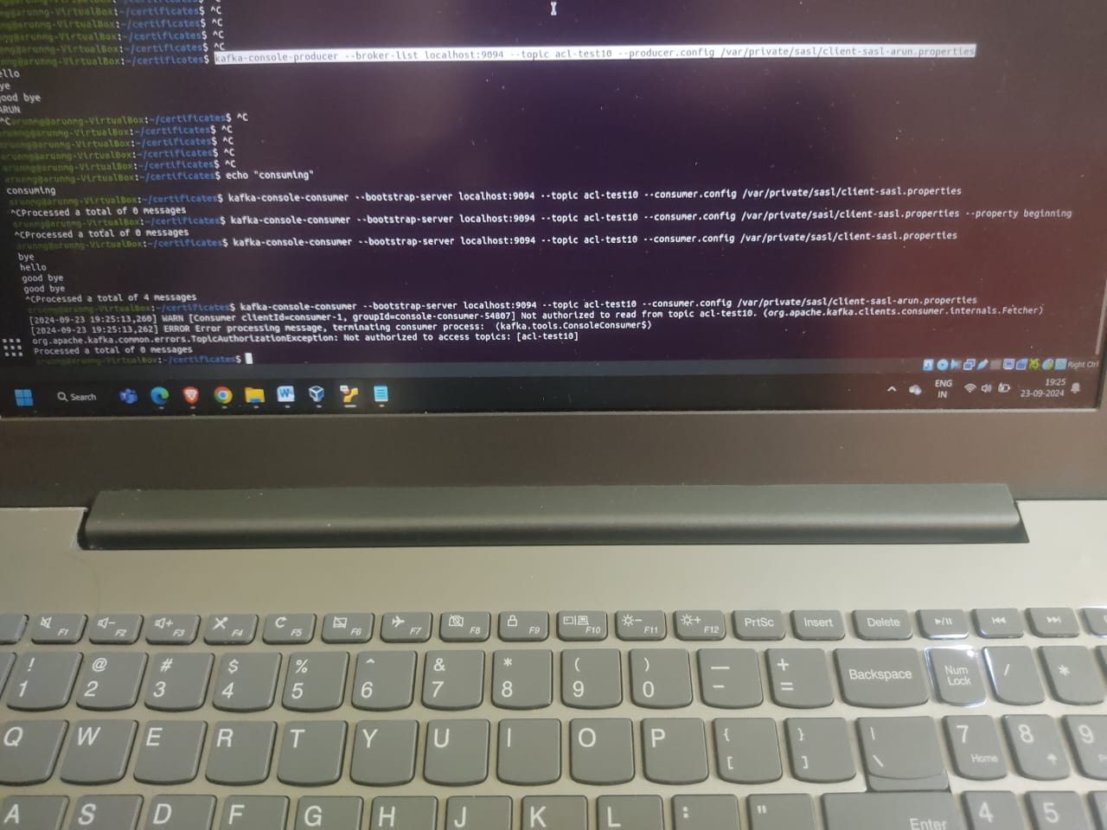
In the above picture we are trying to consume messages with different users kafkauser and Arunuser
Firstly we are consuming using client-sasl.properties of kafkauser on topic and then it displyays the messages bcz kafkaser has reead operation prevlige
But when we tried to consume messages using client-sasl-arun.properties of Arunuser on topic we got error of AUTHORIZATION that’s bcz Aunuser has only produce messages to topic not read or consume messages from topic.

