**1. INTRODUCTION**

**1.1 ABOUT THE PROJECT:**

In the modern world of technology, the use of Internet and World Wide Web revolutionized the provision of information and the facility for the user to take action on the information obtained. The rapid development of information technology has aroused all methods, great changes in the medium of instruction, job scheduling environment and other aspects. The Mahatma Gandhi National Rural Employment Guarantee Act, 2005 (MGNREGA) notified on September 7, 2005 mandate to provide at least 100 days of guaranteed wage employment in a financial year to every rural household whose adult members volunteer to do unskilled manual work. The programme is demand driven. The core objectives of the Scheme are the following:

* Providing not less than one hundred days of unskilled manual work as a guaranteed employment in a financial year to every household in rural areas as per demand, resulting in creation of productive assets of prescribed quality and durability.
* Strengthening the livelihood resource base of the poor.
* Proactively ensuring social inclusion.
* Strengthening Panchayat raj institutions

**2. SYSTEM ANALYSIS**

**2.1 EXISTING SYSTEM:**

Existing system does not involves appropriate solution. There exists emergency system for individual agencies which are non-reliable and difficult to handle by the users and the individual authorities. Even in some agencies still supporting manual way of handling emergency situation fully automated system is not implemented by them bringing all the information from different agencies manually is time consuming and the state of error occurrence is high. No existing system for alerting properly .Sometimes polices misses some cases while handling manually. Absent of police emergency case will be critical.

**2.1.1 DRAWBACKS OF EXISTING SYSTEM**

* Wastage of Time.
* Delay in processing.
* The Routine manual work is time-consuming.
* Difficulties in accessing data because of its clumsy way of storing.
* Tedious process.
* Attendance details are in a manual way.
* It is a time consuming process.

**2.2 PROPOSED SYSTEM**

The proposed system Emergency Assistance response System allows the organisation to access the application with proper login provided only by the authenticated admin. Problems faced by the public are solved by our system. The response system is very fast and provides quick response. This system does not only depend on the Govt.services, but also depends on the private services in different scenario. EARS should involve all cases , so we can rapidly and safely protect a life via this project. This system provides high security to the data at high accuracy rate.it provides a user friendly interaction to the users to operate

**2.2.1 Advantages:**

* Administrator Controls the System.
* Reduce the damages of the machines.
* Minimize manual data entry.
* Greater efficiency.
* User friendly and interactive.
* Minimum time required.
* Eliminates human error.
* Automatic and real-time update of database.
* Flexibility to introduce new services.
* The manager need not to worry about the record to be lost or damaged.

**2.3 FEASIBILITY ANALYSIS**

The main aim of feasibility study is to determine whether developing the product is financially and technically feasible. Feasibility study is made to see if the project on completion will serve the purpose of the organization for the amount of work, effort and the time that spend on it. Feasibility study lets the developer foresee the future of the project and the usefulness. A feasibility study of a system proposal is according to its workability, which is the impact on the organization, ability to meet their user needs and effective use of resources. Thus when a new application is proposed it normally goes through a feasibility study before it is approved for development. The document provide the feasibility of the project that is being designed and lists various areas that were considered very carefully during the feasibility study of this project such as Technical, Economic and Operational feasibilities. The following are its features:

**2.3.1 TECHNICAL FEASIBILITY:**

The project was developed in Flutter, node.js, Express.js which is technically feasible because of the mentioned characteristics or features.  Flutter is a UI toolkit for building fast, beautiful, natively compiled applications for mobile, web, and desktop with one programing language and single codebase. It is free and open-source. Initially, it was developed from **Google** and now manages by an **ECMA standard.** Flutter also offers many ready to use widgets (UI) to create a modern application. These widgets are optimized for mobile environment and designing the application using widgets is as simple as designing HTML. Node.js is an open source, cross-platform runtime environment for developing server-side and networking applications. Node.js applications are written in JavaScript, and can be run within the Node.js runtime on OS X, Microsoft Windows, and Linux. Node.js also provides a rich library of various JavaScript modules which simplifies the development of web applications using Node.js to a great extent. Express.js, or simply Express, is a back end web application framework for Node.js, released as free and open-source software under the MIT License. It is designed for building web applications and APIs. It has been called the de facto standard server framework for Node.js.

In the technical feasibility study it is found that the development of proposed system is technically feasible.

**2.3.2 ECONOMIC FEASIBILITY:**

Economic analysis is the most frequently used method for evaluating the effectiveness of a new system. More commonly known as cost/benefit analysis, the procedure is to determine the benefits and savings that are expected from a candidate system and compare them with costs. If benefits outweigh costs, then the decision is made to design and implement the system. An entrepreneur must accurately weigh the cost versus benefits before taking an action. Cost-based study.The project is economically feasible as it only requires a mobile phone with Android operating system. The application is free to download once released into Android market. The users should be able to connect to internet through mobile phone and this would be the only cost incurred on the project and this application ensures the safety of the users.

**2.3.3 OPERATIONAL FEASIBILITY:**

Operational feasibility is a measure of how well a proposed system solves the problems, and takes advantage of the opportunities identified during scope definition and how it satisfies the requirements identified in the requirements analysis phase of system development. In the operational feasibility study it is found that the development of proposed system is operationally feasible.

**3.SYSTEM SPECIFICATION**

**3.1 SOFTWARE SPECIFICATION**

* Programming language :Flutter
* Designing tool : HTML,CSS
* Web server : Apache
* Server Environment : Uniform server
* Backend : Node.js , Express.js
* Operating System : Windows 7
  1. **HARDWARE SPECIFICATION**
* Processor : Intel i5 or above
* RAM : 8GB
* Hard Disk Drive : 30 GB or higher
* Keyboard : 101/102 Natural Keyboard
* Monitor : Resolution of 800 X 600
* Mouse : Serial Mouse
* CD-ROM Drive : 52X MAX
* Printer : last printer

**4. SYSTEM DESIGN**

The design of the system is essentially a blueprint, or a plan for a solution of the system to develop. In design phase, the detailed design of the system selected in the study phase is accomplished. Principal activities performed during the design include the allocation of functions between computer programs and the system. The design phase is transition from a user-oriented document to the programmers. Software design is both a process and a model. The design process is set of iterative step that enables the designer to describe all aspects of the software to be built. The design model begins with representing the totality of things to be built. A set of fundamental design concepts have been evolved each of which provides the software designer with a foundation from which more sophisticated design method can be applied. Design of a system can be defined as the process of applying various techniques and principles for the purpose of defining a device, a process or a system in sufficient detail to permit its physical realization. Thus system design is a solution, a “how to” approach to the creation of a new system. This important phase provides the understanding and procedural details necessary for implementing the system recommended in the feasibility study. The design step produces a data design, an architectural design and a procedural design. The data design transforms the information domain model created during analysis into the data structures that will be required to implement the software. The architectural design defines the relationships among major structural components into a procedural description of the software. Source code is generated and testing is conducted to integrate and validate the software. From the project management point of view software design is conducted in two steps, preliminary design is concerned with the transformation of requirements into data and software architecture. Detailed data structure and algorithmic representation for software.

**4.2. INPUT DESIGN**

The user interface design is very important for any application. The interface design describes how the software communicates within itself, to system that interpreted with it and with humans who use it. The input design is the process of converting the user-oriented inputs into the computer-based format. The data is fed into the system using simple interactive forms. The forms have been supplied with messages so that user can enter data without facing any difficulty. The data is validated wherever it requires in the project. This ensures that only the correct data have been incorporated into the system. The goal of designing input data is to make the automation as easy and free from errors as possible. For providing a good input design for the application easy data input and selection features are adopted. The input design requirements such as user friendliness, consistent format and Interactive Dialogue for giving the right message and help for the user at right time are also considered for the development of this project. The most common cause of errors in a system is invalid user input. Maximum care is taken prevent invalid data from entering into the system. This was achieved by making proper validation checks on the user input. Error messages are displayed when and where an invalid user entry/action is encountered.

**4.3. OUTPUT DESIGN**

A quality output is one, which meets the requirements of the end user and presents the information clearly. In any systems results of processing are communicated to the user and to other systems through outputs. In the output design it is determined how the information is to be displayed for immediate need. It is the most important and direct source information to the user. Efficient and intelligent output design improves the system’s relationship with the user and helps in decision-making. The objective of the output Design is to convey the information of all the past activities, current status and to emphasize important events. The output generally refers to the results and information that is generated from the system. Outputs from computers are required primarily to communicate the results of processing to the users.

Output Design Concepts: Output is the most visible component of the information system.

* It is the basis of management’s final assessment of the system;
* It is designed by rapidly constructing prototypes.
* During system design outputs are modeled as data flows.
* Outputs may introduce new aspects to the system.

**4.4 DATA FLOW DIAGRAM:**

DFD shows the flow of data through a system. It helps a lot during problem analysis. It is useful in understanding a system and can be effectively used for partitioning during the analysis. It is used to describe and analyze the movement of data through a system-manual or automated-including the processes, stores of data, and delays in the system.

**Symbols in DFD**

**Data flow:**

**Process:**

**Data store:**

**External entities:**

**Context Level- DFD (Level 0)**

Hospital,

Ambulance

Admin

Fire Force

Ears

User

Police

KSEB

**LEVEL 1:**

**ADMIN:**

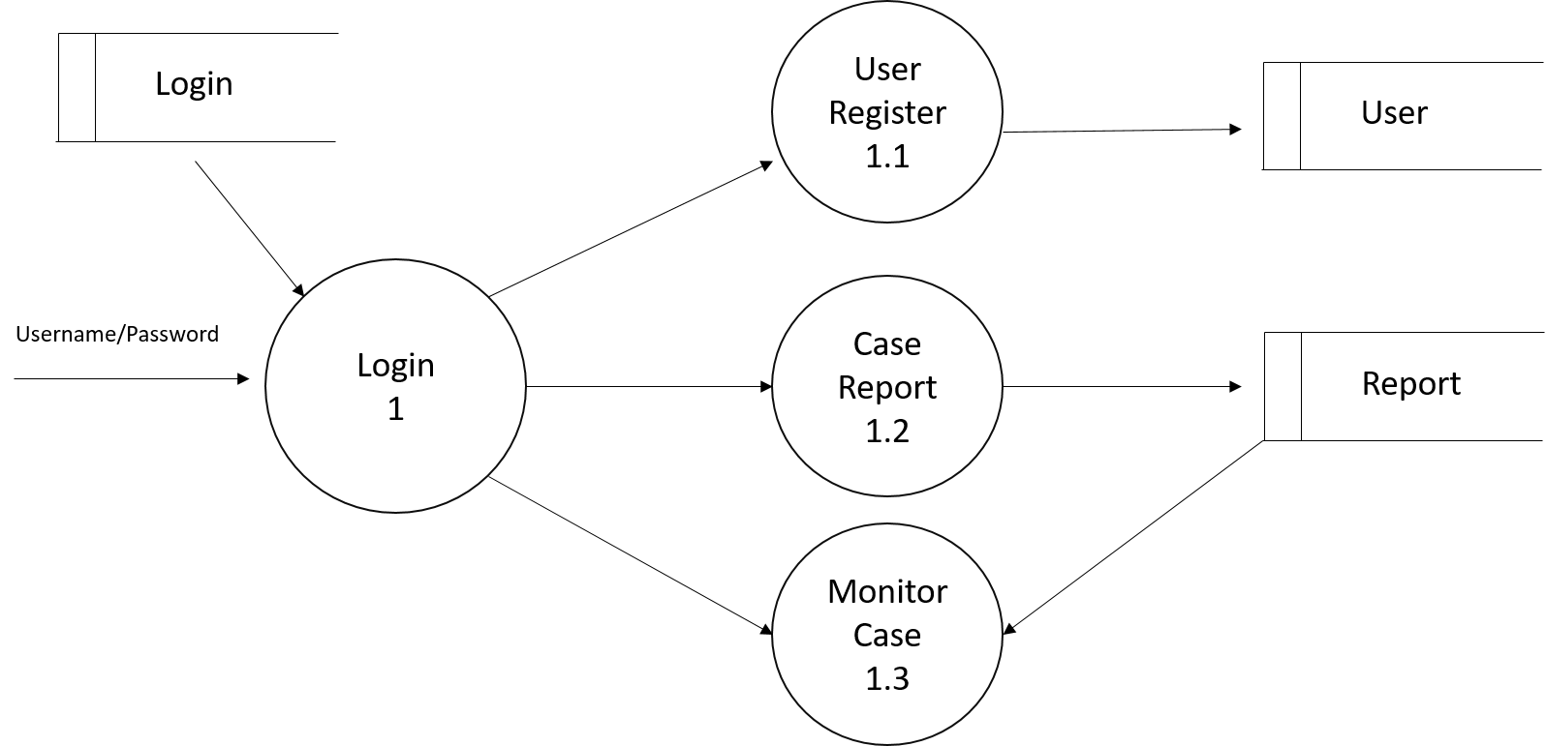

**LEVEL 1: USER**

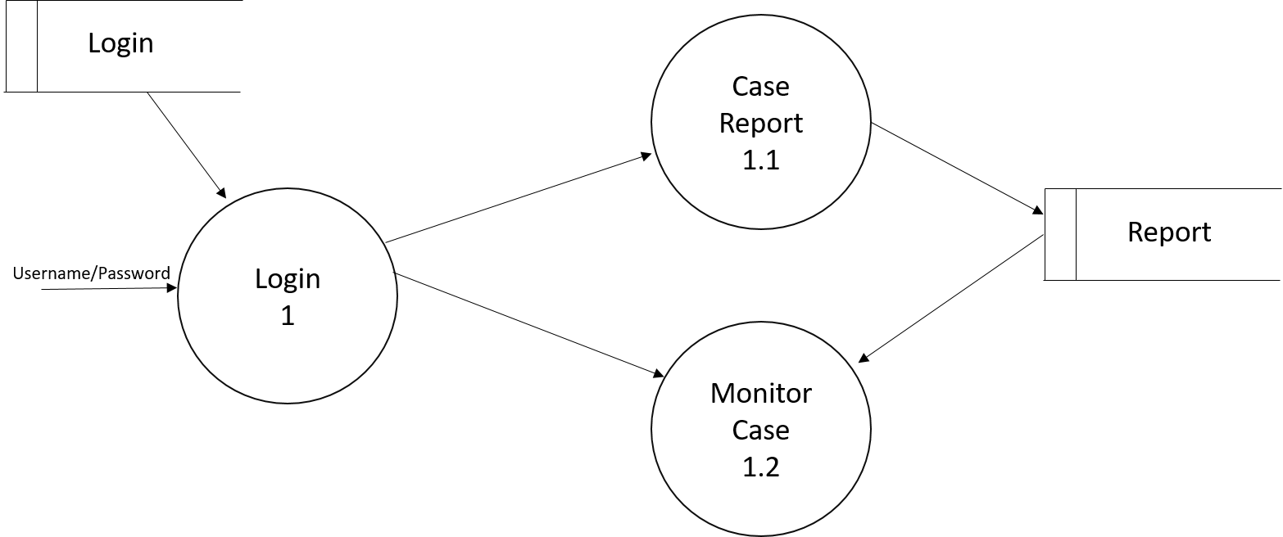

**LEVEL 1: Police, Hospital, Ambulance, Fire Force, KSEB**

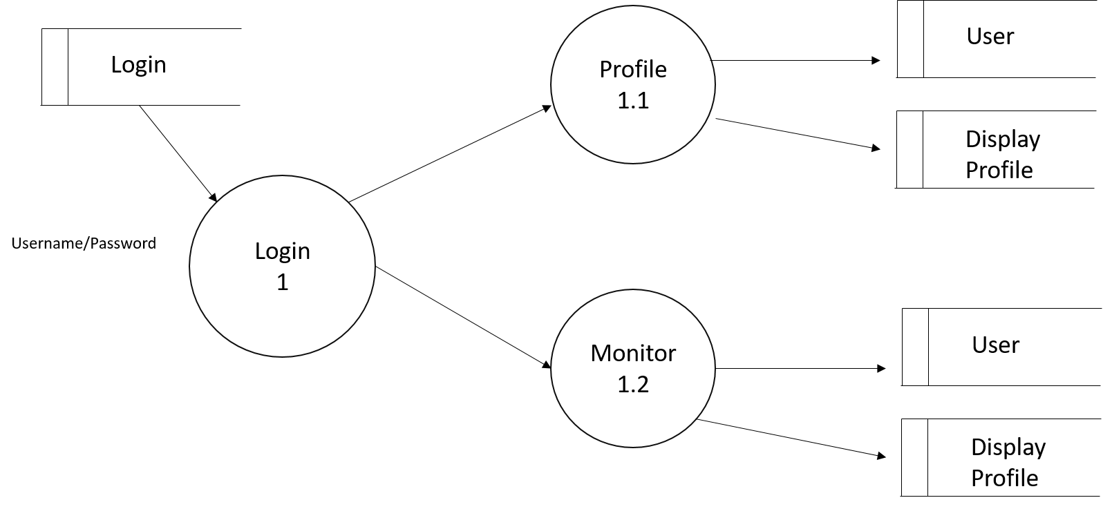

**4.6 use case diagram**

**5. SYSTEM TESTING**

System testing is the process in which the system undergoes experimental testing so as to check that the system does not fail i.e. to check whether the required system is running according to specification and user expectation. System testing also tests to find discrepancies between the system and its original objective, current specification and systems documentation. Hence most useful and practical approach is with the understanding that testing is the process of executing a program with the explicit intention of finding errors that is making the program fail.

Testing Is considered to be the least creative phase of the whole cycle of system design. In the real sense it is the phase, which helps to bring out the creativity of the other phases make it shine.

**5.1. White Box Testing:**

White Box testing, sometimes called glass box, is a test case design method that uses the control structure of the procedural design to derive test cases. Using white box testing methods, we can derive test case that Guarantee that all independent paths with a module have been exercised at least once. Exercise all logical decisions on their true and false sides. Execute all loops at their boundaries and within their operational bounds. Exercise internal data structures to ensure their validity.

**5.2 Black Box Testing:**

Black box testing focuses on the functional requirements of the software. That is, black box testing enables the software engineer to derive sets of input conditions that will fully exercise all functional requirements for a program. Black Box testing is not an alternative to white box testing. Rather it is a complementary approach that is likely to uncover a different class of errors than white box method. Black Box testing attempts to find errors in the following categories. Incorrect or missing functions Interface errors. Error in data structures on external data base access

• Performance errors

• Initialization and termination errors.

Unlike white box testing, which is performed early on the testing process black box testing tends to be applied during later stages of testing because black box testing which is purposely disregards control structures attention is focused on the information domain.

**5.3 Unit Testing:**

Unit testing focuses verification error on the smallest unit of software design the module. Using the procedural design description as a guide, important control paths are tested to uncover errors with the boundary of module. The relative complexity of test and uncovered errors is limited by the constrained scope established for unit testing. The unit test is normally white box oriented and the step can be conducted in parallel for multiple modules. The module interface is tested to ensure that information properly flows into and out of the program unit under test. The local data structure is examined to ensure that data stored temporarily maintains its integrity during all steps in an algorithm’s execution. Boundary conditions are tested to ensure that the module operates properly at boundaries established to limit or restrict processing. All independent paths through the control structure are exercised to ensure that all statements in a module have been executed at least once. And finally, all handling paths are tested.

**5.3.1 Unit Test Procedures:**

Unit testing is normally considered as an adjunct to the coding step. After source level code has been developed, reviewed and verified for correct syntax, unit test case design review of design information provides guidance for establishment test cases that are likely to uncover all errors. Because a modules is not a standalone program, deriver and/or sub software must be developed for each unit test. In most applications a driver is nothing more than a “main program” that accepts test case date, passes such data to the modules (to be tested) and brings relevant results. Stubs serve to replace modules that are subordinate to (called by) the module to be tested. A stub or “dummy subprogram” uses the subordinate module’s interface, may do minimal data manipulation, prints verification of entry and returns. Drivers and stubs represent overhead. That is both the software that must be developed but that is not delivered with the final software products drivers and stubs are kept simple, actual overhead is relatively low. Unit testing is simplified when a module with high cohesion is designed. When only one function is addressed by a module, the number of test cases id reduced and errors can predicated and uncovered.

**5.4 User Interface Testing:**

An interactive interface is a system that is dominated by interaction between the subsystem and external agents, such a humans, devices or other program. The external agents are independent of the system, so their inputs cannot be controlled, although the system may solicit response from them. An interactive interface usually includes only part of an entire application, one that can often be handled independently form the computational part of the application. The major concerns of an interactive interface are the communications protocol between the system and the external agents, the syntax of possible interactions the presentation of output, the flow of control with in the system, the case of understanding and user interface performance and error handling. The dynamic model dominates interactive interfaces. Object in the model represent interaction elements, such as input and output tokens and presentation in response to input event sequences, but the internal structure of the functions is usually unimportant to the behavior of the interface

1. **IMPLEMENTATION**

System implementation phase is the most difficult in the lifecycle. It is defined as the process of converting a new or revised system design into an operational one. Implementation includes all those activities that take place to convert from the old system to new. The old systems consist of manual operations, which are operated in very different manner from the proposed new system. A proper new implementation is essential to provide a reliable system to meet the requirements of the organization. An improper installation may affect the success of the computerized system.

**IMPLEMENTATION METHODS**

These are several methods for handling the implementation and the consequent conversion from the old system to the new computerized system.

The most secure method for conversion from the old system to the new system is to run both systems in parallel. In this approach a person may operate in the manual older processing system as well as start operating the computerized system. This method offers high security, because even if there is a flow in the computerized system, we can depend upon the manual system. However the cost for maintaining two systems in parallel is very high. Here, the problem encountered is converting files, training users, creating accurate files and verifying printout of integrity.

Another commonly used method is a direct cut over from the existing manual system to the computerized system. The system may work within a week or a day. There are no parallel activities. However, there is no remedy in case of a problem. This strategy requires care full planning. A working version of the system can also be implemented in one part of the organization and the personal will be piloting the system and changes can be made as and when required. But this method is less preferable due to the loss of the entire system. This type of conversion is usually difficult and is not properly planned; it can give way to a number of problems.

Implementations of a modified application to replace an existing one, using the same computer are the next method. This type of conversion is relatively easy to handle. Provided there are no changes in the file. In our project we implement a new computer system to replace an existing one.

**IMPLEMENTATION PLAN**

The implementation plan includes a description of all the activities that must occur to implement the new system and to put it in operation. It identifies the personal responsible for the activities and prepares a time chart for implementing system. The implementation plan consist of the following steps

* List all files required for implementation.
* Identify all data required to build new files during the implementation.
* List all new documents and procedures that go into the new system.
* Prepare the cost schedule tied to task and time.
* Establishing a reporting and controlled system.

The implementation plan should anticipate possible problems and able to deal with them. The usual problem may be missing documents mixed data format between current files, errors in data translation, missing data etc…

**7. SYSTEM MAINTENANCE**

System maintenance is that state in the project plan where the theoretical design is put into real test. All the theoretical and practical works are now implemented as a working system. This is the most crucial stage in the life cycle of a project. This project may be accepted or rejected depending on how it gather confident among the user. If the users have achieved satisfaction with the new project, then the project can be termed as successful and then onwards it’s maintained and other subsequent works can be commenced. The System goes for implementation only for after passing through some rigors testing, especially when it comes to operating system and other system software, the testing and implementation phase assumes greater significance

Basically three types of Maintenance. They are:-

1 Maintenance of a computer to replace a manual system: here, the problems encountered are converting files, creating accurate files and verifying print outs for integrity.

2 Maintenance of a new computer system to replace an existing one: this type of conversion is usually difficult and it is not properly planned, it can give way to a number of ways.

3 Maintenance of a modified application to replace an existing one: This type of conversion is relatively easy to handle, provided there are no major change in files. During this phase, problems that had not occurred during the analysis and design phases often surface. Solving of such problems often required modification to the original design.

**8. Conclusion:**

The proposed system is better than existing system. It is compatible to everyone; our system reduces the physical human efforts. Through proposed system the standard will maintain the particular security and also provides features those are not included in existing system. Proposed system provides a way to maintain records. It provides easy way for interaction between public and Emergency organisations. Public will improve their interaction skills by using our proposed system. Proposed system will also help the Emergency organisation to manage their records an save natural resources and job gets done in less time compared to existing system. All the users get the information without delays because of real time use of proposed system. It helps to reach to every Public and faculties in the Emergency organisation in very less time. The data which is stored on database will helps the management to take major decisions on the suggestion and ideas. Proposed system will also help to Public to get their queries solved by the answers of Emergency response section such as admin and respected leaders of the Organisation.

**9. FUTURE ENHANCEMENTS:**

Since there will be many users on system we planned to make it secure and spam free using various algorithms. For additional security we planned the membership identifier in the form of a unique QR code, providing access to all permitted physical facilities as well as all of the key features of Scheme.

**10. BIBLIOGRAPHY**

**∙ W3 schools: W3schools.com**

**∙ You Tube:** [**https://www.youtube.com/**](https://www.youtube.com/)

**∙ Wikkihow:** [**https://www.Wikkihow.com**](https://www.Wikkihow.com)

**∙ Beginning Flutter: A Hands On guide to app development**

∙ **Node.js design patterns by Luciano Mammino and Mario Casciaro**

**11. APPENDIX**

**11.1 GANTT CHART**

|  |  |  |  |  |  |
| --- | --- | --- | --- | --- | --- |
| November 20 | Dec 14 | Dec 25 | Jan 5 | Feb 29 | April 20 |
| Language Study |  | | | | |
| Requirement analysis $ Specification4 |
| Design |
| Coding |
| Testing $ Implementation |
| Maintenance |
| Documentation |

**11.2. SCREENSHOTS**

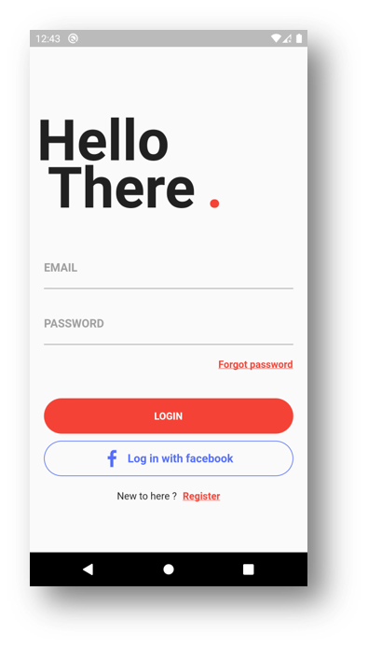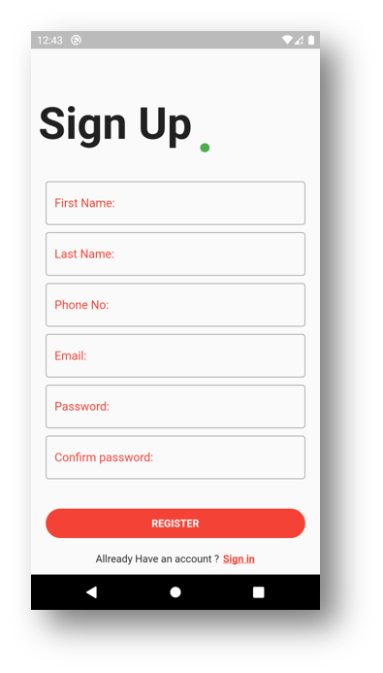

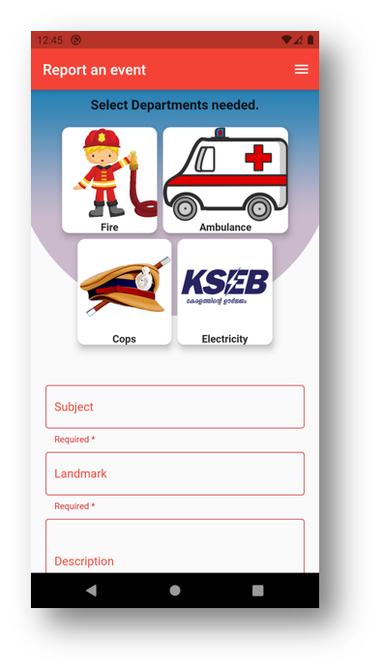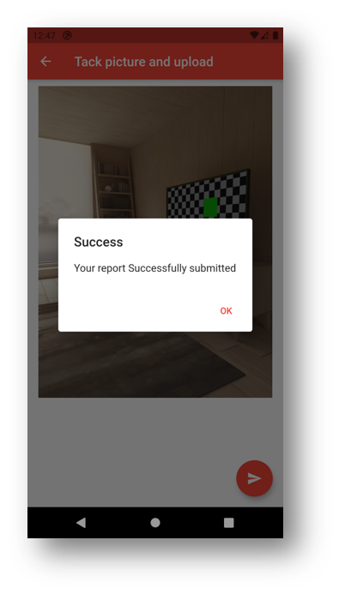

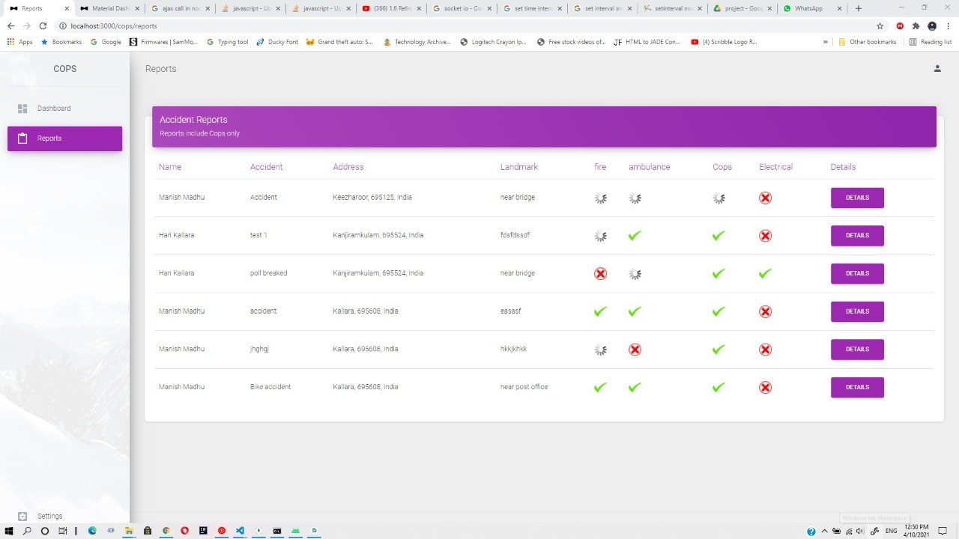

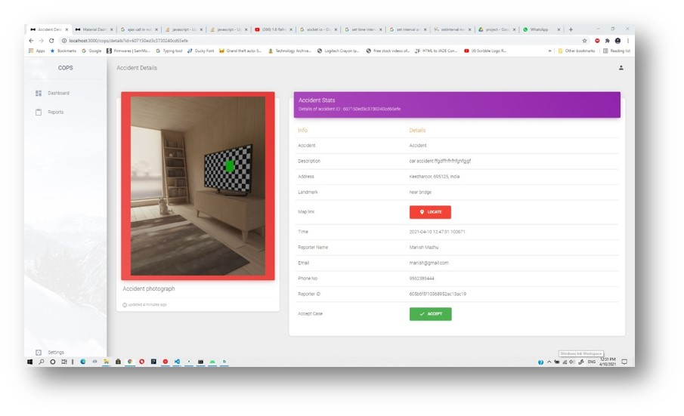

**11.3 MEETING MINUTES**

**Date:** 20-11-2020

**Time:** 10:00 am

**Place:** Trivandrum

**PRESENT**

* Adithyan R
* Amal Lal S
* Haris Muhammed
* Prejin PR

**INDIVIDUAL PROGRESS REPORT**

* Adithyan R:- Study of proposed system
* Amal Lal S:- Study of existing System
* Haris Muhammed:- Understanding functionalities of the system ,Conduct of feasibility study
* Prejin PR:- UI design

**DISCUSSION OF PROBLEM TO BE SOLVED BY SOFTWARE**

The objective of this project is to provide user efficient working environment and more output can be generated through this .This system provide the user friendly interface resulting in knowing each and every usability feature of the system. This system helps in tracking record so that past record can be verified them and one can make decision based on the past records. This system completes the work in a very less time consumption and high level efficiency. This system is developed in such way that even new users can also operate the system easily.

**DISCUSSION OF SOFTWARE REQUIREMENTS**

We would like to develop our system using the Flutter as the front end and Node.js as the back end. And the application software used is Notepad++. The software supports almost every operating system.

**DISCUSSION OF MANAGEMENT PLAN**

The project website will be developed to manage project. We should divide the project parts to all members of the group and set a time scheduling to complete the project well. In order to develop the software in time it is necessary to assure to have sufficient software and hardware component.

**SPECIFIC TASK ASSIGNED WITH DEADLINES**

Instruct the team members to perform their task in the project and tell the members to submit the system report on correct time.

**SCHEDULE OF NEXT MEETING**

Next meeting on 25-12-2020 at 10:00am

**Date:** 14-12-2020

**Time:** 10:00 am

**Place:** Trivandrum

**PRESENT**

* Adithyan R
* Amal Lal S
* Haris Muhammed
* Prejin PR

**INDIVIDUAL PROGRESS REPORT**

* Adithyan R:- Study of proposed system
* Amal Lal S:- Study of existing System
* Haris Muhammed:- Understanding functionalities of the system ,Conduct of feasibility study
* Prejin PR:- UI design

**DISCUSSION OF PROBLEM TO BE SOLVED BY SOFTWARE**

The objective of this project is to provide user efficient working environment and more output can be generated through this .This system provide the user friendly interface resulting in knowing each and every usability feature of the system. This system helps in tracking record so that past record can be verified them and one can make decision based on the past records. This system completes the work in a very less time consumption and high level efficiency. This system is developed in such way that even new users can also operate the system easily **DISCUSSION OF SOFTWARE REQUIREMENTS**

We would like to develop our system using the C# as the front end and SQL as the back end. And the application software used isVisual Studio2012. And the supporting language is c#. The software supports almost every operating system.

**Date:** 25-12-2020

**Time:** 10:00 am

**Place:** Trivandrum

**PRESENT**

* Adithyan R
* Amal Lal S
* Haris Muhammed
* Prejin PR

**INDIVIDUAL PROGRESS REPORT**

* Adithyan R:- Study of proposed system
* Amal Lal S:- Study of existing System
* Haris Muhammed:- Understanding functionalities of the system ,Conduct of feasibility study
* Prejin PR:- UI design

**DISCUSSION OF PROBLEM TO BE SOLVED BY SOFTWARE**

The objective of this project is to provide user efficient working environment and more output can be generated through this .This system provide the user friendly interface resulting in knowing each and every usability feature of the system. This system helps in tracking record so that past record can be verified them and one can make decision based on the past records. This system completes the work in a very less time consumption and high level efficiency. This system is developed in such way that even new users can also operate the system easily.

**DISCUSSION OF SOFTWARE REQUIREMENTS**

We would like to develop our system using the C# as the front end and SQL as the back end. And the application software used isVisual Studio2012. And the supporting language is c#. The software supports almost every operating system.

**DISCUSSION OF MANAGEMENT PLAN**

The project website will be developed to manage project. We should divide the project parts to all members of the group and set a time scheduling to complete the project well. In order to develop the software in time it is necessary to assure to have sufficient software and hardware component.

**SPECIFIC TASK ASSIGNED WITH DEADLINES**

Instruct the team members to perform their task in the project and tell the members to submit the system report on correct time.

**SCHEDULE OF NEXT MEETING**

**Date:** 05-01-2021

**Time:** 10:00 am

**Place:** Trivandrum

**PRESENT**

* Adithyan R
* Amal Lal S
* Haris Muhammed
* Prejin PR

**INDIVIDUAL PROGRESS REPORT**

**INDIVIDUAL PROGRESS REPORT**

* Adithyan R:- Study of proposed system
* Amal Lal S:- Study of existing System
* Haris Muhammed:- Understanding functionalities of the system ,Conduct of feasibility study
* Prejin PR:- UI design

**DISCUSSION OF PROBLEM TO BE SOLVED BY SOFTWARE**

The objective of this project is to provide user efficient working environment and more output can be generated through this .This system provide the user friendly interface resulting in knowing each and every usability feature of the system. This system helps in tracking record so that past record can be verified them and one can make decision based on the past records. This system completes the work in a very less time consumption and high level efficiency. This system is developed in such way that even new users can also operate the system easily.

**DISCUSSION OF SOFTWARE REQUIREMENTS**

We would like to develop our system using the C# as the front end and SQL as the back end. And the application software used isVisual Studio2012. And the supporting language is c#. The software supports almost every operating system.

**DISCUSSION OF MANAGEMENT PLAN**

The project website will be developed to manage project. We should divide the project parts to all members of the group and set a time scheduling to complete the project well. In order to develop the software in time it is necessary to assure to have sufficient software and hardware component.

**SPECIFIC TASK ASSIGNED WITH DEADLINES**

Instruct the team members to perform their task in the project and tell the members to submit the system report on correct time.