**Undo un committed changes**

**@git checkout -- %file-name%**

* Undo the un committed changes

**Undo the committed changes**

Undo the committed changes , means undo the changes which are committed in local repository.

**@git revert “committed id”**

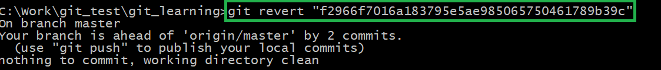

This will first revert the changes and commit it.

**Undo committed changes separately**

* Revert he changes
* After that manually commit the reverted file

**@git revert -n “committed id”**

**@git commit -n “committed id”**

