**Branching**

**@git branch “new – branch name”**

* To create a new branch

**@git checkout “branch-name”**

* To switch between branches

**@git push –set-upstream origin “branch-name”**

* Push the newly created branch to central repo.

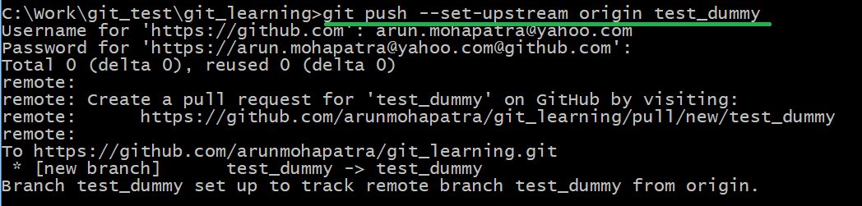

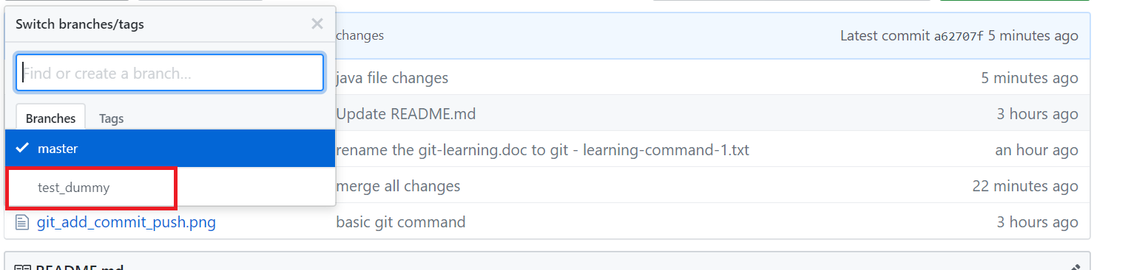

**Merge the branches**

If you want to merge the changes in master branch, then switch to master and execute the command

**@git merge “branch-name”**

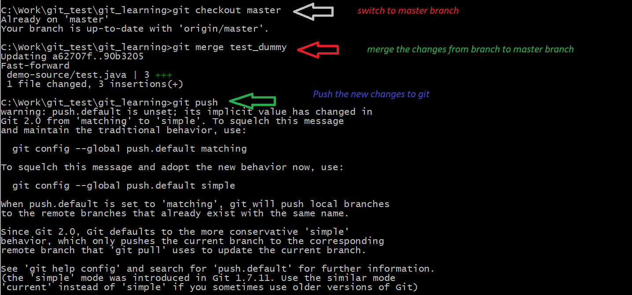

**Show the branches**

@git branch

Will display the branches

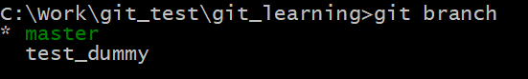

**Delete a branch**

**@git branch -d “branch name”**

