**HEAD**:

HEAD refer to the most recent changes in the current branch.

HEAD always point to the latest commit id of the current branch.

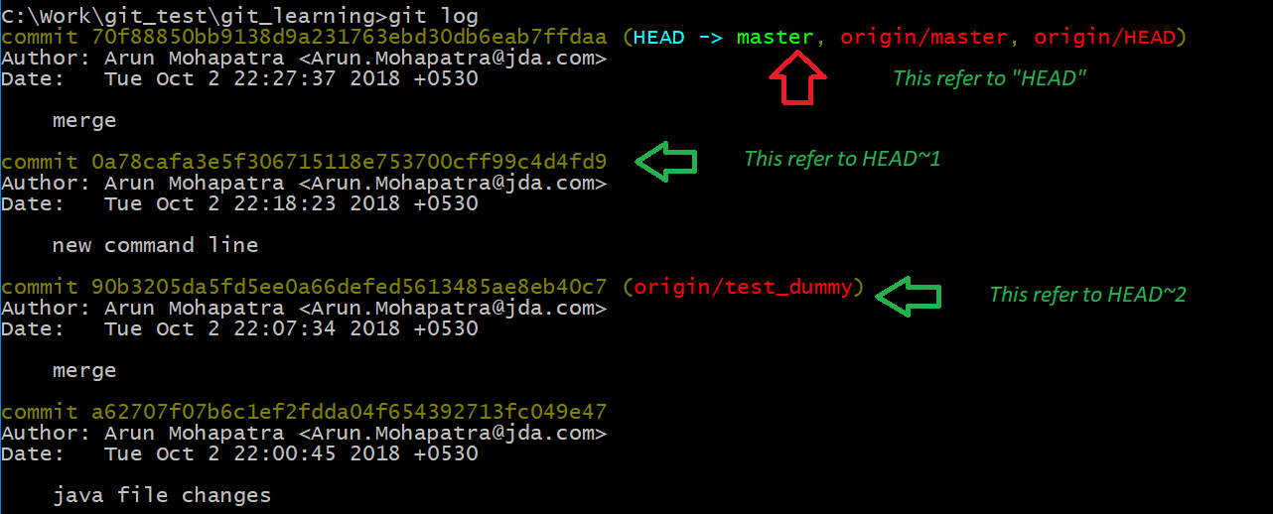

**$git show HEAD**

* Will show the recent changes committed.

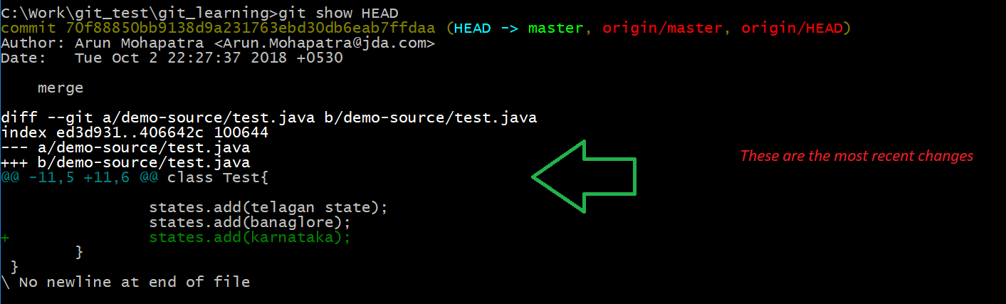

Which is same as **$git show “commit-id”** commit-id is the most recent check in commit id.

**$git difftool “old commit id” “new commit id”**

* Show the changes between two different commit ids.

This is also same as

**$git difftool HEAD~1 HEAD~2**

* This shows the different between HEAD~1 and HEAD~2

**Detach HEAD**

We can move HEAD to any specific commit id. Using command

**$git checkout “commit id”**

* Move HEAD point to specified commit id

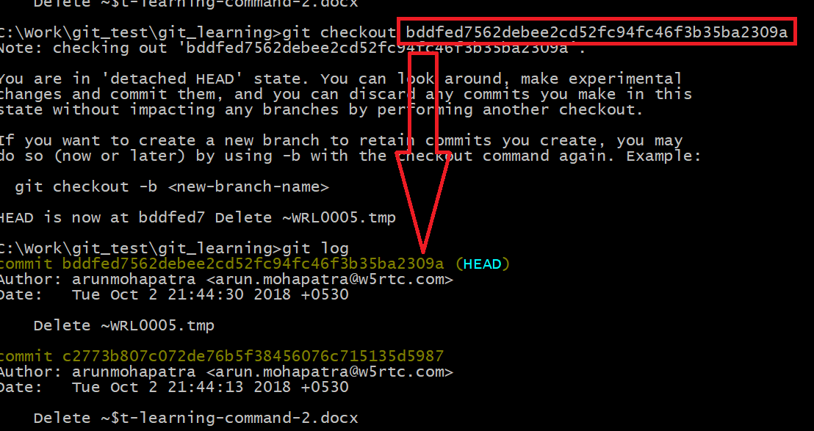

**$git checkout master**

* Again switch the HEAD to most recent changes.