**PULL REQUEST**

Suppose you want to contribute to some code base of other person you need to fork a branch from the repository.

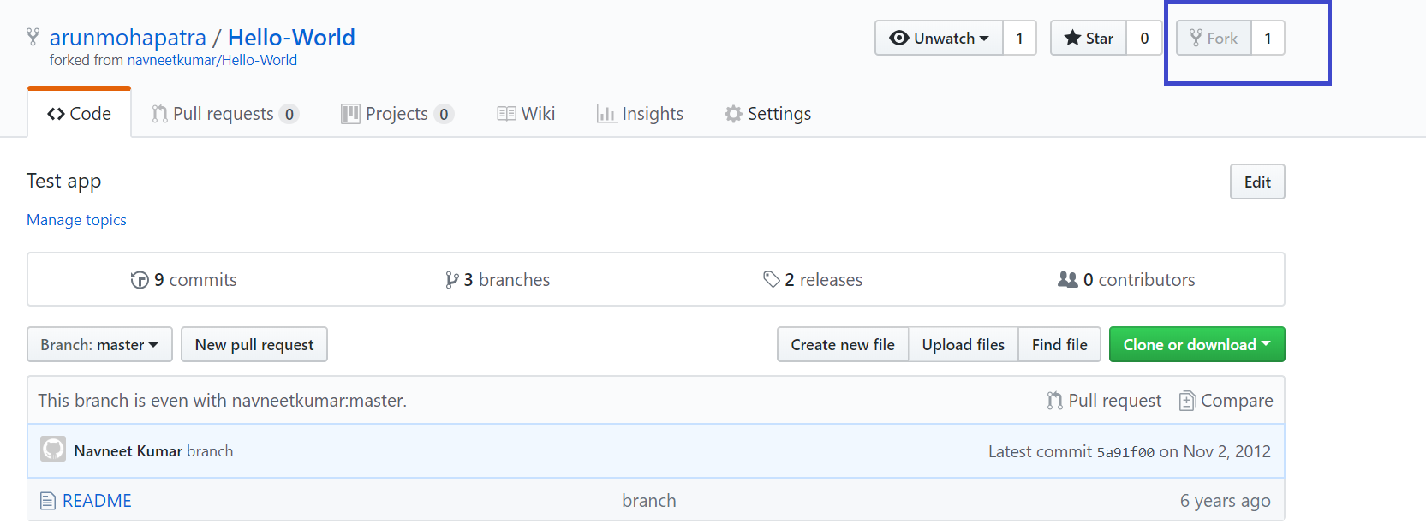

Make the changes and commit in the fork branch.

After that create PULL request.

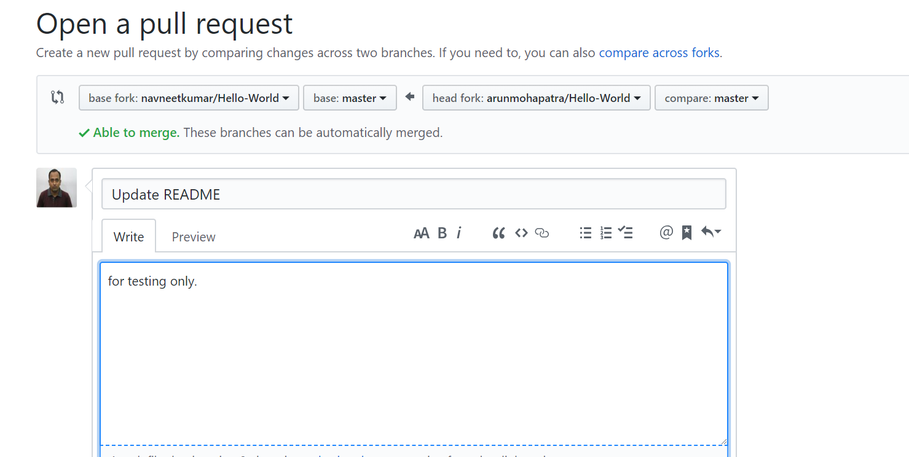

Once you generate the pull request the owner of the will get the notification and accept you changes to merge.