***Create repository***

Using git UI interface first create a repository, which might be empty initially.

After that we need to clone the newly created repository in order to modify or add new files or folders.

***Basic Commands***

**@git clone %repository%**

* Clone the repository

**@git status**

* See the change status in the cloned repository

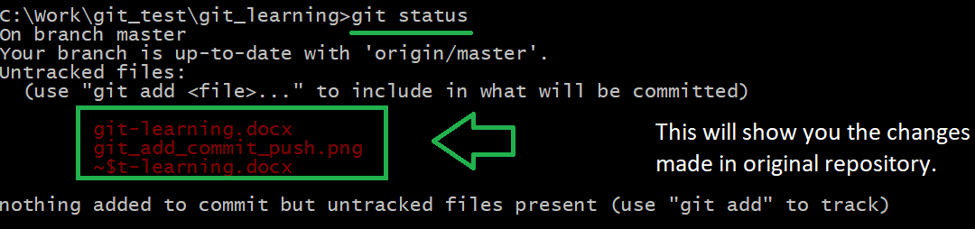

**@git add % changed files and folder%** ( @git add .)

* This will add changes to staging area

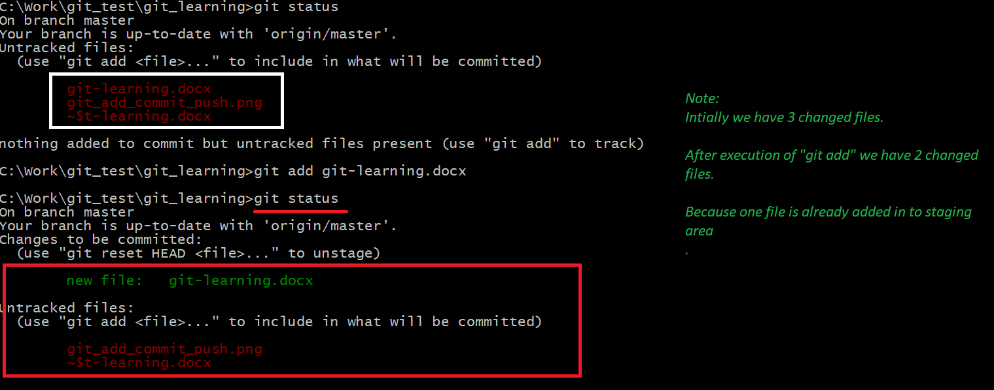

**@git commit**

* Commit the changes to local data base.

**@git push**

* Push the changes to report repository.