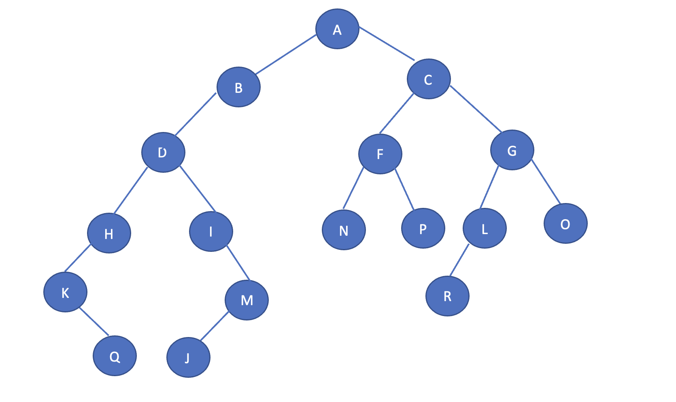

Pre-order:

A, B, D, H, K, Q, I, M, J, C, F, N, P, G, L, R, O

Post-order:

Q, K, H, J, M, I, D, B, N, P, F, R, L, O, G, C, A

In-Order:

K, Q, H, D, I, J, M, B, A, N, F, P, C, R, L, G, O