A Seminar Report on
“TWO FACTOR AUTHENTICATION”
At

“Bhagwan Mahavir College of Computer Application”,
Bharthana -Vesu, Surat
As A Partial Fulfilment for The Degree Of
Bachelor of computer Application
2024-25

Guided by: Submitted by:
Ass. Prof. Ravi J. Patel Mr. Arun S. Bharti

Bhagwan Mahavir College of Computer Application
Bharthana-Vesu, Surat
Constituent College of
Bhagwan Mahavir University, Surat, Gujarat, India
 | BHAGWAN MAHAVIR COLLEGE OF COMPUTER APPLICATION
 | Constituent College of Bhagwan Mahavir University
 |   principle.bmcca@bmusurat.ac.in |   0261-6770125/23, +91-7575803091
 |   www.bmusurat.ac.in |   VIP Road, Surat, Gujarat–395007

Certificate
This is to certify that the Seminar entitled “TWO FACTOR AUTHENTICATION” has been submitted by BHARTI ARUN SUMER Exam No: 2202020101060 at Bhagwan Mahavir College of Computer Application as a partial fulfilment of the requirement for the degree of Bachelor of Computer Application for the academic Year 2024-25.

Place: BMCCA, Surat
Date:

Ass. Prof. Ravi J. Patel  (Seminar Guide, BMCCA) |  | Dr. Hetal Modi  (Program Head)

Acknowledgment

The reason of completing the seminar work successfully is not just our efforts but efforts of many people. The people, who trusted us, guided us and encouraged us with every means. Guide is a person who provides you the direction towards success, so I feel great pleasure to express our gratitude to our guides, our faculty members as well as every person who helped us directly or indirectly with our project.

We are also indebted to our Professor Asst. Prof. Ravi J. Patel who provided constant encouragement, support & valuable guidance before and during our project. It was her effort
who led us to this place for project work. Her guidance and suggestions were valuable.

We are also Thanks full to our all Faculties Members & specially Our Principal Dr. Vikarm Kaushik , to give us opportunity to make us this seminar.
Thank you very much,

2202020101060
Arun Bharti

Abstract

Two-Factor Authentication (2FA) is a security mechanism that enhances user authentication by requiring two distinct forms of identification: something the user knows (e.g., a password) and something the user possesses (e.g., a mobile device or hardware token). This layered defence significantly reduces the risk of unauthorized access, even if login credentials are compromised. Widely adopted across various sectors, 2FA helps protect sensitive information and accounts from common cyber threats such as phishing, credential stuffing, and brute-force attacks. However, despite its benefits, 2FA is not without challenges, including usability concerns, potential account lockouts, and the risk of social engineering. This abstract explores the fundamental principles, benefits, and limitations of 2FA, emphasizing its growing importance in today’s digital security landscape.

  - INDEX
Sr. No. | Topic | Page No.
01. | Introduction | 09
 | 1.1 What is Two Factor Authentication
 | 1.2 Two Factor Authentication stands for
 | 1.3 History of Two Factor Authentication
 | 1.4 How 2FA works (step-by-step)
02. | Types of Two Factor Authentication | 11
 | 2.1 Types of Types of Two Factor Authentication
03. | Knowledge Based Factors | 14
 | 4.1 Types of Knowledge Based Factors
04. | Possession Based Factors | 17
 | 5.1 Types of Possession Based Factors
05. | Inherence Based Factors | 20
 | 6.1 Types of Inherence Based Factors
06. | How to Implement Two Factor Authentication(User Guide) | 22
 | 7.1 Step by step Guide
07. | User Education and Awareness on 2FA | 24
 | 8.1 Why User Awareness matters
 | 8.2 Key Area of 2FA Education
08. | Different 2FA methods | 32
 | 9.1 Different 2FA methods
09. | Benefits of Two Factor Authentication | 34
 | 10.1 Benefits of Two Factor Authentication
10. | Challenges and Limitations | 39
 | 11.1 Challenges
 | 11.2 Limitations

11. | Future of Two Factor Authentication | 42
 | 12.1 Future of Two Factor Authentication
12. | Conclusion | 43
13. | References | 44

Introduction of Two Factor Authentication

In today’s digital age, protecting online accounts is more crucial than ever. Two-Factor Authentication (2FA) is a widely adopted security measure that provides an additional layer of defense against unauthorized access. By requiring users to verify their identity through two different methods—such as a password and a one-time code sent to their device—2FA significantly reduces the risk of breaches. This simple yet effective approach has become a standard practice across various industries, safeguarding personal, financial, and sensitive information in an increasingly connected world.

What is Two Factor Authentication?

Two-Factor Authentication (2FA) is a security process that requires users to verify their identity using two different methods before gaining access to an account or system.
Two factor authentication adds an extra layer of protection by ensuring that even if one factor (like a password) is compromised, the account remains secure because the second factor is required. It’s commonly used in banking, social media, email, and other online platforms to prevent unauthorized access.

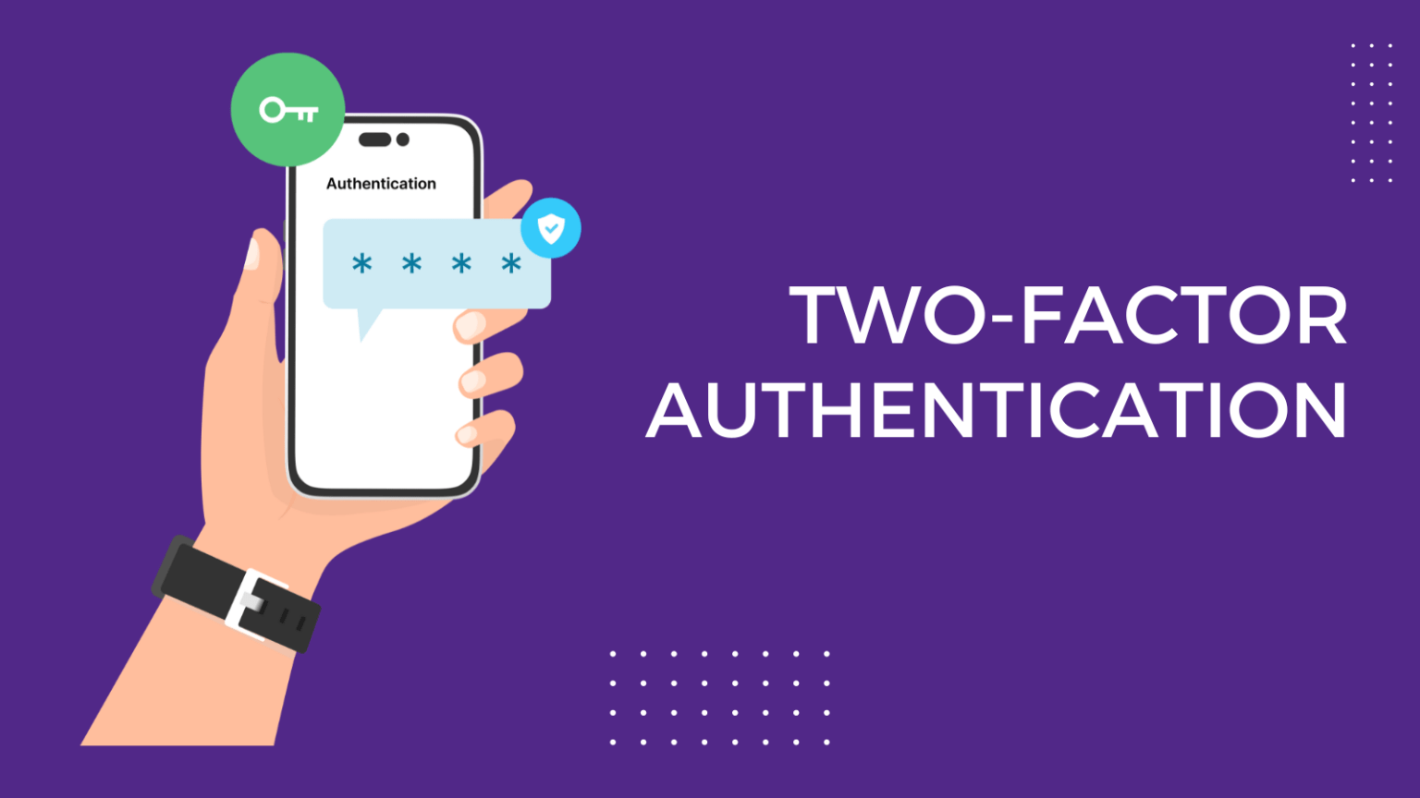

Two Factor Authentication stands for

These authentication methods typically fall into two of three categories:

- Something you know – like a password or PIN.
- Something you have – like a smartphone, security token, or email access for a code.
- Something you are – like a fingerprint or facial recognition.

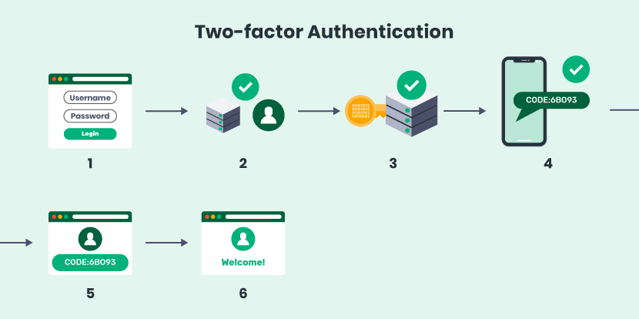

History of Two Factor Authentication

Two-Factor Authentication (2FA) originated from the idea of enhancing security by combining multiple verification methods. In the 1980s, RSA introduced hardware tokens generating one-time passcodes, paving the way for modern 2FA. With the internet boom in the 2000s, SMS-based 2FA became popular for banking and online services. In the 2010s, mobile authenticator apps and biometrics gained traction, offering more secure and convenient options. Today, 2FA continues to evolve with advancements in passwordless systems, biometrics, and regulatory mandates, becoming a critical tool in cybersecurity.

How 2FA Works – Step-by-Step Mechanism

Step 1: User Enters Credentials
- The user enters their username and password (first factor: something they know).
- The server verifies the credentials.

Step 2: 2FA Challenge
- If the credentials are correct, the system triggers a second authentication step.

Step 3: Second Factor Verification
- The system now prompts the user for a second factor, which could be:

Method | How It Works
OTP via SMS | A one-time password (OTP) is sent to the user's mobile number.
Authenticator App | App like Google Authenticator generates time-based OTPs (TOTP).
Email OTP | A unique code is sent to the user's registered email.
Hardware Token | Physical device generates OTP or contains a certificate.
Biometric | Fingerprint or face scan is used (common in mobile apps).
Push Notification | App sends a prompt to approve the login.

Step 4: Verification and Access
- User enters the OTP or confirms the prompt.
- If the second factor is valid:
- User is granted access.
- If invalid:
- Access is denied, and security measures may be triggered (e.g., account lockout).

Types of Two Factor Authentication

Types of Two Factor Authentication –

Two-factor authentication (2FA) adds an extra layer of security by requiring two forms of identification to access a system. These factors fall into three main categories:

- Knowledge-Based​
- Possession-Based​
- Inherence-Based​
- Location-Based​
- Time-Based​
- QR code-Based​
- Smartcards​
- Push notification​
- Passwordless Authentication​

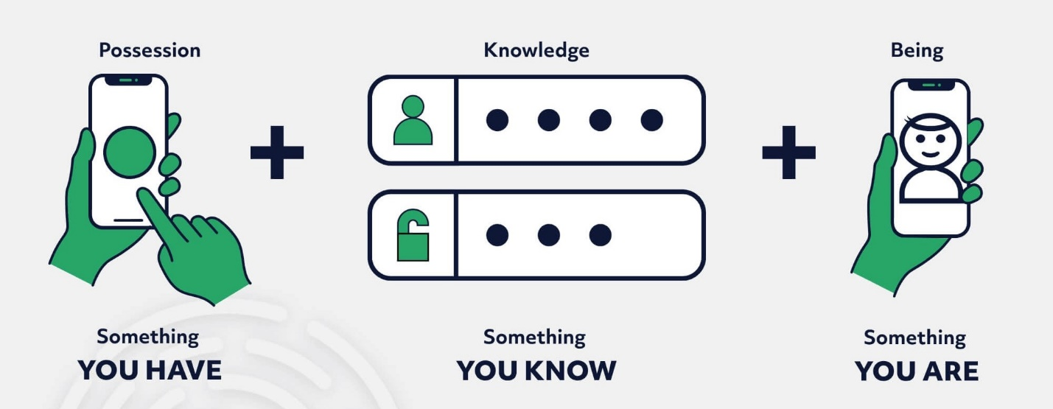

- Knowledge-Based (Something You Know) - Relies on information the user knows, such as passwords, PINs, or answers to security questions.

- Possession-Based (Something You Have) - Requires a physical or digital item the user owns, like a smartphone, hardware token, or SMS code.

- Inherence-Based (Something You Are) - Uses unique biological or behavioral traits, such as fingerprints, facial recognition, or voice patterns.

- Location-Based (Somewhere You Are) - Authenticates based on the user’s geographical location, using GPS or IP address data.

- Time-Based (Something You Do at a Specific Time) - Relies on time-sensitive factors, such as one-time passwords (OTPs) that expire within seconds.

- QR Code-Based - Involves scanning a unique QR code with a trusted device for authentication.

- Smartcards - Uses physical cards with embedded chips that require insertion into a reader, often combined with a PIN.

- Push Notification - Sends a real-time notification to the user’s device, allowing them to approve or deny login attempts.

- Passwordless Authentication - Eliminates traditional passwords by using biometrics, magic links, or authentication devices like YUBI, FIDO keys.

Knowledge-Based Factor

Knowledge-based authentication (KBA) is a method that relies on something the user knows, such as a password, PIN, or the answer to a security question. It is one of the most common and straightforward factors in multi-factor authentication systems.

Types of Knowledge-Based Factor –

- Passwords
- Pins
- Security Questions
- Passphrases

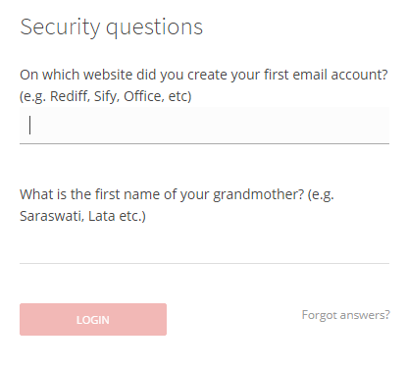

- Passwords
- A string of characters set by the user for authentication.
- Application: Used for accessing accounts and systems.
- Advantage: Simple and widely understood.
- Risk: Prone to guessing, reuse, or phishing.

- PINs (Personal Identification Numbers)
- A short numeric code set by the user.
- Application: Common in ATM and mobile device authentication.
- Advantage: Quick and easy to use.
- Risk: Vulnerable to shoulder-surfing and brute-force attacks.

- Security Questions
- Pre-set questions with answers known only to the user.
- Application: Used for account recovery or additional authentication.
- Advantage: Adds a layer of protection.
- Risk: Answers may be easily guessed or found online.

- Passphrases
- Longer phrases combining multiple words for security.
- Application: Used in high-security systems requiring strong passwords.
- Advantage: Harder to crack than regular passwords.
- Risk: Users may forget them or write them down insecurely

Example of Knowledge-Based Factor usage -

- Banking and Finance: PINs used at ATMs or for verifying card transactions.

- Corporate Environments: Passwords for accessing work emails, networks, and internal systems.

- Personal Accounts: Passwords for logging into social media, email accounts, and e-commerce sites.

- E-Government Services: Security questions or passwords for accessing government portals and services.

- Mobile Devices: Pattern-based locks or PINs for unlocking smartphones and tablets.

Possession-Based Factor

Possession-based authentication relies on something the user physically owns or has access to. This factor ensures that only individuals with the specific item can complete the authentication process. It is commonly used in conjunction with knowledge-based or inherence-based factors to provide enhanced security.

Types of Possession-Based Factor –

- Hardware Tokens
- Software Token
- SMS and Email codes
- Smartcards
- Mobile Authentication Apps
- QR code scanning

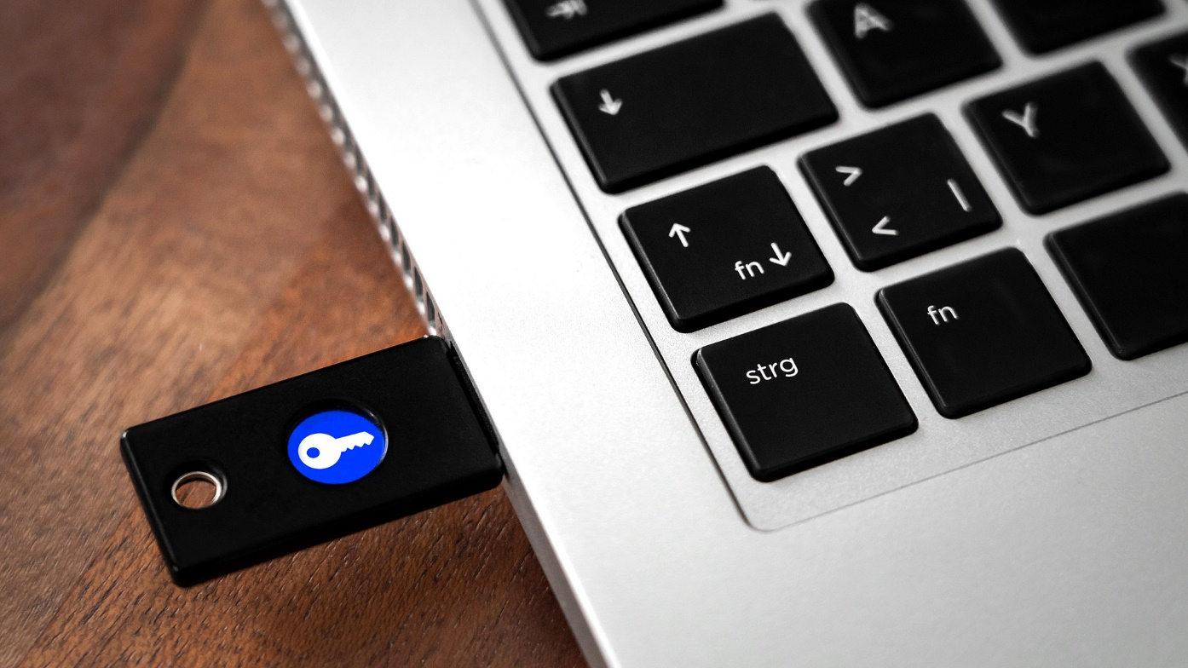

- Hardware Tokens
- Physical devices that generate or store authentication credentials.
- Application: Used for secure logins and transaction approvals.
- Advantage: Highly secure and resistant to phishing.
- Risk: Can be lost, damaged, or stolen.

- Software Tokens
- Digital tokens generated by authentication apps like Google Authenticator.
- Application: Used for online account security and enterprise logins.
- Advantage: Convenient and works offline.
- Risk: Device loss or compromise can block access.

- SMS and Email Codes
- Temporary codes sent via text or email for authentication.
- Application: Used for login verification and transaction security.
- Advantage: Accessible without additional hardware.
- Risk: Vulnerable to phishing and SIM-swapping attacks.

- Smartcards
- Cards with embedded chips storing authentication data.
- Application: Used for secure access control and banking.
- Advantage: Secure and difficult to clone.
- Risk: Requires a reader and can be stolen or lost.

- Mobile Authentication Apps
- Mobile apps that generate OTPs or push notifications for authentication.
- Application: Used for securing online accounts and enterprise systems.
- Advantage: Easy to use and supports multiple accounts.
- Risk: Loss or reset of the device can result in access issues.
- QR Code Scanning
- Authentication via scanning a unique QR code with a trusted device.
- Application: Used for web logins, payments, and device pairing.
- Advantage: Fast and user-friendly.
- Risk: Prone to spoofing if implemented poorly.

Example of Possession-Based Factor usage –

- Banking and Finance: OTP tokens or SMS codes for online transactions.

- Corporate Environments: Hardware tokens or smart cards for secure access to sensitive systems.

- Personal Accounts: Authenticator apps for services like Google, Facebook, or GitHub.

- E-Government Services: Smart cards for digital signatures and secure login.

Inherence-Based Factor

Inherence-based authentication relies on something intrinsic to the user, such as biological or behavioural characteristics. These factors are unique to the individual, making them difficult to replicate or steal. Commonly referred to as biometric authentication, this method ensures that access is granted only to the person physically present.

Types of Inherence-Based Factor –

- Fingerprint Recognition
- Facial Recognition
- Iris Recognition
- Retina Recognition
- Voice Recognition
- Hand Geometry
- Behavioral Biometrics

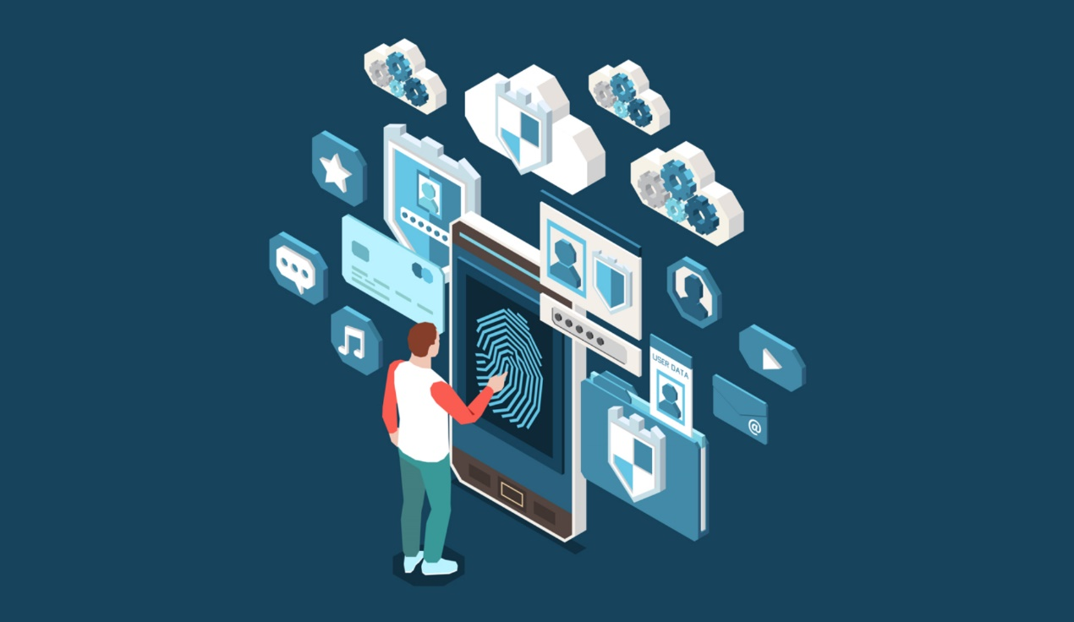

- Fingerprint Recognition
- Uses the unique patterns of ridges and valleys in a person’s fingerprint.
- Applications: Smartphone unlocking, biometric door access.
- Advantages: Quick, accurate, and difficult to fake.
- Risks: Vulnerable to high-quality replicas or damaged fingerprints.

- Facial Recognition
- Maps and analyses facial features like the distance between eyes, nose shape, and jawline.
- Applications: Smartphone security (e.g., Apple Face ID), airport systems.
- Advantages: Contactless and fast.
- Risks: May struggle in low light or with appearance changes (e.g., glasses, beards).

- Iris Recognition
- Scans the unique patterns in the coloured part of the eye.
- Applications: High-security areas, advanced smartphone features.
- Advantages: Extremely accurate, even among identical twins.
- Risks: Requires close proximity to a scanner and expensive hardware.

- Retina Scanning
- Maps the blood vessel pattern in the retina at the back of the eye.
- Applications: Military and governmental systems.
- Advantages: Highly accurate and unique.
- Risks: Inconvenient and costly.

- Voice Recognition
- Analyses vocal patterns, pitch, and tone to identify the user.
- Applications: Phone banking, smart assistants.
- Advantages: Contactless and convenient.
- Risks: Can be spoofed with recorded audio or affected by illness.

- Behavioural Biometrics
- Tracks behaviours such as typing speed, mouse movements, or swipe gestures.
- Applications: Continuous authentication for devices or apps.
- Advantages: Passive and unique to each user.
- Risks: Requires advanced algorithms and may have false positives.

- Palm or Hand Geometry
- Measures the shape and structure of the user’s hand.
- Applications: Timekeeping systems, physical access control.
- Advantages: Non-intrusive and user-friendly.
- Risks: Less accurate than fingerprints or iris scans.

Example of Inherence-Based Factor usage –

- Banking and Finance: Fingerprint or facial recognition for mobile banking apps and ATMs.

- Corporate Environments: Iris or fingerprint scans for accessing secure facilities or systems.

- Personal Devices: Facial recognition or fingerprints for unlocking smartphones and laptops.

- Healthcare: Biometric authentication for accessing patient records and medical equipment.

- E-Government Services: Fingerprint or facial scans for national ID systems or border control.

How to Implement 2FA (User guide)

This guide walks you through the process of setting up and using Two-Factor Authentication (2FA) on your account. It is intended for non-technical users who want to improve the security of their personal or work accounts.

Step by step Guide

Step 1: Login to Your Account
- Go to the website or app where you want to enable 2FA.
- Enter your username and password to log in as usual.

Step 2: Go to Security Settings
- Navigate to Account Settings, then look for Security or Privacy options.
- Find a section labeled Two-Factor Authentication, 2FA, or Multi-Factor Authentication (MFA).

Step 3: Choose Your 2FA Method
- Most platforms offer a few different 2FA options:

Method | Description
Authenticator App | Use apps like Google Authenticator or Authy to generate codes.
SMS | Receive a code via text message.
Email | Receive a code in your inbox.
Push Notification | Approve login via a mobile app (like Duo or Microsoft Authenticator).

Note: Authenticator apps are considered the most secure method.

Step 4: Set Up the Method
- Depending on the method you choose:

Using an Authenticator App:
- Download an authenticator app on your smartphone.
- Scan the QR code shown on the screen.
- Your app will now display a 6-digit code that changes every 30 seconds.

Using SMS or Email:
- Enter your phone number or email address.
- You’ll receive a 6-digit code.
- Enter the code to verify the setup.

Step 5: Save Backup Codes (Important!)
- Most systems will provide backup codes in case you lose access to your phone.
- Download or write these down and keep them in a secure place (e.g., a password manager or locked file).

Step 6: Complete the Setup
- Click “Enable” or “Turn On” to activate 2FA.
- You may be asked to re-enter your password or test the 2FA method once.

Step 7: Test Your 2FA
- Log out and log in again.
- After entering your password, you should be prompted to enter a 2FA code.
- Enter the code from your app, SMS, or email to verify it's working.

User Education and Awareness on 2FA

Even the strongest security tools are only effective if people know how to use them properly. This section focuses on the importance of user education in promoting Two-Factor Authentication (2FA), helping users understand, trust, and correctly use it to protect their accounts and data.

Why User Awareness Matters

- Most security breaches are caused by human error (e.g., weak passwords, falling for phishing).
- Many users avoid 2FA simply because they don’t understand how it works.
- A well-informed user is the first line of defence against cyber threats.

Key Areas of 2FA Education

1. What 2FA Is and Why It’s Needed
- Explain it in plain language: “2FA adds an extra lock to your digital door.”
- Emphasize that even a stolen password is not enough to break in with 2FA active.

2. How to Set It Up (with Clear Steps)
- Offer step-by-step guides with visuals.
- Break down setup instructions for:
  - Mobile devices
  - Email accounts
  - Social media platforms

3. Types of 2FA Methods Explained Simply
- SMS or Email codes (easy but less secure)
- Authenticator apps (recommended)
- Hardware tokens (very secure)
- Biometric options (e.g., fingerprint, facial recognition)

4. Common Mistakes to Avoid
Mistake | Tip to Prevent It
Ignoring backup codes | Always download and save them safely
Reusing passwords | Use a unique password per account
Sharing 2FA codes with others | Never share 2FA codes, even with "support"
Delaying 2FA setup | Enable it as soon as it's available

- What to Do If You Lose Access
- Guide users on recovering their account via:
  - Backup codes
  - Recovery email/phone
  - Contacting support
- Encourage storing recovery information in a safe location (like a password manager).

Different 2FA methods

There are several types of 2FA methods available today, each with its own strengths and weaknesses. Choosing the right method depends on the user's needs, device availability, and security level required.

Different 2FA Methods

(1). Google Authenticator

Type:( App-based TOTP Generator
Platform: Android, iOS
Authentication Methods: Time-Based One-Time Passwords (TOTP)

Features:
- Generates 6-digit codes every 30 seconds
- Supports multiple accounts
- Works offline after setup

Pros:
- Free and widely adopted
- Simple interface
- Easy to set up for most services

Cons:
- No backup or cloud sync
- Cannot lock app with PIN or biometrics
- Recovery is difficult if device is lost

Use Cases:
- Individual users securing email, social media, cloud accounts

(2). Microsoft Authenticator

Type: Multi-function Authentication App
Platform: Android, iOS
Authentication Methods: TOTP, Push Notification, Passwordless Login

Features:
- Supports TOTP and push notifications
- Passwordless login for Microsoft accounts
- Backup and restore using cloud sync (with Microsoft account)

Pros:
- Easy integration with Azure AD and Office 365
- Includes biometric/PIN protection
- Useful in corporate environments

Cons:
- Limited customization
- Works best within Microsoft ecosystem

Use Cases:
- Enterprise employees, Office 365 users, cloud service login

(3). Authy (by Twilio)

Type: App-based 2FA
Platform: Android, iOS, Windows, Mac
Authentication Methods: TOTP, Encrypted Backup

Features:
- Multi-device support
- Encrypted backups to cloud
- PIN or biometric lock

Pros:
- More secure than Google Authenticator (backup & restore support)
- Works across devices
- Simple interface

Cons:
- Requires phone number for setup
- Limited push-based integration

Use Cases:
- Developers, power users, small businesses

(4). Duo Security (by Cisco)

Type: Cloud-based Enterprise 2FA Solution
Platform: Web, Mobile, Desktop
Authentication Methods: Push Notifications, TOTP, Biometrics, U2F

Features:
- Adaptive authentication and policy management
- Device health checks
- Integration with SSO, VPN, and cloud apps

Pros:
- Highly secure and scalable
- Suitable for large organizations
- Centralized admin dashboard

Cons:
- Expensive for small organizations
- Some features behind higher-tier plans

Use Cases:
- Government, healthcare, finance, and enterprise IT environments

(5). Okta Adaptive Multi-Factor Authentication

Type: Enterprise Identity and Access Management (IAM)
Platform: Cloud-Based
Authentication Methods: Push, TOTP, Biometric, U2F, Security Questions

Features:
- Adaptive risk-based authentication
- Integration with cloud, mobile, on-prem apps
- Central user directory and SSO

Pros:
- High flexibility and customization
- Strong reporting and compliance support
- Scalable for large organizations

Cons:
- Complex setup for non-technical teams
- Subscription-based pricing

Use Cases:
- Enterprises with hybrid infrastructure6. Okta Adaptive Multi-Factor Authentication

(6). Apple Two-Factor Authentication

Type: Built-in Platform Security
Platform: iOS, macOS
Authentication Methods: Push Notification, Device Approval, TOTP fallback

Features:
- Sends code to trusted Apple devices
- Passwordless features via Face ID/Touch ID

Pros:
- Seamless experience within Apple ecosystem
- No external app required

Cons:
- Works best only for Apple services
- Limited for third-party applications

Use Cases:
- Individual users within Apple environment

(7). FreeOTP (by Red Hat)

Type: Open-Source Authenticator App
Platform: Android, iOS
Authentication Methods: TOTP, HOTP

Features:
- Simple OTP generation
- Lightweight and open-source

Pros:
- Free, open, and secure
- No tracking or analytics

Cons:
- Lacks modern UI/UX
- No backup/restore options

Use Cases:
- Developers, open-source advocates

(8). LastPass Authenticator

Type: Authenticator App
Platform: Android, iOS
Authentication Methods: TOTP, Push Notification

Features:
- Push-based approval for LastPass accounts
- Supports TOTP for third-party services
- Backup and restore via LastPass vault

Pros:
- Integrates well with LastPass password manager
- App lock and cloud sync supported

Cons:
- Limited functionality without LastPass account
- Security concerns due to recent breaches (as of 2023)

Use Cases:
- Users already using LastPass

Benefits of Two Factor Authentication

Benefits of Two Factor Authentication

- Enhanced Security
- Adds an extra layer of security by requiring two forms of authentication: something you know (password) and something you have (e.g., phone, security key).
- Reduces the risk of unauthorized access, even if passwords are compromised.

- Protection Against Credential Theft
- Safeguards against phishing, keylogging, and other attacks that target passwords.
- Even if an attacker acquires your password, they cannot access your account without the second factor.

- Prevention of Identity Theft
- Makes it significantly harder for attackers to impersonate users.
- Protects personal and financial information from being misused.

- Versatility and Customization
- Supports a variety of authentication methods, such as SMS, app-based codes, biometrics, or hardware keys.
- Can be adapted to different platforms and user needs.

- Peace of Mind for Users
- Provides users with confidence that their accounts and data are secure.
- Reduces anxiety about potential breaches.

- Ease of Implementation for Developers
- Many 2FA solutions integrate easily with existing systems using APIs and SDKs.
- Offers scalable options for small businesses and large enterprises alike.

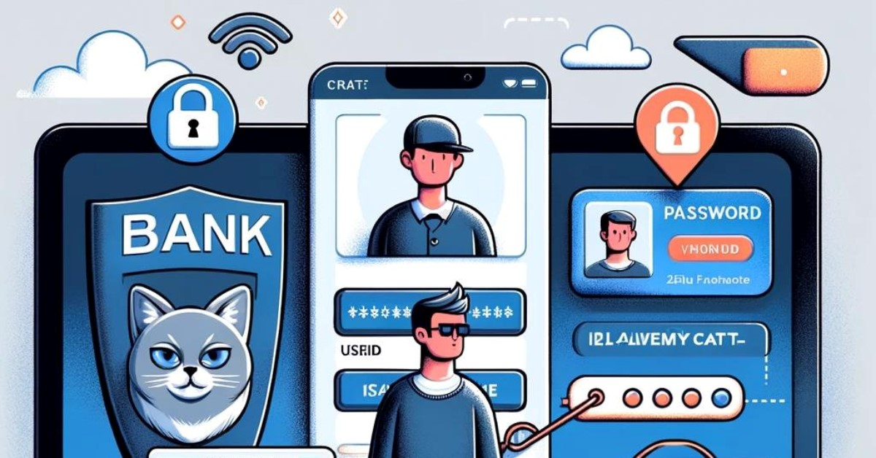

- Minimized Risk of Account Takeover
- Even if one authentication factor (e.g., a password) is compromised, the second factor provides an additional safeguard.

- Future-Proof Security
- Prepares organizations for advanced security challenges as threats evolve.
- Compatible with modern authentication practices, including passwordless systems.

Challenges and Limitations

Challenges and Limitations

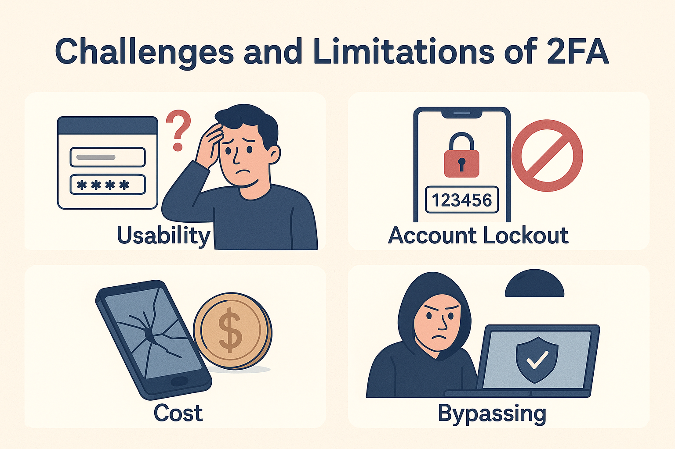

1. Usability and User Experience Issues

Complexity and Inconvenience
- Users are often frustrated with the need to use a second device or remember an additional step during login.
- Multiple steps can discourage users from using or activating 2FA, especially if not mandated.

Increased Login Time
- Traditional username-password authentication is quicker.
- Introducing a second factor such as a code, hardware key, or biometric scan can slow down access, especially in time-sensitive scenarios.

Accessibility Concerns
- Individuals with disabilities or impairments (e.g., visual or motor impairments) may find certain 2FA methods difficult to use.
- Not all users have equal access to devices or mobile connectivity required for receiving second factors.

2. Device Dependency and Loss

Loss or Theft of Second Factor
- If users lose their smartphone, hardware token, or other device used for authentication, access recovery can be complicated and time-consuming.
- This creates a single point of failure—exactly what 2FA was designed to mitigate.

SIM Swapping Attacks
- Attackers can exploit mobile carriers’ weak security procedures to transfer a phone number to another SIM card.
- Once completed, they can intercept SMS-based 2FA codes and gain access to secured accounts.

Hardware Token Vulnerabilities
- Hardware tokens (e.g., RSA SecurID) can be lost, damaged, or stolen.
- Replacing these devices can be expensive and involve downtime.

3. Cost and Implementation Barriers

High Initial Setup Costs
- Organizations must invest in infrastructure, training, and potentially new hardware/software to roll out 2FA solutions at scale.

Maintenance Overhead
- Long-term costs include support for token distribution, device replacement, and managing lost access incidents.

Vendor Lock-in
Some 2FA solutions are proprietary and lock organizations into specific ecosystems (e.g., Duo, Google Authenticator, Microsoft Authenticator).
Switching vendors later can involve compatibility challenges and additional costs.

4. Technical and Integration Challenges

Compatibility Issues
- Legacy systems or older applications may not support modern 2FA methods.
- Some cloud services or third-party applications may offer limited 2FA integration options, requiring custom solutions.
Inconsistent Experience Across Platforms
- Not all services implement 2FA uniformly—some use OTPs, others use push notifications, and others use biometric methods.
- This inconsistency can cause confusion and reduce adoption.

Token and Sync Errors
- Time-based One-Time Passwords (TOTP) can fail if the time on the server and the device is out of sync.
- Push notifications can be blocked by corporate firewalls or poor network connectivity.

5. False Sense of Security

Misconception of Invincibility
- Some users believe that enabling 2FA makes them completely immune to cyberattacks.
- In reality, 2FA only reduces risk, and other vectors (e.g., social engineering, malware) can still compromise systems.

Phishing of Second Factor
- Advanced phishing attacks can trick users into providing their 2FA code in real-time.
- Examples include man-in-the-middle (MITM) attacks or phishing proxies that relay credentials and 2FA codes simultaneously.

6. Recovery and Support Complexity

Account Recovery Procedures
- If both the primary (password) and secondary (e.g., smartphone) factors are lost, recovery can be a complex and manual process.
- Often involves identity verification via documents, which can be exploited or delayed.

Increased Help Desk Load
- Users frequently contact support due to lost devices, expired tokens, or login problems.
- This places an operational burden on IT departments, especially in large organizations.

7. Scalability Concerns

Enterprise-Wide Deployment Challenges
- Rolling out 2FA across thousands of users requires robust planning, user training, and policy enforcement.
- Poorly planned rollouts can lead to widespread login failures and operational disruptions.

Resource Constraints
- Small to mid-sized organizations may lack the IT personnel or financial resources to maintain 2FA systems effectively.

8. Dependence on Mobile Infrastructure

Mobile Network Reliability
- SMS or app-based codes are dependent on stable mobile networks or internet access.
- In regions with poor infrastructure or during outages, users may be locked out of critical systems.

Battery and Device Issues
- If a mobile device is out of battery or damaged, users may be temporarily unable to authenticate.
- There’s also a risk of sharing mobile phones, which weakens the integrity of the second factor.

9. Privacy and Data Concerns

Biometric Data Collection Risks
- Inherently-based 2FA (fingerprints, facial recognition) involves collecting sensitive personal data.
- If compromised, biometric data cannot be changed, unlike a password or PIN.

User Reluctance
- Some users feel uncomfortable providing personal data such as phone numbers or biometric scans.
- This can lead to resistance, especially in contexts involving surveillance or data tracking concerns.

10. Evolving Threat Landscape

Sophisticated Attacks Continue to Emerge
- Cybercriminals adapt quickly—new forms of 2FA-targeted malware, phishing kits, and MITM tools appear frequently.
- Even advanced authentication protocols are at risk if other system vulnerabilities remain unpatched.

Obsolescence of Certain Methods
- SMS-based authentication is considered less secure due to multiple known vulnerabilities.
- Without updates, organizations risk using outdated methods that provide a false sense of security.

Future of Two Factor Authentication

Future of Two Factor Authentication –

Two-Factor Authentication (2FA) has become a critical security measure in protecting online accounts and sensitive data from cyber threats. It adds an additional layer of security beyond just a password, making unauthorized access more difficult. However, as technology advances and cybercriminals develop more sophisticated attack methods, the future of 2FA must evolve to address new challenges and enhance both security and user experience.

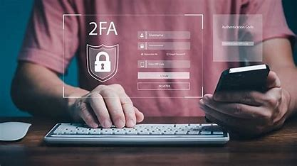

- Moving Beyond Traditional 2FA Methods

- Decline of SMS-Based 2FA
For years, SMS-based 2FA has been widely used, but it is increasingly viewed as an insecure method due to vulnerabilities like SIM swapping, phishing, and man-in-the-middle attacks. As a result, security experts and technology companies are shifting towards more secure authentication mechanisms. The future will see a gradual phasing out of SMS-based authentication in favour of modern alternatives such as hardware security keys and biometric authentication.

- The Rise of Passwordless Authentication
Traditional 2FA still relies on passwords as the primary authentication factor, but the future is moving towards passwordless authentication. Technologies like FIDO2/WebAuthn, passkeys, and biometrics (e.g., fingerprint and facial recognition) are becoming more common. These methods eliminate the risks associated with weak or stolen passwords and provide a seamless authentication experience.

- Enhanced Security Through Advanced 2FA Techniques

- Phishing-Resistant Authentication
Cybercriminals frequently use phishing attacks to trick users into revealing their 2FA codes. To counter this, phishing-resistant authentication methods such as FIDO2 security keys and passkeys are being adopted. These methods ensure that authentication happens only on legitimate websites and cannot be intercepted or stolen by attackers.

- AI-Powered Adaptive Authentication
Artificial Intelligence (AI) and Machine Learning (ML) are set to revolutionize 2FA by introducing adaptive authentication. AI can analyse user behavior, device usage, and login patterns to determine the risk level of authentication attempts. If a login attempt is deemed suspicious, additional authentication factors may be required, while familiar login attempts can be streamlined to improve user experience.

- Multi-Modal Authentication
Future authentication systems will use multiple biometric and contextual authentication factors, such as combining fingerprint recognition with geolocation verification or behavioural biometrics. This approach will further strengthen authentication security by reducing reliance on a single factor.

- Integration with Emerging Technologies

- Wearable and IoT-Based Authentication
The growing adoption of smartwatches, fitness bands, and other Internet of Things (IoT) devices opens the door for more seamless authentication experiences. Users may soon authenticate logins simply by being in proximity to their trusted device, reducing the need for manual code entry.

- Blockchain-Based Authentication
Blockchain technology introduces the concept of decentralized identity, allowing users to authenticate themselves without relying on a central authority. This enhances privacy and security while giving users full control over their authentication credentials.

- Regulatory and Industry Trends

- Government Regulations and Compliance
With the increasing number of cyberattacks, governments worldwide are implementing stricter authentication regulations. Compliance frameworks such as GDPR, PSD2, and CCPA are pushing organizations to adopt stronger authentication measures. Future policies will likely mandate the use of phishing-resistant authentication for sensitive transactions and government-related access.

- Mandatory 2FA Adoption
Despite its benefits, many users and organizations still do not enable 2FA, leaving them vulnerable to attacks. In the future, companies and platforms may enforce mandatory 2FA policies, ensuring that all users adopt stronger authentication measures by default.

Conclusion

Two-Factor Authentication (2FA) is a critical security measure that significantly enhances user protection against unauthorized access. By requiring two forms of authentication—whether based on knowledge, possession, or inherence—2FA adds an extra layer of defence beyond traditional passwords. The various types of 2FA, such as SMS codes, authentication apps, and biometric verification, cater to different security needs while balancing user convenience.

Despite its numerous benefits, including improved security and reduced risk of credential theft, 2FA is not without challenges. Issues such as usability concerns, potential vulnerabilities in certain authentication methods, and reliance on external factors like mobile devices highlight the need for continuous improvements.

Looking ahead, the future of 2FA is likely to evolve with advancements in technology, such as passwordless authentication, adaptive security models, and more seamless biometric integration. As cyber threats become more sophisticated, organizations and individuals must stay vigilant and adopt robust authentication strategies to safeguard digital assets.

Implementing 2FA is no longer just an option—it is a necessity in today’s digital world. By understanding its benefits, limitations, and future developments, users and businesses can make informed decisions to enhance their security posture and protect sensitive information effectively.

References

Microsoft - https://learn.microsoft.com/en-us/azure/active-directory/authentication/concept-mfa-howitworks

Cybersecurity & Infrastructure Security Agency (CISA) - https://www.cisa.gov/mfa

Authy - https://authy.com/what-is-2fa

GeeksForGeeks - https://www.geeksforgeeks.org/what-is-two-factor-authentication

National Institute of Standards and Technology (NIST) - https://pages.nist.gov/800-63-3/sp800-63b.html

FIDO Alliance - https://fidoalliance.org/fido2/

