## Transferring your Provident Fund Account in India: Documents and Steps

Documents required:

* Form 13 (Revised): This form needs to be filled out and submitted to the previous employer's PF office or the PF Trust of the exempted establishment (in case of an exempted establishment).
* Form 19: This form needs to be filled out and submitted to the new employer's PF office.
* UAN(Universal Account Number): This is a mandatory requirement for online transfer.
* Previous PF account number: This information can be found on your PF passbook or salary slip.
* Present PF account number: This information can be found on your new employer's PF passbook or salary slip.
* Bank account details: Provide details of your bank account where you want the transferred amount to be credited.

Steps involved:

1. Check your eligibility for online transfer:

* Visit the EPFO website (<https://www.epfindia.gov.in/>) and click on "Online Transfer Claim Portal (OTCP)" under the "FOR EMPLOYEES" section.
* Select "Check Eligibility for filing Online Transfer Claim".
* Enter your previous and present PF account numbers and click "Check eligibility".
* If eligible, you will be redirected to the Member Portal.

2. Registration on Member Portal (if not already registered):

* Click on "Click here to register on Member Portal".
* Provide your UAN, PAN, Aadhaar number, and other required details.
* Complete the registration process and verify your mobile number and email address.

3. Login to the Member Portal:

* Select "Document type" as UAN/Member ID.
* Enter your UAN/Member ID, mobile number, and captcha code.
* Click on "Login".

4. File the online transfer claim:

* Click on "Online Transfer Claim".
* Select the previous PF account number from the dropdown list.
* Enter the present PF account number.
* Verify your bank account details.
* Review the details and submit the claim.

5. Offline transfer process:

* If not eligible for online transfer, fill out Form 13 (Revised) and submit it to the previous employer's PF office or the PF Trust.
* Fill out Form 19 and submit it to the new employer's PF office.
* Attach all required documents with the forms.

Screenshots:

1. Online Transfer Claim Portal:
2. 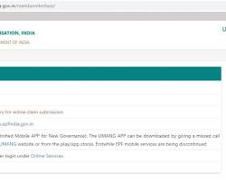
3. [Opens in a new window](https://www.bankbazaar.com/saving-schemes/how-to-transfer-epf-online.html)
4. [www.bankbazaar.com](https://www.bankbazaar.com/saving-schemes/how-to-transfer-epf-online.html)
5. Online Transfer Claim Portal screenshot on EPFO website
6. Member Portal Login Page:
7. 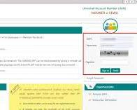
8. [Opens in a new window](https://www.bankbazaar.com/saving-schemes/steps-to-upload-kyc-for-epf-uan.html)
9. [www.bankbazaar.com](https://www.bankbazaar.com/saving-schemes/steps-to-upload-kyc-for-epf-uan.html)
10. Member Portal Login Page screenshot on EPFO website
11. Online Transfer Claim Form:
12. 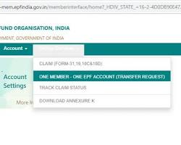
13. [Opens in a new window](https://www.bankbazaar.com/saving-schemes/how-to-transfer-epf-online.html)
14. [www.bankbazaar.com](https://www.bankbazaar.com/saving-schemes/how-to-transfer-epf-online.html)
15. Online Transfer Claim Form screenshot on EPFO website

Additional information:

* You can track the status of your transfer claim online on the EPFO website.
* The transfer process typically takes 15-20 days.
* For any assistance, you can contact the EPFO customer care at 1800 118 005.

Note: These are just general guidelines. The specific process may vary depending on your situation. It is recommended to contact the EPFO office for detailed information and assistance.