**Deep Learning With Generative AI**

Intelligence is the ability to learn, understand, and apply knowledge to solve problems, adapt to new situations, and think abstractly.

**What is Artificial Intelligence ?**

Artificial Intelligence (AI) is the field of computer science that focuses on creating machines and software capable of performing tasks that typically require human intelligence. These tasks include learning from experience, understanding natural language, recognizing patterns, solving problems, and making decisions.

*Geoffrey Hinton, the software engineer who is often regarded as the “godfather of artificial intelligence” has said that he is “very worried” about the artificial intelligence technology “taking lots of mundane jobs”*





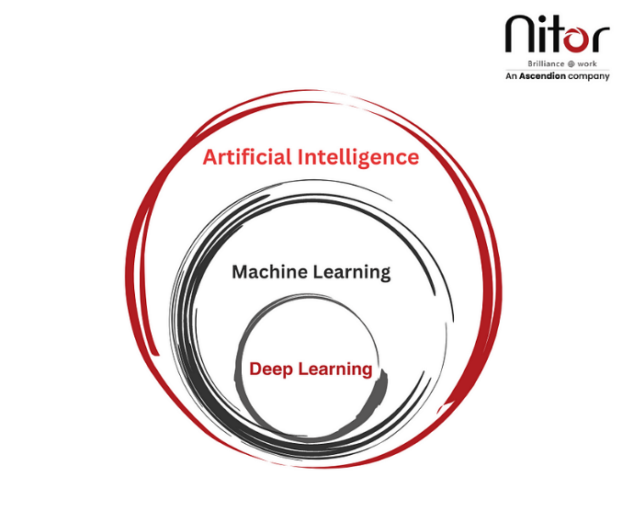

**Real-World Case Studies: AI in Action**

AI has found practical applications across diverse industries, transforming the way businesses operate. Let’s explore some real-world examples to gain a deeper understanding of AI’s impact:

In the healthcare sector, AI-powered diagnostic systems are revolutionizing patient care. By analyzing medical images such as X-rays and MRIs, AI algorithms can detect abnormalities, assist in accurate diagnoses, and predict diseases at an early stage. This leads to improved patient outcomes, reduced costs, and enhanced healthcare delivery. Additionally, AI is being utilized to identify patterns in patient data, enabling early detection of potential health risks and the development of personalized treatment plans.

The finance industry is leveraging AI to automate tasks and enhance decision-making processes. AI algorithms can analyze vast amounts of financial data, detect patterns, and identify potential fraud or anomalies. This enables financial institutions to manage risks more effectively, optimize investment strategies, and provide personalized financial advice. Furthermore, AI-based chatbots and virtual assistants are being employed to provide customer support, handle routine inquiries, and even assist in financial planning.

Customer service is being revolutionized by AI-powered chatbots and virtual assistants. These intelligent systems utilize natural language processing and machine learning to understand and respond to customer queries in real-time, providing instant support and personalized recommendations. By automating routine customer interactions, businesses can reduce response times, improve customer satisfaction, and free up human agents to handle more complex inquiries.

**The Future of AI**

Looking ahead, the future of AI holds immense promise:

**Increased Adoption**: AI technologies are becoming more accessible, driving increased adoption across industries. Businesses that embrace AI will gain a competitive edge, harnessing its transformative capabilities to drive growth and innovation. As AI continues to advance and become more user-friendly, it will find applications in even more areas, from agriculture to transportation.

**Ethical Considerations**: As AI becomes more pervasive, ethical considerations such as privacy, bias, and accountability become crucial. Striking a balance between innovation and responsible AI usage will be vital to build trust and ensure fairness in AI systems. The development of robust ethical frameworks and regulations will be necessary to guide the responsible use of AI.

**Advancements in Natural Language Processing**: Natural language processing, a subfield of AI, focuses on enabling computers to understand and respond to human language. Ongoing advancements in this area will lead to more sophisticated conversational AI interfaces and voice assistants, enabling more natural and seamless interactions between humans and machines. As language models improve, AI systems will better understand context, nuances, and even emotions, further enhancing their ability to engage in meaningful conversations.

## Advantages and Disadvantages of Artificial Intelligence

There are always challenges and limitations of any technological advancement. There is a ton of debate about the benefits and risks of AI at every phase. Everyone knows that AI provides software businesses with a competitive advantage.

On one hand, companies increasingly utilize artificial intelligence tools to streamline their internal processes (as well as some customer-facing processes and applications) to achieve results faster and with more precision. The primary benefit of adopting AI is its ability to reduce human error. Moreover, AI systems boast remarkable accuracy, paving the way for innovative solutions and personalized user experiences.

However, the rapid advancement of AI also brings forth concerns such as job displacement, biased algorithms, and privacy infringements.

Addressing these complexities requires careful considerations and responsible governance to maximize the benefits while mitigating risks.

AI holds the potential to reshape software businesses, but we must navigate its ethical challenges and consequences cautiously.

**Machine Learning: The Essence of AI**

Machine Learning (ML) is a subset of artificial intelligence that involves the development of algorithms and statistical models that enable computers to learn from and make predictions or decisions based on data. Instead of being explicitly programmed to perform a task, machine learning models improve their performance as they are exposed to more data over time.

Machine learning algorithms identify patterns and relationships within data, extract meaningful insights, and make predictions or decisions based on those patterns. This ability to learn from experience enables machines to automate tasks, recognize speech, classify images, and more. It provides machines with the ability to automatically learn patterns, make predictions, and make decisions without explicit programming.

In supervised learning, the algorithm learns from labeled examples to make predictions or classifications. It is provided with a dataset where each data point is associated with a target value or label. The algorithm analyses the features of the data and learns to map them to the corresponding target value. This allows the algorithm to make accurate predictions or classifications for new, unseen data. For example, in a spam email classification system, the algorithm is trained on a dataset of labeled emails, where each email is classified as either spam or non-spam. By analyzing the features of the emails, such as the words used or the presence of certain keywords, the algorithm learns to distinguish between spam and non-spam emails. Once trained, it can accurately classify new emails as spam or non-spam.

Unsupervised learning, on the other hand, involves learning from unlabeled data, where the algorithm is not provided with any target labels. The algorithm analyses the patterns and structures in the data to discover inherent relationships and groupings. Clustering algorithms are commonly used in unsupervised learning to group similar data points together. For example, in customer segmentation, an unsupervised learning algorithm can analyze customer data based on various attributes and group customers into segments based on their similarities.

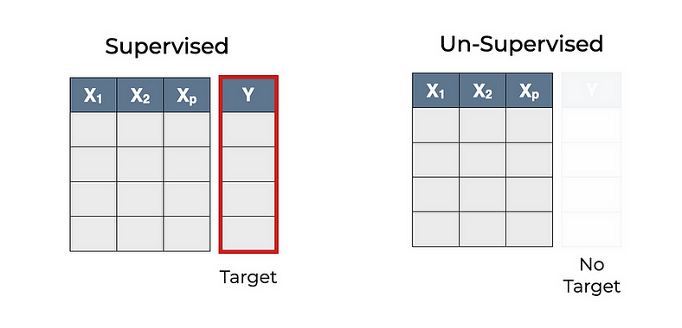

Reinforcement learning is a different paradigm of machine learning where an agent learns to interact with an environment and takes actions to maximize a reward signal. The agent learns through trial and error, receiving feedback in the form of rewards or penalties for its actions. It explores the environment, learns which actions yield higher rewards, and adjusts its behavior accordingly. Reinforcement learning has been successfully applied in various domains, including robotics, game playing, and autonomous vehicle control.

Within each of these learning paradigms, there are numerous algorithms and techniques, such as decision trees, support vector machines, neural networks, and deep learning. These algorithms differ in their approach to learning and the types of problems they are best suited for. The choice of algorithm depends on the specific problem at hand, the available data, and the desired outcome.

To apply Machine learning effectively, several key steps are involved. These include data preprocessing, feature selection or extraction, model training, model evaluation, and deployment. Data preprocessing involves cleaning and transforming the data to ensure its quality and compatibility with the chosen algorithm. Feature selection or extraction focuses on identifying the most relevant features that will contribute to the learning process. Model training refers to the process of fitting the algorithm to the data, adjusting its parameters to minimize errors or maximize performance. Model evaluation assesses the performance of the trained model using appropriate metrics and techniques. Finally, the trained model can be deployed to make predictions or automate decision-making tasks.

Machine learning is broadly categorized into several types, each with different approaches and applications:

1.Supervised Learning:

- Definition: The model is trained on a labeled dataset, where the input data is paired with the correct output.

- Examples: Regression, classification.

- Applications: Spam detection, image recognition, medical diagnosis.

2. Unsupervised Learning:

- Definition: The model is trained on data that does not have labeled responses. It tries to find patterns and relationships in the data.

- Examples: Clustering, dimensionality reduction.

- Applications: Customer segmentation, anomaly detection, market basket analysis.

3. Semi-Supervised Learning:

- Definition: The model is trained on a dataset that contains a small amount of labeled data and a large amount of unlabeled data.

- Examples: Combination of supervised and unsupervised learning techniques.

- Applications: Web content classification, text document categorization.

4. Reinforcement Learning:

- Definition: The model learns by interacting with an environment and receiving rewards or penalties for actions it performs.

- Examples: Markov decision processes, Q-learning.

- Applications: Game playing, robotics, autonomous driving.

5. Transfer Learning:

- Definition: The model is pre-trained on one task or domain and then fine-tuned on a different, but related, task or domain.

- Examples: Pre-trained neural networks like BERT, GPT.

- Applications: Image classification with limited data, language translation.

Each type of machine learning has its unique strengths and is suited to different kinds of problems and data sets.

**Data Analytics and Data Science: The Pillars of AI**

Data science is an interdisciplinary field that uses scientific methods, processes, algorithms, and systems to extract knowledge and insights from structured and unstructured data. It combines aspects of statistics, computer science, and domain-specific knowledge to analyze and interpret complex data, enabling data-driven decision-making. Data science involves several key activities:

1. Data Collection: Gathering data from various sources, such as databases, sensors, web scraping, surveys, and more.

2. Data Cleaning: Preprocessing the data to handle missing values, remove noise, and correct inconsistencies.

3. Data Analysis: Exploring and analyzing the data using statistical and computational techniques to uncover patterns and insights.

4. Data Visualization: Creating visual representations of data to help understand trends and relationships.

5. Machine Learning: Developing models and algorithms to make predictions, classify data, and identify patterns.

6. Data Interpretation: Interpreting the results and translating them into actionable insights for decision-makers.

Data scientists use a variety of tools and programming languages, such as Python, R, SQL, and machine learning libraries, to perform their tasks. The goal of data science is to leverage data to gain insights, solve problems, and inform strategic decisions across various domains, including business, healthcare, finance, and more.

Data analytics and data science play crucial roles in AI by providing the necessary tools and techniques to extract value from data. Data analytics involves the collection, organization, and analysis of vast amounts of data to uncover patterns, trends, and insights. It utilizes various statistical and computational techniques to transform raw data into actionable information. Data science complements data analytics by utilizing statistical models, algorithms, and scientific methods to extract knowledge and generate predictions.

By combining data analytics, data science, and machine learning, businesses can gain valuable insights, optimize processes, improve decision-making, and drive innovation. For example, in the field of marketing, data analytics can be used to analyze customer behavior, segment customers based on their preferences, and identify the most effective marketing strategies. Machine learning algorithms can then be employed to predict customer responses, personalize marketing campaigns, and maximize customer engagement.

**Deep Learning**

Deep learning is a subset of machine learning that involves the use of artificial neural networks with many layers (hence "deep") to model and understand complex patterns in data. These neural networks are inspired by the structure and function of the human brain.

Key aspects of deep learning include:

1. Neural Networks: Deep learning models are built using layers of artificial neurons, which are mathematical functions that process input data to produce an output. The simplest form of a neural network is called a feedforward neural network.

2. Layers: Deep learning networks consist of multiple layers, including input layers, hidden layers, and output layers. Each layer transforms the input data to extract features and patterns. Hidden layers can number from a few to several hundred or more in deep networks.

3. Training: Deep learning models are trained using large amounts of labeled data and powerful computational resources. Training involves adjusting the weights of the connections between neurons to minimize the difference between the predicted and actual outputs, typically using a method called backpropagation.

4. Activation Functions: Non-linear functions (such as ReLU, sigmoid, or tanh) are applied to the output of each neuron to introduce non-linearity, enabling the network to learn complex patterns.

5. Applications: Deep learning has been successfully applied to a wide range of tasks, including:

- Image Recognition: Identifying objects in images (e.g., convolutional neural networks or CNNs).

- Natural Language Processing: Understanding and generating human language (e.g., recurrent neural networks or RNNs, transformers).

- Speech Recognition: Converting spoken language into text.

- Autonomous Vehicles: Enabling self-driving cars to perceive and navigate the environment.

- Healthcare: Analyzing medical images and predicting disease outcomes.

6. Popular Architectures: Some common deep learning architectures include:

- Convolutional Neural Networks (CNNs): Specialized for processing grid-like data such as images.

- Recurrent Neural Networks (RNNs): Designed for sequential data, such as time series or natural language.

- Transformers: Effective for a wide range of tasks, particularly in natural language processing.

Deep learning's ability to automatically extract features from raw data has made it a powerful tool in many fields, leading to significant advancements in technology and industry.

**Generative AI: What is it?**

Let’s start with the concept of Generative AI. This is more than a fashionable buzzword. It is a form of artificial intelligence in which algorithms generate data instead of just analyzing it. GenAI makes it possible to create new content, ranging from text to images, videos, speech and even music. It can thus achieve realistic and personal interactions between humans and machines.

**Several specific examples of where Generative AI is used for:**

* Answering first-line customer questions about the services provided by organizations.
* Writing promotional and marketing materials by marketers and content writers.
* Generating images based on textual descriptions (or vice versa).
* Writing, checking and improving programming code or queries by developers.

Take for example a Generative AI in the context of a service provider like us. Based on data about frequently asked questions and customer reviews, an AI can generate personalized and relevant answers to a new customer question. For a new question, such as about our opening hours or how an appointment can be scheduled, the AI ​​first interprets the assignment/question, retrieves the necessary information from our (internal and public) data and then formulates a unique and personalized answer to the customer.

This is a fairly simple example. But you can also apply similar interactions in other, more complex business situations. In the policy context, you can think of an application for answering parliamentary questions, for answering Information Notes when carrying out European tenders or for recognizing commercial opportunities for companies based on market information. If you want to know more about these applications, take a look at our portfolio of AI projects.

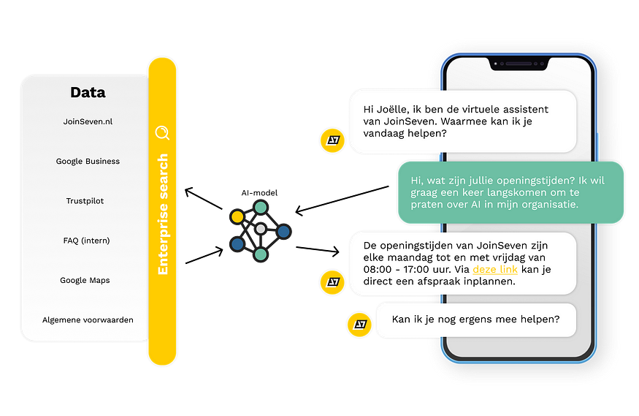

**The engine behind Generative AI: Large Language Models (LLMs)**

Generative AI models learn from large amounts of data. They analyze this data to recognize patterns and relationships. The engine behind this is a language model (also called “Large Language Model” or “LMM”). Consider a language model as an algorithm that learns to understand the structure and use of language. Language models are based on statistical analyzes of texts. They calculate the probability of word orders in sentences.

Modern language models, such as those based on Transformer architectures (e.g. Open AI’s GPT-3 and 4, Google Bard and Meta’s LLaMa), use multi-layered neural networks to understand relationships between words and phrases in a text. Texts are first divided into pieces (“tokens”), which can vary from one character to whole words. These tokens are converted into numerical vectors (“embeddings”) that capture the meaning and relationships between words.

First, the model is trained on a general dataset and then it can be tuned for specific tasks on a specific dataset for the relevant use case, such as answering customer questions or generating texts, images or music in a certain context or genre.

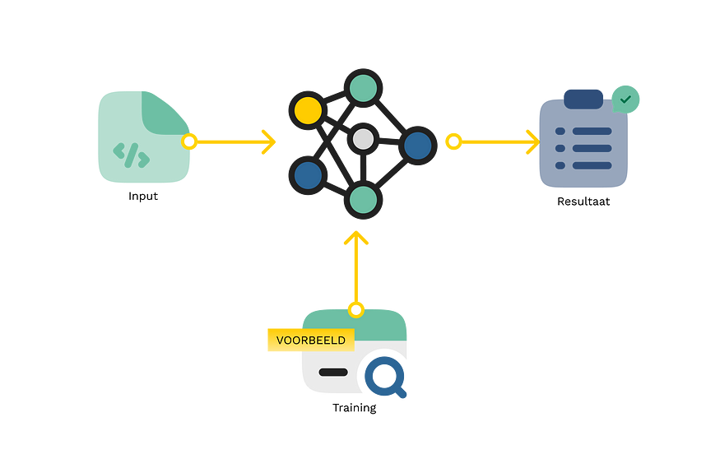

**Success factors in AI-implementations**

Through our experience in the field of AI and innovative data projects, we have gained a clear picture of what is needed to implement Generative AI successfully and responsibly. Some of these aspects are specifically important for projects in the field of GenAI, but many are also broadly applicable to projects with a major technological and innovative character.

When implementing Generative AI in your organization, consider the following elements:

* **You need a clear use case.** Our advice is: Find a solution to a problem and not the other way around! First make an inventory of problems you want to solve, and then create a vision of how (Generative) AI can solve this problem.
* **Successful use of AI requires a solid information strategy.**This also applies to AI; “garbage in, garbage out”. This is not just about the language models you use, but also the data and systems that feed these models.
* **Train and tune your AI model for your specific use case.**Most use cases require more than an “off-the-shelf” solution. Training and/or tuning your language model for your use case makes a big difference.
* **Take into account ethical and social considerations**, such as privacy and algorithm bias. Technology in itself is not “good” or “bad”, but incorrect implementation can cause unnecessary risks. We stand for responsible and human-oriented use of AI.
* **Choose an innovation-oriented, people-oriented and short-cycle approach.** A Generative AI project is innovative by definition. Validate assumptions and investigate unknown facets of AI in your organization. Our Data Discovery Sprint implements this in a concrete, user-oriented and fast way.
* **Guide people in your organization to work with AI.**Generative AI turns business processes upside down and many people find it exciting. A successful implementation therefore requires a thorough implementation strategy with an eye for the people who (will) work with it, the technology and work processes. This is the only way to ensure that an AI project has a truly positive impact.