Stochastic Gradient Descent (SGD) is an iterative optimization algorithm used to minimize the loss function (error) of a neural network by adjusting the weights and biases of the network during training. Here's how it works:

1. **Stochastic**: In traditional Gradient Descent, you compute the gradient of the loss with respect to all training examples, which can be computationally expensive, especially for large datasets. In SGD, you randomly select a small subset (mini-batch) of training examples (typically 32, 64, or 128) at each iteration and update the model's parameters based on the gradient of the loss computed for this mini-batch.

2. **Gradient**: The gradient is the direction of the steepest increase in the loss function. SGD calculates the gradient of the loss with respect to the model's parameters, indicating how to adjust the parameters to minimize the loss.

3. **Descent**: "Descent" indicates that the algorithm aims to move in the direction opposite to the gradient. The goal is to find the parameters that minimize the loss function, which is achieved by iteratively adjusting the parameters in the direction of the negative gradient.

SGD is preferred over batch gradient descent for several reasons:

- **Faster Convergence**: Since SGD updates the model parameters more frequently, it can converge faster, especially when dealing with large datasets.

- **Regularization**: The randomness introduced by using mini-batches can act as a form of regularization, helping prevent overfitting.

- **Parallelization**: Mini-batch processing can be easily parallelized, making it efficient for training on GPUs or distributed systems.

- **Escape Local Minima**: The stochastic nature of SGD can help the algorithm escape local minima in the loss landscape.

In practice, variations of SGD are often used, such as momentum, RMSprop, and Adam, to further enhance convergence and training stability.

Sure, here are the equations for the Stochastic Gradient Descent (SGD) algorithm. The goal of SGD is to minimize a loss function \(J(\theta)\) by updating the model parameters \(\theta\) iteratively. The parameters are typically weights and biases in the context of training a neural network.

1. **Initialization**: Initialize the model parameters \(\theta\) with some initial values.

2. **Choose a Learning Rate**: Select a learning rate \(\alpha\) that determines the step size for parameter updates. The learning rate is usually a small positive value.

3. **Iterative Updates**:

For each iteration, do the following:

a. **Mini-Batch Sampling**: Randomly select a mini-batch of training examples from the dataset. Let this mini-batch be denoted as \(\text{MiniBatch}\).

b. **Compute the Gradient**: Compute the gradient of the loss function with respect to the parameters for the mini-batch. This is often denoted as \(\nabla J(\theta; \text{MiniBatch})\).

c. **Update Parameters**: Update the model parameters using the gradient information and the learning rate. The update equation is as follows:

\[ \theta \leftarrow \theta - \alpha \nabla J(\theta; \text{MiniBatch}) \]

This update is performed for each parameter \(\theta_i\) in \(\theta\), and the learning rate \(\alpha\) controls the step size in the direction of the negative gradient.

4. **Stopping Criteria**: Repeat the iterative updates until a stopping criterion is met. Common stopping criteria include a fixed number of iterations, convergence of the loss, or other conditions based on the specific problem.

The key equation in SGD is the parameter update step, which is responsible for moving the parameters in the direction that reduces the loss. The learning rate \(\alpha\) determines the size of the step, and the negative gradient \(\nabla J(\theta; \text{MiniBatch})\) indicates the direction of steepest descent in the loss landscape.

In practice, variations of SGD, like mini-batch size, learning rate schedules, and momentum, are often used to improve convergence and training efficiency.

Certainly! Here's a simple numerical example of Stochastic Gradient Descent (SGD) to illustrate how it works. In this example, we'll consider a linear regression problem, which is a straightforward case for demonstration.

**Problem**: We want to fit a straight line to a set of data points using SGD.

**Linear Regression Model**: The linear regression model has the form \(y = mx + b\), where \(m\) is the slope and \(b\) is the y-intercept. Our goal is to find the values of \(m\) and \(b\) that best fit the data.

**Loss Function**: We'll use the mean squared error (MSE) as the loss function to minimize:

\[J(m, b) = \frac{1}{2N} \sum_{i=1}^{N} (y_i - (mx_i + b))^2\]

Where:

- \(N\) is the number of data points.

- \(x_i\) and \(y_i\) are the coordinates of the data points.

**SGD Algorithm**:

1. Initialize \(m\) and \(b\) with some initial values, e.g., \(m = 0\) and \(b = 0\).

2. Choose a learning rate, e.g., \(\alpha = 0.01\).

3. Repeat for a fixed number of iterations or until convergence:

a. Randomly select a data point from the dataset.

b. Calculate the gradient of the loss with respect to \(m\) and \(b\) for the selected data point.

\[

\begin{align*}

\frac{\partial J}{\partial m} &= -(y_i - (mx_i + b))x_i \\

\frac{\partial J}{\partial b} &= -(y_i - (mx_i + b))

\end{align*}

\]

c. Update \(m\) and \(b\) using the gradients and the learning rate:

\[

\begin{align*}

m &\leftarrow m + \alpha \frac{\partial J}{\partial m} \\

b &\leftarrow b + \alpha \frac{\partial J}{\partial b}

\end{align*}

\]

**Sample Data**:

Let's consider a dataset with three data points:

```

Data point 1: (x1, y1) = (2, 3)

Data point 2: (x2, y2) = (4, 5)

Data point 3: (x3, y3) = (6, 7)

```

**SGD Steps**:

Let's perform one iteration of SGD using the provided data and initial values of \(m\) and \(b\). We'll use \(\alpha = 0.01\).

1. Initialize \(m = 0\) and \(b = 0\).

2. Select a random data point (e.g., data point 2: \(x2 = 4\), \(y2 = 5\)).

3. Compute the gradients:

\[

\begin{align*}

\frac{\partial J}{\partial m} &= -(5 - (4m + b)) \cdot 4 = -(5 - (4 \cdot 0 + 0)) \cdot 4 = -5 \cdot 4 = -20 \\

\frac{\partial J}{\partial b} &= -(5 - (4m + b)) = -(5 - (4 \cdot 0 + 0)) = -5

\end{align*}

\]

4. Update \(m\) and \(b\):

\[

\begin{align*}

m &\leftarrow m + \alpha \frac{\partial J}{\partial m} = 0 + 0.01 \cdot (-20) = -0.2 \\

b &\leftarrow b + \alpha \frac{\partial J}{\partial b} = 0 + 0.01 \cdot (-5) = -0.05

\end{align*}

\]

After this iteration, the values of \(m\) and \(b\) have been updated. You would repeat these steps for a fixed number of iterations or until convergence to find the best-fitting line for the given data points.

**Drawbacks of base optimizer:(GD, SGD, mini-batch GD)**

* Gradient Descent uses the whole training data to update weight and bias. Suppose if we have millions of records then training becomes slow and computationally very expensive.
* SGD solved the Gradient Descent problem by using only single records to updates parameters. But, still, SGD is slow to converge because it needs forward and backward propagation for every record. And the path to reach global minima becomes very noisy.
* Mini-batch GD overcomes the SDG drawbacks by using a batch of records to update the parameter. Since it doesn't use entire records to update parameter, the path to reach global minima is not as smooth as Gradient Descent.

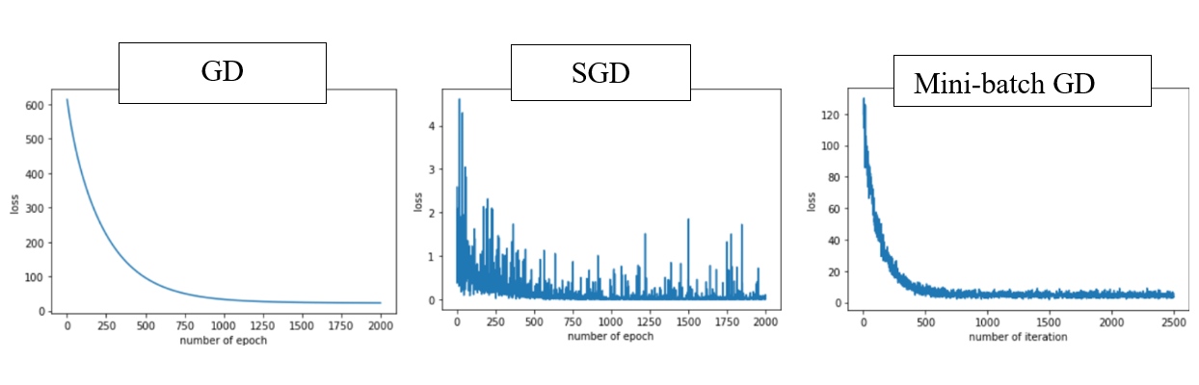

loss vs no. of the epoch

The above figure is the plot between the number of epoch on the x-axis and the loss on the y-axis. We can clearly see that in Gradient Descent the loss is reduced smoothly whereas in SGD there is a high oscillation in loss value.

**Exponentially Weighted Averages** is used in sequential noisy data to reduce the noise and smoothen the data. To denoise the data, we can use the following equation to generate a new sequence of data with less noise.

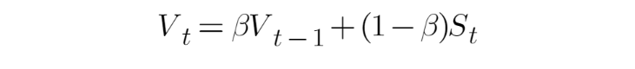

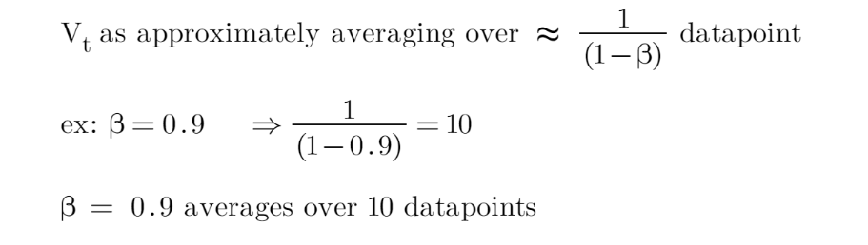

Now, let’s see how the new sequence is generated using the above equation: For our example to make it simple, let’s consider a sequence of size 3.

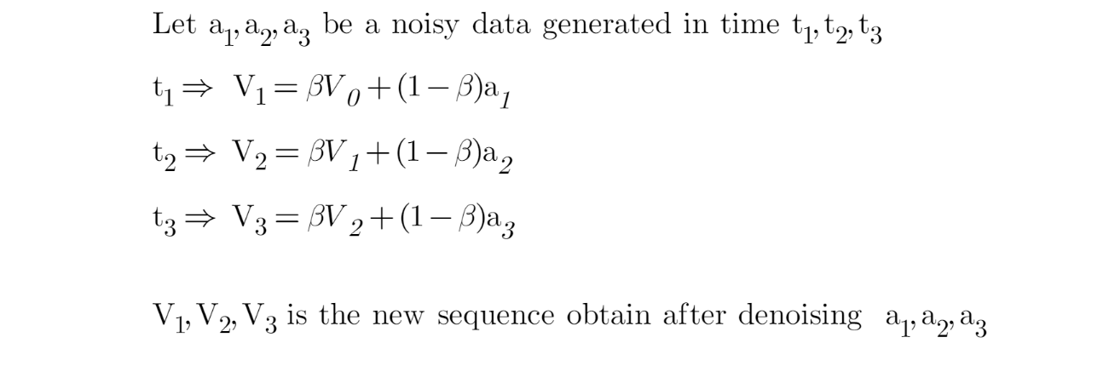

Let’s expand V3 equation:

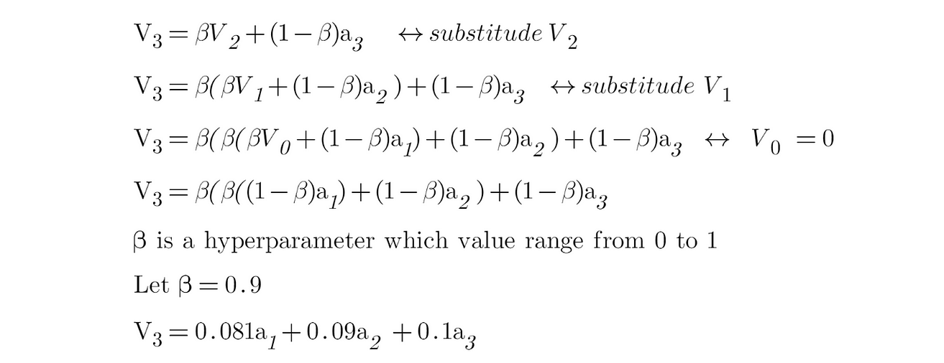

From the above equation, at time step t=3 more weightage is given to a3(which is the latest generated data) then followed by a2 previously generated data, and so on. This is how the sequence of noisy data is smoothened. It works better in a long sequence because, in the initial period, the averaging effect is less due to fewer data points.

**1. SGD with momentum**

It always works better than the normal Stochastic Gradient Descent Algorithm. The problem with SGD is that while it tries to reach minima because of the high oscillation we can’t increase the learning rate. So it takes time to converge. In this algorithm, we will be using Exponentially Weighted Averages to compute Gradient and used this Gradient to update parameter.

* An equation to update weights and bias in SGD

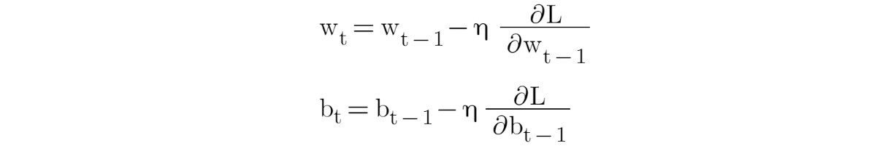

* An equation to update weights and bias in SGD with momentum

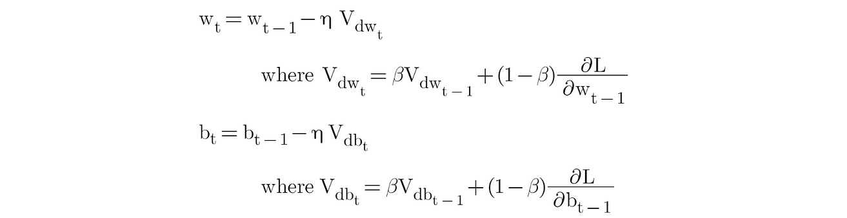

In SGD with momentum, we have added momentum in a gradient function. By this I mean the present Gradient is dependent on its previous Gradient and so on. This accelerates SGD to converge faster and reduce the oscillation.

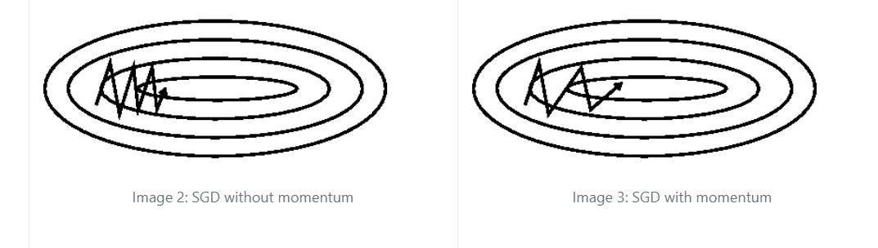

The above picture shows how the convergence happens in SGD with momentum vs SGD without momentum.

**2. Adagrad (Adaptive Gradient Algorithm)**

Adagrad (Adaptive Gradient Algorithm) is an optimization algorithm that is used to update the learning rate adaptively for each parameter during the training of machine learning models, particularly in the context of deep learning and neural networks. It was introduced by John Duchi, Elad Hazan, and Yoram Singer in 2011.

Adagrad is designed to address two common challenges in gradient-based optimization:

1. **Fixed Learning Rates**: In traditional optimization algorithms like stochastic gradient descent (SGD), a fixed learning rate is used for all parameters throughout training. This can lead to slow convergence or divergence, as it may not be the ideal learning rate for all parameters.

2. **Sparse Features**: In some machine learning tasks, certain features or parameters are rarely updated because they are not informative. Traditional optimizers may waste updates on these parameters.

Adagrad tackles these challenges by adapting the learning rate for each parameter individually based on their historical gradients.

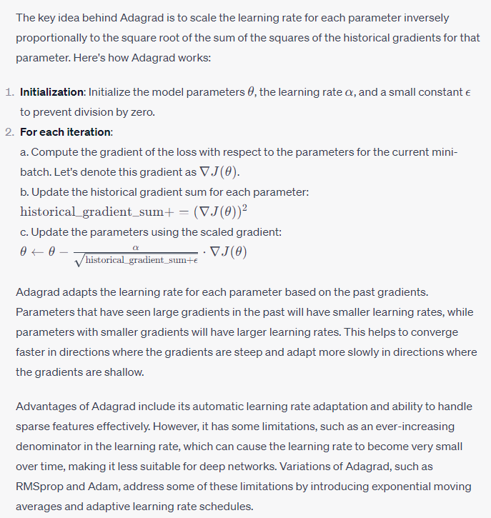

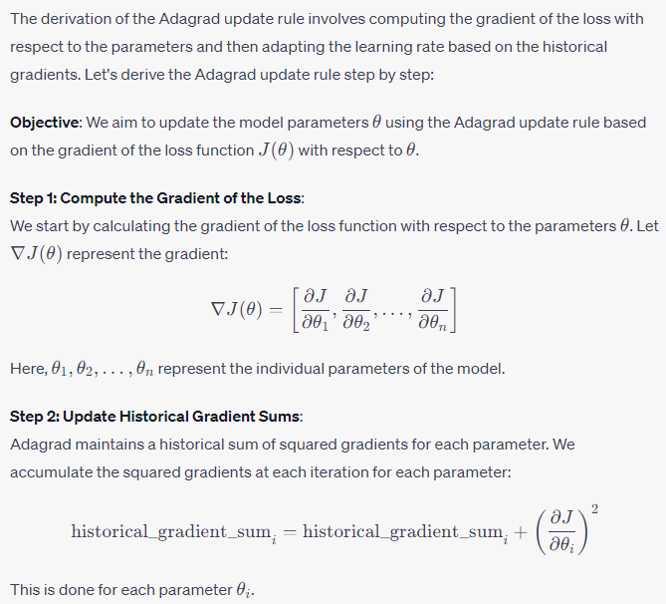

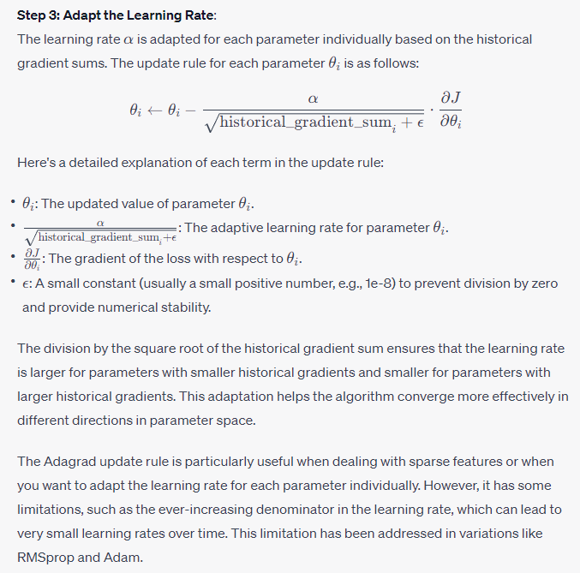

Adagrad (Adaptive Gradient Algorithm) offers several advantages and disadvantages, which are important to consider when deciding whether to use it in training machine learning models, particularly deep neural networks.

**Advantages**:

1. **Adaptive Learning Rates**: Adagrad automatically adapts the learning rate for each parameter based on the historical gradients. This can be especially beneficial when dealing with sparse features or parameters with different scales. It helps to converge effectively in different directions in parameter space.

2. **Effective for Sparse Features**: Adagrad is particularly useful when working with sparse data, such as natural language processing tasks, where many features are rarely active. It ensures that parameters associated with active features receive appropriately scaled updates.

3. **No Need for Manual Learning Rate Tuning**: Unlike traditional gradient descent, where you might need to manually tune the learning rate, Adagrad eliminates the need for such tuning. It can provide reasonable learning rates automatically.

**Disadvantages**:

1. **Accumulation of Historical Gradients**: One major disadvantage of Adagrad is that it accumulates the squared gradients in the denominator over time. As a result, the learning rate can become extremely small, which can lead to very slow convergence or a premature halt in learning. This issue can be particularly problematic in deep neural networks where the learning rates may become impractically small.

2. **Lack of Momentum**: Adagrad does not include momentum, which can help accelerate convergence and overcome local optima in optimization landscapes. Momentum is a useful feature provided by other optimization algorithms like RMSprop and Adam.

3. **Difficulty with Non-Convex Functions**: Adagrad may struggle with non-convex loss functions and high-curvature surfaces. Its adaptive learning rates may not be ideal for rapidly changing landscapes.

4. **Memory Overhead**: Storing and managing the historical gradient sums for each parameter can result in significant memory overhead, especially when dealing with a large number of parameters.

5. **Numerical Stability**: The addition of a small constant (\(\epsilon\)) to prevent division by zero is essential for numerical stability. However, the choice of \(\epsilon\) can be somewhat arbitrary and may need to be adjusted in practice.

6. **Variants with Improved Performance**: Over time, variations of Adagrad, such as RMSprop and Adam, have been developed to address some of its limitations. These variants often provide better performance and numerical stability.

In practice, Adagrad can be a useful optimization algorithm, especially for small-scale tasks and when dealing with sparse data. However, for deep neural networks and more complex optimization landscapes, variations like RMSprop and Adam are often preferred due to their improved performance and adaptive learning rate scheduling. The choice of optimizer should be based on the specific problem and may require experimentation to find the most effective algorithm.Adagrad adapts the learning rate for each parameter based on the past gradients. Parameters that have seen large gradients in the past will have smaller learning rates, while parameters with smaller gradients will have larger learning rates. This helps to converge faster in directions where the gradients are steep and adapt more slowly in directions where the gradients are shallow.

Advantages of Adagrad include its automatic learning rate adaptation and ability to handle sparse features effectively. However, it has some limitations, such as an ever-increasing denominator in the learning rate, which can cause the learning rate to become very small over time, making it less suitable for deep networks. Variations of Adagrad, such as RMSprop and Adam, address some of these limitations by introducing exponential moving averages and adaptive learning rate schedules.

Whatever the optimizer we learned till SGD with momentum, the learning rate remains constant. In Adagrad optimizer, there is no momentum concept so, it is much simpler compared to SGD with momentum.

The idea behind Adagrad is to use different learning rates for each parameter base on iteration. The reason behind the need for different learning rates is that the learning rate for sparse features parameters needs to be higher compare to the dense features parameter because the frequency of occurrence of sparse features is lower.

* Equation:

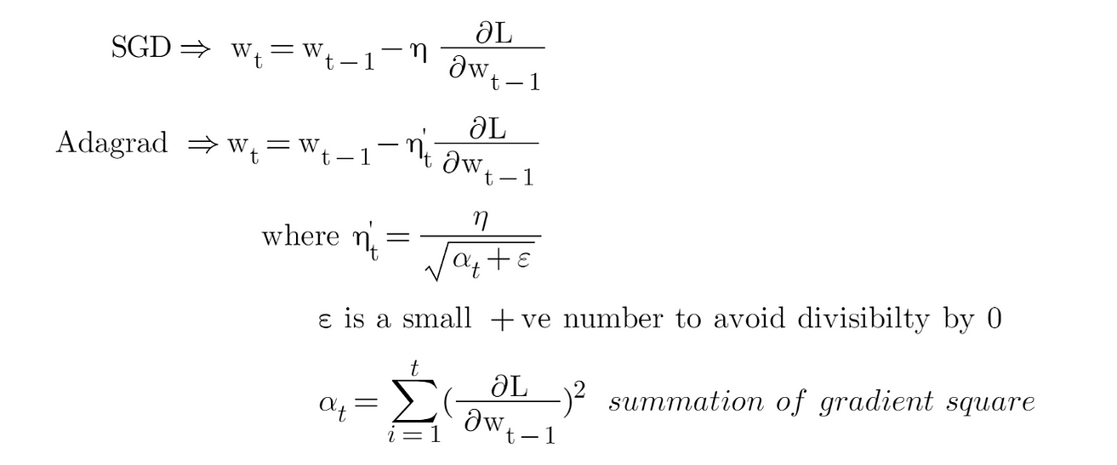

In the above Adagrad optimizer equation, the learning rate has been modified in such a way that it will automatically decrease because the summation of the previous gradient square will always keep on increasing after every time step. Now, let’s take a simple example to check how the learning rate is different for every parameter in a single time step. For this example, we will consider a single neuron with 2 inputs and 1 output. So, the total number of parameters will be 3 including bias.

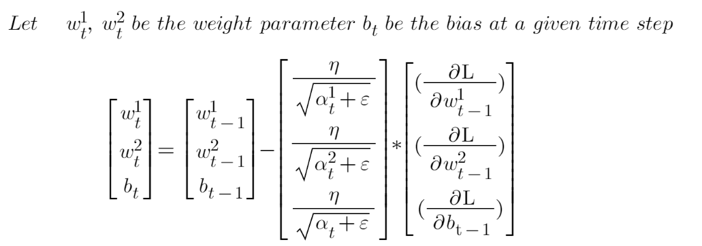

The above computation is done at a single time step, where all the three parameters learning rate “η” is divided by the square root of “α” which is different for all parameters. So, we can see that the learning rate is different for all three parameters.

Now, let’s see how weights and bias are updated in Stochastic Gradient Descent.

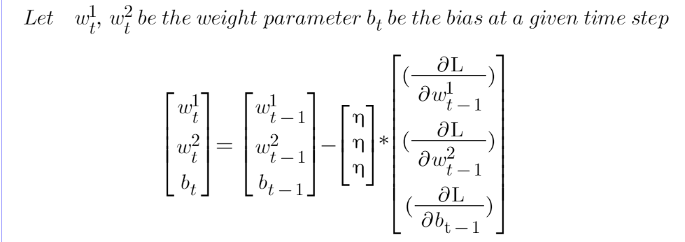

Similarly, the above computation is done at a single time step, and here the learning rate “η” remains the same for all parameters.

Lastly, despite not having to manually tune the learning rate there is one huge disadvantage i.e due to monotonically decreasing learning rates, at some point in time step, the model will stop learning as the learning rate is almost close to 0.