**Section 1- What are activation functions?**

***Def:****One of the most crucial roles in neural network architecture is played by****activation functions****. Activation functions are simple transformations that are applied to the outputs of individual neurons in the network, introducing non-linearity to it and enabling it to learn more complex patterns.*

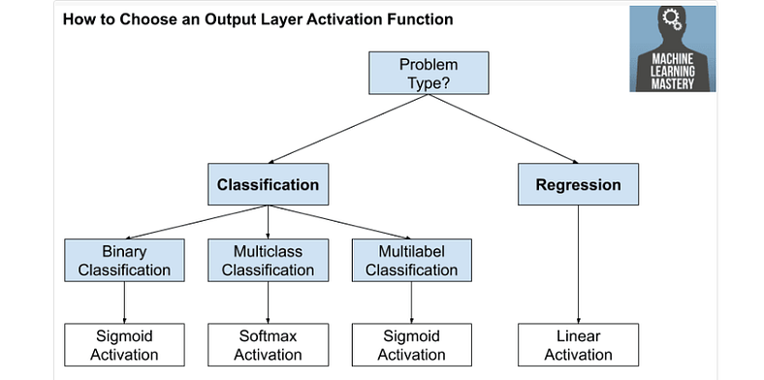

The activation function is like a gatekeeper for each neuron in the ANN. It decides whether a neuron should be “turned on” or “turned off.” Different types of activation functions perform this decision-making process in different ways [6].

**Section 2-The Role of Activation Functions in Neural Networks**

*When you build your neural network, one of the choices you get to make is what activation function to use in the hidden layers as well as at the output units of your neural network. So far, we’ve just been using the sigmoid activation function, but sometimes other choices can work much better [2].*

*Yet without activation functions, the neurons would just be doing boring linear math with the inputs. This means that no matter how many layers of neurons we add to the network, it would still be limited in what it can learn because the output would always be a simple linear combination of the inputs.*

*Activation functions come to the rescue by introducing non-linearity into the network. This indicates that a neuron’s output can be more complex than a simple linear sum of its inputs. By adding non-linearity, the network can model more complex relationships between the inputs and outputs, allowing it to discover more interesting and valuable patterns [2].*

*So, in short, activation functions are like the secret sauce that makes neural networks more powerful by introducing non-linearity and allowing them to learn complex patterns [2].*

*So, in short, activation functions are like the secret sauce that makes neural networks more powerful by introducing non-linearity and allowing them to learn complex patterns [2].*

*Non-linear functions, such as the sigmoid function, Tanh, ReLU and ELUs, provide results that are not proportional to the input. As a result, each type of activation function has its own unique characteristics that can be useful in different scenarios [2]*.

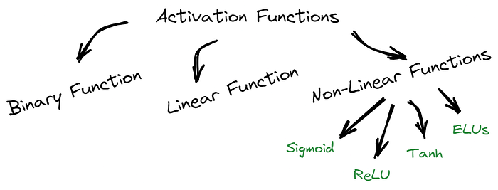

**Section 2- Sigmoid Function**

So that sigmoid is called an activation function. And here’s the familiar sigmoid function, a = 1/1 + e to -z.

So for example, **the sigmoid function goes between zero and one. An activation function that almost always works better than the sigmoid function is the tangent function or the hyperbolic tangent function**.

*Let me break down the Sigmoid Activation Function for you. This function takes any number as input and gives us an output between 0 and 1. The more positive the input, the closer the output will be to 1. On the other hand, the more negative the input, the closer the output will be to 0, as illustrated in the image below [2].*

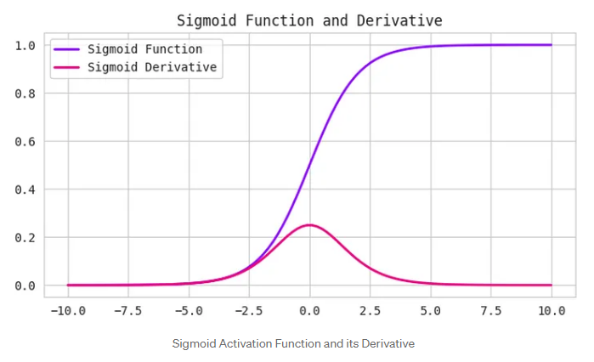

**Section 3- Tan H Function**

So this is z, this is a, this is a = tan h(z). And this goes between +1 and -1. The formula for the tan h function is e to the z minus e to-z over their sum. And it’s actually**mathematically a shifted version of the sigmoid function**. So as a sigmoid function just like that but shifted so that it now crosses the zero zero point on the scale. So it goes between minus one and plus one.

*So, the Tanh function, also known as the hyperbolic tangent function, is another type of activation function used in neural networks. It takes any real number as input and outputs a value between -1 and 1 [2]. Here’s the thing, the Tanh function is very similar to the Sigmoid function, but it’s a bit more centred around zero. That means when the input is close to zero, the output will be close to zero as well. This can be useful when dealing with data that has both negative and positive values because it can help the network learn better [2].*

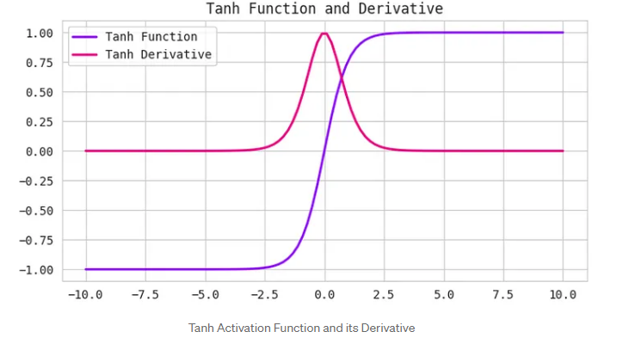

And it turns out that for hidden units, if you let the function g(z) be equal to tan h(z). This almost always works better than the sigmoid function because with values between plus one and minus one, the mean of the activations that come out of your hidden layer are closer to having a zero mean. And so just as sometimes when you train a learning algorithm, you might center the data and have your data have zero mean using a tan h instead of a sigmoid function. Kind of has the effect of centering your data so that the mean of your data is close to zero rather than maybe 0.5. And this actually makes learning for the next layer a little bit easier.

But one takeaway is that I pretty much never use the sigmoid activation function anymore. The tan h function is almost always strictly superior. The one exception is for the output layer because if y is either zero or one, then it makes sense for y hat to be a number that you want to output that’s between zero and one rather than between -1 and 1. So the one exception where I would use the sigmoid activation function is when you’re using binary classification. In which case you might use the sigmoid activation function for the upper layer. So g(z2) here is equal to sigmoid of z2. And so what you see in this example is where you might have a tan h activation function for the hidden layer and sigmoid for the output layer.

So the activation functions can be different for different layers. And sometimes to denote that the activation functions are different for different layers, we might use these square brackets superscripts as well to indicate that gf square bracket one may be different than gf square bracket two, right. Again, square bracket one superscript refers to this layer and superscript square bracket two refers to the output layer.

Now, one of the downsides of both the sigmoid function and the tan h function is that if z is either very large or very small, then the gradient of the derivative of the slope of this function becomes very small. So if z is very large or z is very small, the slope of the function either ends up being close to zero and so this can slow down gradient descent

**Section 4-Rectified Linear Unit / ReLU Function**

**Def**: *Rectified Linear Unit, or ReLU, is a common activation function that is both simple and powerful. It takes any input value and returns it if it is positive or 0 if it is negative. In other words, ReLU sets all negative values to 0 and keeps all positive values as they are [2].*

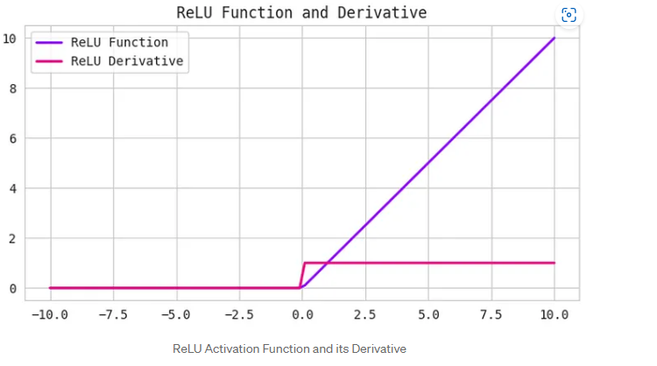

So one other choice that is very popular in machine learning is what’s called the rectified linear unit. So the value function looks like this and the formula is a = max(0,z). So the derivative is one so long as z is positive and derivative or the slope is zero when z is negative. If you’re implementing this, technically the derivative when z is exactly zero is not well defined. But when you implement this in the computer, the odds that you get exactly z equals 000000000000 is very small. So you don’t need to worry about it. In practice, you could pretend a derivative when z is equal to zero, you can pretend is either one or zero. And you can work just fine. So the fact is not differentiable.

The fact that, so here’s some rules of thumb for choosing activation functions. If your output is zero one value, if you’re using binary classification, then the sigmoid activation function is very natural choice for the output layer. And then for all other units value or the rectified linear unit is increasingly the default choice of activation function. So if you’re not sure what to use for your hidden layer, I would just use the value activation function, is what you see most people using these days. Although sometimes people also use the tan h activation function. One disadvantage of the value is that the derivative is equal to zero when z is negative. In practice this works just fine.

**Leaky ReLU Function**

*Def:The Leaky ReLU function is an extension of the ReLU function that attempts to solve the “dying ReLU” problem. Instead of setting all negative values to 0, Leaky ReLU sets them to a small positive value, such as 0.1 times the input value. his guarantees that even if a neuron receives negative information, it may still learn from it[2].*

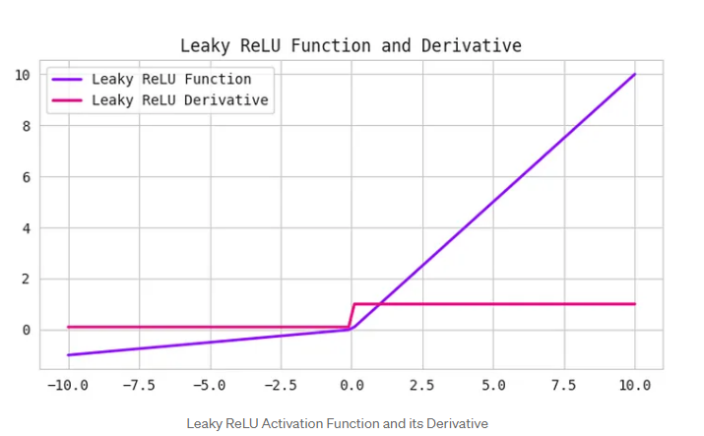

But there is another version of the value called the Leaky ReLU. We’ll give you the formula on the next slide but instead of it being zero when z is negative, it just takes a slight slope like so. So this is called Leaky ReLU. This usually works better than the value activation function. Although, it’s just not used as much in practice. Either one should be fine. Although, if you had to pick one, I usually just use the value. And the advantage of both the value and the Leaky ReLU is that for a lot of the space of z, the derivative of the activation function, the slope of the activation function is very different from zero. And so in practice, using the value activation function, your neural network will often learn much faster than when using the tan h or the sigmoid activation function. And the main reason is that there’s less of this effect of the slope of the function going to zero, which slows down learning. And I know that for half of the range of z, the slope for value is zero. But in practice, enough of your hidden units will have z greater than zero. So learning can still be quite fast for most training examples.

**Section 6- Exponential Linear Units (ELUs) Function**

*Another form of activation function that has gained prominence in recent years is Exponential Linear Units or ELUs. Like ReLU, they aim to address the vanishing gradient problem. ELUs introduce a non-zero slope for negative inputs, which aids in the prevention of the “dying ReLU” problem [2].*

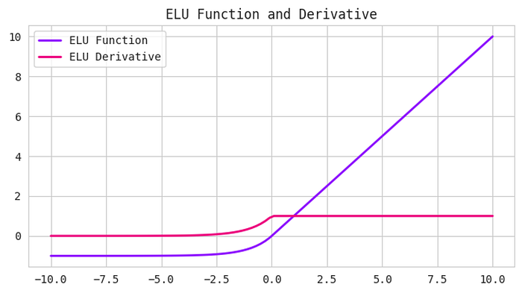

The formula for Exponential Linear Units (ELUs) is:

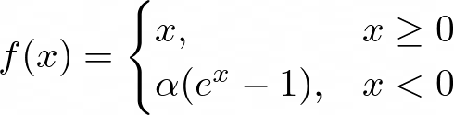

*Where alpha is a hyperparameter that controls the degree of negative saturation.*

*ELUs have been shown to improve both training and test accuracy compared to other activation functions like ReLU and tanh. They are particularly useful in deep neural networks that require a high level of accuracy [2].*

**Section 7- Softmax Function**

*The softmax function is often used as the activation function in the output layer of a neural network that needs to classify inputs into multiple categories. It takes as input a vector of real numbers and returns a probability distribution that represents the likelihood of each category [2].*

*The formula for softmax is:*

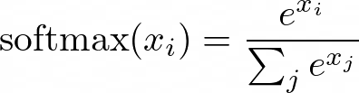

Where **x** is the input vector and **i** and **j** are indices that range from 1 to the number of categories [2].

Softmax is useful for multi-class classification problems because it ensures that the output probabilities sum to 1, making it easy to interpret the results. It is also differentiable, which allows it to be used in backpropagation during training[2].

**Section 8- Swish**

*The Swish function is a relatively new activation function that has gained attention in the deep learning community for its improved performance over other activation functions like ReLU [2].*

*The formula for Swish is:*

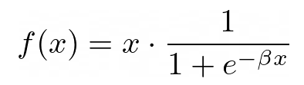

Where beta is a hyperparameter that controls the degree of saturation.

*Swish is similar to ReLU in that it is a simple function that can be computed efficiently. It does, however, have a smooth curve that aids in the prevention of the “dying ReLU” problem. Swish has been shown to outperform ReLU on a variety of deep learning tasks [2].*

**Section 9- Pros and Cons of activation function**

So let’s just quickly recap the pros and cons of different activation functions.

Here’s the sigmoid activation function. I would say never use this except for the output layer if you’re doing binomial classification or maybe almost never use this.

And the reason I almost never use this is because the tan h is pretty much strictly superior. So the tan h activation function is this.

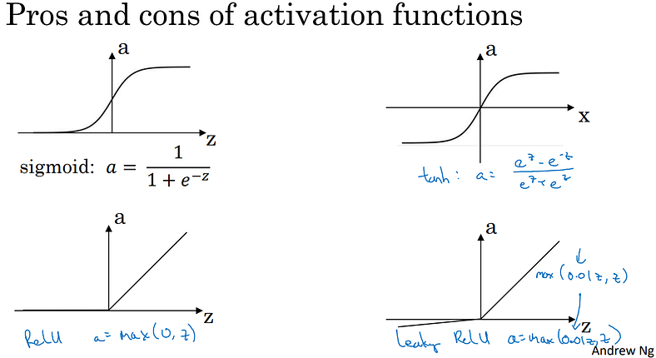

And then the default, the most commonly used activation function is the ReLU, which is this. So if you’re not sure what else to use, use this one. And maybe, feel free also to try the Leaky ReLU where might be 0.01(z,z), right? So a is the max of 0.1 times z and z. So that gives you this bend in the function. And you might say, why is that constant 0.01? Well, you can also make that another parameter of the learning algorithm. And some people say that works even better, but how they see people do that. So, but if you feel like trying it in your application, please feel free to do so. And you can just see how it works and how well it works, and stick with it if it gives you a good result.

So I hope that gives you a sense of some of the choices of activation functions you can use in your neural network. One of the things we’ll see in deep learning is that you often have a lot of different choices in how you build your neural network. Ranging from a number of hidden units to the choices activation function, to how you initialize the ways which we’ll see later. A lot of choices like that. And it turns out that it is sometimes difficult to get good guidelines for exactly what will work best for your problem. So throughout these courses, I’ll keep on giving you a sense of what I see in the industry in terms of what’s more or less popular. But for your application with your applications, idiosyncrasies is actually very difficult to know in advance exactly what will work best. So common piece of advice would be, if you’re not sure which one of these activation functions work best, try them all. And evaluate on like a holdout validation set or like a development set, which we’ll talk about later. And see which one works better and then go of that. And I think that by testing these different choices for your application, you’d be better at future proofing your neural network architecture against the idiosyncracies problems. As well as evolutions of the algorithms rather than, if I were to tell you always use a value activation and don’t use anything else. That just may or may not apply for whatever problem you end up working on. Either in the near future or in the distant future. All right, so, that was choice of activation functions and you see the most popular activation functions. There’s one other question that sometimes you can ask which is, why do you even need to use an activation function at all? Why not just do away with that? So, let’s talk about that in the next tutorial where you see why neural networks do need some sort of non linear activation function.

Here is a quick recap of the pros and cons of different activation functions:

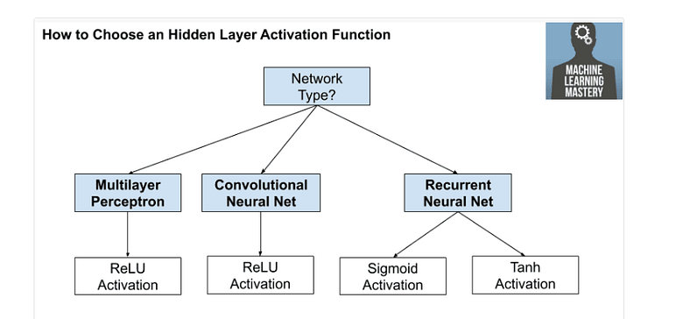

* Sigmoid Activation Function: Almost never used, except for the output layer in binary classification.
* Tanh Activation Function: Strictly superior to the sigmoid function, especially for hidden units.
* ReLU Activation Function: The default choice for most hidden layers, as it often leads to faster learning.
* Leaky ReLU Activation Function: Similar to ReLU, but with a slight slope for negative values of z. Can be an alternative to ReLU.
* *Sigmoid function it suffers from the vanishing gradient problem. This indicates that when the input becomes increasingly large or tiny, the gradient of the function becomes very small, slowing down the learning process in deep neural networks[2].*
* However, like the Sigmoid function, the Tanh function can also suffer from the vanishing gradient problem as the input becomes very large or very small. Yet, the Tanh function is still commonly used in neural networks, especially in the hidden layers of the network [2].
* One of the benefits of using ReLU is that it is computationally efficient and simple to implement. It is also known for helping to mitigate the vanishing gradient problem that can occur in deep neural networks [2].
* However, ReLU can suffer from a problem known as the “dying ReLU” problem. This happens when a neuron’s input is negative, leading the neuron to output 0. If this happens too frequently, the neuron “dies” and stops learning [2].
* The fact that, so here’s some rules of thumb for choosing activation functions. If your output is zero one value, if you’re using binary classification, then the sigmoid activation function is very natural choice for the output layer. And then for all other units value or the rectified linear unit is increasingly the default choice of activation function. So if you’re not sure what to use for your hidden layer, I would just use the value activation function, is what you see most people using these days. Although sometimes people also use the tan h activation function. One disadvantage of the value is that the derivative is equal to zero when z is negative. In practice this works just fine.
* PReLU has been shown to work well in some types of problems, particularly in image recognition tasks[2].
* *ReLU activation function should only be used in the hidden layers[2].*
* *Sigmoid/Logistic and Tanh functions should not be used in hidden layers as they can cause problems during training.[2]*
* *Regression — Linear Activation Function*
* *Binary Classification — Sigmoid/Logistic Activation Function*
* *Multiclass Classification — Softmax*
* *Multilabel Classification — Sigmoi*

**Quick Recap of Activation Functions**

#### **1. Sigmoid Activation Function**

- **Pros:**

- **Binary Classification:** Good for the output layer in binary classification problems.

- **Cons:**

- **Vanishing Gradient:** Can cause learning problems in deep networks because gradients become very small with large or small inputs.

- **Rarely Used:** Almost never used in hidden layers due to the problems above.

**When to Use:** For the output layer of binary classification.

---

#### **2. Tanh Activation Function**

- **Pros:**

- **Better than Sigmoid:** Generally preferred over sigmoid for hidden layers because it’s zero-centered and can help with convergence.

- **Cons:**

- **Vanishing Gradient:** Can still suffer from vanishing gradients for very large or small inputs, though less than sigmoid.

**When to Use:** For hidden layers in deep networks.

---

#### **3. ReLU (Rectified Linear Unit) Activation Function**

- **Pros:**

- **Default Choice:** Often used in hidden layers because it speeds up learning and is computationally efficient.

- **Avoids Vanishing Gradients:** Helps avoid the vanishing gradient problem.

- **Cons:**

- **Dying ReLU Problem:** Neurons can "die" and stop learning if they output zero for all inputs.

**When to Use:** For most hidden layers in neural networks.

---

#### **4. Leaky ReLU Activation Function**

- **Pros:**

- **Fixes Dying ReLU:** Allows a small gradient for negative inputs to avoid the dying ReLU problem.

- **Cons:**

- **Not as Common:** Not always used, but can be tried as an alternative to ReLU.

- **Needs Tuning:** The slope for negative values (\(\alpha\)) might need tuning.

**When to Use:** When ReLU causes too many dead neurons.

---

#### **5. Parametric ReLU (PReLU) Activation Function**

- **Pros:**

- **Adaptive:** Learns the slope for negative values during training, which can lead to better performance.

- **Cons:**

- **More Complex:** Adds more parameters to learn, which can increase complexity.

**When to Use:** For advanced applications, particularly in image recognition tasks.

---

#### **6. ELU (Exponential Linear Unit) Activation Function**

- **Pros:**

- **Improves Learning:** Addresses both vanishing gradients and dead neurons.

- **Cons:**

- **Computationally Expensive:** More complex and resource-intensive compared to ReLU.

**When to Use:** When you need a smooth, non-linear activation that avoids dead neurons.

---

#### **7. Softmax Activation Function**

- **Pros:**

- **Multi-Class Classification:** Converts output into probabilities for multi-class classification.

- **Cons:**

- **Not for Hidden Layers:** Generally used only for the output layer.

**When to Use:** For the output layer in multi-class classification problems.

---

#### **8. Swish Activation Function**

- **Pros:**

- **Smooth and Effective:** Can lead to better performance in some applications.

- **Cons:**

- **Computationally Expensive:** Requires calculation of the sigmoid function.

**When to Use:** As an alternative to ReLU for potentially better performance.

### **Rules of Thumb**

- **Binary Classification Output:** Use **Sigmoid**.

- **Hidden Layers:** Use **ReLU** (or try **Leaky ReLU** or **ELU**).

- **Multi-Class Classification Output:** Use **Softmax**.

- **Experiment:** If unsure, try different activation functions and choose based on validation performance.

### **Why Use Activation Functions?**

Activation functions introduce non-linearity into the model, which is crucial for learning complex patterns and solving real-world problems.