**Adadelta**

Adadelta is an adaptive learning rate optimization algorithm used for training machine learning models, particularly in deep learning and neural networks. It is an extension and improvement over the Adagrad algorithm, designed to address some of Adagrad's limitations, particularly the issue of continually decreasing learning rates. Adadelta was introduced by Matthew Zeiler in his paper titled "ADADELTA: An Adaptive Learning Rate Method" in 2012.

Adadelta shares the idea of adapting learning rates to individual parameters based on their historical gradients, but it introduces several modifications to make it more robust and efficient. Here's how Adadelta works in detail:

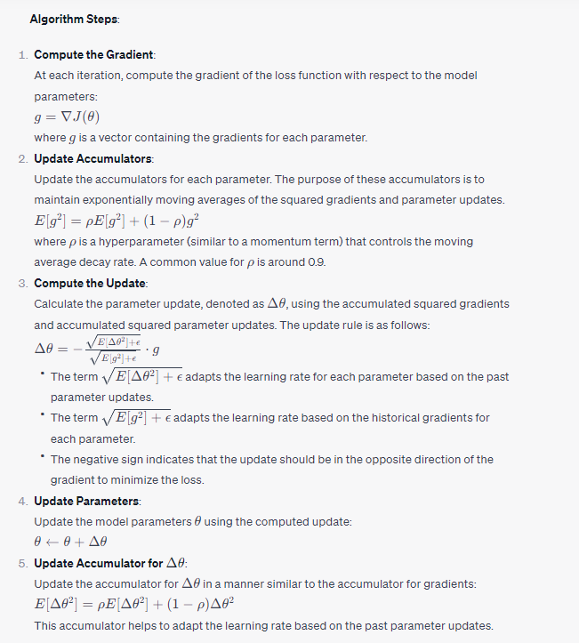

**Advantages of Adadelta**:

1. **Adaptive Learning Rates**: Adadelta automatically adapts learning rates for individual parameters, making it less sensitive to the choice of a global learning rate.

2. **Numerical Stability**: The use of accumulated squared parameter updates and gradients, along with the addition of \(\epsilon\), enhances numerical stability.

3. **No Need for Learning Rate Tuning**: Adadelta eliminates the need for manually tuning the learning rate, making it more user-friendly.

4. **Effective for Non-Stationary Data**: Adadelta can handle non-stationary and noisy data effectively because it uses a moving average of past parameter updates.

**Disadvantages of Adadelta**:

1. **Memory and Computational Overhead**: Adadelta requires additional memory and computational resources to maintain accumulators for each parameter.

2. **May Still Need Hyperparameter Tuning**: Although it has fewer hyperparameters than some other optimizers, Adadelta may still require tuning of the hyperparameters, such as \(\rho\) and \(\epsilon\), in certain cases.

In practice, Adadelta is a popular optimization algorithm for training deep neural networks and is known for its robustness and effectiveness in adapting learning rates. It is often used in combination with other techniques like mini-batch training and early stopping for efficient and effective model training.

**Limitations of Adadelta**

1. **Complexity**:
   * Adadelta is more complex to implement and understand compared to simpler optimization algorithms like SGD.
2. **Hyperparameter Sensitivity**:
   * While Adadelta reduces the dependency on the initial learning rate, the decay rate (rho) still needs to be carefully tuned for optimal performance.
3. **Memory Consumption**:
   * Similar to Adagrad, Adadelta needs to maintain moving averages of squared gradients and squared updates for each parameter, which can consume significant memory for large models.
4. **Slower Convergence**:
   * In some cases, Adadelta may converge more slowly compared to other adaptive learning rate methods like RMSprop and Adam, especially for non-convex optimization problems.

[Adadelta](https://golden.com/wiki/Adadelta) is an extension of Adagrad that attempts to solve its radically diminishing learning rates. The idea behind Adadelta is that instead of summing up all the past squared gradients from 1 to “t” time steps, what if we could restrict the window size. For example, computing the squared gradient of the past 10 gradients and average out. This can be achieved using Exponentially Weighted Averages over Gradient.

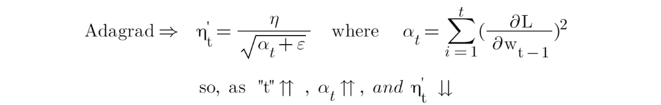

The above equation shows that as the time steps “t” increase the summation of squared gradients “α” increases which led to a decrease in learning rate “η”. In order to resolve the exponential increase in the summation of squared gradients “α”, we replaced the “α” with exponentially weighted averages of squared gradients.

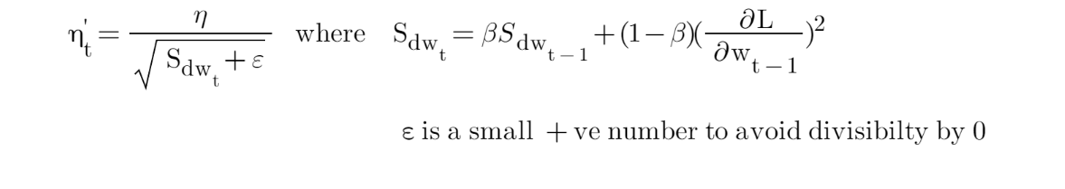

So, here unlike the alpha “α” in Adagrad, where it increases exponentially after every time step. In Adadelda, using the exponentially weighted averages over the past Gradient, an increase in “S*dw”*is under control.

RMSprop, short for Root Mean Square Propagation, is an optimization algorithm used in machine learning and deep learning to adapt the learning rate during training. It is designed to mitigate some of the limitations of traditional gradient descent, particularly when dealing with problems involving sparse data or ill-conditioned optimization surfaces. RMSprop is part of a family of adaptive learning rate algorithms that automatically adjust the learning rates for different parameters based on their past gradients.

Here's a detailed explanation of how RMSprop works:

### Basic Idea:

RMSprop adapts the learning rates individually for each parameter during training. It does so by keeping track of a moving average of the squared gradients of each parameter. The intuition behind this is to give smaller learning rates to parameters that are updated frequently and larger learning rates to parameters that are updated less often. This helps prevent divergence and accelerates convergence.

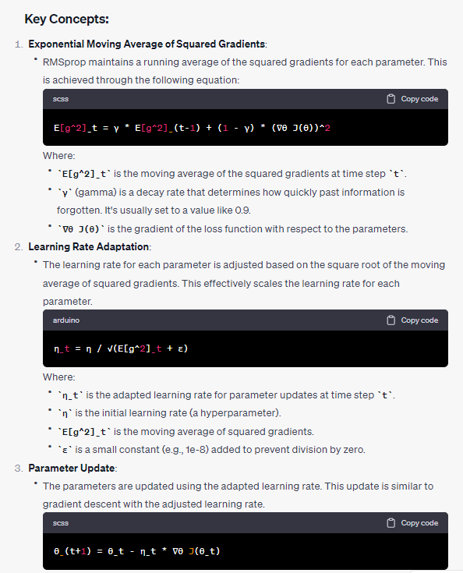

### Advantages of RMSprop:

1. **Adaptive Learning Rates**: RMSprop adapts the learning rates individually for each parameter. This is especially helpful when dealing with high-dimensional and complex optimization problems.

2. **Robustness to Sparse Gradients**: RMSprop is less sensitive to noisy or sparse gradients, making it suitable for a wide range of machine learning tasks.

3. **Automatic Adjustment**: It doesn't require manual tuning of learning rates as frequently as standard gradient descent.

### Limitations of RMSprop:

1. **Hyperparameter Sensitivity**: Like many optimization algorithms, the performance of RMSprop depends on the choice of hyperparameters, such as the initial learning rate (`η`) and the decay rate (`γ`).

2. **Lack of Momentum**: RMSprop does not include momentum, which is present in algorithms like Adam. This can sometimes result in slower convergence in certain cases.

In practice, RMSprop is widely used in various deep learning applications and is often the optimizer of choice for tasks like training neural networks for image recognition, natural language processing, and more. It provides a good balance between adaptive learning rate adjustment and simplicity of use.

RMSProp (Root Mean Squared Propagation) is an adaptive learning rate [optimization algorithm](https://www.geeksforgeeks.org/optimization-techniques-for-gradient-descent/). It is an extension of the popular[Adaptive Gradient Algorithm](https://www.geeksforgeeks.org/intuition-of-adam-optimizer/) and is designed to dramatically reduce the amount of computational effort used in training [neural networks.](https://www.geeksforgeeks.org/artificial-neural-networks-and-its-applications/) This algorithm works by exponentially decaying the learning rate every time the squared [gradient](https://www.geeksforgeeks.org/gradient-descent-algorithm-and-its-variants/) is less than a certain threshold. This helps reduce the learning rate more quickly when the gradients become small. In this way, RMSProp is able to smoothly adjust the learning rate for each of the parameters in the network, providing a better performance than regular Gradient Descent alone.

The RMSprop algorithm utilizes exponentially weighted moving averages of squared gradients to update the parameters. Here is the mathematical equation for RMSprop:

1. Initialize parameters:
   * Learning rate: α
   * Exponential decay rate for averaging: γ
   * Small constant for numerical stability: ε
   * Initial parameter values: θ
2. Initialize accumulated gradients (Exponentially weighted average):
   * Accumulated squared gradient for each parameter: Et​= 0
3. Repeat until convergence or maximum iterations:
   * Compute the gradient of the objective function with respect to the parameters:
   * Update the exponentially weighted average of the squared gradients:
   * Update the parameters:

where,

* gt is the gradient of the loss function with respect to the parameters at time t
* is a decay factor
* Et​ is the exponentially weighted average of the squared gradients
* α is the learning rate
* ϵ is a small constant to prevent division by zero

This process is repeated for each parameter in the optimization problem, and it helps adjust the learning rate for each parameter based on the historical gradients. The exponential moving average allows the algorithm to give more importance to recent gradients and dampen the effect of older gradients, providing stability during optimization.