**SOP to join servers to AD:**

Here, we are taking example of Edific server.

**Steps:**

Step1: whitelist your IP and login to jump server of the environment

Step2: whitelist server (Edifics) with private ip of the jump server.

Step3: After, logging in to the jump server connect to the Edifics server(windows) through RDP.

Step4: Follow the below actions.

***Action1: Change the computer name accordingly***

Go to **this PC** and right click and **Properties**

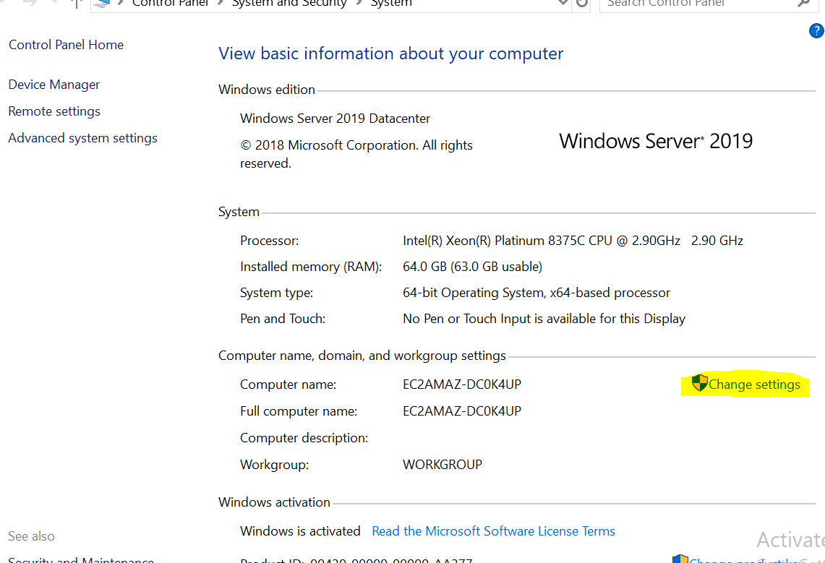

Click on change

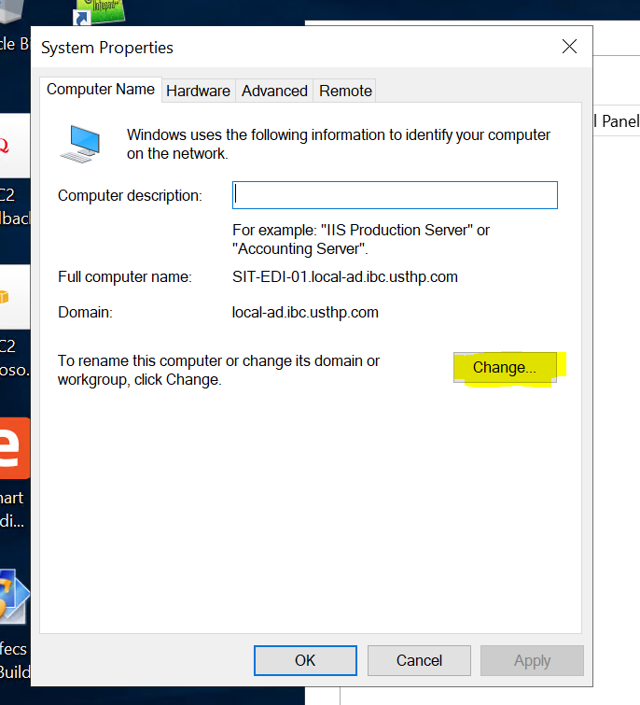

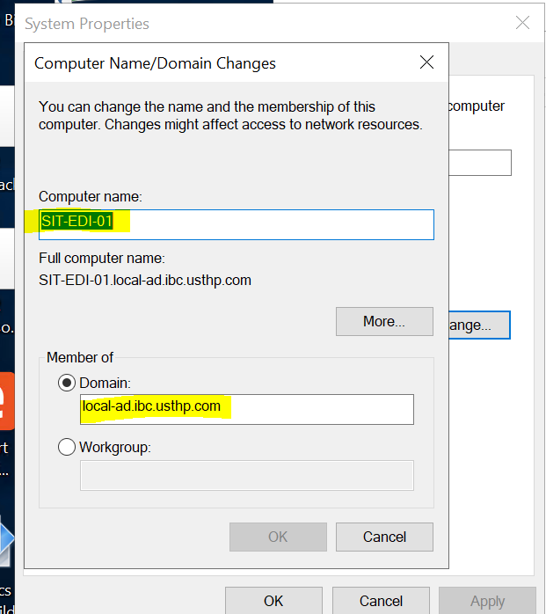

Give the Name and Domain accordingly

Enter the AD Credential after configuring this.

Note: we can restart later after configuring rest of the required configurations.

***Action2: Partition the Disk volumes:***

Go to run and hit command ***diskmgmt.msc***

Select the drive and click on ‘new simple volume’, give the drive name accordingly.

***Action3:***

Go to run and hit command ***regedit***

Go to the below path

Computer\HKEY_LOCAL_MACHINE\SYSTEM\CurrentControlSet\Control\Terminal Server\WinStations\RDP-Tcp

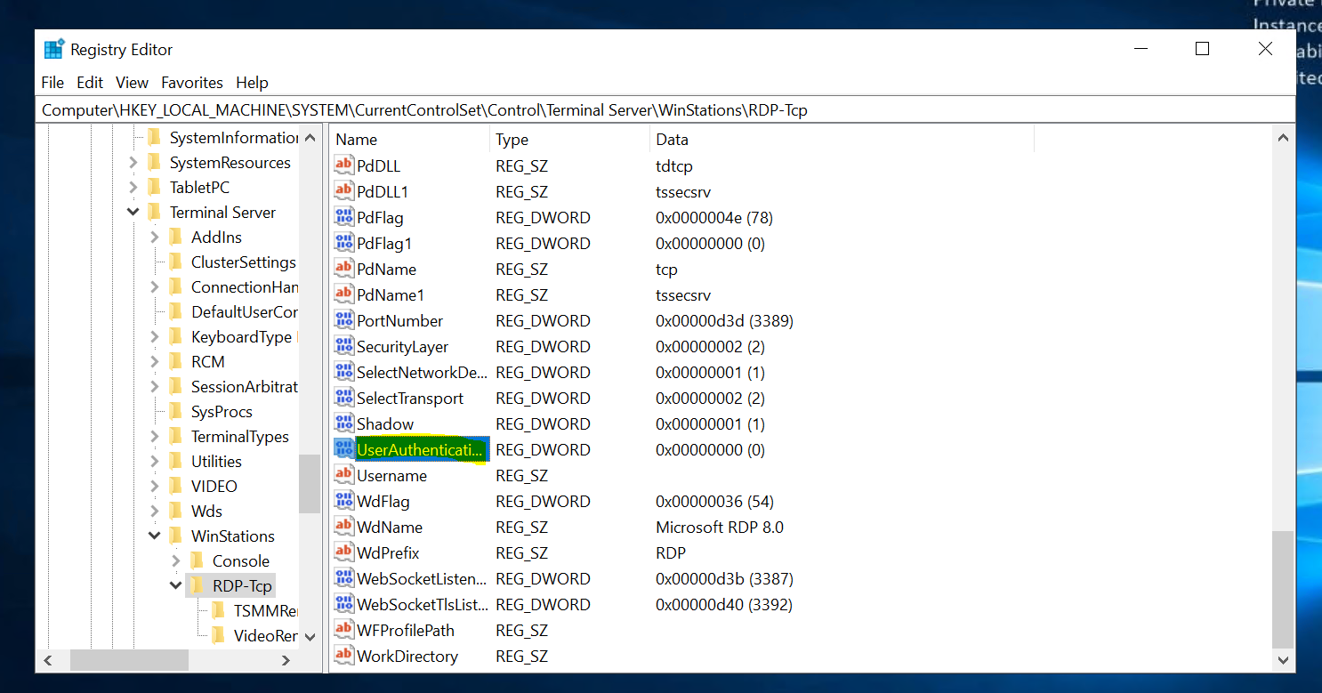

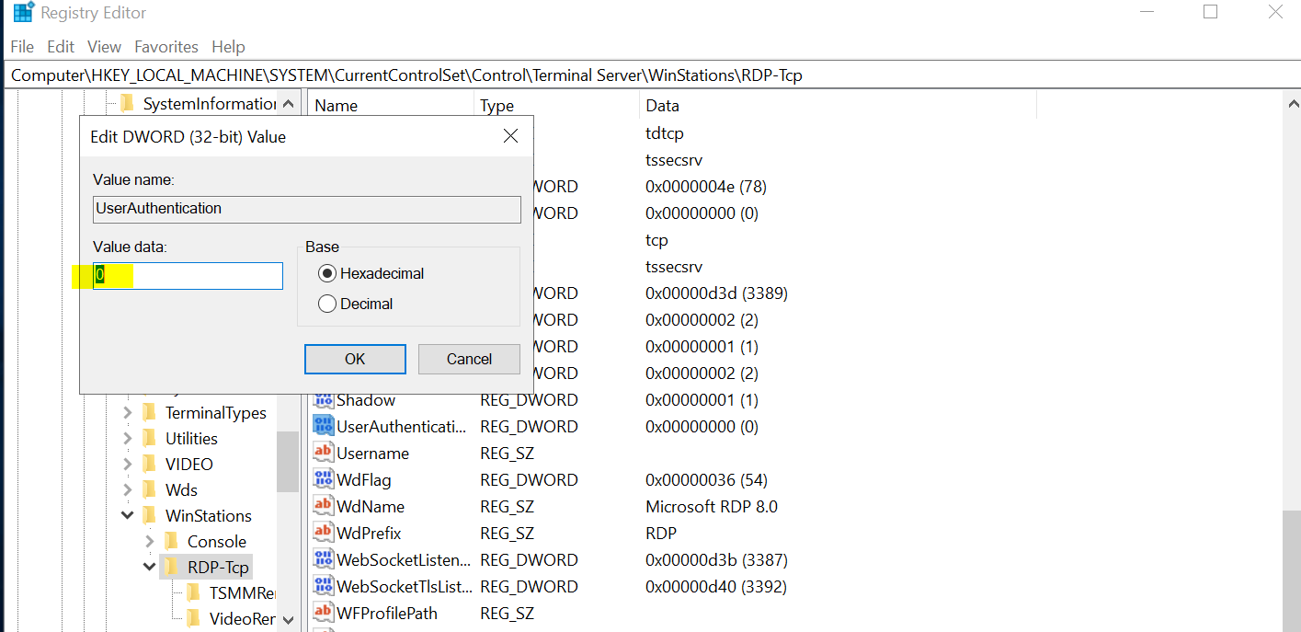

***Action4:***

Go to run and hit command ***gpedit.msc.***

1) Select Administrative Templet => Windows Components => Remote desktop services => Remote desktop Session host => Security

Disable the REQUIRE USER AUTHENTICATION FOR REMOTE CONNECTIONS BY USING NETWORK LEVEL.

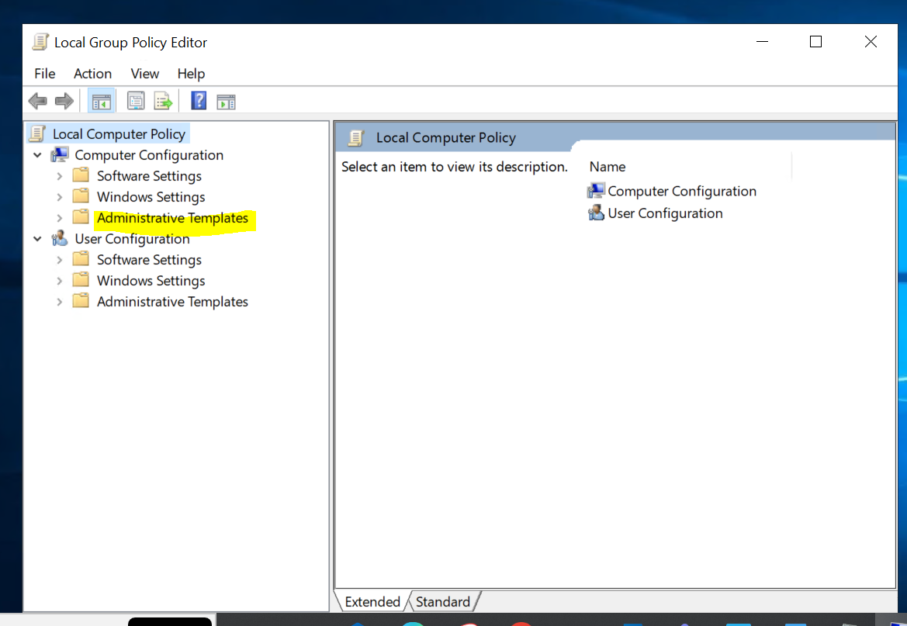

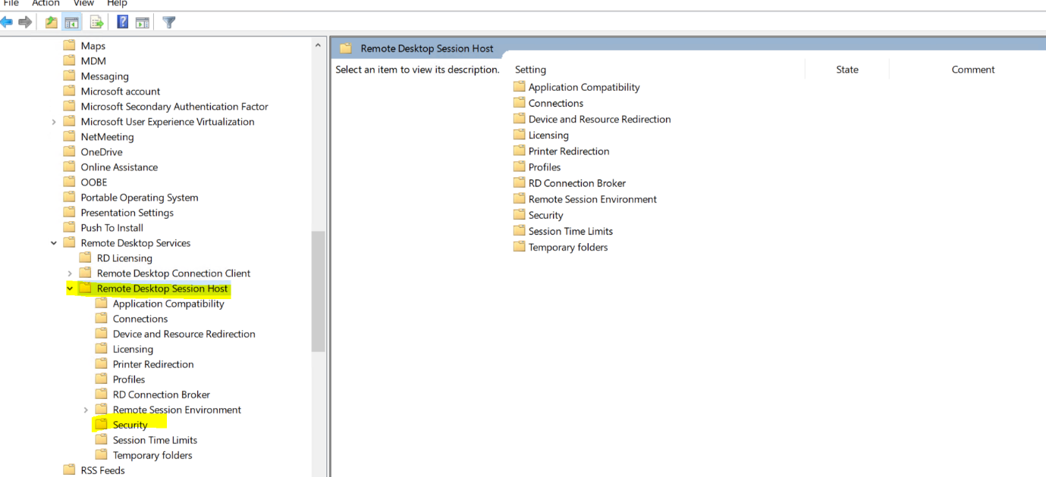

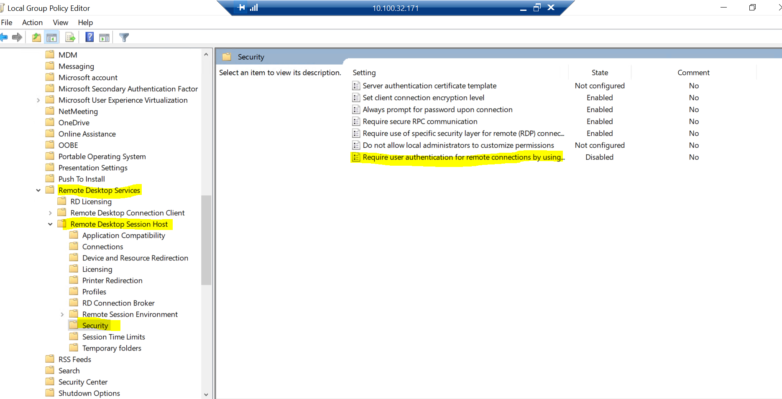

2)Go to Administrative Templet => Windows Components => Remote desktop services => Remote desktop Session host =>Device and Remote Redirection.

Disable the Do not allow drive redirection.

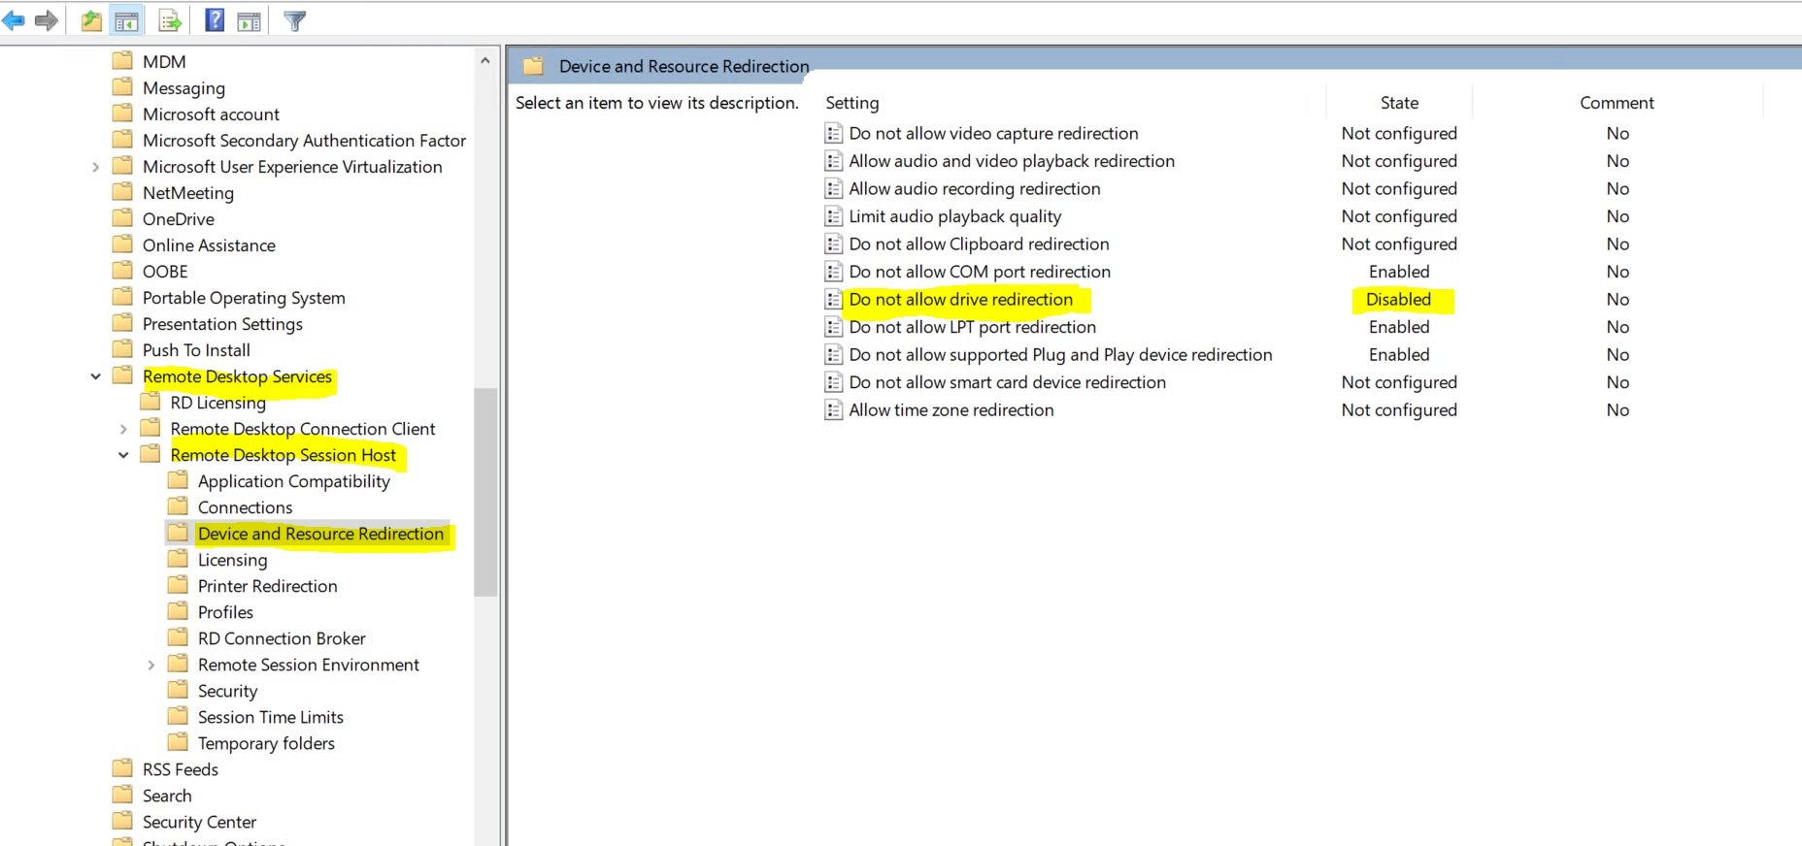

3) go to Windows Settings =>Security Settings => Windows Defender Firewall with Advanced Security-Local Group

Turn off the Firewall for Domain, Public and Private.

