**CLOUDFORMATION**

Runbook



December 2022

**ust.com**

Copyright and Confidentiality

Copyright © 2022 by UST Global Inc. All rights reserved. This document is protected under the copyright laws of United States, India, and other countries as an unpublished work and contains information that shall not be reproduced, published, used in the preparation of derivative works, and/or distributed, in whole or in part, by the recipient for any purpose other than to evaluate this document. Further, all information contained herein is proprietary and confidential to UST Global Inc and may not be disclosed to any third party. Exceptions to this notice are permitted only with the express, written permission of UST Global Inc.

UST® is a registered service mark of UST Global Inc

**UST**

**5 Polaris Way**

**Aliso Viejo, CA 92656**

**T +1 949 716 8757**

**F +1 949 716 8396**

**ust.com**

# 

# Version history

|  |  |  |  |  |  |
| --- | --- | --- | --- | --- | --- |
| **Date** | **Version** | **Updates** | **Author** | **Reviewer** | **Approver** |
| 08-Dec-22 | **0.1** | Initial draft | Ravi | Raja | Ramana |

Contents

Version history 3

Introduction 5

What is AWS CloudFormation? 5

CloudFormation Concept 6

1. Template 6

2. Stacks 7

**3.** Change sets 7

How does AWS CloudFormation work? 7

Getting started with AWS CloudFormation 8

Step 1: Pick a template 8

Step 2: Make sure we have prepared any required items for the stack 8

Step 3: Create the stack 8

Step 4: Monitor the progress of stack creation 10

To view the events for the stack 10

Step 5: Use our stack resources 10

Step 6: Clean up 10

To delete the stack and its resources 10

Conclusion: 11

Reference: - 11

# Introduction

# What is AWS CloudFormation?

AWS CloudFormation is a service that helps us model and set up our AWS resources so that we can spend less time managing those resources and more time focusing on our applications that run in AWS. We create a template that describes all the AWS resources that we want (like Amazon EC2 instances or Amazon RDS DB instances), and CloudFormation takes care of provisioning and configuring those resources for us.

* Simplify infrastructure management
* Quickly replicate your infrastructure
* Easily control and track changes to our infrastructure

# CloudFormation Concept

1. Template
2. Stacks
3. Changeset

## Template

A CloudFormation template is a JSON or YAML formatted text file. We can save these files with any extension, such as .json, .yaml, .template, or .txt. CloudFormation uses these templates as blueprints for building our AWS resources.

**Example: JSON**

{

    "AWSTemplateFormatVersion": "2010-09-09",

    "Description": "A sample template",

    "Resources": {

        "MyEC2Instance": {

            "Type": "AWS::EC2::Instance",

            "Properties": {

                "ImageId": "ami-0ff8a91507f77f867",

                "InstanceType": "t2.micro",

                "KeyName": "testkey",

                "BlockDeviceMappings": [

                    {

                        "DeviceName": "/dev/sdm",

                        "Ebs": {

                            "VolumeType": "io1",

                            "Iops": 200,

                            "DeleteOnTermination": false,

                            "VolumeSize": 20

                        }

                    }

                ]

            }

        }

    }

}

**Example: YAML**

AWSTemplateFormatVersion: 2010-09-09

Description: A sample template

Resources:

  MyEC2Instance:

    Type: 'AWS::EC2::Instance'

    Properties:

      ImageId: ami-0ff8a91507f77f867

      InstanceType: t2.micro

      KeyName: testkey

      BlockDeviceMappings:

        - DeviceName: /dev/sdm

          Ebs:

            VolumeType: io1

            Iops: 200

            DeleteOnTermination: false

            VolumeSize: 20

## 2. Stacks

When you use CloudFormation, we manage related resources as a single unit called a stack. We create, update, and delete a collection of resources by creating, updating, and deleting stacks. All the resources in a stack are defined by the stack's CloudFormation template.

## 3. Change sets

If we need to make changes to the running resources in a stack, we update the stack. Before making changes to our resources, we can generate a change set, which is a summary of our proposed changes. Change sets allow us to see how our changes might impact our running resources, especially for critical resources, before implementing them.

# How does AWS CloudFormation work?

When creating a stack, AWS CloudFormation makes underlying service calls to AWS to provision and configure our resources. CloudFormation can only perform actions that we have permission to do. For example, to create EC2 instances by using CloudFormation, we need permissions to create instances. we need similar permissions to terminate instances when we delete stacks with instances. we use [AWS Identity and Access Management](https://docs.aws.amazon.com/IAM/latest/UserGuide/) (IAM) to manage permissions.

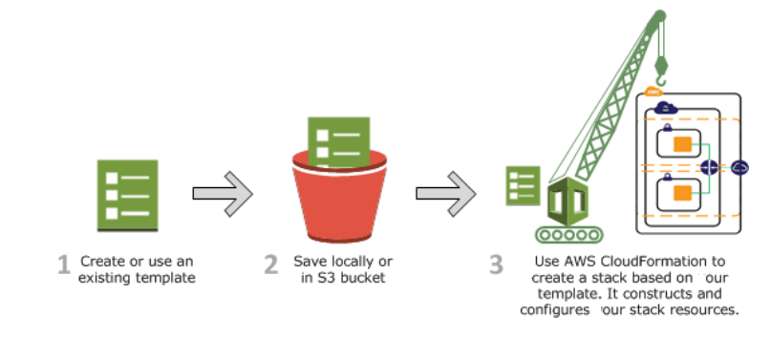

# Getting started with AWS CloudFormation

## Step 1: Pick a template

First, we need a template that specifies the resources that we want in our stack. For this step need to prepare a CloudFormation stack with .json or yaml format.

## Step 2: Make sure we have prepared any required items for the stack

Before we create a stack from a template, we must ensure that all dependent resources that the template requires are available. A template can use or refer to both existing AWS resources and resources declared in the template itself. CloudFormation takes care of checking references to resources in the template and also checks references to existing resources to ensure that they exist in the region where we are creating the stack. If our template refers to a dependent resource that doesn't exist, stack creation fails.

## Step 3: Create the stack

1. Sign in to the AWS Management Console and open the AWS CloudFormation console at [https://console.aws.amazon.com/cloudformation](https://console.aws.amazon.com/cloudformation/).

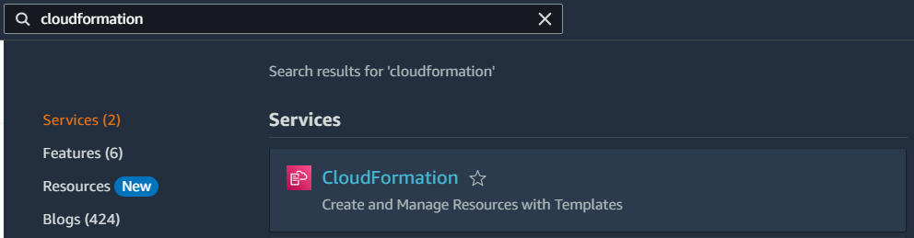

1. Choose Create Stack.

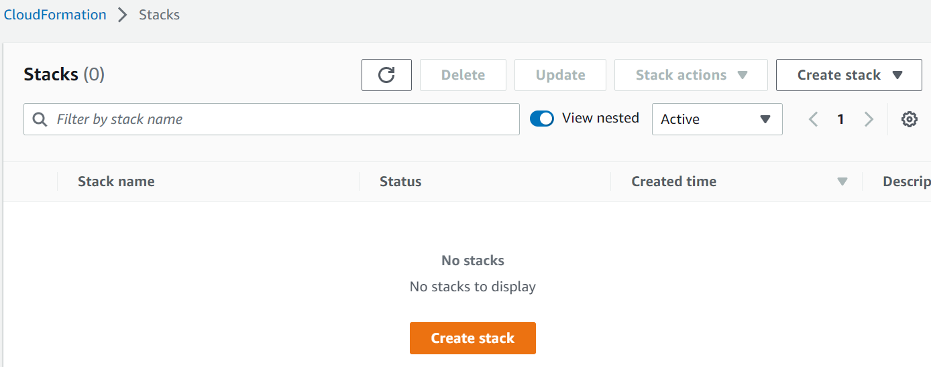

1. In the Template section, select Specify an Amazon S3 Template URL to type or paste the URL for template, and then choose Next:

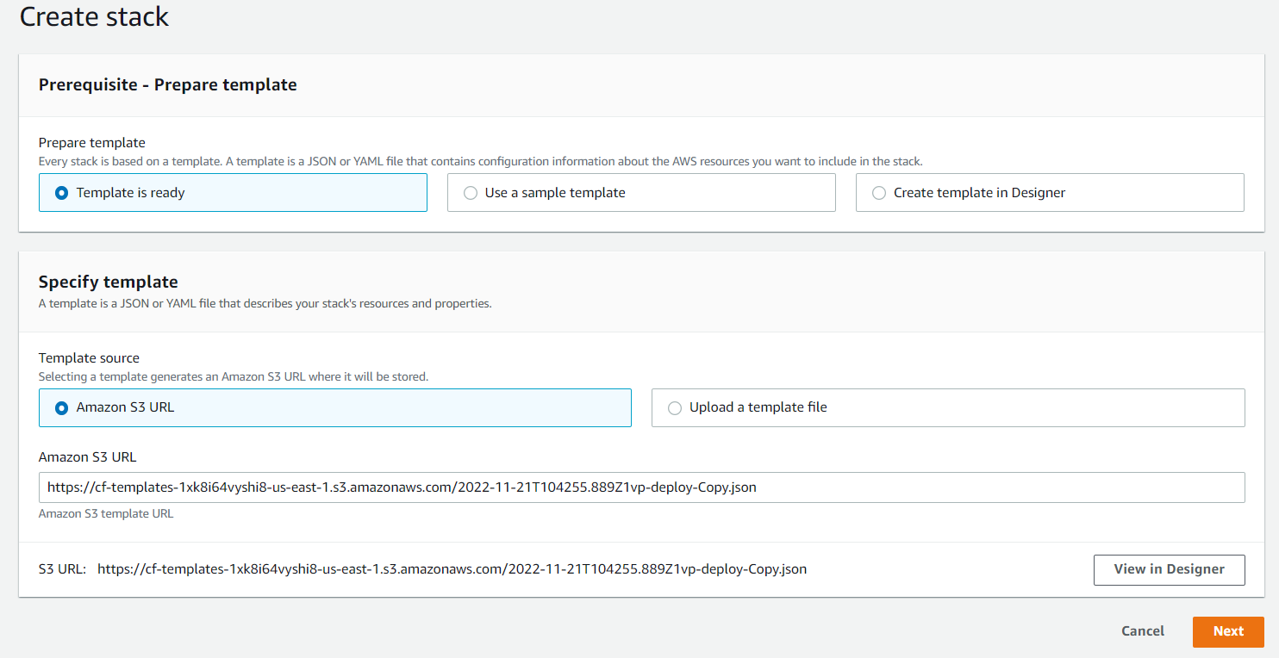

1. In the Specify Details section, enter a stack name in the Name field.

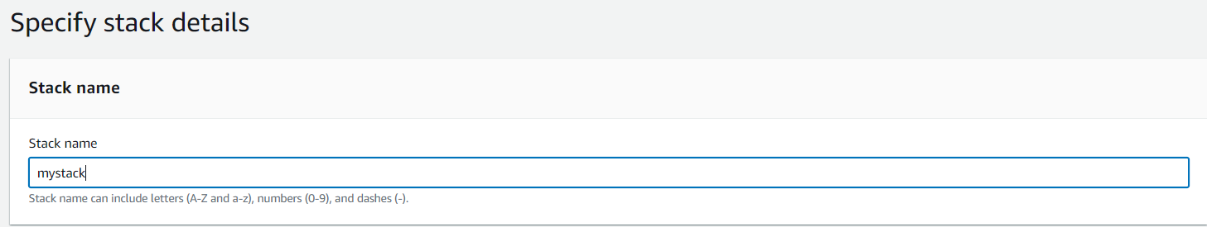

1. On the Specify Parameters page, we will recognize the parameters from the Parameters section of the template. We must provide values for all parameters that don't have default values.

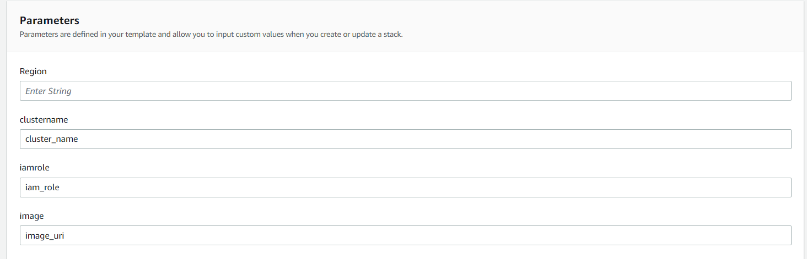

1. Choose Next.
2. Review the information for the stack. When we're satisfied with the settings, choose Submit.

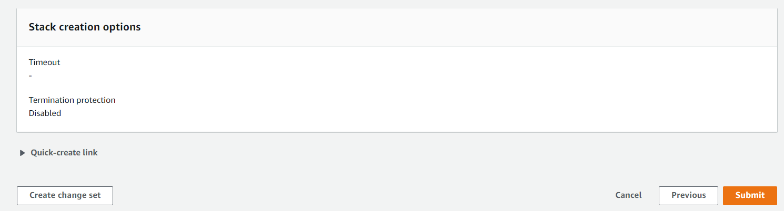

Stack might take several minutes to create

## Step 4: Monitor the progress of stack creation

After we complete the **Create Stack** wizard, CloudFormation begins creating the resources that are specified in the template. our new stack, MYstack, appears in the list at the top portion of the **CloudFormation** console. Its status should be CREATE_IN_PROGRESS. we can see detailed status for a stack by viewing its events.

### To view the events for the stack

1. On the CloudFormation console, select the stack Mystack in the list.
2. In the stack details pane, choose the **Events** tab.

The console automatically refreshes the event list with the most recent events every 60 seconds.

The **Events** tab displays each major step in the creation of the stack sorted by the time of each event, with latest events on top.

## Step 5: Use our stack resources

When the stack MyStack has a status of CREATE_COMPLETE, CloudFormation has finished creating the stack, and we can start using its resources.

## Step 6: Clean up

we have completed the CloudFormation getting started tasks. To make sure we aren't charged for any unwanted services, we can clean up by deleting the stack and its resources.

### To delete the stack and its resources

1. From the CloudFormation console, select the MyStack stack.
2. Choose **Delete Stack**.
3. In the confirmation message that appears, choose **Yes, Delete**.

The status for MyStack changes to DELETE_IN_PROGRESS. In the same way we monitored the creation of the stack, we can monitor its deletion by using the **Event** tab. When CloudFormation completes the deletion of the stack, it removes the stack from the list.

# Conclusion:

Congratulations! We successfully picked a template, created a stack, viewed, and used its resources, and deleted the stack and its resources. We can find other templates in the [**AWS CloudFormation sample template library**](http://aws.amazon.com/cloudformation/aws-cloudformation-templates/).

Now it's time to learn more about templates so that we can modify existing templates or create our own: [**Learn template basics**](https://docs.aws.amazon.com/AWSCloudFormation/latest/UserGuide/gettingstarted.templatebasics.html).

# Reference: -

<https://docs.aws.amazon.com/cloudformation/index.html>

Sample templates: <https://docs.aws.amazon.com/AWSCloudFormation/latest/UserGuide/cfn-sample-templates.html>





Together, we build for boundless impact