**AZURE CI/CD PIPELINE**

Build.yml file

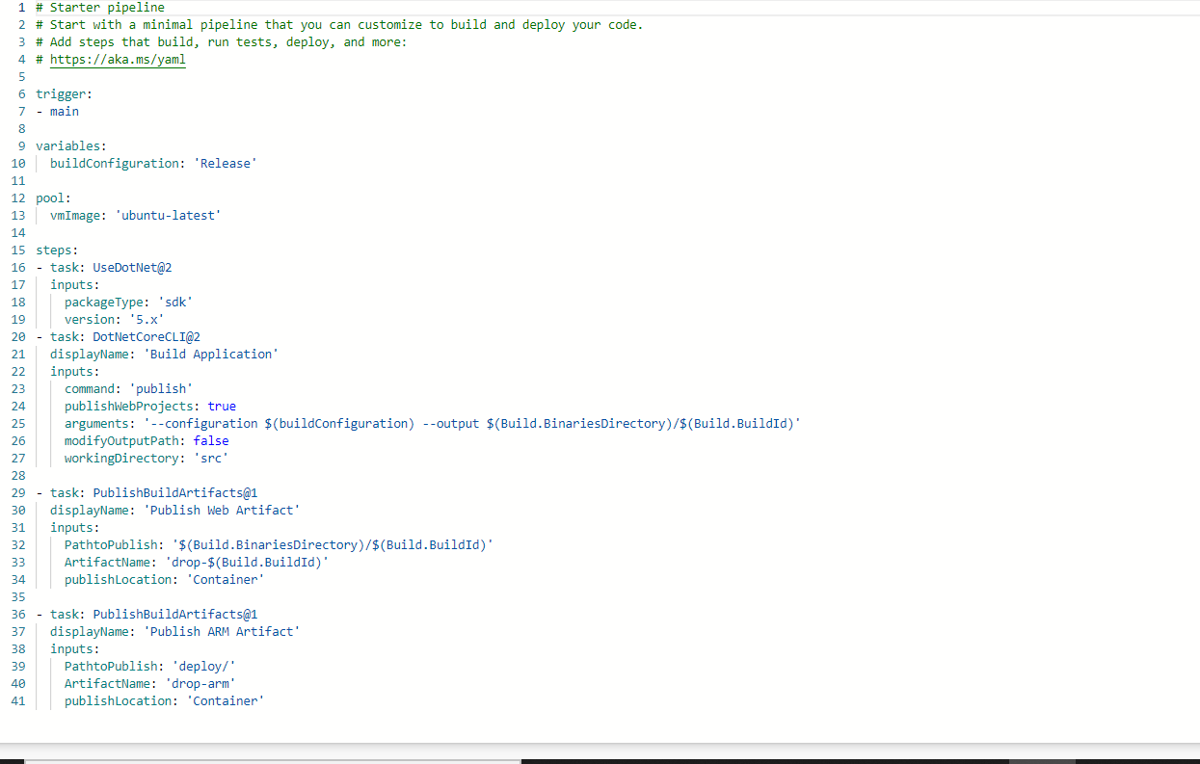

Adding build stage to above pipeline

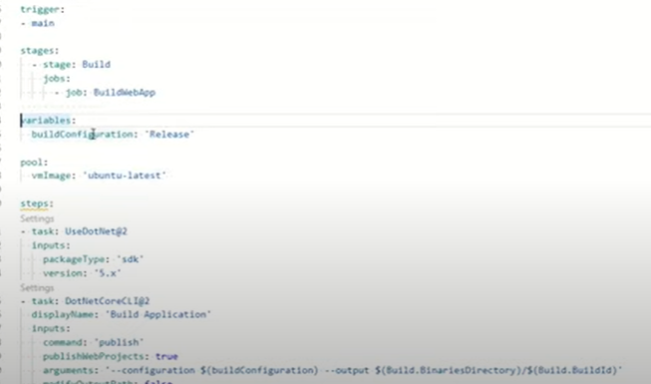

Adding Deploy stage to above pipeline

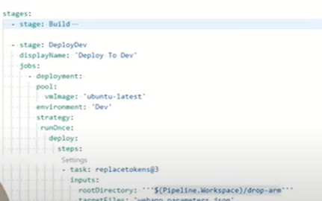

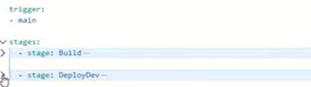

Defining variable group for the stage

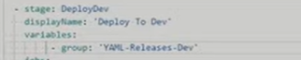

Path: Library->create variable group ->Add variable group

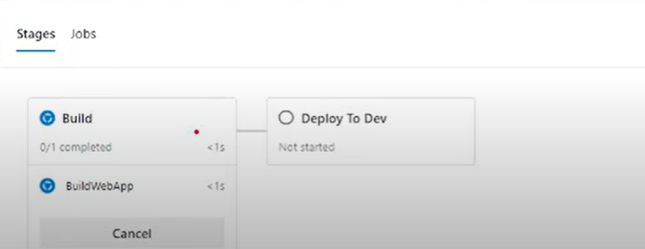

……………………………………………………………………………………………………………………………………………….

Path to add environment

Environments –> New environment.

