Raspberry pi Temperature and video stream in Flask server

Step 1:
1. Download a raspberry pi (Jessie/stretch debian) image from the website.
URL:https://www.raspberrypi.org/downloads/raspbian/
2. Use Win32-DiskImager to boot the Img file to Raspberry.
URL:https://sourceforge.net/projects/win32diskimager/
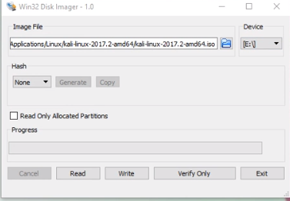

In the box load the image raspberry stretch or raspberry jessie and click Write button.
3. Insert the SD card to Raspberry pi and connect it to the monitor via HDMI cable
4. Open the terminal in raspberry and type
I. $ sudo apt-get update
II.$ sudo apt-get upgrade
III.$sudo apt-get install tightvncserver.
5. sudo raspi-config
Enable the camera ,ssh,VNC etc
sudo reboot in terminal

FOR SECURED SERVER HOST (SSH connection):
IN linux:
1.Use Fing mobile app from android playstore
scan it u will get the Ip address of raspberry

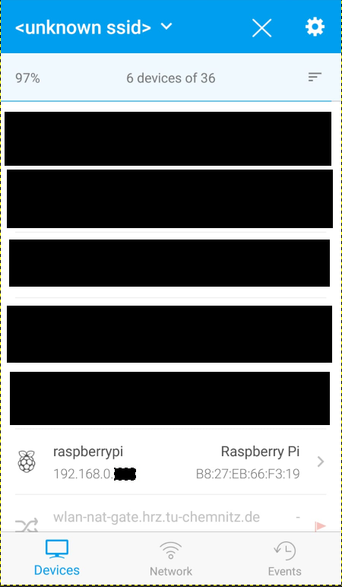
2.ssh pi@<ip-address of pi>
login:pi
password:raspberry (login and password is default for all)
For Windows:
Download putty and tightvnc server
putty :https://www.putty.org/
Tightvncserver: https://www.tightvnc.com/licensing-tvnserver.php

In putty type the ip address in session
select ssh→X11→ enable→ save the port → click open
Login:pi
Password:raspberry

Activate motion in raspberry pi:
1. We will be using the terminal, so open the terminal on the Pi or connect to it via SSH.
2. To begin, first, update the Raspberry Pi, so you’re running on the latest version.
sudo apt-get update
sudo apt-get upgrade
Depending on the version of Raspbian you’re using you will need to do a few different steps.

Raspbian Jessie
1. We start by removing libraries that may conflict with the newer packages. These may or may not already exist on your copy of Raspbian.
sudo apt-get remove libavcodec-extra-56 libavformat56 libavresample2 libavutil54
2. Download and install the following packages by inserting the following commands into the terminal.
wget https://github.com/ccrisan/motioneye/wiki/precompiled/ffmpeg_3.1.1-1_armhf.deb
sudo dpkg -i ffmpeg_3.1.1-1_armhf.deb
3. Now we need to install the following packages. We will need these as the Motion software relies on them.
sudo apt-get install curl libssl-dev libcurl4-openssl-dev libjpeg-dev libx264-142 libavcodec56 libavformat56 libmysqlclient18 libswscale3 libpq5
4. With those packages installed we can now grab the latest version of the motion software and install it. To do this run the following commands.
wget https://github.com/Motion-Project/motion/releases/download/release-4.0.1/pi_jessie_motion_4.0.1-1_armhf.deb
sudo dpkg -i pi_jessie_motion_4.0.1-1_armhf.deb

Raspbian Stretch
1. First, install the following packages. This command will work both on the full and lite version of Raspbian Stretch.
sudo apt-get install libmariadbclient18 libpq5 libavcodec57 libavformat57 libavutil55 libswscale4
2.Next, download the Motion deb file from the GitHub and install it using the dpkg command.
sudo wget https://github.com/Motion-Project/motion/releases/download/release-4.0.1/pi_stretch_motion_4.0.1-1_armhf.deb
sudo dpkg -i pi_stretch_motion_4.0.1-1_armhf.deb
That’s all you need to do before moving on to configuring Motion so that it will run on your Pi.

Configuring Motion
1. Now we need to make some edits to the configuration file (motion.conf)
sudo nano /etc/motion/motion.conf
2. Find the following lines and change them to the following.
- daemon on
- stream_localhost off
Note: Change the following two lines from on to off if you’re having issues with the stream freezing whenever motion occurs.
- output_pictures off
- ffmpeg_output_movies off
Optional (Don’t include the text in brackets)
- stream_maxrate 100 (This will allow for real-time streaming but requires more bandwidth & resources)
- framerate 100 (This will allow for 100 frames to be captured per second allowing for smoother video)
- width 640 (This changes the width of the image displayed)
- height 480 (This changes the height of the image displayed)
3. Now we need to setup up the daemon. First, we need to edit the motion file.
sudo nano /etc/default/motion
4. Find the following line and change it to the following:
start_motion_daemon=yes
5. Once you’re done, simply save and exit by pressing ctrl+x then y.
6. Now make sure the camera is connected and run the following line:
sudo service motion start
7. If you need to stop the service, simply run the following command:
sudo service motion stop
8. Now you should be able to check out the Webcam Stream at the IP address of our Pi so in your browser go to the following address:
192.168.1.103:8081
9. If the webpage isn’t loading, try restarting the service.
sudo service motion restart
10. If you’re using a Raspberry Pi camera, then you will need to do a few extra steps that are mentioned below.

First make sure the camera is switched on within raspi config, enter the following command and then enable the camera. (You will need to restart once you have done this).
sudo raspi-config
2. Now open up the modules file by entering the following line.
sudo nano /etc/modules
3. Enter the following line at the bottom of the file if it doesn’t already exist, once done save & exit by pressing ctrl+x then y.
bcm2835-v4l2
4. Now reboot the Pi, and the stream should now work.
sudo reboot
5. You should now be able to access the Raspberry Pi webcam stream by going to the Pi’s IP address on port 8081.
192.168.1.103:8081
You should now have a fully working Raspberry Pi camera server that is accessible within your local network. If you want to allow external access to the camera, then please follow my instructions below.

INSTALL FLASK
sudo pip install flask

DHT_22 :
Here I create a folder called DHT_22
Inside it has a folder called templates where index.html (design of the webpage) is present
ro.py contains the python program of it
I have used adafruit DHT_22 library for this project

Now
in terminal if you use ssh connection if ubuntu or window refer the step 1 and 2
Open the terminal
cd DHT_22
python ro.py
